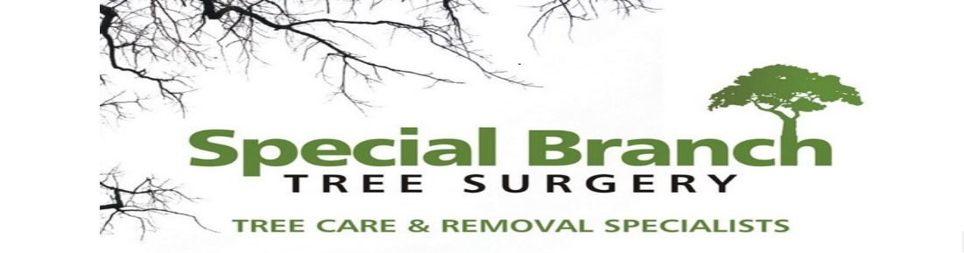

Top O’th Meadow Farm
Meadowhead Lane
Norden, Rochdale
OL11 5UL
Tel: 01706 658771

22nd April 2024

Hammad Akbar
1 Byron Grove
Rochdale
OL11 4BS

As requested, please see the completed tree report, as discussed this offers no guarantees as trees are living organisms and can fail at any time. We would also like to advise that no indemnity or insurance cover is offered. This report is in “my opinion” only and covers only the trees that have been inspected.

Trees in question are subject to a Tree preservation order – TPO254

Local authority: Rochdale

Location
TPO Ref: TPO254
TPO name: 587 Bury Road, Rochdale
Date confirmed: 2005-09-27
Tree type: Sycamore
Description: T1
ID: T1TPO254
Local authority: Rochdale

Work provided

Site visit, arboricultural inspection, photography, report, and quotation.
All trees have been thoroughly inspected and only the tree with any defects or concerns have been noted.

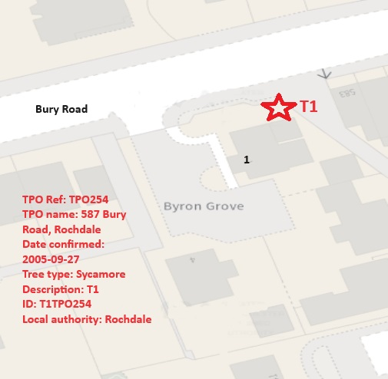

Trees included
T1 – Sycamore

Issues found

A Mature Sycamore tree located within proximity to the property currently poses a high risk to the property and surroundings. T6 has significant stem decay and rot at the base of the tree and noticeable dieback within the upper crown. Auriculariaceae currently present.

Recommendations

T1 – Sycamore – Remove and replant 2 new trees.

- Reasons to Remove a Poor Specimen Tree

- There are several reasons why it may be necessary to remove a poor specimen tree from a property. These reasons can range from the tree posing a safety hazard to it being diseased or damaged beyond repair. Here are some of the most common reasons for removing a poor specimen tree:

- Safety Concerns: One of the primary reasons for removing a poor specimen tree is when it poses a safety risk. This can occur if the tree is leaning precariously, has large dead branches, or shows signs of decay. Such trees can pose a danger to people and property, especially during storms or high winds. In such cases, it is crucial to remove the tree to prevent potential accidents and damage.
- Structural Issues: Poorly developed root systems, weak trunk structures, or other structural issues can make a tree unstable and prone to failure. In such cases, the tree may need to be removed to avoid potential hazards.
- Aesthetic Considerations: In some cases, a poor specimen tree may detract from the overall aesthetic appeal of a landscape due to its unattractive appearance or poor form. Removing such a tree can enhance the visual appeal of the surroundings.
- Tree root compaction issues can arise when the soil surrounding a tree's roots becomes densely packed or compressed. This compression limits the root's ability to absorb nutrients, water, and oxygen, leading to stunted growth or even the decline of the tree's health. It's crucial to avoid heavy machinery or excessive foot traffic around trees to prevent root compaction. Implementing techniques like mulching, aeration, or creating protective barriers can help alleviate this problem and support the tree's health.

In this situation, it is crucial to consider the safety risks associated with a tree that has a rotten and decaying base. Trees with compromised structural integrity pose a significant hazard as they are more susceptible to falling, especially during adverse weather conditions. The presence of Auriculariaceae, a type of fungus commonly found on decaying wood, further indicates the deteriorating health of the tree. Removing the tree in question would be advisable for several reasons. Firstly, it would eliminate the potential danger posed by a weakened tree, reducing the risk of property damage or personal injury. Additionally, removing the tree can prevent the spread of fungal diseases to nearby healthy trees, preserving the overall health of your landscape. When considering tree removal, it is essential to consult with a certified arborist or tree removal specialist to assess the situation accurately. They can provide expert advice on the best course of action based on the specific condition of the tree and its surroundings. In conclusion, removing the T1 Sycamore tree with a rotten base and Auriculariaceae presence is recommended to ensure safety and prevent further damage. Seeking professional guidance will help you make an informed decision tailored to your unique circumstances.

Removing a tree with Auriculariaceae present is important because this fungal family, commonly known as jelly fungi, can indicate decay within the tree. If left unchecked, the presence of Auriculariaceae can lead to structural weaknesses in the tree, making it more susceptible to falling or causing potential harm to people or property. Additionally, the fungus itself can spread spores that may infect nearby trees, contributing to the overall decline of the tree population in the area. Therefore, removing a tree with Auriculariaceae present is a proactive measure to prevent further decay and potential hazards

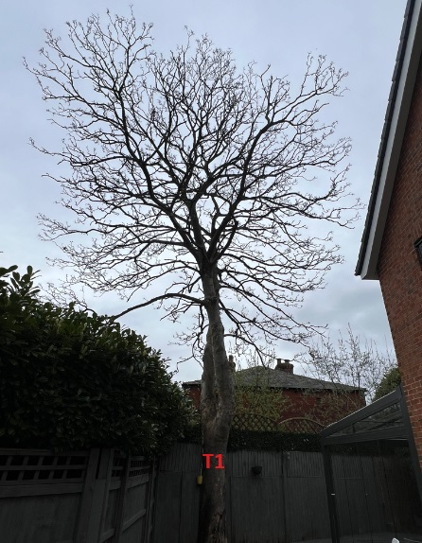
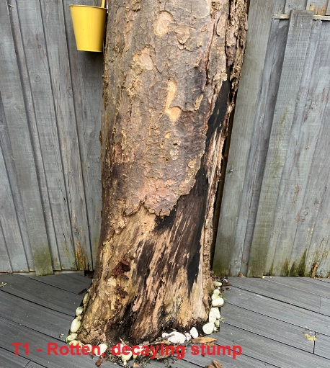
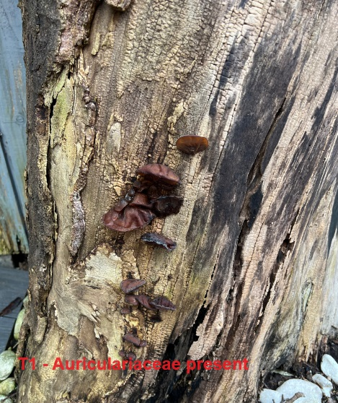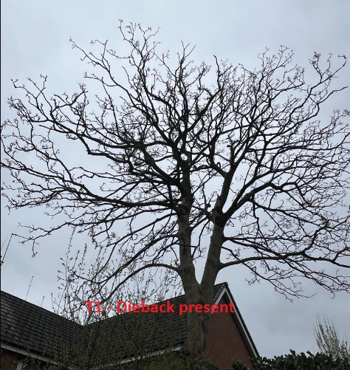
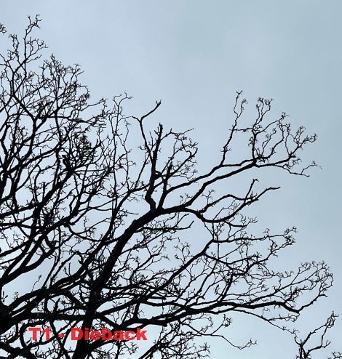
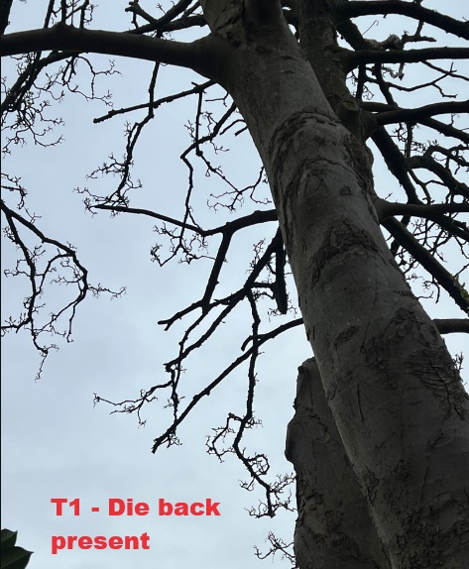

If permission is granted for the removal the property owner is willing to plant two new trees in his garden.
The property owner will choose from the list of which trees he will plant to replace the Sycamore removal from the list below.

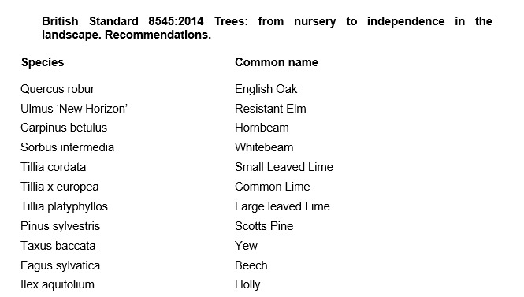

Aftercare

To ensure success when planting trees, providing good aftercare is as important as good planting practice. The first two to three years after planting are critical for a tree’s establishment. Planted well and cared for correctly, it should flourish and become a valuable feature in your garden. It is an investment of time and money, and it would be a shame to lose the benefit of a fine tree through post-planting neglect. The first challenge is moving the plant from the nursery to its new home: this can cause stress to any tree. Give it attention for the first few years to ensure re-establishment and survival in its new location. Watering, weeding, staking, mulching and formative pruning are important for successful establishment, but none are onerous or time consuming. Tree aftercare the guidelines on these pages apply primarily to ornamental trees: fruit trees are established in the same way, but pruned and managed differently to maximise fruit production. Newly planted trees ideally need regular watering in dry spells for three to five years to ensure good root growth. After planting a tree, pruning may be necessary to enhance the natural shape or improve its structure and strength. In the first few years, identify and correct problems with the main framework of the tree – prune early, as this helps avoid future complications. With a young tree, one of the most common tasks is to remove lower branches that begin to interfere with other gardening activities, create shade or block views. Look out, too, for pests such as aphids and diseases such as canker – they can reduce the vigour of your tree and make establishment slower. If you keep your tree vigorous and healthy, it is less likely to succumb to pests and disease

For the first two to three years, irrigate newly planted trees weekly during dry spells in spring and summer. Too much water, and roots will not extend in the search for moisture – but underirrigation results in slow establishment and symptoms of stress, such as canopy dieback and bark splits on the trunk. Water directly at the base of the tree and, particularly if the ground is dry, apply slowly to stop it running off. Make sure water has penetrated the soil; on our well-drained soil, we apply two to three full watering cans of water per week to new plantings.

From initial planting, mulch annually in spring or autumn to suppress weedy competitors and help retain soil moisture. ✤ Organic or inorganic materials can be used; composted wood chippings, leaf mould and well-rotted manure. ✤ Organic materials should be part composted: six-month-old wood chip is ideal. ✤ Mulch should be 7–10cm (3–4in) deep; avoid piling it round the trunk as this can soften the bark.

New trees should be staked until their roots provide good anchorage – this can take several years. If loose, the tree will rock in the wind and its root ball will move, which hinders plant establishment and could even result in death. ✤ Check ties are secure and a padded cushion is between the tree and stake. Rubbing against a stake can create a scar, which leaves the tree open to disease. ✤ Check regularly: ties left too tight cause serious bark damage. Fast-growing trees may need ties loosening every year.

Formative pruning trees
Formative pruning is the process of shaping a tree when it is young. Every variety has a different natural growth habit, but unpruned trees will for the most part produce a crown cluttered with branches. The aim is to develop an open, balanced network of strong, unshaded branches and at a height that allows for good management such as grazing livestock and machinery. This is achieved by creating a good height trunk and pruning young growth back to encourage the tree to grow in the right direction and develop thick branches.

Kind regards,
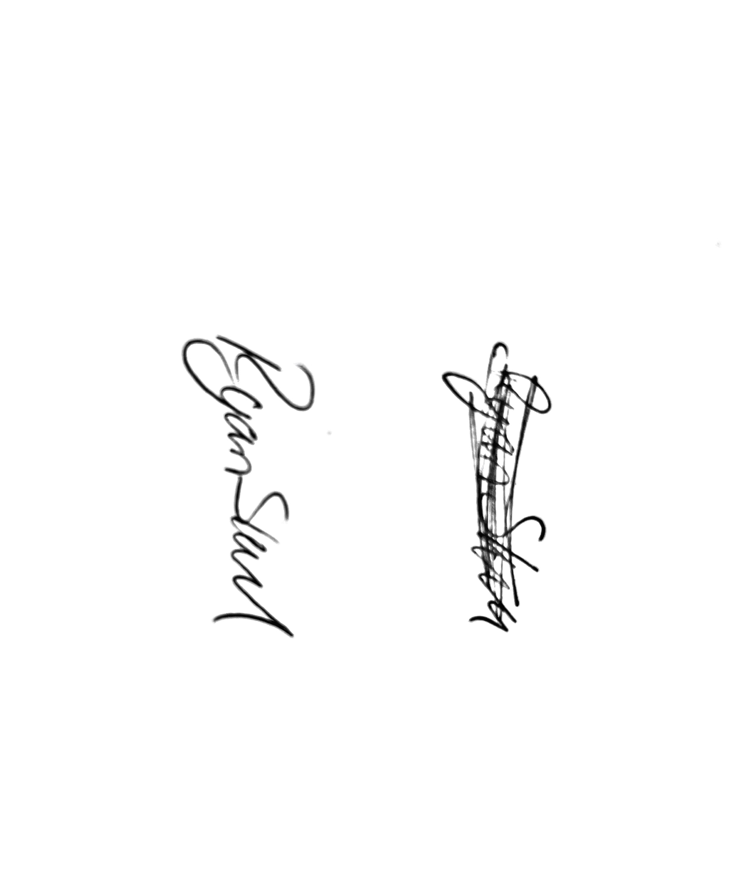
Mr. Ryan Slack
General Manager and Director
SEG Award, Cert Arb L2 (ABC)

