

Top O’th Meadow Farm
Meadowhead Lane
Norden, Rochdale
OL11 5UL
Tel: 01706 658771

12th March 2025

Report for
Phil Roberts
The Old Rectory
Mellalieu Street, Middleton
M24 5DN

As requested, please see the completed tree report, as discussed this offers no guarantees as trees are living organisms and can fail at any time. We would also like to advise that no indemnity or insurance cover is offered. This report is in “my opinion” only and covers only the trees that have been inspected.

Trees in question are subject to a Tree preservation order – TPO177

Local authority; Rochdale

Location
Garden of The Old Rectory.

TPO Ref: TPO177
- TPO name: The Old Rectory, Mellalieu Street, Middleton
- Date confirmed: 1999-03-17
- Tree type: Weeping Willow
- Description: T5
- ID: T5TPO177
- Local authority: Rochdale

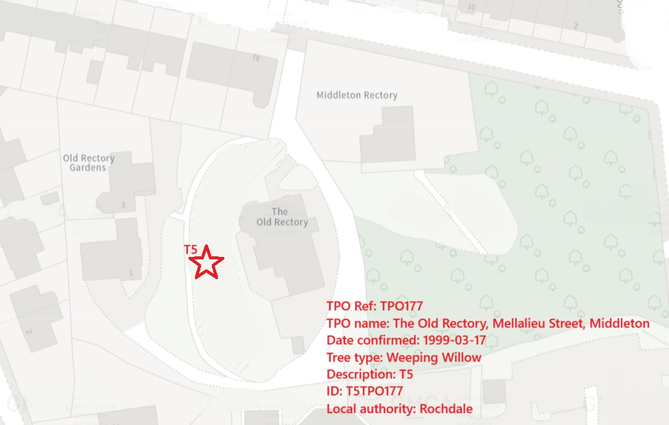

Work provided

Site visit, arboricultural inspection, photography, report, and quotation.
All trees have been thoroughly inspected and only the tree with any defects or concerns have been noted.

Trees included

T5 Willow.

Issues found

T5 – Willow, Mature tree with a large cavity at approximately 4 meters. Numerous large limbs are currently being supported by the weakened structure.

Recommendations

T5 – Willow. Crown reduce by 4-5 meters.

The Importance of Heavy Reduction on T5 (Willow) to Mitigate Hazards in Residential Gardens
This article discusses the necessity of heavy reduction on a Willow tree (T5) that exhibits a large cavity at approximately 4 meters, coupled with heavy branches within the same area. This case presents significant safety concerns as the tree is situated in a garden where adjacent properties and vehicles are at risk. By examining the potential risks and benefits of heavy reduction, this paper highlights the crucial role that timely and appropriate tree maintenance plays in ensuring the safety of residential environments.
Introduction:
Maintaining trees in residential settings is essential for safeguarding inhabitants and property from potential hazards. When a tree, such as the Willow tree (T5) in question, displays signs of structural weaknesses, proactive measures must be taken to mitigate the associated risks. In this context, heavy reduction is a recommended strategy to address the large cavity and heavy branches that pose a threat to nearby structures.
Assessment of the Tree's Condition:
The presence of a large cavity at the 4-meter mark on the Willow tree indicates internal decay and compromised structural integrity. Additionally, the existence of heavy branches in close proximity to the cavity further exacerbates the risk of branch failure. Given the tree's location in a residential garden with properties and vehicles in the immediate vicinity, the potential consequences of a branch failure or tree collapse cannot be understated.
Rationale for Heavy Reduction:
Heavy reduction, as opposed to complete removal, offers a balanced approach to managing the risks associated with the compromised Willow tree. By strategically pruning back the heavy branches and reducing the overall canopy size, the tree's load-bearing capacity can be redistributed, minimising the likelihood of branch failure or tree collapse. This approach aims to preserve the aesthetic value of the tree while prioritising safety considerations.
Benefits of Heavy Reduction:
Implementing heavy reduction on T5 (Willow) carries several benefits for both the tree and its surrounding environment. By reducing the weight and leverage of heavy branches, the risk of structural failure is significantly reduced, prolonging the tree's lifespan and minimising the need for emergency interventions. Furthermore, maintaining a controlled canopy size through heavy reduction enhances the tree's overall health and vigor, promoting continued growth and vitality.
Conclusion:
In conclusion, heavy reduction on T5 (Willow) is a proactive and effective solution to address the structural vulnerabilities present in the tree while mitigating risks to nearby properties and vehicles. By prioritising safety through targeted pruning and canopy reduction, residential gardens can maintain a harmonious balance between aesthetic appeal and risk mitigation. It is imperative for property owners and arborists to collaborate in implementing timely tree maintenance practices to ensure the long-term well-being of trees and the safety of their surroundings.

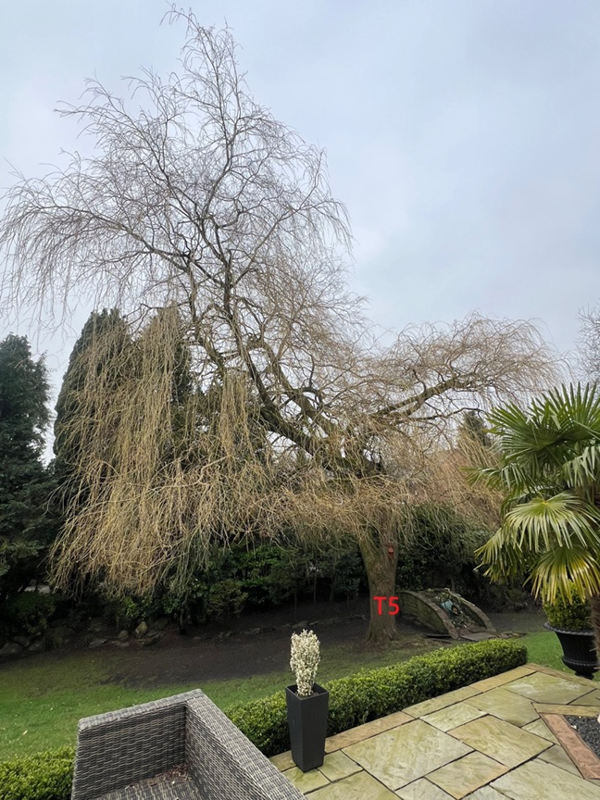
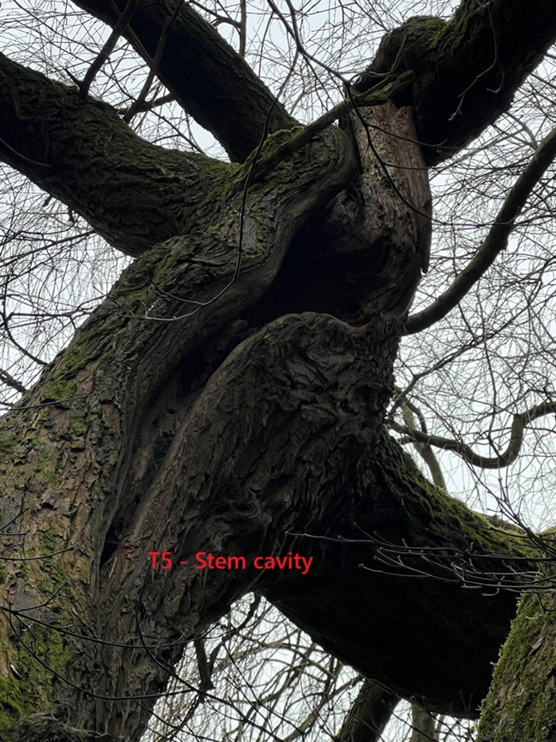
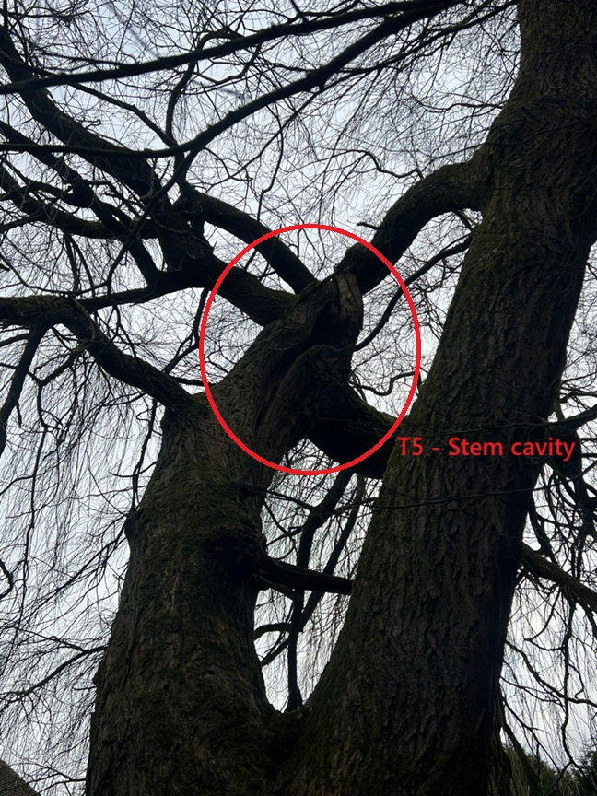
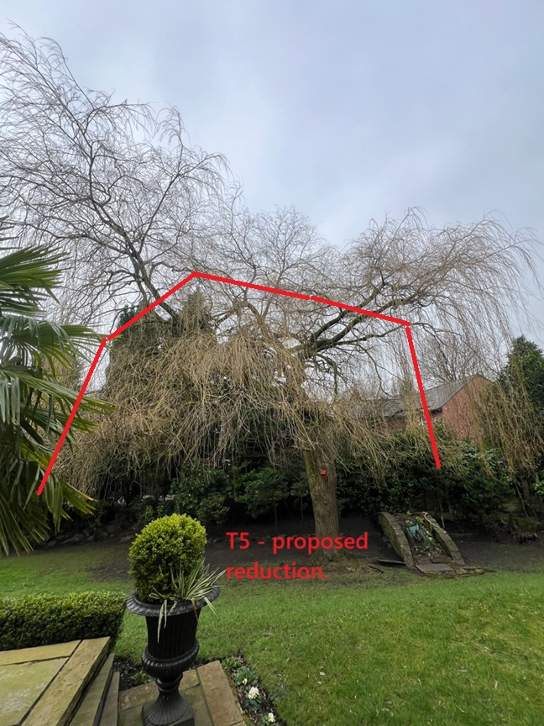

Kind regards,

Mr. Ryan Slack
General Manager and Director
SEG Award, Cert Arb L2 (ABC)

