Full Planning application for the conversion and extension of an existing building to form one dwelling at Harwood Fields Farm, Castle Hill Road, Birtle, BL9 6UL

Planning Statement

H | P
D | A

March 2024

Prepared by Hartley Planning and Development Associates Ltd

The proposed development

The applicant owns land at the above address where there is a mix of stone built barns and converted houses and more modern agricultural buildings.

This full application is for the conversion and extension of part of an equestrian building including the demolition of the remainder.

The farm and its buildings are in the Green Belt.

The main issues
The main issues are (i) whether or not the proposal would be inappropriate development in the Green Belt including its impact upon openness and its purpose (ii) the effect on the character and appearance of the area; and (iii) if it is inappropriate development, whether the harm by reason of inappropriateness and any other harm, would be clearly outweighed by other considerations, so as to amount to the very special circumstances necessary to justify the development.

Whether inappropriate development

Policy G4 of the Rochdale Core Strategy 2016 (CS) states that ‘development will be restricted to those limited types of development which are deemed not to be inappropriate by national planning policies unless very special circumstances can be demonstrated’.

The National Planning Policy Framework, December 2023 (the Framework) states: -
152. ‘Inappropriate development is, by definition, harmful to the Green Belt and should not be approved except in very special circumstances’, while paragraph 154 states that ‘a local planning authority should regard the construction of new buildings as inappropriate in the Green Belt.’

However, paragraph 154 allows the following as exceptions: -

c) the extension or alteration of a building provided that it does not result in disproportionate additions over and above the size of the original building

g) limited infilling or the partial or complete redevelopment of previously developed land, whether redundant or in continuing use (excluding temporary buildings), which would:
‒ not have a greater impact on the openness of the Green Belt than the existing development

Paragraph 155 of the Framework also allows the following in the Green Belt ‘provided they preserve its openness and do not conflict with the purposes of including land within it.

d) the re-use of buildings provided that the buildings are of permanent and substantial construction’

The proposed conversion and extension relates to an equestrian stable block with solid walls with a double pitched roof, Its use, being an equestrian building is ‘previously developed land’ (paragraph 155(g) above).It is of permanent and substantial construction.

Moreover, the equestrian building (including an adjoining tack room building) has a volume of some 1394m3. That part to remain and to be extended would have a volume of approximately 855m3, a reduction of some 39% in terms of openness of the Green Belt.

Moreover, the application building used to be two storeys in height: -

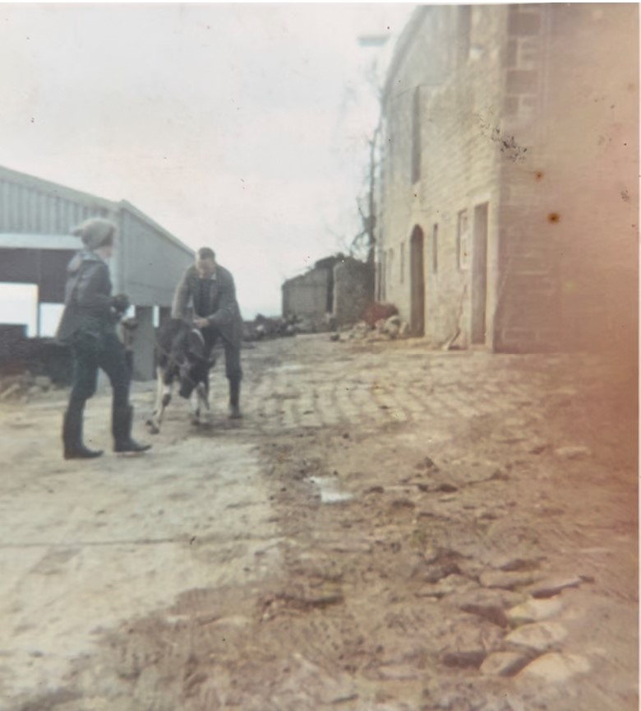

So far as the purpose of the Green Belt is concerned, paragraph 143 of the Framework states that the Green Belt has 5 purposes of which three are pertinent to the current application -

‘a) to check the unrestricted sprawl of large built-up areas;
b) to prevent neighbouring towns merging into one another;
c) to assist in safeguarding the countryside from encroachment’.

However, the application site is already previously developed land. The proposal would not add to any unrestricted sprawl of large built up areas and would not lead to the merging of neighbouring towns. As the site is already developed, the proposal would not lead to encroachment into the countryside.
Therefore, for the above reasons, the proposed development would not be inappropriate development in the Green Belt.
As the proposed development is not inappropriate, there is no need to consider very special circumstances.

Character and appearance
Various barns have been previously converted under both full planning approvals and also ,under ’prior notice’ provisions of the General Permitted Development Order, to houses. These are two storey, stone built properties and face the building for which application is now made for conversion to a dwelling.
External walls would be constructed from the natural stone in the building to be demolished.
The roof would be natural blue slate: -

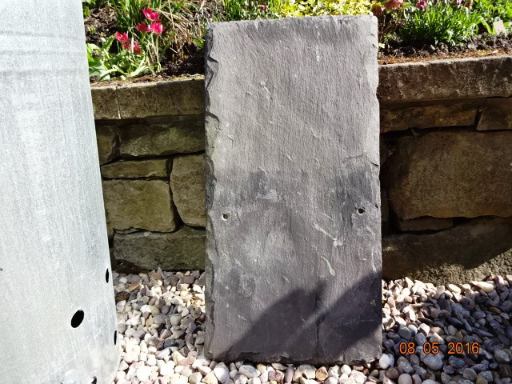

Windows would be wooden casements, set in from the external elevations by 100mm.
The proposed dwelling would have a similar character and appearance and would have a similar height to existing dwellings on the site.
It would be occupied by the applicants daughter and family.
Landscaping
The building is located against existing boundaries and in an area where tree planting is absent and not appropriate. No such planting is therefore proposed.
Access
No changes are proposed to the existing access.

Flood Risk
The site is within the lowest flood risk zone (Zone 1): -

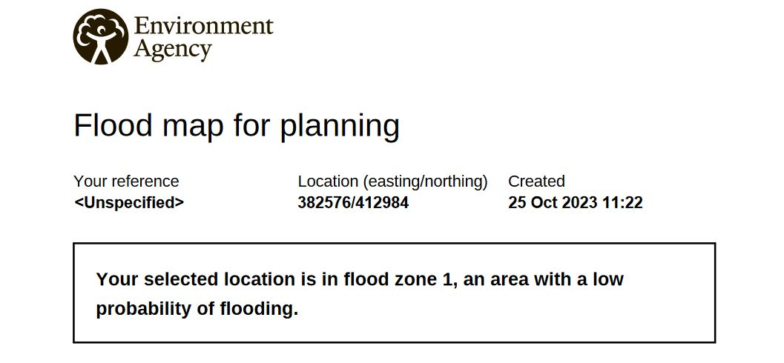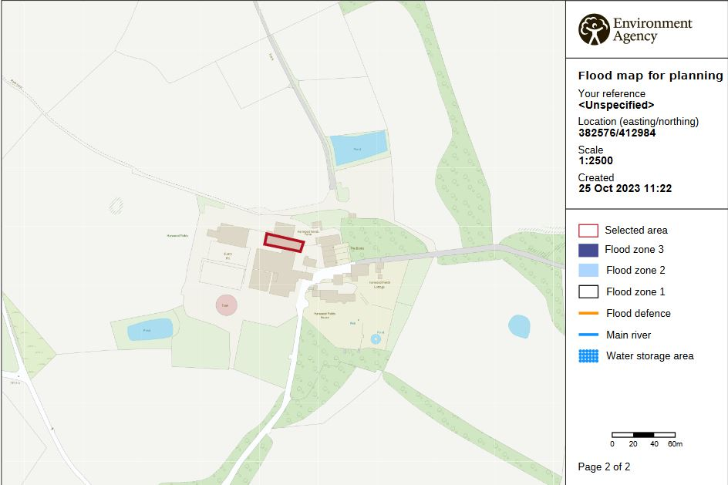

It is not in a Coal Authority High risk zone: -
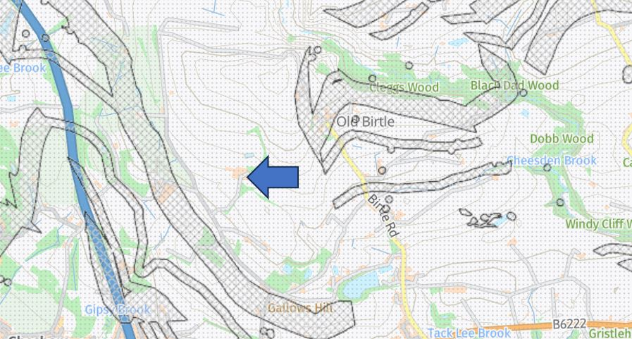

Biodiversity enhancement
The submitted bat and bird report advises that 3 no. bat boxes plus 3 no bird boxes should be installed on the outside of the proposed dwelling.
These would be fitted under the eaves or on the gable ends, all prior to the first occupation of the dwelling.

Drainage
Foul drainage would be to the existing septic tank which serves the other dwellings on the site and where there is sufficient additional capacity.
Surface water would feed int the existing culvert leading to an existing pond in the field owned by the applicants, and which serves the existing dwellings

