HERITAGE STATEMENT
216 Yorkshire Street Rochdale OL16
February 2024
Building Design Services
M Farooq

HERITAGE STATAMENT

This heritage statement has been prepared by Building Design Services in support of the planning application for the proposed change of use at first floor and second floor from storage space into two self-contained flats and new opening in front elevation at the site of 216 Yorkshire Street Rochdale. Also replacement of fenestration to front and rear and the replacement of the extraction flue to the rear.

The site sits in the middle of a row of terraces along Yorkshire Street, a key commercial area close to the centre of Rochdale. Located to the east side of St Mary’s Gate, the site has views of Ukrainian Catholic Church of St Mary a grade II listed entry from nearby the site a short distant away near the highway and a public car park. The property is currently occupied by a hot food takeaway on the ground floor with the 1st and 2nd floors vacant and was last used as storage space. The site is located within the Yorkshire Street local centre. The adjoining properties to the side are also commercial.
The property is not a Listed Building, nor it is located within the conservation area. The building is not listed as Non-Designated Heritage Asset (NDHA) within the council’s online register.
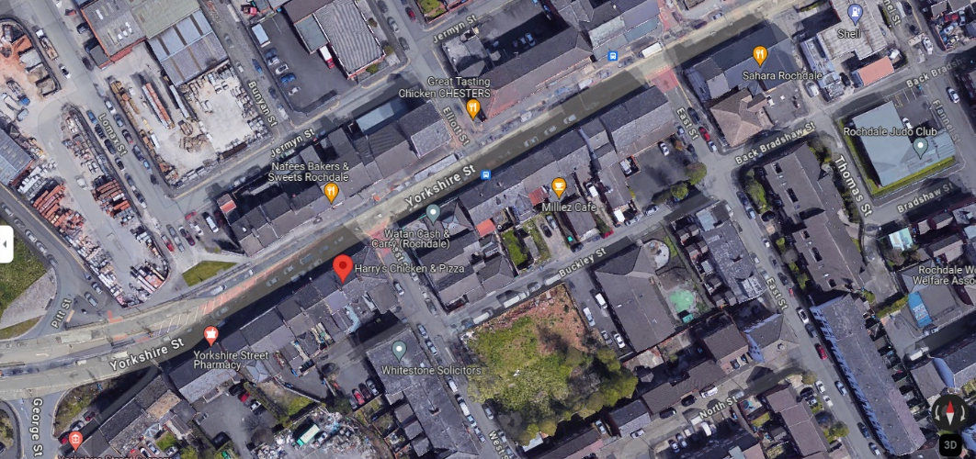

The building is located along Yorkshire Street Local Centre.
Guidance for heritage statement emphasises the need for the documents to be appropriate in length. The nature of the property, which encompasses a number of distinct elements with different features, the extent of the proposed works and the designation and surrounding architectural buildings have driven the length. The nature of this property, which encompasses a number of distinct elements with different features, the extent of the proposed work and the designation and surrounding architectural buildings have driven the length of this document.

PLANNING POLICY

The key theme of delivering sustainable development is at the core of all the policies and objectives in this document. Sustainable development incorporates not only an environmental role (protection of heritage and townscape assets of value), but also a social role (supporting the communities health and social needs) and economic role (contributing to building a strong, competitive, and responsive economy by supporting growth and the provision of infrastructure).

There is a presumption in favour of sustainable development. This means approving development that accords with the development plan without delay (where the development plan is up to date) and (where the development plan is silent), granting permission unless any adverse impacts of doing so would significantly and demonstrably outweigh the benefits, when assessed against the policies in the Framework taken as a whole.

Section 66 of the Planning (Listed Buildings and Conservation Areas) Act 1990 (as amended) states that in considering whether to grant planning permission for development which affects a listed building or its setting, the local planning authority shall have special regard to the desirability of preserving the building or its setting or any features of special architectural or historic interest which it possesses.

Policy P2 of the Rochdale Core Strategy sets out that the Council will conserve, enhance, and promote key heritage assets, including consideration of their wider settings.

‘Significance’ with regard to heritage assets is defined by the NPPF as: ‘The value of a heritage asset to this and future generations because of its heritage interest. That interest may be archaeological, architectural, artistic or historic. Significance derives not only from a heritage asset’s physical presence, but also from its setting.’

Planning practice guidance identifies that substantial harm is a high test and may not arise in many cases. Whether a proposal causes substantial harm will be a judgment for the decision taker, having regard to the circumstances of the case and the policy in the National Planning Policy Framework. In determining whether works to a listed building constitute substantial harm, an important consideration would be whether the adverse impact seriously affects a key element of its special architectural or historic interest. It is the degree of harm to the asset’s significance rather than the scale of the development that is to be assessed. The harm may arise from works to the asset or from development within its setting
When considering potential impacts, the NPPF provides the guidance below-;

199. When considering the impact of a proposed development on the significance of a designated heritage asset, great weight should be given to the asset’s conservation (and the more important the asset, the greater the weight should be). This is irrespective of whether any potential harm amounts to substantial harm, total loss or less than substantial harm to its significance.

- Where a development proposal will lead to less than substantial harm to the significance of a designated heritage asset, this harm should be weighed against the public benefits of the proposal including, where appropriate, securing its optimum viable use.

- The effect of an application on the significance of a non-designated heritage asset should be taken into account in determining the application. In weighing applications that directly or indirectly affect non- designated heritage assets, a balanced judgement will be required having regard to the scale of any harm or loss and the significance of the heritage asset.

- Local planning authorities should not permit the loss of the whole or part of a heritage asset without taking all reasonable steps to ensure the new development will proceed after the loss has occurred.

ROCHDALE CORE STRATEGY - ADOPTED OCTOBER 2016

Policy DM1: General Development Requirements This seeks to ensure that new development meets a range or criteria including: a) Are of a high quality of design and take the opportunity to enhance the quality of the area b) Are compatible with surrounding land uses c) Do not adversely affect the amenity of residents through visual intrusion, overbearing impact, overshadowing or loss of privacy e) Provide satisfactory vehicle access and parking h) Minimize opportunities for crime against people or property

Policy P2: Protecting and enhancing character, landscape, and heritage. This seeks to protect and enhance the Borough’s character through amongst other things, Conserving and enhancing townscape character and conserving, enhancing, and promoting key heritage assets both statutory and non-statutory.

HERITAGE ASSETS

Listed Buildings

188A, 190 and 190A Yorkshire Street – Grade II Listed.

Terraces of houses, now flats and other uses. c.1800 Brick with stone dressings and stones slates roof. Numbers 190A and 194 were formally one house, two rooms wide with central entrance and stair. Number 190 and 188A are each single rooms in width with door to right and left respectively. All are two rooms deep. The houses were (from left to right) of 4, 3 and 2 bays. Doors have stuccoed cornice and surround and overlight. Sash windows have flat brick arches, keystones, and stone cills. No glazing bar survive. Rear elevation of number 190 has two-storey octagonal bay with tripartite windows. Dog -leg staircases remain internally.
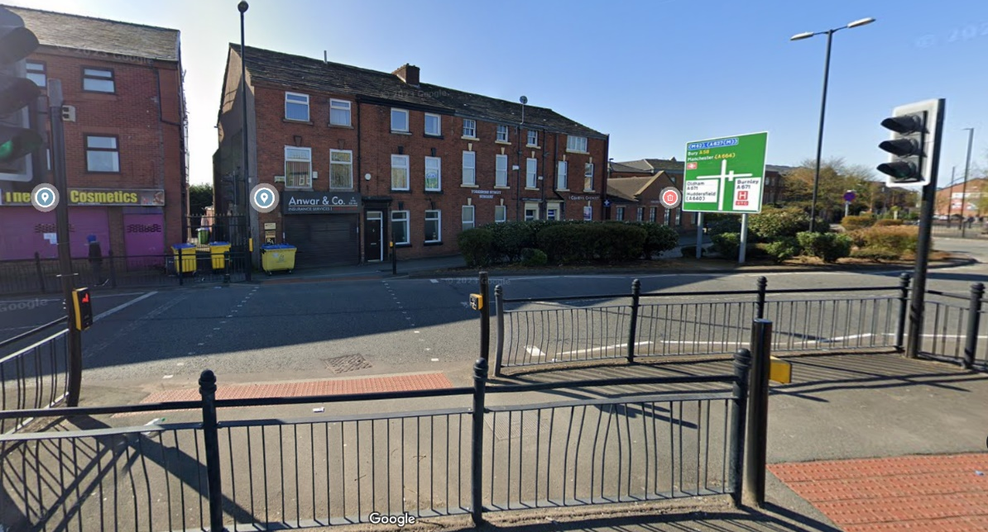

NDHAs
None-designated heritage assets (NDHA) are places we’ve identified as having some significance to the local heritage.
They make an important contribution to the local distinctiveness, settlement formation, traditional character or history of the bough but don’t meet the criteria for listed buildings.

Listed Buildings
Ukrainian Catholic Church of St Mary

District: Rochdale (Metropolitan Authority)
Parish: None Civic Parish
National Grid Reference SD 89696 13588
GRADE II list entry number 1346258
Date first listed; 12- Feb-1985

Details: this entry was subject to minor amendments on 11th April 2022 reformat the text to current standards
SD. 8913 NE 10/132
Rochdale YORKSHIRE STREET (north Side) Ukrainian Catholic Church of St Mary.
G.V II Former Anglican Church of St James 1821. Ashlar with slate roof. Wide naves central west tower with entrance porches attached to north and south, small chancel with vestry to north side. The church is in the style of a commissioner’s church.
Five-by nave with weathered gobleted plain buttresses. Constellations and three stage castellated tower, diagonal weathered buttresses having crocked pinnacles. Clock in second stage and double openings to match the nave windows in belt stage. Interior has quadripartite vaults to both nave and chancel and now lacks the galleries it may have had. (buildings of England)
Listing NGR -SD8994913765
Legacy
The contents of this record have been generated from a legacy data system.
Legacy System number:
358963
LBS

The proposal site falls outside the Town head Conservation Area. According to Rochdale Borough Council, the area was granted this status in 2008

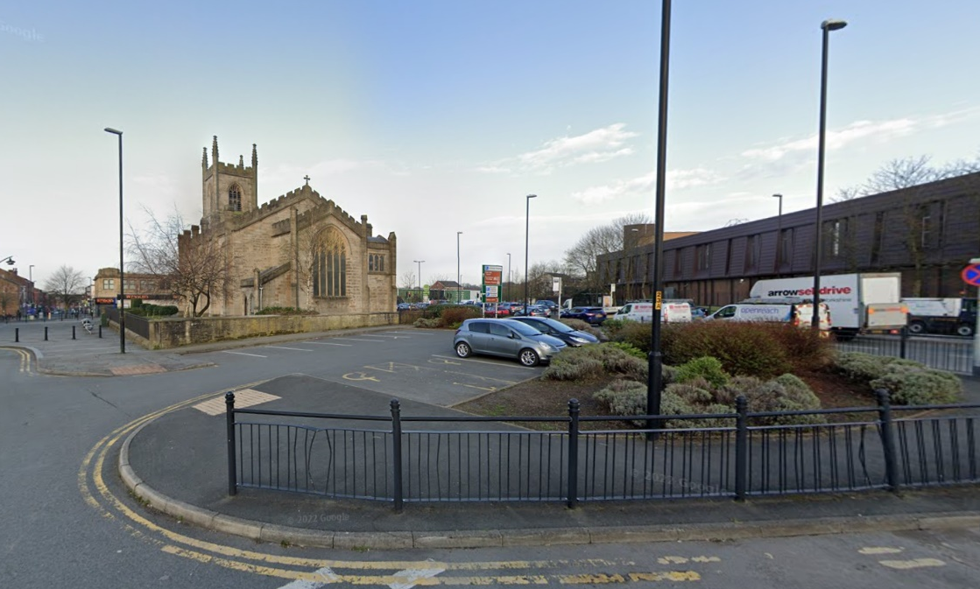

Non-designated heritage assets can be buildings, monuments, sites, places, areas, and landscapes.

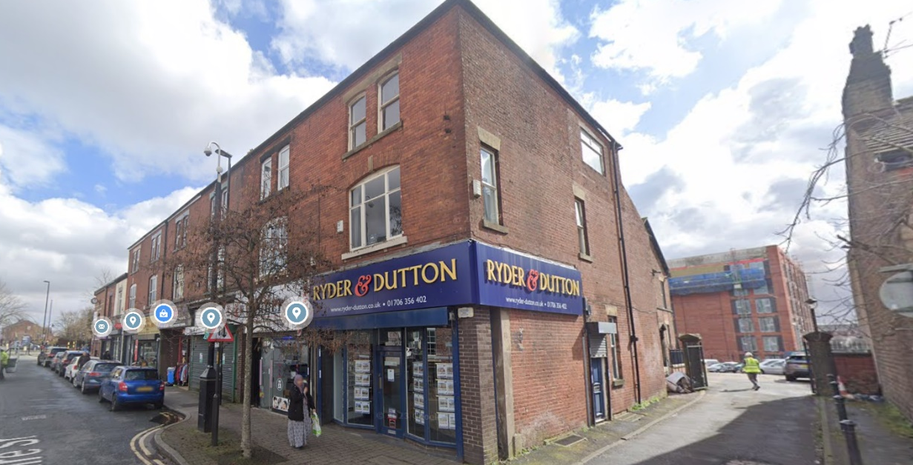
No. 132-148 Yorkshire Street (NDHA)

Although this property is positioned on Yorkshire Street, it is positioned within the actual Rochdale town centre which is over 250m from the application site.
No. 210-218 (Evans) Yorkshire Street (NDHA)
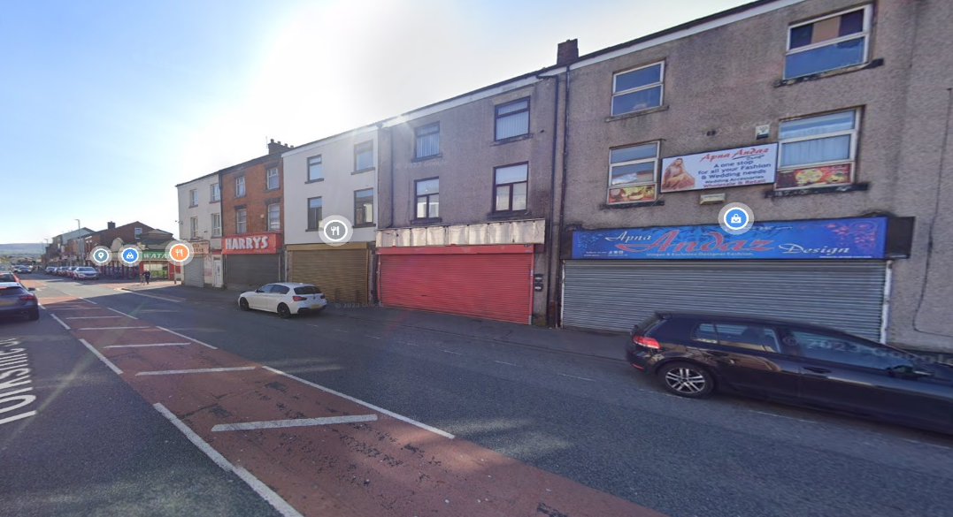
The below properties are adjacent to the site on Yorkshire Street. These properties have been extensively changed at ground floor, whilst at the first-floor render and pebbledash have been applied. Some architectural features still survive.

Application Site.
The application site relates to a mid-terrace property 216 Yorkshire Street in Rochdale. The property is currently a hot food takeaway at the ground floor with the 1st and 2nd floors vacant and used for storage space. The building currently occupies the second building from the corner of West Street and West Street is within the Yorkshire Street Local Centre. The adjoining properties side to side are both commercial, which of both are jewellery shops one on the corner and the other one on the other side. On the opposite side of the site are similar shops, jewellers, fish and chips and eye care. Waiting restrictions prevent vehicles parking to the opposite side of the site and cars are able to park just outside on the road outside the host building. There is a small rear yard at the rear of the building which can be accessed from the rear from West Street.

The application building is attractive in appearance, particularly when viewed from the front, being of brick constructed with a slate roof. The property had large vertical windows with stone cills and lintels. On the ground floor the property hosts a Hot food takeaway.
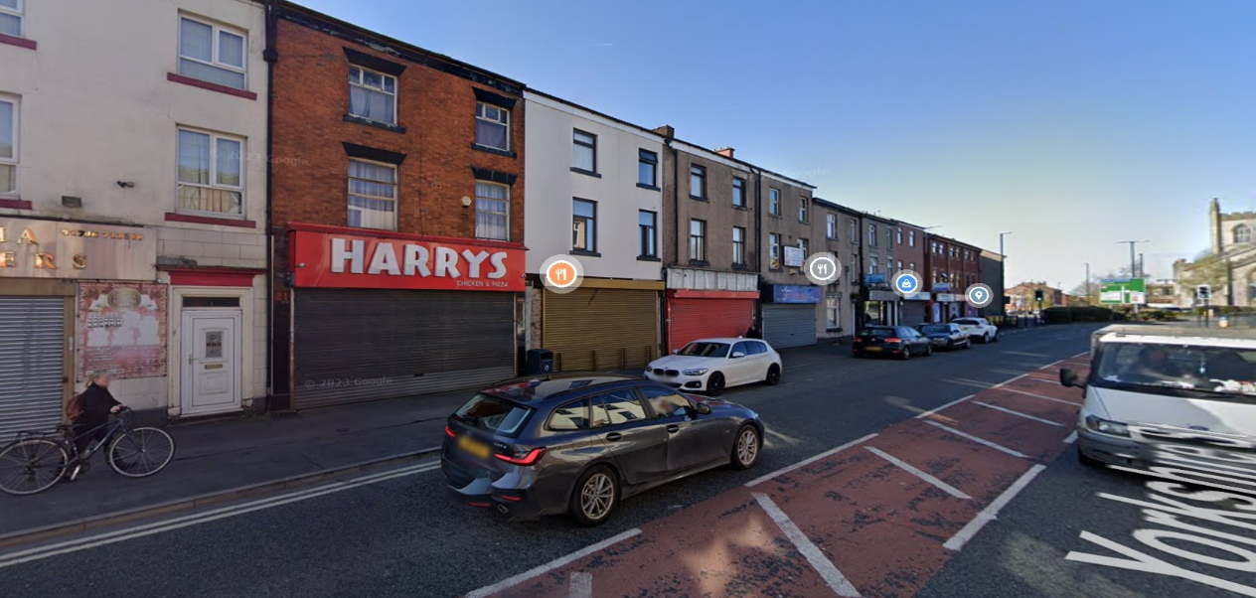

PROPOSAL IMPACT
The applicant is applying for planning permission to change the use of the building at first and second floors in to two self-contained residential flats at first and second floor. The flats would consist of 1 bedroom each. Each flat would provide their own washing facilities and living room/kitchen areas. Externally the front elevation would require a new opening to the flats above.
Most of the building internally would be predominantly left as existing and where partitions need to be created, these would be finished with acoustic barriers where necessary.
Access to the flats would be provided from the new door opening to the front of the building, and the replacement of the windows to the front and rear elevations would be upgraded to new aluminium /timber window frames. Also, replacement of the extraction flue at the rear would be repositioned near to one side of the property as the flue is directly facing the middle of the window. The SVP will remain as existing.
The proposed flats would be used by individuals/couples who need medium to long term accommodation and are likely to be rented to individuals who visit the rear or who have businesses nearby, or staff who work in and around the town/local centre who want comfortable accommodation close to the commercial arears and offices with lower rates in comparison to hotels.
The proposed development would make use of the upper floors which is prominently underutilised. If planning is successful, and the site is in use, it would add to the quality of the area. It should be noted that in order to bring the upper floors into residential use, the existing extraction flue will need to be replaced with one which extends beyond the eaves line as proposed, to ensure that occupants are not adversely impacted by noise and odours produced by the flue.
The proposal for the residential flats would be appropriate within the local centre location where it would not lead to a concentration of residential use which undermines the overall mix of main town centres uses. The change of use of the first and second floors of the building, the change of use itself is considered to result in neutral impact on the character of the area and adjacent assets which would mainly retain their commercial uses. Rochdale’s apparently weak retail economy needs to be bolstered in order to attract shoppers back to the local centres and encourage the return of shoppers.
Living in the local centres should be promoted to ensure upper floors of historic buildings is used and maintained. A number of properties have been sensitively converted into residential use they have brought life and a resident population back to the local centres.
In addition, it is considered the change of use proposed would help maintain and regenerate this prominent area of Yorkshire Street and introduce a continued use for the site to ensure that it is an attractive place to live, work play and visit. If not supported concerns are raised that the upper floors may remain disused and unoccupied given the current climate nationwide.
The public benefits of the change of use and occupation of the site for the future would have a positive but neutral impact on the building itself and the mentioned Hertiage Assets which are not within its settings and distance away, the application should therefore be supported.

In light of the above, the proposal would result in no undue harm to visual amenity and would be acceptable to the overall character and appearance of the area and the street scene. The application would be therefore accord in this regard with policies DM1 and P2, and the NPPF where it would have a neutral impact with no harm to the significance of any of the mentioned designated and non-designated heritage assets.

CONCLUSION
In conclusion, it is considered that the application would overall have a neutral impact on the character and appearance of the area, on the Listed buildings mentioned, and the non-designated heritage Assets. The proposal would maintain the upkeep of the area and the setting of the heritage assets, and the listed buildings. The application therefore accords with policies DM1 and P2 of the development plan, and the NPPF, in addition to section 66 and 72 of the 1990 Act.

