Application for a holiday- let cabin known as Summit Cabin, adj. Salley Street, Calderbrook Road. Littleborough OL15 9NG
Retrospective

Heritage Assessment

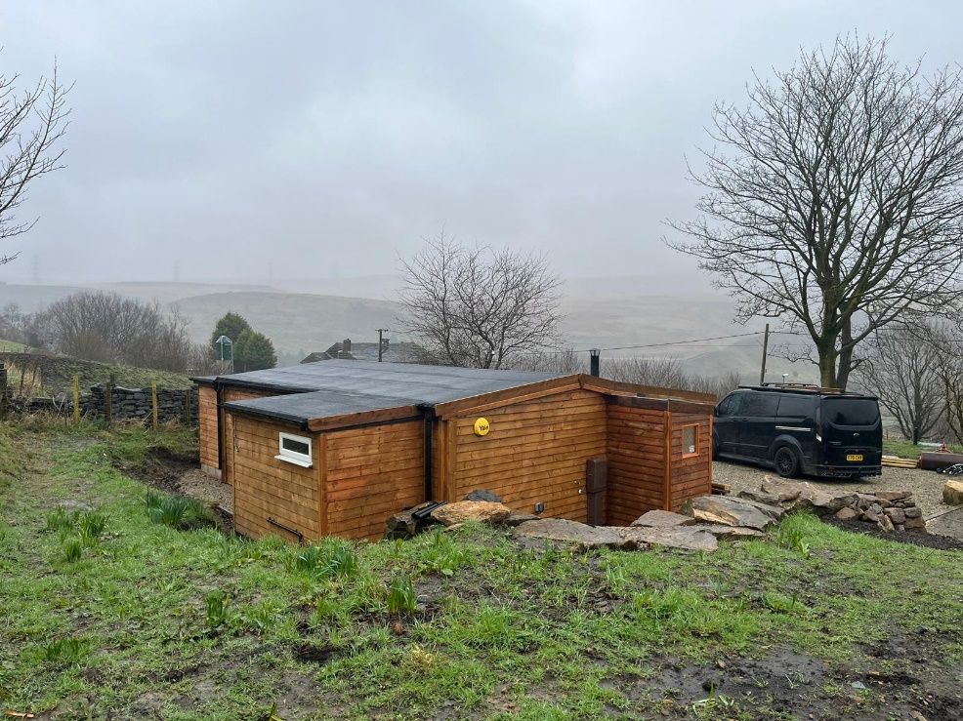

H | P
D | A

November 2024

Prepared by Hartley Planning and Development Associates Ltd
The proposed development lies to the rear of No’s 9-19 Calderbank Road, a terrace of dwellings dating from at least 1850. The terrace is shown on the first edition OS map and were probably weavers cottages.

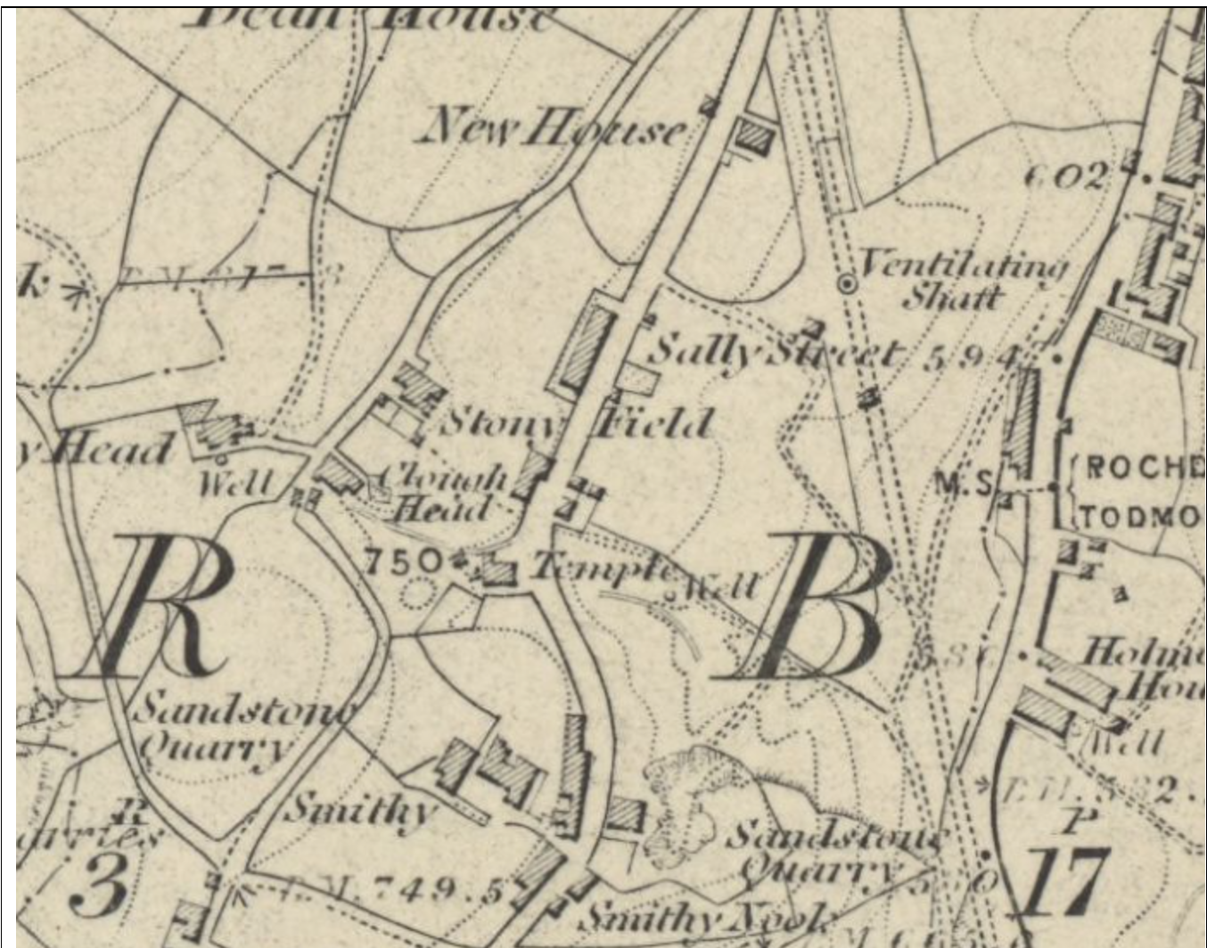
The local planning authority (LPA) considers that the terrace is a non-designated heritage asset, though it does not seem to appear to be listed in its schedule of such buildings for’ Pennines (Firgrove, Littleborough, Milnrow, Newhey, Smallbridge and Wardle)’ :-

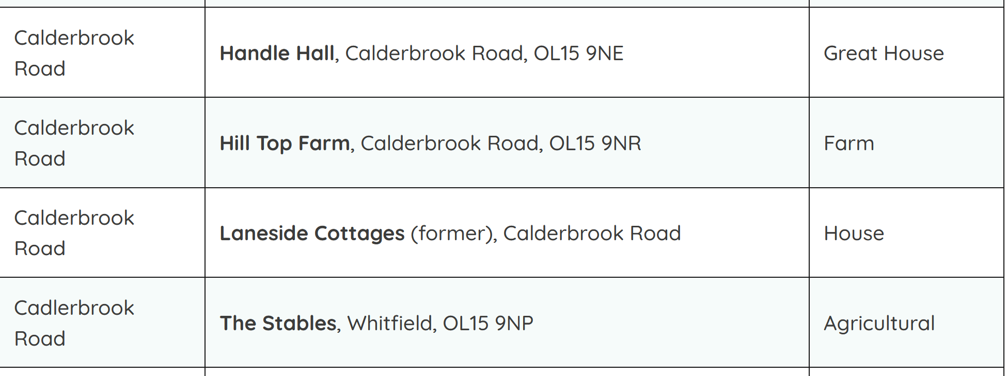

Be that as it may, National Planning Policy Framework (the Framework) requires that
‘in determining applications, local planning authorities should require an applicant to describe the significance of any heritage assets affected, including any contribution made by their setting‘.

Attempts have been made to access the records of the Greater Manchester Historic Environment Record but without being able to find any additional meaningful data.

The setting of the adjoining terrace of houses (No’s 9-19) is characterised by its position directly onto Calderbank Road and by its otherwise open rural position. Unfortunately, parked cars, refuse bins and various outbuildings form part of its setting.

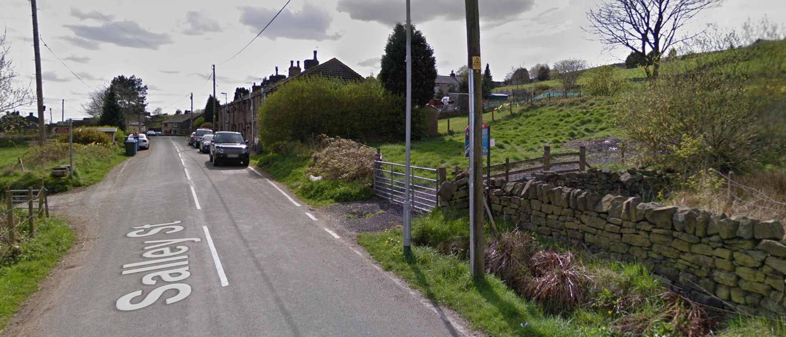

The proposed development is situated at some distance to the rear of the terrace and associated rear spaces. By its distance from the terrace and the retention of intervening open areas, the proposed Cabin would have a neutral impact upon its setting. Equally the access to the Cabin, which uses a long established access point, is sufficiently removed from the terrace so as not to impact adversely upon its setting.
The key views of the terrace are from Calderbrook Road. The retention of the Cabin would not adversely affect these.

