SPECIAL BRANCH
`

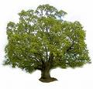
Tree Surgeons Ltd
Top O’th Meadow Farm
Meadowhead Lane
Norden, Rochdale
OL11 5UL
Tel: 01706 658771

Mini Tree Report Date: 8th February 2023
Dave Hammerton
Hopwood Manor
Heywood
OL10 2NN
As requested, please see my mini tree report, as previously mentioned this offers no guarantees as trees are living organisms and can fail at any time. We would also like to point out no indemnity or insurance cover is offered. This report is in “my opinion” only and covers only the trees that have been inspected.

Map
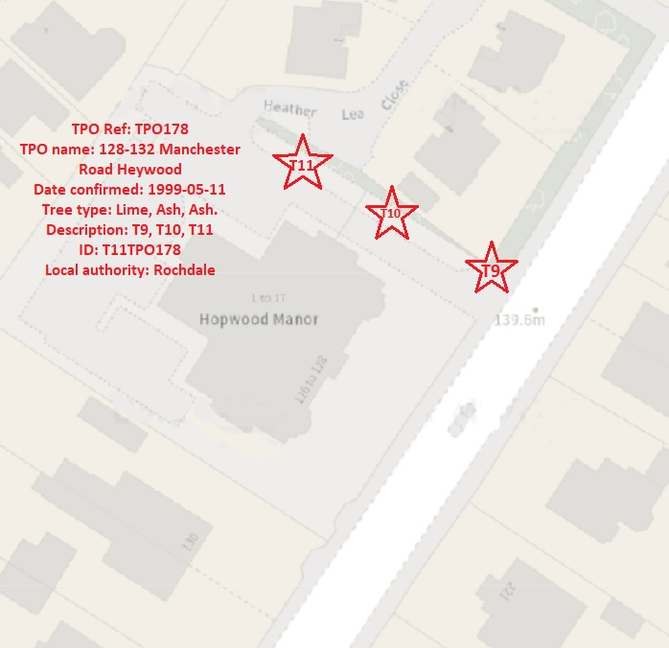

Tree in question subject to Tree Preservation Order 178

T11- A 18meter mature Ash. We recommend removal as this tree has extensive signs of Ash die back disease. As there are no known cures for this disease which has a 95% mortality rate. With a short life expectancy, we feel it would be prudent to remove this tree now before it goes into further decline and becomes dangerous. We feel this tree is in a high-risk area between populated buildings the foot and vehicular traffic underneath and as such there is an unacceptable risk to people and property.

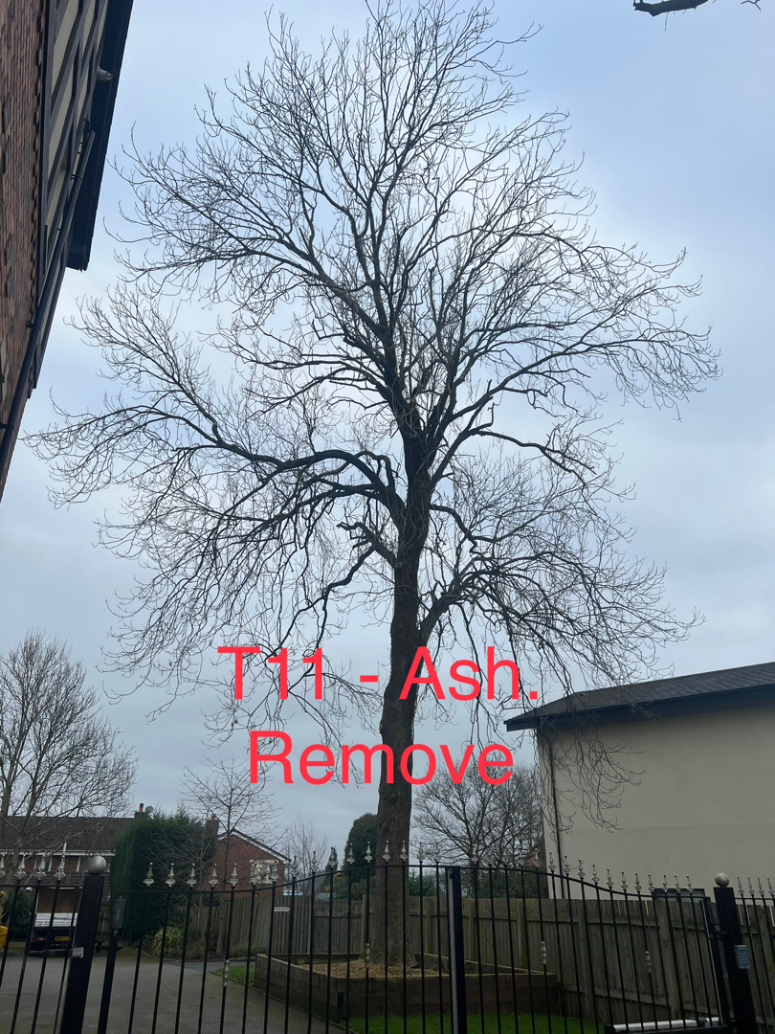

Tree in question subject to Tree Preservation Order 178

T10- A 16meter mature Ash. We recommend removal as this tree has extensive signs of Ash die back disease. As there are no known cures for this disease which has a 95% mortality rate. With a short life expectancy, we feel it would be prudent to remove this tree now before it goes into further decline and becomes dangerous. We feel this tree is in a high-risk area between populated buildings the foot and vehicular traffic underneath and as such there is an unacceptable risk to people and property.

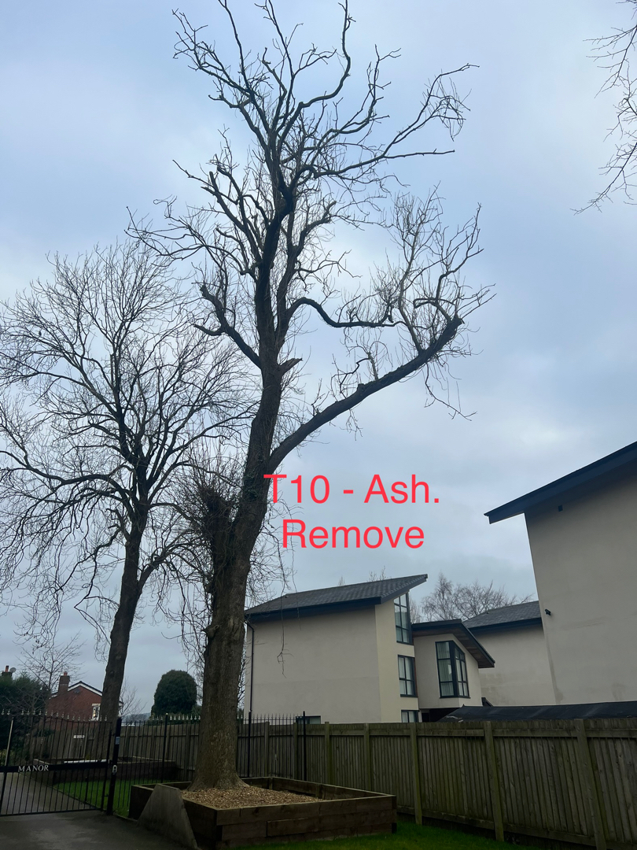

Tree in question subject to Tree Preservation Order 178

T9 – A 17meter mature Lime. We recommend a minor crown lift over the road with only removing protruding secondary branches as shown in the diagram below. This will not have any detrimental effects on the tree’s health, nor should it effect the visual appearances as well as the amenity values.

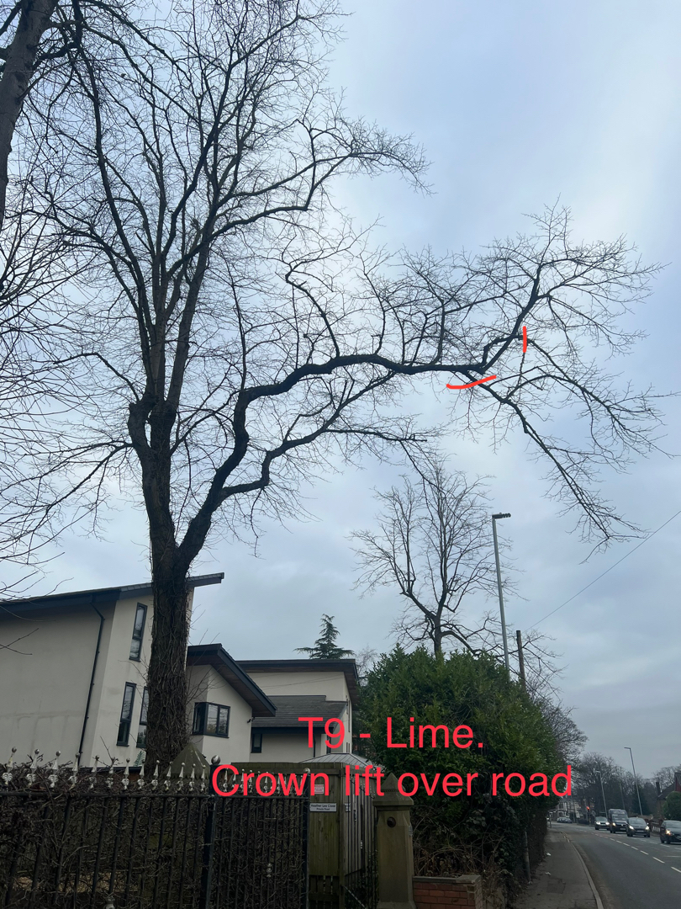

We recommend replanting with 6 replacement trees.

Regards
R.Slack
Mr Ryan Slack, cert Arb L2 (ABC)

