SPECIAL BRANCH
`

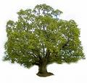
Tree Surgeons Ltd
Top O’th Meadow Farm
Meadowhead Lane
Norden, Rochdale
OL11 5UL
Tel: 01706 658771

Mini Tree Report Date: 25th September 2023

John Preston
23 Broadhaulgh
Bamford
OL11 5LX
As requested, please see my mini tree report, as previously mentioned this offers no guarantees as trees are living organisms and can fail at any time. We would also like to point out no indemnity or insurance cover is offered. This report is in “my opinion” only and covers only the trees that have been inspected.

TPO Ref: TPO079
- TPO name: "The Hut" Broadhalgh, Rochdale
- Date confirmed: 1983-09-22
- Tree type: Beech, Beech, Lime
- Description: T18, T22, T20
- ID: T18TPO079, T22TPO079, T20TPO079
- Local authority: Rochdale

Location

Front garden of no.23 Broadhaulgh.

Work done

Site visit, arboricultural inspection, photography and report.

Trees in question

T18, T20 & T22. Two semi-mature Beech trees and one semi-mature Lime tree (see plan attached)

Problem

- The trees are causing excessive shading to the two properties and driveway areas
- The trees are encroaching onto both property
- The trees have had some previous maintenance and contain dead wood and overhang to the driveway and neighbouring property.

Recommendation

T18 Beech 400mm DBH x 18 meters high – Removal of one low limb. 2meter reduction back from the property to give room for the house, improve light and improve form and balance of the tree, plus remove any deadwood. Also, to crown thin by 5% to help improve tree and garden amenity.

T20 Lime 380mm DBH x 18 meters high - 2-3meter reduction back from the property to give room for the house, improve light and improve form and balance of the tree. plus remove any deadwood. Also, to crown thin by 15-20% to help improve tree and garden amenity.

T24 Beech 380mm DBH x 17 meters high - 2–3-meter reduction back from the property to give room for the house and driveway, improve light and improve form and balance of the tree. plus remove any deadwood. Also, to crown thin by 10-15% to help improve tree and garden amenity.

This maintenance will help with a number of problems while not affecting the health of the trees and improving the amenity value.

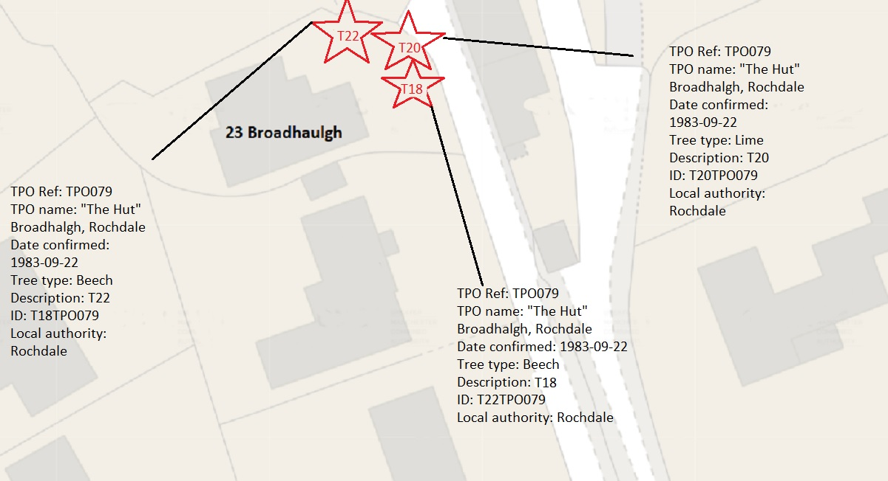

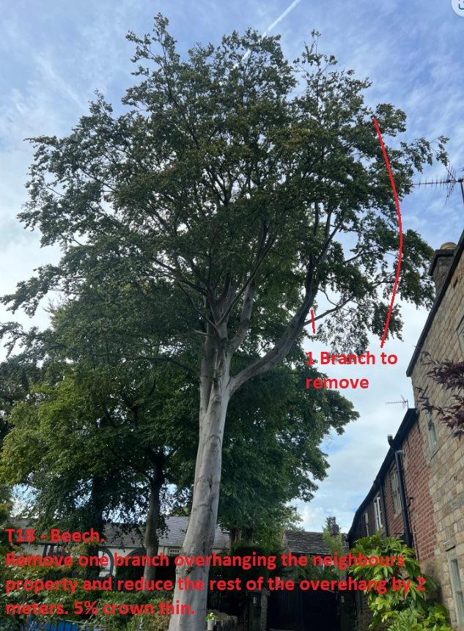

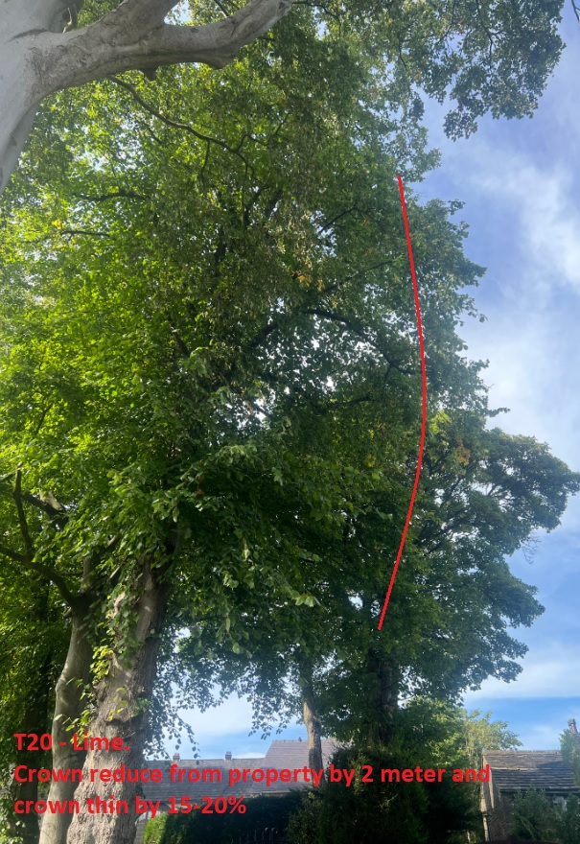

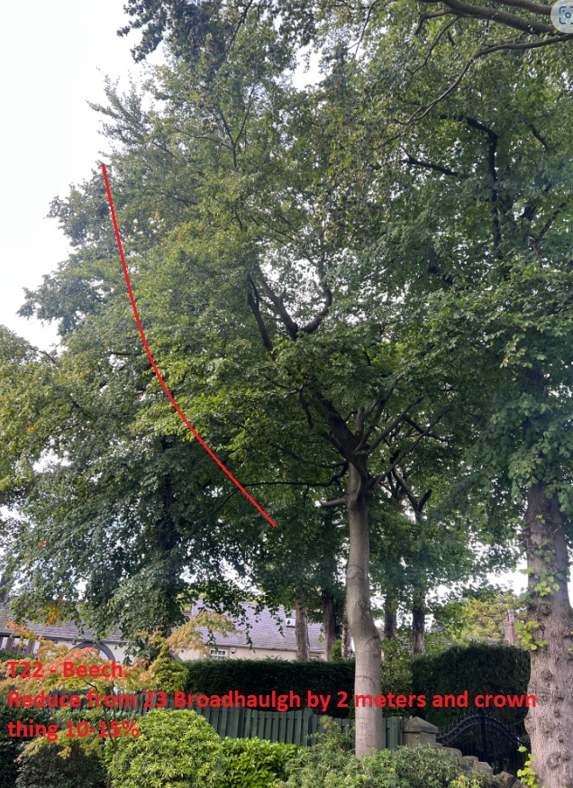

Regards

C.Ashton
Mr C. Ashton cert Arb L2 (ABC)

