Biodiversity Net Gain (BNG) Exemption Statement
For:
(enter a brief description of development proposals)
Complete re-build of a pre-existing detached bungalow.

Planning Reference:
Previous ref: 25/00134/FUL

At:
(enter site address)
2 Inchfield Close, Rochdale OL11 5SB

Completed By:
(enter name, job title, company)
John Chapman Project Manager, Cubic Surveying Solutions Ltd

Date of Exemption Statement Completion:
12/06/25

- Article 7 (‘General requirements: applications for planning permission including outline planning permission’) of Part 3 of The Town and Country Planning (Development Management Procedure) (England) Order 2015, as amended by Regulation 5 of Part 4 of The Biodiversity Gain (Town and Country Planning) (Modifications and Amendments) (England) Regulations 2024 has introduced national validation prerequisites for planning applications relating to Biodiversity Net Gain (BNG).

- Schedule 14 of the Environment Act 2021 introduced the concept of BNG into planning legislation, stating that “the biodiversity gain objective is met in relation to development for which planning permission is granted if the biodiversity value attributable to the development exceeds the pre-development biodiversity value of the onsite habitat by at least [10%]”.

- Schedule 14 of the Environment Act 2021 additionally mandates that biodiversity gain objectives will be achieved through the imposition of planning conditions, thus constituting a post-permission process.

- However, certain types of development for which planning permission is required are exempt from biodiversity net gain requirements and planning conditions. These are outlined in The Biodiversity Gain Requirements (Exemptions) Regulations 2024

- The development proposals for this application meets the following exemption criterion from the Regulations (reference wording from the Regulations):
Replacement building occupies the same footprint as the previous structure.
No more than 9 dwellings constructed.
Site is no larger than 0.5 hectares.
Item C - Housholder Application.

- State how this application meets the exemption criterion stated above (see worked example for reference):
Condition 1 -The site does not contain any priority habitats listed under the Government’s list of priority habitats and species in England (‘Section 41 habitats and species’).
Condition 4 -The site has not decreased biodiversity / no habitat lost or degraded, as the same footprint has gone back.
Meets Article 2.1 of The Town & Country Planning Order 2015.
Item 3a Application (original application) for small development was made prior to 2nd April 2024

- Provide aerial imagery / photographs (or alternative sources), plans and captions to evidence your statement. For example, you may wish annotate images to show how the proposed development sits within the existing site/habitats, and how the proposals accord with the exemption claim. Add more photographs, plans or imagery of proposals if necessary.
Aerial imagery: Marked with red boundary line.
Photograph 1: 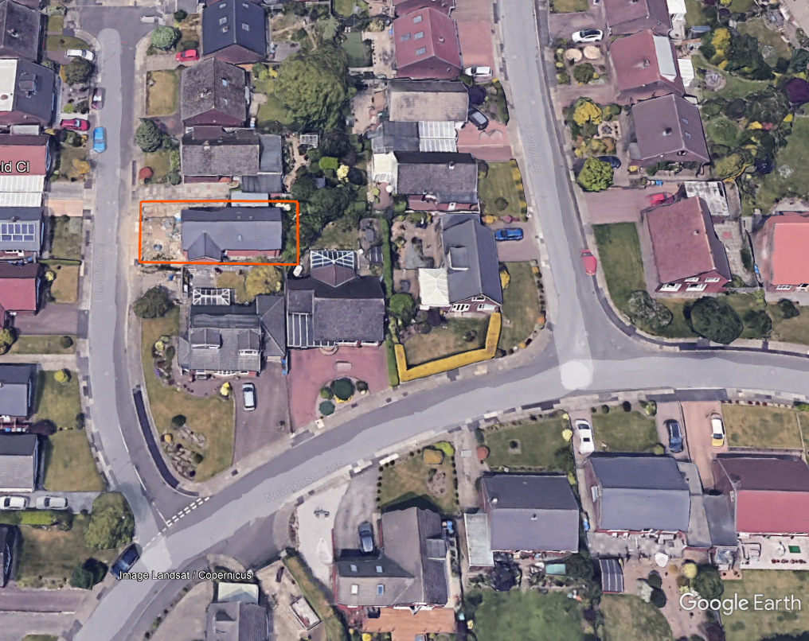

Photograph 2:
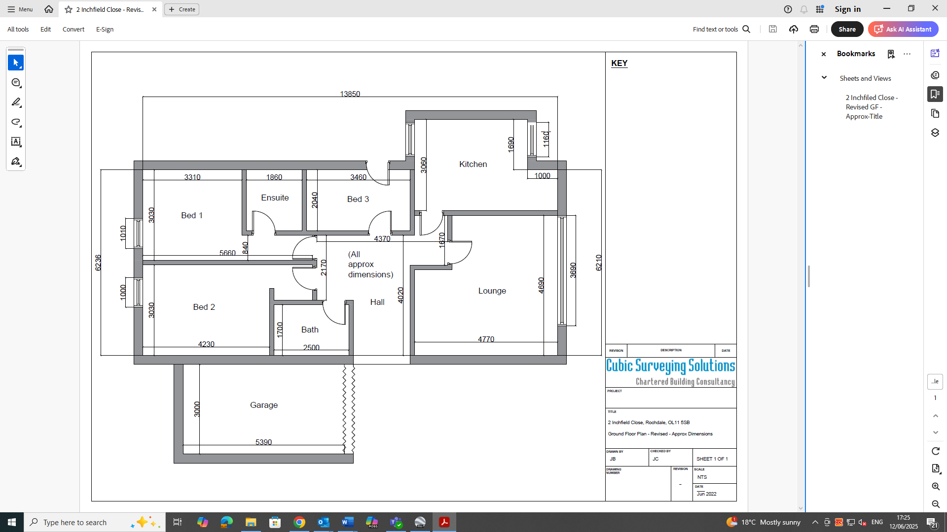

- Whilst the development may be exempt from statutory Biodiversity Net Gain (BNG) requirements, the application for planning permission will deliver measurable net gains for nature conservation which are proportional and locally appropriate, in the following ways:

Property is on an existing housing estate. The garden area has not decreased with the re-building of the property. Therefore, no loss of biodiversity.

Boundary lines are accessible for wildlife to enter freely.

Example response:
Section 5: The exemption criterion claimed:
Section 4 of The Biodiversity Gain Requirements (Exemptions) Regulations 2024, also known as the “de minimis exemption”, states the following: The biodiversity gain planning condition does not apply in relation to planning permission for development which: (Condition 1) does not impact an onsite priority habitat, and (Condition 2) impacts less than 25 square metres of onsite habitat that has a biodiversity value greater than zero; and less than 5 metres in length of onsite linear habitat.
The proposed development meets Conditions 1 and 2 of Section 4 of The Biodiversity Gain Requirements (Exemptions) Regulations 2024.

Section 6: Statement
The site does not contain any priority habitats listed under the Government’s List of priority habitats and species in England (‘Section 41 habitats and species’) for public bodies, landowners and funders to use for biodiversity conservation, a copy of which can be found at the following website: https://www.gov.uk/government/publications/habitats-and-species-of-principal-importance-in-england
The proposed dwelling house will be constructed on land currently occupied by outbuildings and hardstanding surfaces, consisting of a mix of resin, stones, and concrete.
Consequently, the area to be developed can be described as consisting of a mix of habitats classified under the UK Habitat Classification, as detailed in Appendix 2 of The Small Sites Metric (Statutory Biodiversity Metric) User Guide (2024), as follows:
• Urban - Un-vegetated garden
• Urban - Developed land; sealed surface (“Impermeable Hardscape”)
• Urban - Artificial unvegetated, unsealed surface (“Permeable Hardscape”)
None of the habitat classifications within the red line boundary have a biodiversity value exceeding zero, as can be verified in the Government’s Small Sites Metric (Statutory Biodiversity Metric) User Guide and Calculation Tools (2024). Consequently, the proposed development would impact less than 25 square metres of onsite habitat that has a biodiversity value greater than zero, thereby meeting Condition 2 of Section 4 of The Biodiversity Gain Requirements (Exemptions) Regulations 2024.
As a result, the proposed development is exempt from biodiversity net gain requirements and planning conditions under the de minimis rule of Section 4 of The Biodiversity Gain Requirements (Exemptions) Regulations 2024.

Section 7: Evidence
Provide aerial images / photos and plans of the site, marked up to show existing and proposed development areas, and how that accords with the exemption criteria claimed above, together with photographs of the current site conditions, to provide the context.

Section 8: Measurable Net Gains for Nature Conservation
- A biodiverse green roof with features for invertebrates including log piles and a varied substrate
- Soft landscape schedule comprised of native plant species
- Provision of 2 bird boxes and 1 bat box
- Creation of a wildlife pond
- Hedgehog highways in gravel boards of boundary fence

The Biodiversity Gain Requirements (Exemptions) Regulations 2024: https://www.legislation.gov.uk/uksi/2024/47/made/data.pdf

