Anti-vandal rollers

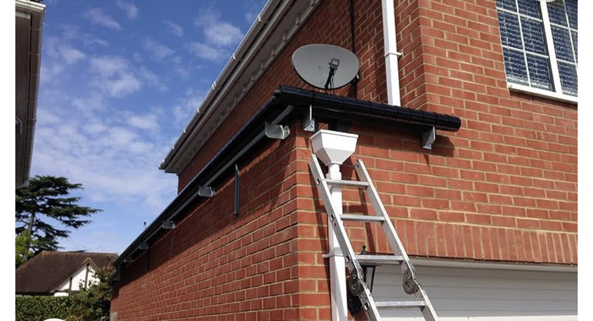
‘vangard’ Single roller barrier (Colour: black) fixed with a cranked support bracket in galvanised aluminium 25mm support shaft.

Vandgard Roller Barrier – Vandgard® - Anti Climb Guards Ltd
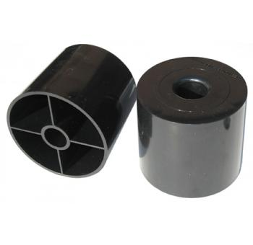

115mm dimeter tumblers rotating freely

