

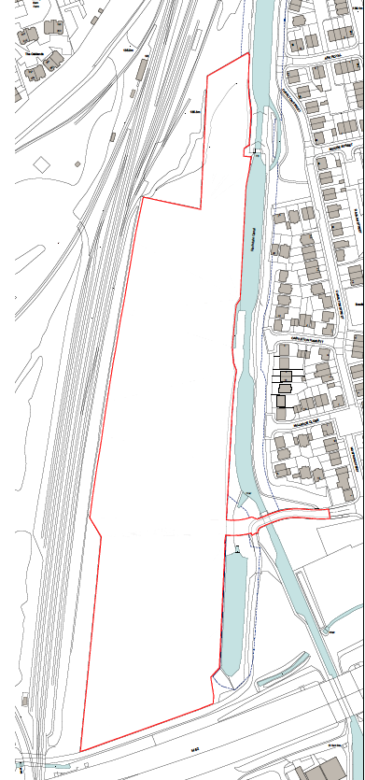

MCI Developments Ltd-
Trub Road, Rochdale
Broadband Statement – 12/09/2024

DOCUMENT CONTROL SHEET

Issued by | MCI Developments Ltd  15 Beecham Court  Wigan  WN3 6PR
Project name | Trub Road, Rochdale
Title | Broadband Statement
Doc ref | Trub/BT
Project no. | 0100/Cale
Status | issue
Date | 12/09.24

Document Production Record
Issue Number | 01 | Name
Prepared by |  | Ryan Dodd
Checked by |  | Stuart Ratcliffe
Approved by |  | Mark Hadfield

Document Revision Record
Issue Number | Status | Date | Revision Details
01 | Issue | 12.09.24 | Issue

This document has been prepared by and for MCI Developments Ltd and any third parties who may use the information contained herein do so at their own risk.

CONTENTS

TELECOMMUNICATIONS – OPENREACH 1
Existing infrastructure 1
Risk Assessment 1
Utility Depths 1
New connections 1
TELECOMMUNICATIONS – VIRGIN MEDIA 2
Existing infrastructure 2
Risk Assessment 2
Utility Depths 2
New connections 2
LOCAL INTERNET SPEEDS 3

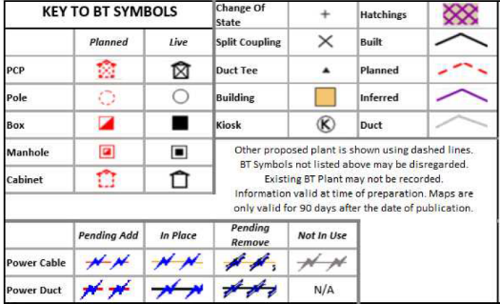
TELECOMMUNICATIONS –
OPENREACH
Existing infrastructure
Records received from Openreach show:
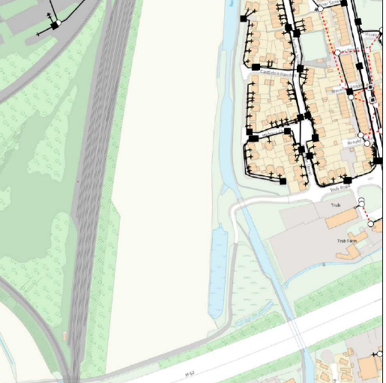
- Existing Openreach apparatus and associated chambers are present along Trub Road, Rochdale

- Risk assessment
Disconnections
No disconnections are required across the site

Figure 1 - BT Openreach infrastructure is present at the site.
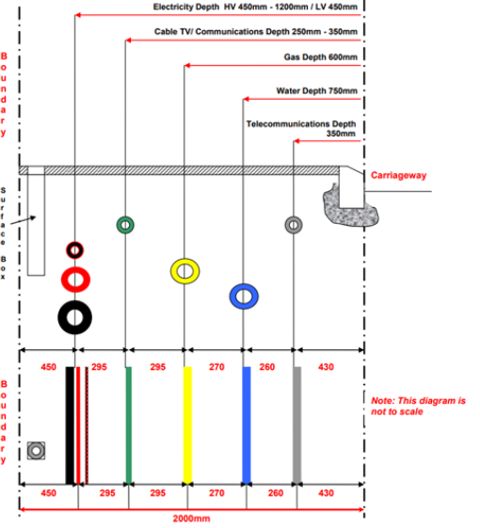

- Utility Depths
The National Joint Utilities Group (NJUG) are an industry-recognized non-regulatory body that provide guidance on new utility infrastructure and construction. The recommended minimum depth for Comms apparatus, as per NJUG guidelines, is as follows:
»250mm – 350mm in footway/verge.

Figure 2 - NJUG Detail

New connections
Fibre to the Premise enables superfast broadband to be delivered directly into a property. Fibre is run from the local exchange, terminating in a cabinet.
From here, fibre lines connect each property to the cabinet to provide superfast speeds.
Openreach give access to a multitude of Internet Service Providers (ISP) within their network, allowing a variety of options to the end occupants of the buildings in terms of who can supply their internet.

We would typically Install BT Openreach to all our sites as a main service but in this instance, there is also Virgin Media available as a secondary comms supplier to provide resilience to the site and more options to the end occupants of the building in terms of the internet service providers available to them.

TELECOMMUNICATIONS –  VIRGIN MEDIA  Existing infrastructure  •Virgin Media apparatus and associated chambers are present along Trub Road, Rochdale  - Risk assessment  Disconnections  No disconnections are required across the site  - Utility Depths  The National Joint Utilities Group (NJUG) are an industry-recognized non-regulatory body that provide guidance on new utility infrastructure and construction. The recommended minimum depth for Comms apparatus, as per NJUG guidelines, is as follows:  » 250mm – 350mm in footway/verge. | 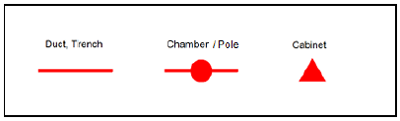  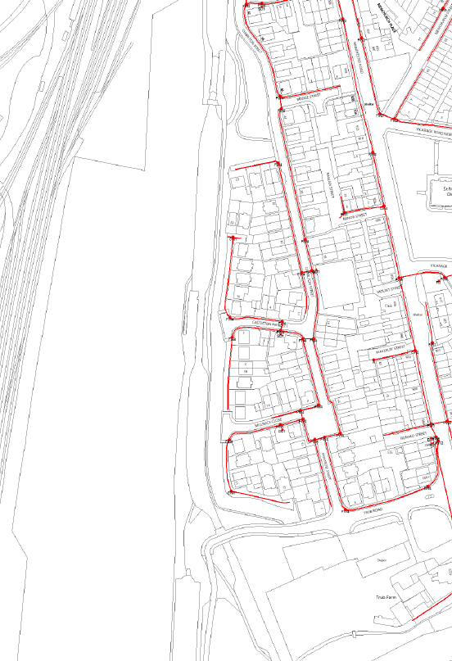  figure 3 - Virgin Media infrastructure is present at the site
Figure 4 - NJUG Detail

New connections
To procure Virgin Media MCI Developments Ltd will need to register the site and submit a formal enquiry to provide new connections to the site. This would provide an alternative fibre option to Openreach.

Local Internet Speeds-

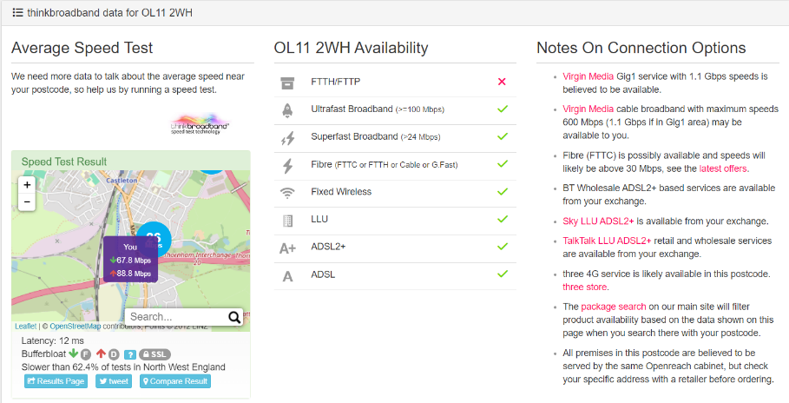
An internet speed search for Cale Lane, Wigan shows that the standard download speed for this area is – 67.8Mbps. Superfast Broadband is also available. The UK average download speed is between 50.4 and 79.1Mbps meaning that the site towards the upper threshold of the UK average therefore ample internet speed is available for most homes utilizing the internet for normal requirements such as TV, internet, and gaming.

Figure 5 - Speed Map

