

Top O’th Meadow Farm
Meadowhead Lane
Norden, Rochdale
OL11 5UL
Tel: 01706 658771

19th October 2023

Lee Revilo
Watergrove Manor
Lower House Lane
Wardle
OL12 9PL

As requested, please see the completed tree report, as discussed this offers no guarantees as trees are living organisms and can fail at any time. We would also like to advise that no indemnity or insurance cover is offered. This report is in “my opinion” only and covers only the trees that have been inspected.

Tree in question is subject to a Tree preservation order TPO 274

TPO Ref: TPO274
- TPO name: Land at Watergrove Reservoir, Wardle
- Date confirmed: 2007-10-24
- Tree type: Trees of whatever species within area marked on map
- Description: A1
- ID: A1TPO274
- Local authority: Rochdale

Location

Surrounding the full property.

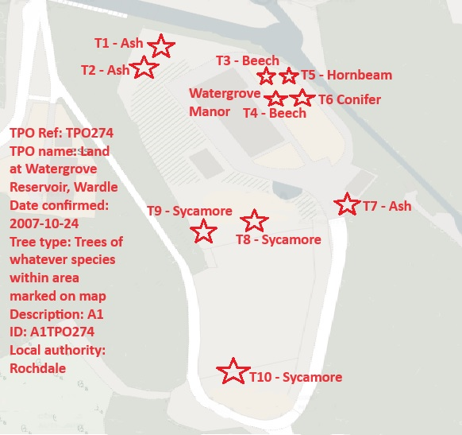

Work done

Site visit, arboricultural inspection, photography and report.

Trees in question

T1, T2 & T7 – Ash
T3 & T4 – Beech
T5 – Hornbeam
T6 – Conifer
T8, T9 & T10 - Sycamore

Problem

- T1 & T2 – Standing dead Ash trees.
- T3, T4, T5 & T6 – Young established trees, maintenance work advised to limit the trees height
- T7 – Mature Ash tree, succumb to the Die Back Disease
- T8 – Semi-mature Sycamore with a large portion of deadwood within the upper canopy
- T9 – Standing dead Sycamore tree
- T10 – Standing dead Sycamore tree

Recommendation

Removal of T1, T2, T9 & T10
Crown reducing T3, T4, T5 & T6 by 2 meters
Removal of present deadwood within T7 & T8

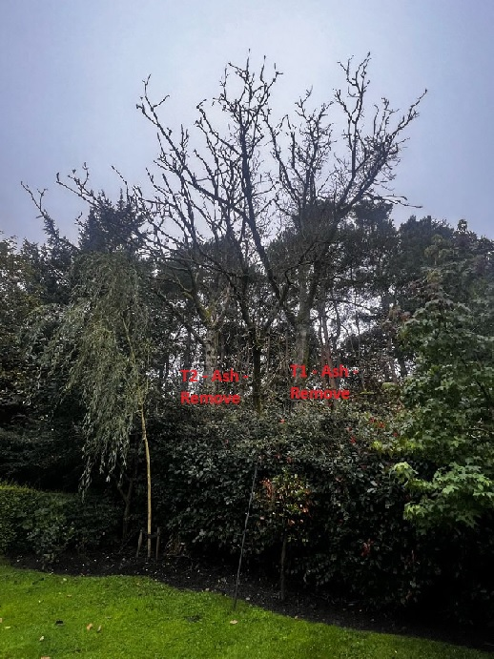

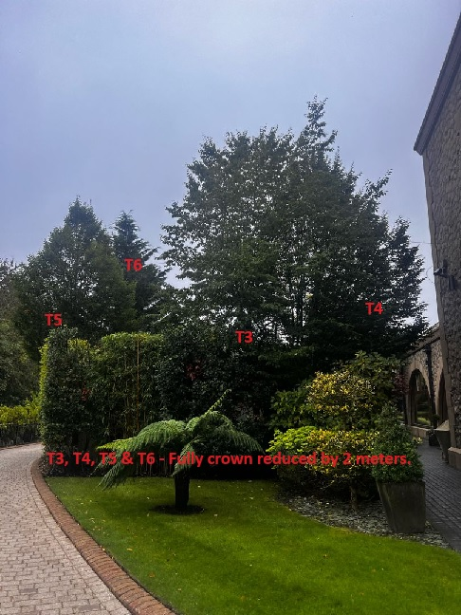

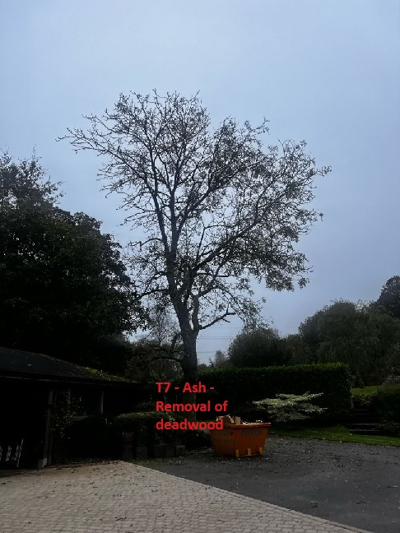

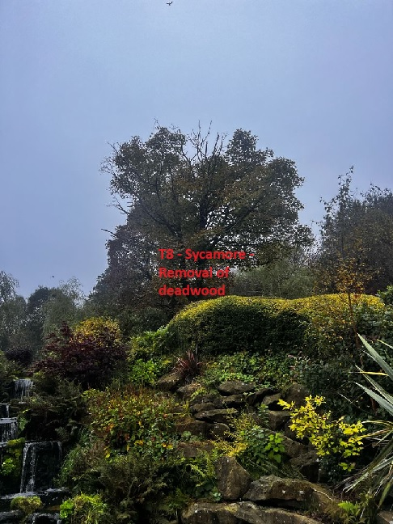

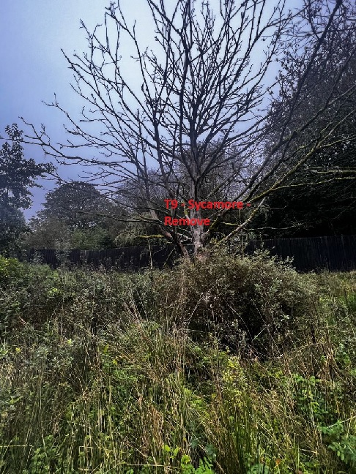

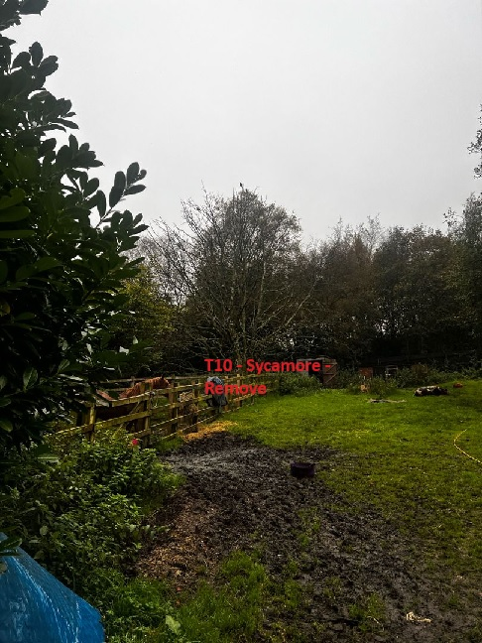

Within the past 24 months Lee has planted in excess of 15 new trees within the grounds of his property, all being a mix in species. Evidence of this can be provided if required. Lee has a fond loving of his land and all the trees within his property, the works requested is based on an ongoing maintenance plan with more tree species to be planted.

Kind regards,

Mr. Ryan Slack

General Manager and Director
SEG Award, Cert Arb L2 (ABC)

