DESIGN AND ACCESS STATEMENT / PLANNING STATEMENT

IN RELATION TO DOMESTIC HOUSE EXTENSION AT:

410 Birch Road
Wardle
Rochdale
OL12 9LX

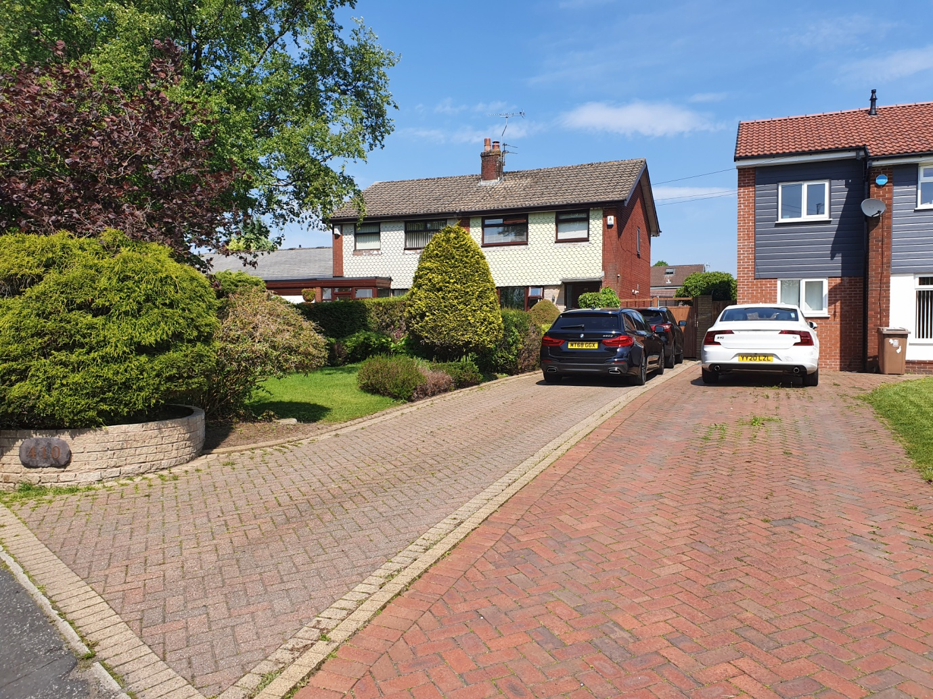

REVISION: V4
DATE: 31ST JANUARY 2025

CONTENTS

1.0: Introduction 3

2.0: The Site / Property 3

3.0: Planning History 3

4.0: Proposal / Design 4

5.0: Conclusion 8

1.0: Introduction
This Design and Access Statement has been prepared to accompany a house holder planning application for a proposed rear extension with conversion and extension of the roof and roof space to create a 2-storey rear elevation, together with an entrance porch to the front elevation at 410 Birch Road, Wardle, Rochdale, OL129LX.
Reference should be made to the supporting drawings & documents accompanying this document.

2.0: The Site / Property
The property is located on Birch Road, comprising of a semi-detached two storey property, with the principle front elevation facing south at a slight easterly angle. A driveway is situated to the front of the house, leading down the side of the property, with gardens to the front and rear. A double garage is also positioned to the rear of the property, accessed via an access road off Newhouse Close (around the rear of the property).
There is known to be a culvert routed below ground to the side of the property bordering the property line between 410 and 408 Birch Road. The culvert is understood from drain maps to be comprised of circa 1050 x 1050mm square section at a depth of circa 2000mm below ground level.
From liaison with United Utilities regarding the culvert, it has been advised that the watercourse running though the property is a private water course. Albeit from liaison with The Environment Agency, they have advised that it would not be permitted to build over the culverted water course.
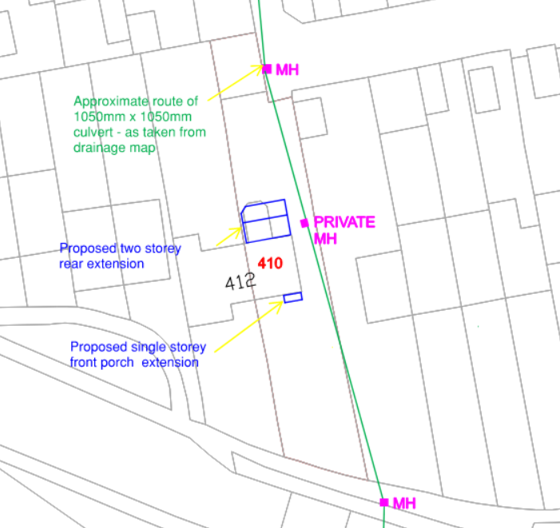

3.0: Planning History
A planning application was previously made and granted permission on 10th March 2022. That application was for a two storey side and single storey rear extension including front porch, following demolition of existing conservatory.
Previous Planning Application Reference: 22/00144/HOUS.
The previous extension proposal has not been progressed due to The Environment Agency advising it would not be permitted to build over the culverted watercourse to the side of the existing house.
The new proposal (this proposal) does not look to extend sideways, and thus does not impose issues regarding building over the existing culverted waterway.

4.0: Proposal / Design
This proposal is for a rear extension with conversion and extension of the roof and roof space to create a 2-storey rear elevation, together with an entrance porch to the front elevation.
An entrance porch is proposed to the front of the property, extending outwards by circa 1500mm and across the front of the existing entrance door way to the living room window. The new entrance porch is proposed to have a single pitch roof sloping away from the property.
Note, the front façade of the property (410) is set back from the adjacent (408) property extension façade line by circa 3500mm.
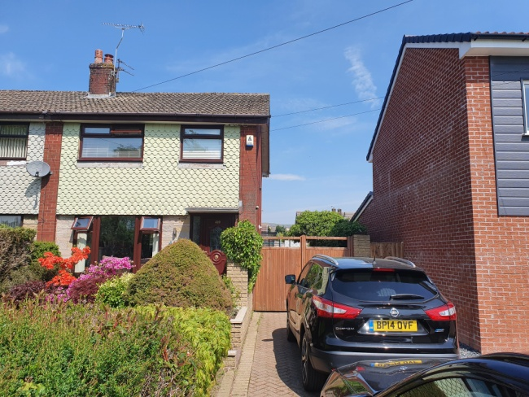
Regarding the rear extension, it is proposed to remove the existing rear conservatory (circa 2500mm wide extending out circa 4500mm), and modify the roof of the house, with a new cross gable pitched roof extending rearwards over the newly proposed rear extension.
The roof modification would look to maintain the existing roof, with a new cross gable pitched roof extending from the existing roof over the new extension to the rear elevation. The modified roof would extend backwards over the new rear extension.
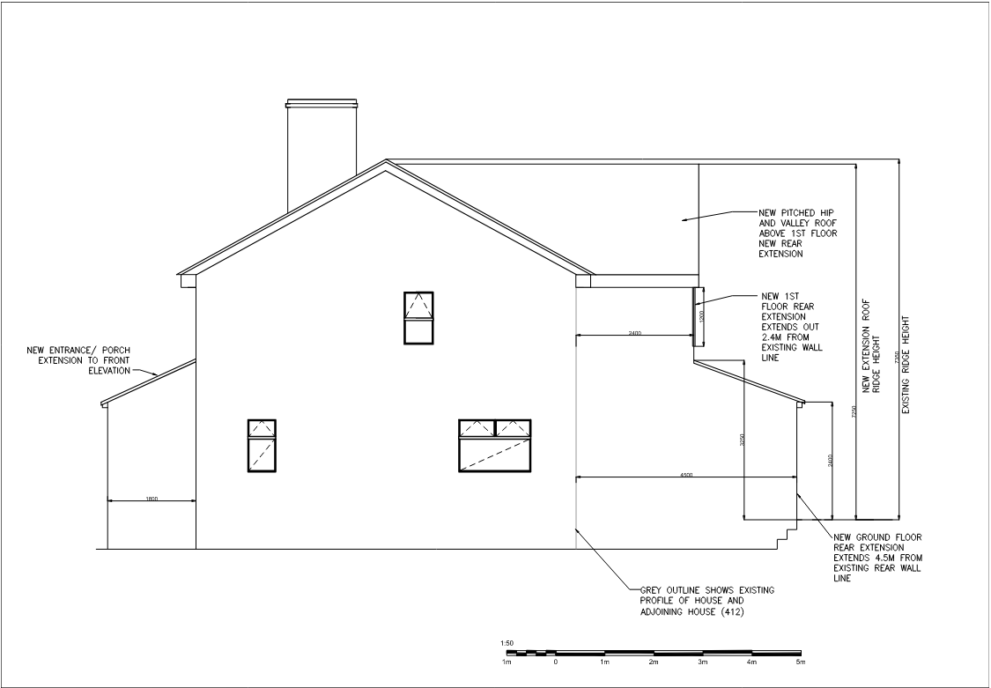
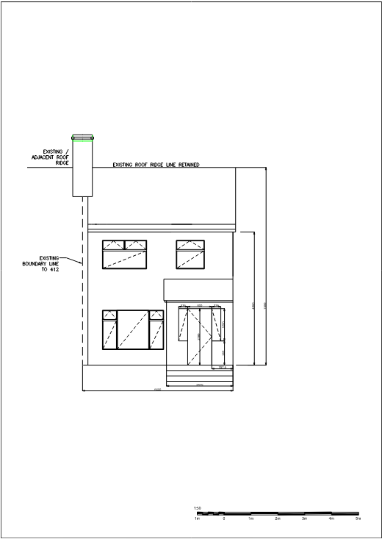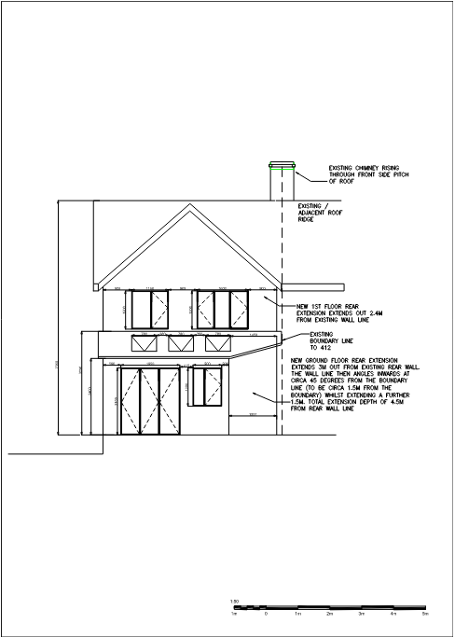
The rear extension is proposed to have 2-storeys.
The ground floor of the new rear extension is proposed to extend out circa 4500mm from the rear elevation of the existing house. This is intended to provide open plan living, dining and kitchen space including roof ‘velux’ type windows for natural light provision, with improved storage and laundry space.
The 1st floor of the new rear extension is proposed to extend out circa 2400mm from the rear elevation of the existing house, above the proposed ground floor extension. This is intended to provide and additional bedroom space and enable a new additional bathroom to be integrated into the house.
The new roof extension is proposed to be a new cross gable pitched roof extending from the existing roof over the new extension to the rear elevation.

GROUND FLOOR FIRST FLOOR
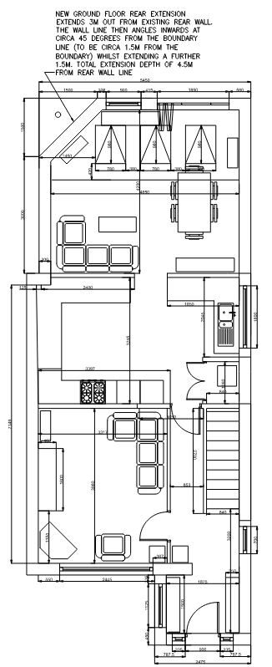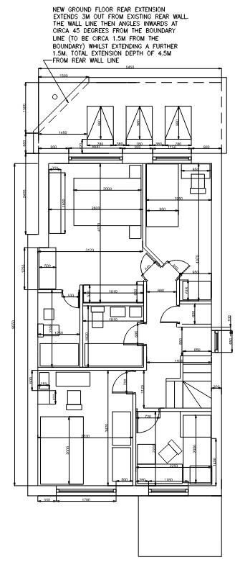

ROOF
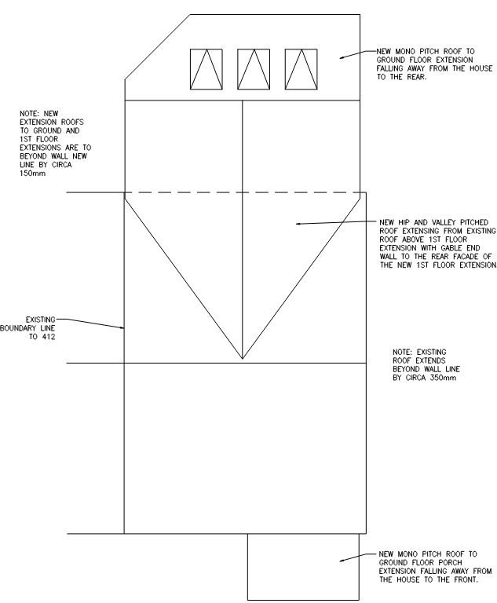
It is proposed that the new extension wall line adjacent the adjoining property line to 412 Birch Road would be inset slightly (within the property line of 410) to match the line of the wall of the existing conservatory that is to be removed. It is noted that to comply with paragraph 5.6 of the Rochdale Council SPD, the wall line at ground floor level along the boundary to 412 Birch Road would extend outwards from the existing rear façade by 3000mm, the wall line would then set back at a 45 degrees angle whilst extending out to 4500mm away from the existing rear façade.

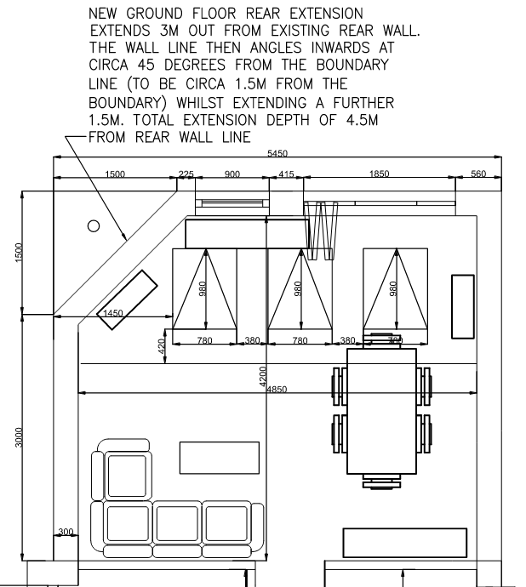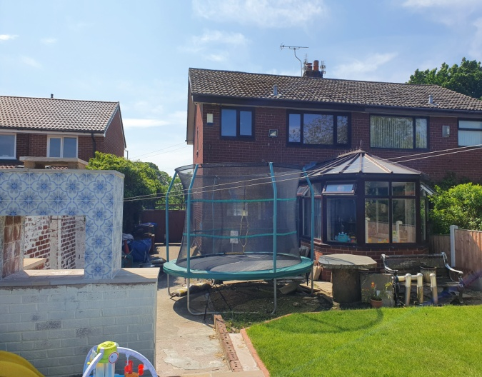

The proposal is for the roof for the ground floor level of the rear extension to be a single pitch sloping away from the property.
The proposal for the new modified main roof to the rear elevation (over the new extension), is a new pitched ‘open’ gable roof, with the new extension rear wall proposed as a gable end.
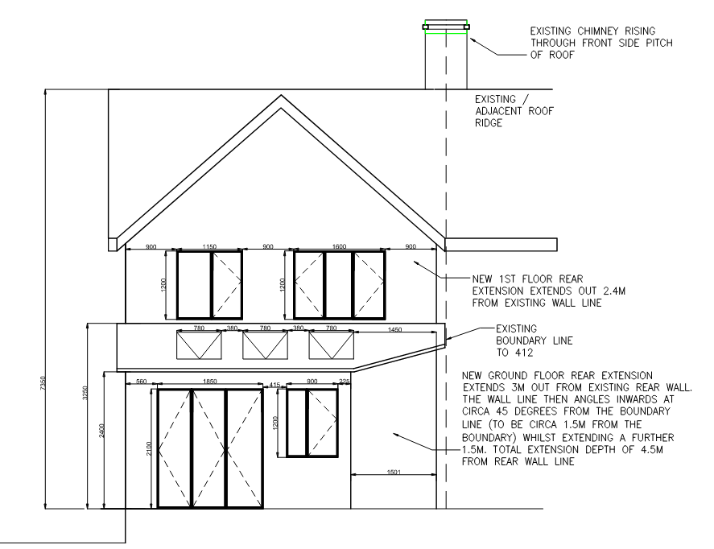
The layout of the proposed extension/accommodation is principally as detailed on the accompanying drawings, with an open-plan kitchen dining, living area all with access to natural light via the extension roof and wall windows and glazed patio doors. There would also be a porch to the front at ground level. At 1st floor level the extension would enable the floor plan to be re-worked to provide an extra bedroom and bathroom space. At (loft) level the extension would provide an additional storage space.
The patio doors to the rear will provide access to adjacent garden and patio areas.
The existing driveway down the side of the existing house and proposed extension will maintain access to the rear of the property.
With respect to appearance/aesthetics, the extension is to be constructed of materials to match existing, with facing brickwork to the front and side elevations, but with rendered elevations to the rear. The proposal also includes the removal and replacement of the aged existing roofing, soffits, gutters and windows to the property to improve energy efficiency and the appearance of the existing house.
It is noted that the new proposed extension would NOT extend over the existing below ground culverted watercourse (Wardle Brook).
The existing driveway will be retained to the front of the property which will retain capacity for parking up to four cars. This is in addition to the capacity for parking two cars in the double garage to the rear of the property.

5.0: Conclusion
The application seeks planning permission for a proposed rear extension including roof modification, as well as a single storey porch extension to the front, which will be designed and constructed in materials to be sympathetic to those of the existing house, in order to integrate the development visually with the existing surroundings. It is considered that the proposals are sympathetic to the setting and are considered to have minimal impact on the surrounding streetscape and minimal impact to the neighbouring properties.

