Design & Access Statement
Former Tack Lea Works & Shephard Mill, Rochdale
Proposed Residential Development

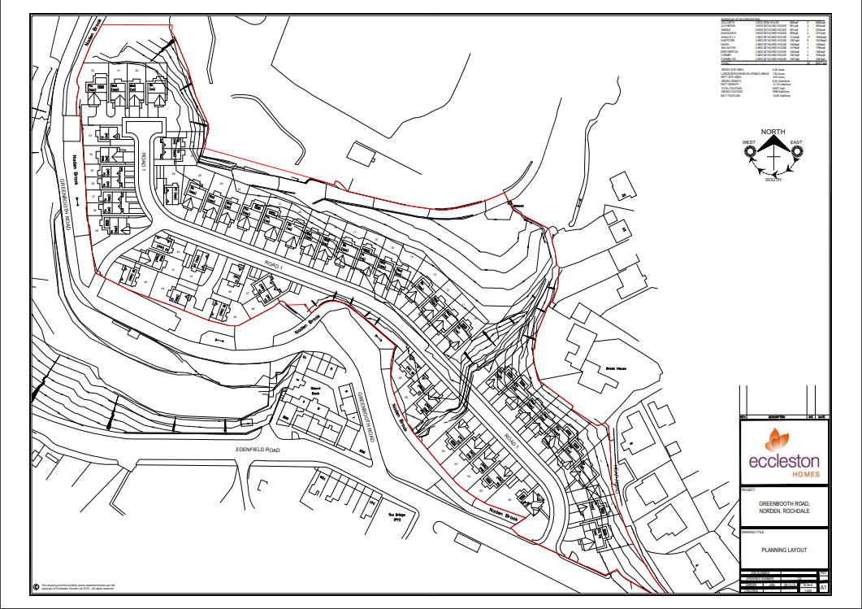

Prepared for Norden Developments
By MacLean Solutions

I. MacLean September 2020

  - This Design & Access Statement has been compiled to accompany the submission for an Outline Planning Application (all matters reserved) on behalf of Norden Developments Ltd. for a development consisting of 56 no detached dwellings.

  - The development site is situated off Edenfield Road, on the site of the former Tack Lea Works, Rochdale and is approximately 2.67Ha (6.6 Acres) in area.

  - It is the intention of this supporting document to address the proposals under the three steps as recommended by national Planning Policy Guidance notes; site analysis and evaluation; identification of design principles and the concluding proposed design solution.

  - This document is to be read in conjunction with the planning submission drawings by Eccleston Homes.

  - The development site is situated off Edenfield Road (A680), in the residential area of Norden approximately 3.5km west of Rochdale Town Centre. on the site of the former Tack Lea Works
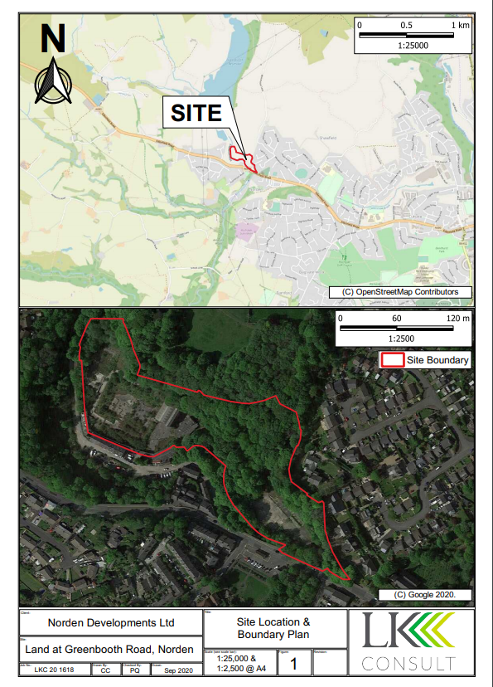
2.2. The site is situated within the Greenbelt, on an area designated for ‘Infilling at Major Existing Development Sites in the Green Belt’ in accordance with Policy D/5 of the Rochdale Unitary Development Plan. It is on the site of the former Tack Lea Works, Rochdale and is approximately 2.6Ha (6.6 Acres) in area.

2.3. The site is occupied by the now derelict buildings of the former Tack Lea Works, with an existing vehicular access to Edenfield Road. To the rear (North) of the site the topography slopes upwards, with the existing buildings on level ground. There is a brook running through the site and a retaining wall to the North.

  - An old industrial site with some tree cover,
  - A terrace of two-storey stone and brick houses adjoins the site entrance to the west together with an existing commercial site.
  - The existing buildings on the site have been constructed over various periods, various materials. The older mill buildings are constructed of red brick with slateroofs (now in a state of disrepair/ collapse). A mill chimney stands in the centre of the buildings.
2.7 Woodhouse Lane brook runs through the site, which flows south into Norden brook..

2.8 The site is within an area designated as at LOW risk of flood on the Environment Agency

3.0 Design Principles

  - The development seeks to contribute to the diversity of residential property types in the area to encourage sustainable communities in accordance with national Planning Policy Statement 1 (Delivering Sustainable Development).

  - The proposal seeks to provide 56no detached dwellings on the site, which will provide an increased mixture of housing within in the area.

  - The scheme seeks to re-develop a currently derelict site, contributing positively to the visual, physical, and environmental quality of the local area.

  - The buildings are located across the site and generally reflect the original the footprint of the commercial some of which are now demolished.

  - The proposal will provide different house types within the site, with a mixture of detached dwellings all with associated off road car parking.

4.0 Access

  - There are four bus services that run along Edenfield Road, fronting the site, with bus stops well within the recommended walking distance. The No. 162 has a regular daily service comprising of 3 outbound AM & 4 inbound PM Monday – Saturday (no service on Sundays), between Norden and Manchester. The No. 880
service runs between Norden and St Cuthberts High Scholl twice a day (Monday-Friday). The R2 & R8 services run daily every 60 mins between Rochdale and Bury and Rochdale and Norden respectively.
At survey date all services were being run under Covid-19 restrictions.

  - Rochdale Railway Station is located within a 3.8 mile (6.2 km) catchment area, with a direct link to Manchester Victoria using the Metrolink. Advice contained in PPG13 indicates that cycling offers a realistic and healthy opportunity to replace car journeys up to 5km in length as a total journey or as part of a longer journey by public transport.

  - Heywood station is 4 miles (6.4Km) from the development, but is less well served by public transport from the site.

  - Vehicular access to the site is to be taken from the existing access to the Western end of the site from Edenfield Road. The existing junction includes adequate visibility splays for the development.

  - Each property is to have allocated parking which is suitable for each house type.

  - Each house will have its own refuse storage. Access to the whole site will be viable for a refuse collection vehicle.

  - It is proposed that all of the house types will be DDA compliant and that all routes and access points through the site will be designed with visual impairment and wheelchair access in mind.

  - To help maintain a good level of security external lighting will be provided across the site. The cul-de-sac layout affords views from neighboring properties reducing the opportunities for burglars.
  - Pedestrian access will be gained directly from the pavement to Edenfield Road.

5.0 Conclusions

  - The proposal seeks to re-develop a currently derelict site in an area designated for ‘Infilling at Major Existing Development Sites in the Green Belt’ with a view to improving the local environment and meeting district housing needs.

  - The design of the proposed development will seek to complement and enhance the appearance of the area by the use of sympathetic form and materials.

  - The footprint of the proposed development totals 65571ft2 with 1.93 acres of landscaped/undevelopable area. Given the topography and screening, the site will enhance both the derelict site and the wider area, leading to a positive impact upon the streetscape.

  - The scheme will present a pleasing and buildable scheme that will enhance the local settlement and provide much needed quality housing for the area.

  - The development will be designed to meet all Building Regulations requirements.

  - The site is readily accessible for pedestrian & cyclists and by public transport.

  - Each dwelling has designated off street car parking, with minimum travel distances to the related dwelling.

  - Each dwelling within the development will accommodate adequate private family gardens.

The following photographs show the existing site
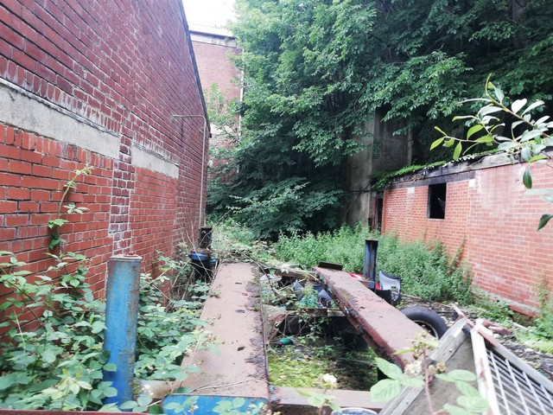

01 – Derelict Buildings Tack Lea Works.

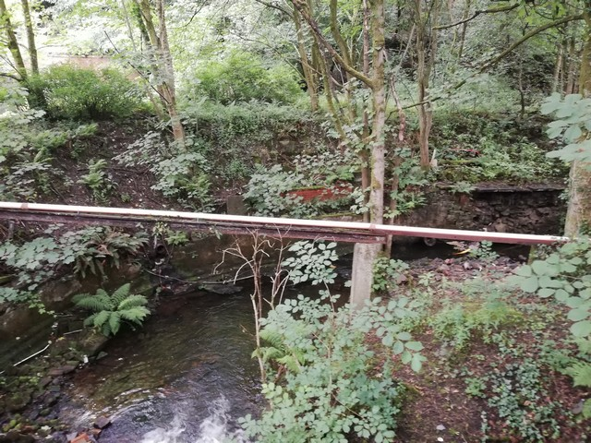

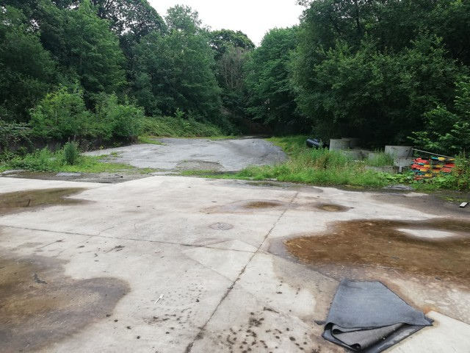
02 - Brook Tack Lea Works southern edge.

03 - Shephard Mill central view towards existing access.

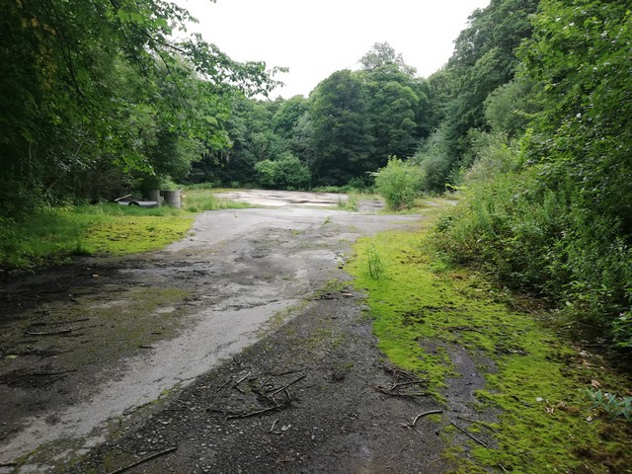

04 - Shephard Mill from access.

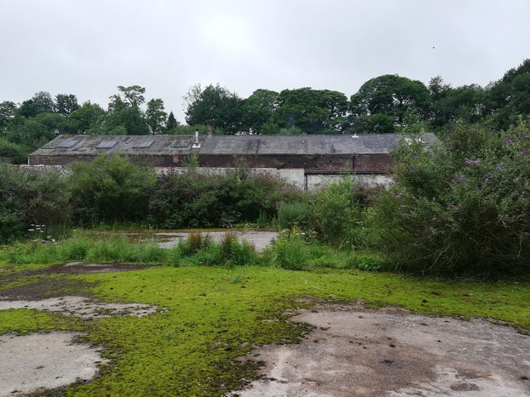

05 - Tack Lea Works towards southern boundary.

