Proposed agricultural building, Leaches Farm, Ashworth Road, Rochdale OL11 5UN

Planning Statement

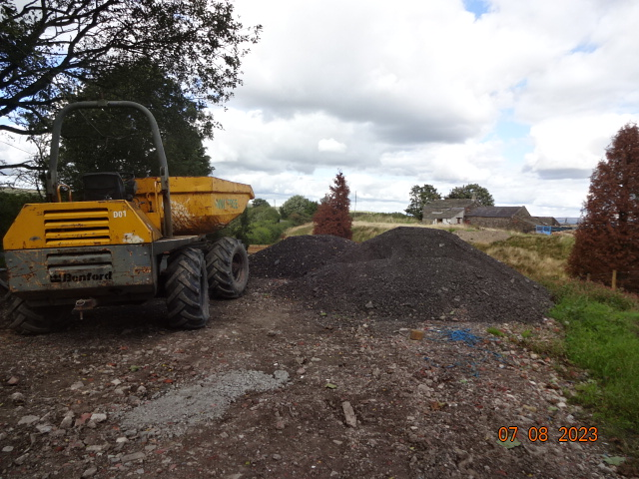

H | P
D | A

August 2023

Prepared by Hartley Planning and Development Associates Ltd

The application relates to land at Leaches Farm, Ashworth Road OL11 5UN where the agricultural unit extends to some 5.27 acres.
The building would be used for the storage of hay and for agricultural machinery.
The application site is within the Green Belt

The main issues
The main issues are (i) whether the proposal would be inappropriate development in the Green Belt; (ii) the effect of the development upon the character and appearance of the area and (iii) whether any harm by reason of inappropriateness, and any other harm, is clearly outweighed by other considerations so as to amount to very special circumstances required to justify the proposal.

Whether inappropriate development

Policy G4 of the Rochdale Core Strategy 2016 (CS) states that ‘Development will be restricted to those limited types of development which are deemed not to be inappropriate by national planning policies unless very special circumstances can be demonstrated’.

Paragraph 147 of the National Planning Policy Framework 2021 (the Framework) states that inappropriate development is, by definition, harmful to the Green Belt and should not be approved except in very special circumstances. However, paragraph 149 lists certain categories of development which form an exception to the general policy of restraint. Part (a) of that paragraph relates to ‘buildings for agriculture and forestry’.

The exception does not require an assessment of the impact in terms of openness or upon the purpose of the Green Belt.

Therefore, the proposed development would not be inappropriate in the Green Belt.

Character and appearance

The proposed development is small both in area and height and would cluster with the existing farmhouse.
The proposed external materials are those commonly found in the area for agricultural
buildings

The proposed colour is for it to blend into the rural scene.

Other considerations

Need

There are no other agricultural buildings on the land ,and it is needed both for the storage of hay to be taken from the land and for agricultural machinery storage including, amongst others, a digger, a dumper, a mower and a quad bike.

In any event, numerous appeal decisions indicate that the establishment of ‘need’ is not a requirement of the Framework (See submitted, highlighted appeal decisions in the area)

Coal Authority high risk area

The proposed development lies outside the high risk area

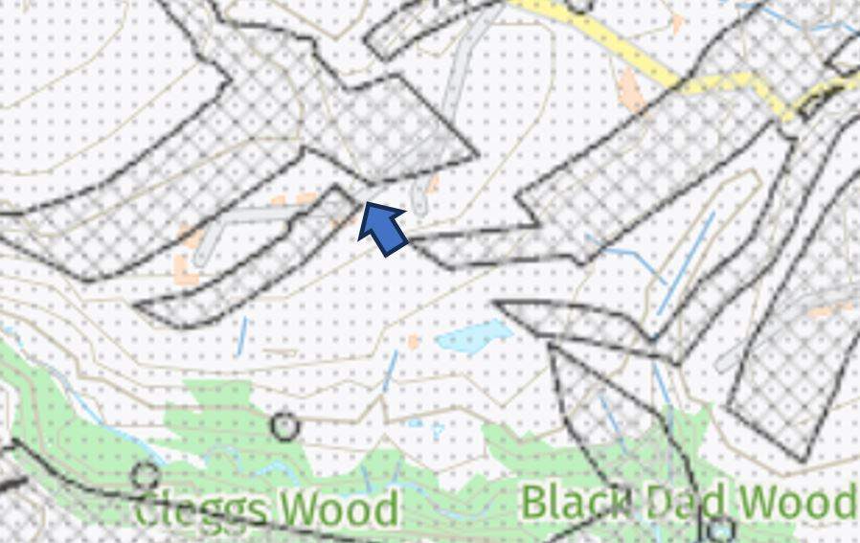

Flood risk

The proposed development is in the least risk category (Flood zone 1)

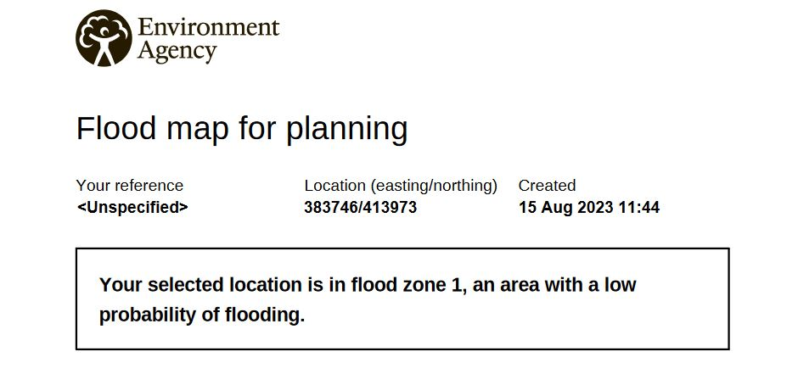

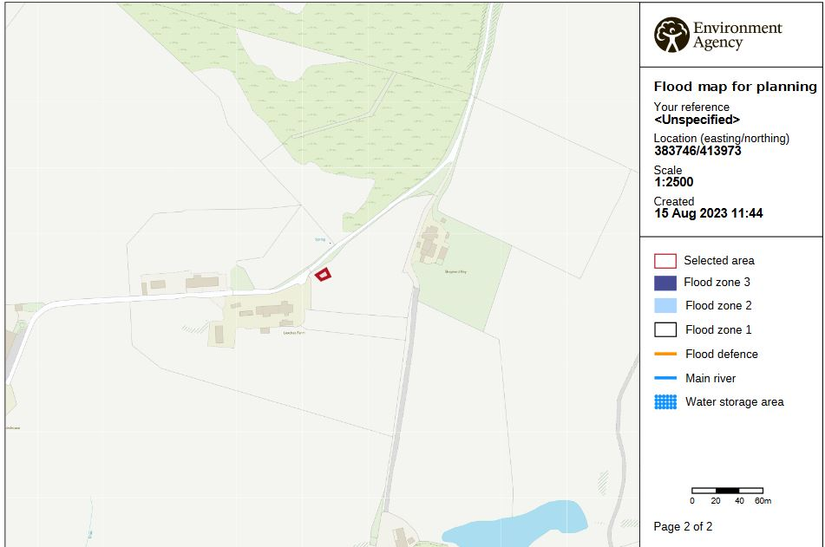

Summary
- Policy G4 of the Core Strategy states that proposals for development in the Green Belt will be judged against the contents of the Framework.
- The Framework considers that the construction of agricultural buildings are not inappropriate in the Green Belt.
- There would be no adverse or significant impact on the character and appearance of the area.
- Consequent to the above there is no need to show very special circumstances in this case.

