Proposed agricultural building, Long Clough Farm, Clough Road, Littleborough OL15 9PA
Ecological Enhancement
Ref:AG.270125.A

There is no vegetation on the site and the proposal will not impact any habitats (including priority habitats), hedgerows or watercourses.

Therefore, in accordance with Regulation 4 (De minimis exemption) of The Biodiversity Gain Requirements (Exemptions) Regulations 2024, the proposal is exempt from biodiversity net gain regulations requiring at least a 10% improvement.

Nevertheless, It is appreciated that paragraph 193(d) of the Framework aims to protect and enhance biodiversity. For this reason, therefore, we propose that the agricultural building shall include sparrow boxes and bat boxes, one at each gable end of the proposed building: -
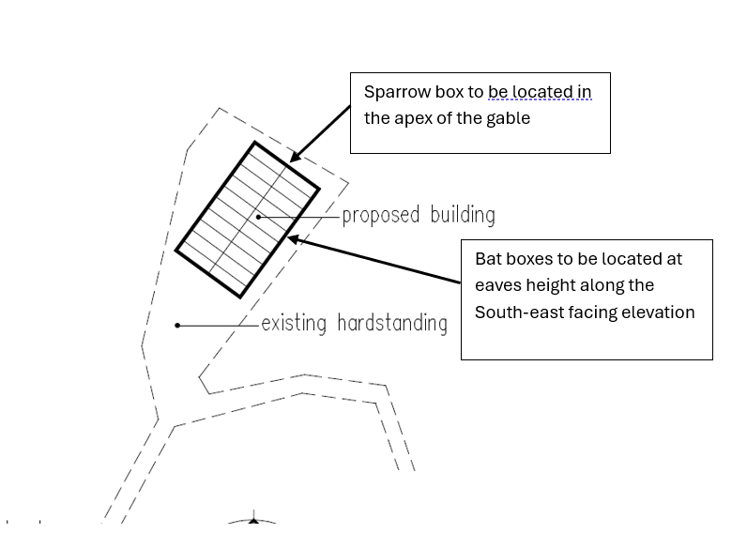

Sparrow boxes
Two Vivara Pro Woodstone House Sparrow nest boxes are proposed.
House sparrow terraces would be beneficial as this species is declining and the locality would
be suitable for these small communal birds.
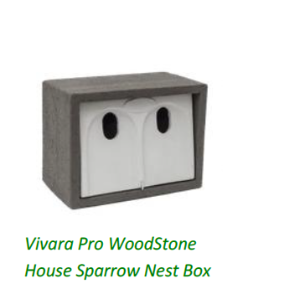
Wildcare Ltd, Eastgate House, Moreton Road, Longborough, Gloucestershire
GL56 0QJ
01451 833 181
sales@wildcare.co.uk
Bat boxes
A Schwegler bat access panel is proposed
