SPECIAL BRANCH
`

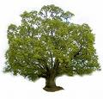
Tree Surgeons Ltd
Top O’th Meadow Farm
Meadowhead Lane
Norden, Rochdale
OL11 5UL
Tel: 01706 658771

Mini Tree Report Date: 7th December 2022

David Edwards
9 Pargate Chase
Bamford
Rochdale
OL11 5DZ
As requested, please see my mini tree report, as previously mentioned this offers no guarantees as trees are living organisms and can fail at any time. We would also like to point out no indemnity or insurance cover is offered. This report is in “my opinion” only and covers only the trees that have been inspected.

Location

Rear Garden of No.9 Pargate Chase

Work done

Site visit, arboricultural inspection, photography and report.

Trees in question

T58 mature Sycamore tree approx. 16 metres tall (see plan attached and photographs). Subject to Tree preservation order.

TPO Ref: TPO157
TPO name: Palatine Road/Palatine Avenue, Norden
Tree type: Sycamore
Description: T58
ID: T58TPO157
Local authority: Rochdale

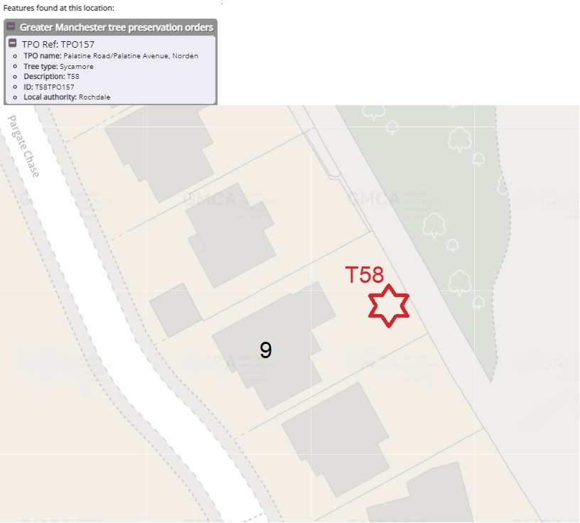

Problem

- The tree is causing excessive shading to the garden
- The tree has not been maintained and is becoming less attractive.

Recommendation

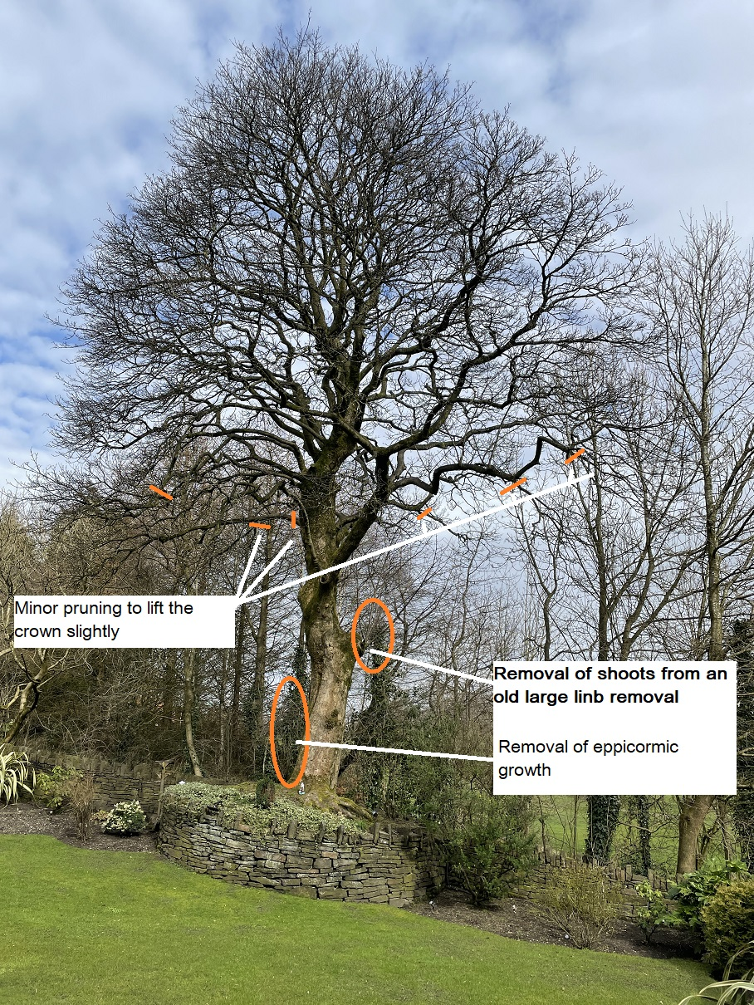

I would recommend removing the epicormic growth from the trunk along with the sprouting growth from a large historical wound, this will clean up the trunk. I also recommend a slight crown lift; this can be achieved with some smaller pruning cuts to remove the lowest drooping branches.

This maintenance will help improve light into the garden at the same time improving the visual appearance and the amenity value to the wider public while not affecting the health of the tree.

Regards

C.Ashton
Mr C. Ashton cert Arb L2 (ABC)

