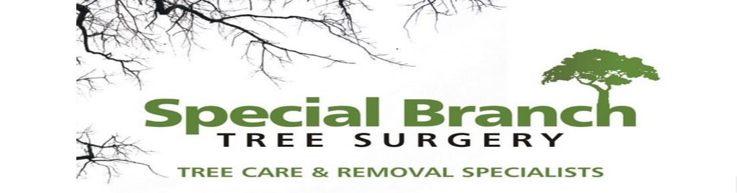

Top O’th Meadow Farm
Meadowhead Lane
Norden, Rochdale
OL11 5UL
Tel: 01706 658771

15th May 2024

Oliver Bradley
13 Bealbank View
Rochdale
OL16 4LF

As requested, please see the completed tree report, as discussed this offers no guarantees as trees are living organisms and can fail at any time. We would also like to advise that no indemnity or insurance cover is offered. This report is in “my opinion” only and covers only the trees that have been inspected.

Trees in question are subject to a Tree preservation order – TPO141

TPO Ref: TPO141
TPO name: Land at Cedar Lane Newhey
Date confirmed: 1996-09-12
Tree type: Sycamore
Description: T13
ID: T13TPO141
Local authority: Rochdale

Local authority: Rochdale

Location
13 Bealbank View.

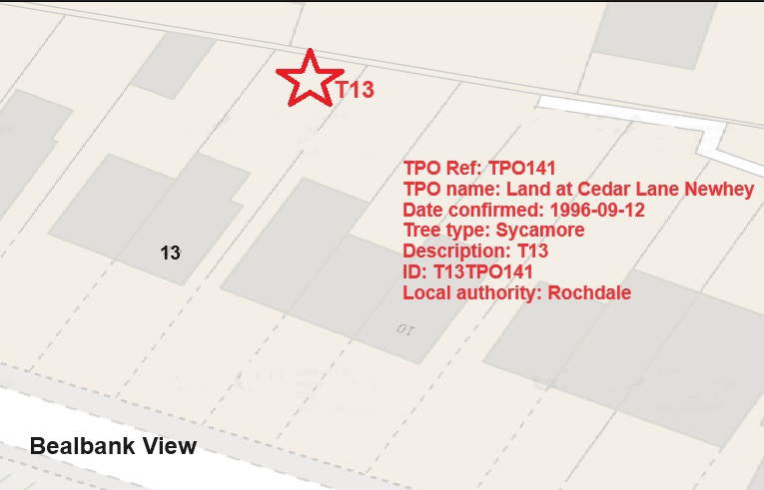

Work provided

Site visit, arboricultural inspection, photography, report, and quotation.
All trees have been thoroughly inspected and only the tree with any defects or concerns have been noted.

Trees included

T13 – Sycamore

Issues found

- The trees are causing excessive twig/branch dropping into the gardens.
- Tree can be evidently seen to be declining. (Dead upper crown, leaf discolouration)
- The tree is now showing signs of die back disease and the tree owner want to make the local area safe.
- The tree owners and adjacent property owners are suffering anxiety over fears the tree will completely fail or a larger limb would snap off.

Recommendations

T13 – Remove – Replant 2 new trees.

Reason for Removing a Sycamore Tree with Dieback and Leaf Discolouration:
Sycamore trees, are known for their large size, distinctive bark, and broad leaves. However, these trees can develop certain conditions that may warrant removal. One such condition is dieback and leaf discolouration.
Dieback refers to the death of branches or the entire tree from the top down. This condition can be caused by various factors such as diseases, pests, environmental stressors, or age. In the case of sycamore trees, common causes include Anthracnose disease and Verticillium wilt.
Leaf discolouration is another symptom that may indicate a problem with the tree’s health. Sycamore leaves typically have a bright green colour in the spring and summer. However, when the tree is under stress due to diseases or other factors, its leaves may turn yellow, brown, or red.
Removing a sycamore tree with dieback and leaf discolouration may be necessary for several reasons:
Safety: Dieback weakens the structural integrity of the tree, making it more susceptible to falling during storms or high winds. A fallen tree can pose a significant risk to people and property.
Prevention of Spread: Dieback and leaf discolouration can be contagious and spread to other trees in the vicinity. Removing the affected tree can help prevent the spread of diseases or pests to healthy trees.
Cost-Effectiveness: Treating a dying sycamore tree with chemicals or other methods can be expensive and time-consuming. In some cases, it may be more cost-effective to remove the tree and replace it with a new one.
Aesthetics: A dying sycamore tree with significant dieback and leaf discolouration can detract from the appearance of a landscape or neighbourhood. Removing it can improve overall aesthetics and property values.
Environmental Impact: A dead sycamore tree can also have negative environmental impacts if it remains standing for an extended period of time. It may attract pests or insects that can harm other trees or plants in the area.
In conclusion, removing a sycamore tree with dieback and leaf discolouration is often necessary for safety reasons, to prevent the spread of diseases or pests, cost-effectiveness, aesthetics, and environmental impact considerations. It is essential to consult with certified arborists or local extension services before making any decisions regarding tree removal to ensure accurate diagnoses and appropriate solutions

Reasons to Remove a Poor Specimen Tree
There are several reasons why it may be necessary to remove a poor specimen tree from a property. These reasons can range from the tree posing a safety hazard to it being diseased or damaged beyond repair. Here are some of the most common reasons for removing a poor specimen tree:
1. Safety Concerns: One of the primary reasons for removing a poor specimen tree is when it poses a safety risk. This can occur if the tree is leaning precariously, has large dead branches, or shows signs of decay. Such trees can pose a danger to people and property, especially during storms or high winds. In such cases, it is crucial to remove the tree to prevent potential accidents and damage.
2. Structural Issues: Poorly developed root systems, weak trunk structure, or other structural issues can make a tree unstable and prone to failure. In such cases, the tree may need to be removed to avoid potential hazards.
3. Aesthetic Considerations: In some cases, a poor specimen tree may detract from the overall aesthetic appeal of a landscape due to its unattractive appearance or poor form. Removing such a tree can enhance the visual appeal of the surroundings.
Tree root compaction issues can arise when the soil surrounding a tree's roots becomes densely packed or compressed. This compression limits the root's ability to absorb nutrients, water, and oxygen, leading to stunted growth or even the decline of the tree's health. It's crucial to avoid heavy machinery or excessive foot traffic around trees to prevent root compaction. Implementing techniques like mulching, aeration, or creating protective barriers can help alleviate this problem and support the tree's health.

If permission is granted for the removal the property owner is willing to plant two new trees in his garden.
The property owner will choose from the list of which tree’s he will plant to replace the Sycamore removal from the list below.

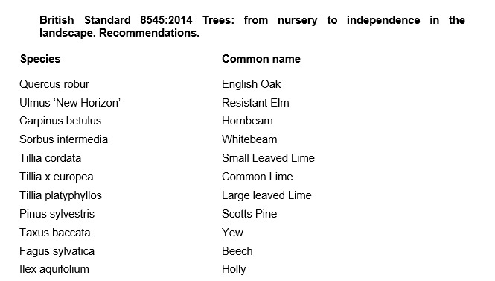

Aftercare

To ensure success when planting trees, providing good aftercare is as important as good planting practice. The first two to three years after planting are critical for a tree’s establishment. Planted well and cared for correctly, it should flourish and become a valuable feature in your garden. It is an investment of time and money, and it would be a shame to lose the benefit of a fine tree through post-planting neglect. The first challenge is moving the plant from the nursery to its new home: this can cause stress to any tree. Give it attention for the first few years to ensure re-establishment and survival in its new location. Watering, weeding, staking, mulching and formative pruning are important for successful establishment, but none are onerous or time consuming. Tree aftercare the guidelines on these pages apply primarily to ornamental trees: fruit trees are established in the same way, but pruned and managed differently to maximise fruit production. Newly planted trees ideally need regular watering in dry spells for three to five years to ensure good root growth. After planting a tree, pruning may be necessary to enhance the natural shape or improve its structure and strength. In the first few years, identify and correct problems with the main framework of the tree – prune early, as this helps avoid future complications. With a young tree, one of the most common tasks is to remove lower branches that begin to interfere with other gardening activities, create shade or block views. Look out, too, for pests such as aphids and diseases such as canker – they can reduce the vigour of your tree and make establishment slower. If you keep your tree vigorous and healthy, it is less likely to succumb to pests and disease

For the first two to three years, irrigate newly planted trees weekly during dry spells in spring and summer. Too much water, and roots will not extend in the search for moisture – but underirrigation results in slow establishment and symptoms of stress, such as canopy dieback and bark splits on the trunk. Water directly at the base of the tree and, particularly if the ground is dry, apply slowly to stop it running off. Make sure water has penetrated the soil; on our well-drained soil, we apply two to three full watering cans of water per week to new plantings.

From initial planting, mulch annually in spring or autumn to suppress weedy competitors and help retain soil moisture. ✤ Organic or inorganic materials can be used; composted wood chippings, leaf mould and well-rotted manure. ✤ Organic materials should be part composted: six-month-old wood chip is ideal. ✤ Mulch should be 7–10cm (3–4in) deep; avoid piling it round the trunk as this can soften the bark.

New trees should be staked until their roots provide good anchorage – this can take several years. If loose, the tree will rock in the wind and its root ball will move, which hinders plant establishment and could even result in death. ✤ Check ties are secure and a padded cushion is between the tree and stake. Rubbing against a stake can create a scar, which leaves the tree open to disease. ✤ Check regularly: ties left too tight cause serious bark damage. Fast-growing trees may need ties loosening every year.

Formative pruning trees
Formative pruning is the process of shaping a tree when it is young. Every variety has a different natural growth habit, but unpruned trees will for the most part produce a crown cluttered with branches. The aim is to develop an open, balanced network of strong, unshaded branches and at a height that allows for good management such as grazing livestock and machinery. This is achieved by creating a good height trunk and pruning young growth back to encourage the tree to grow in the right direction and develop thick branches.

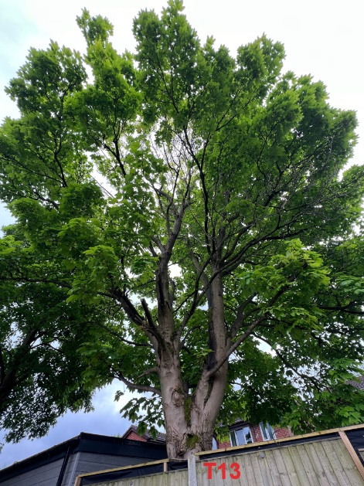
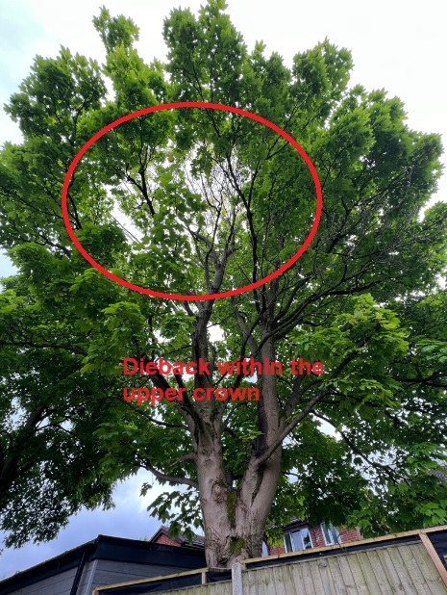
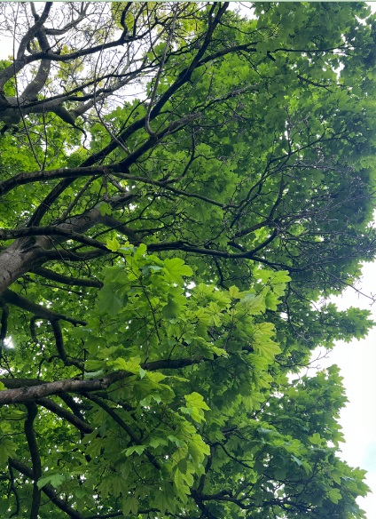
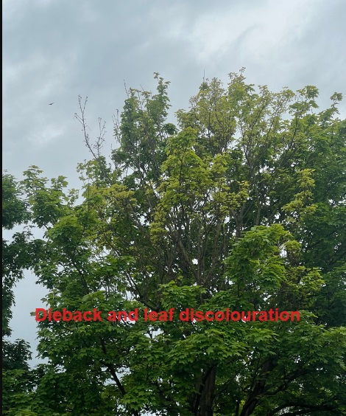
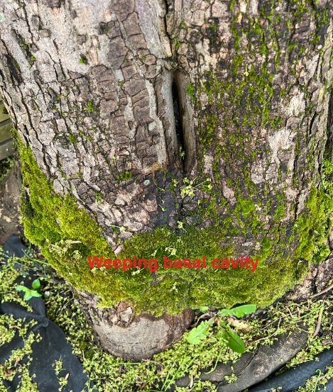
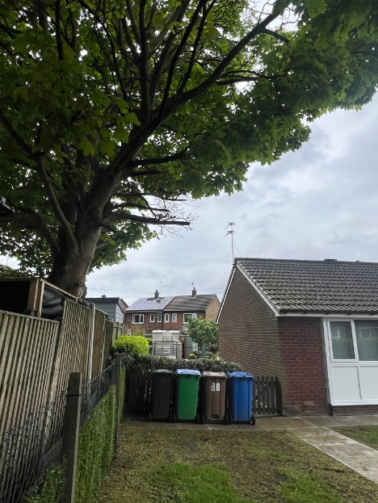

Kind regards,
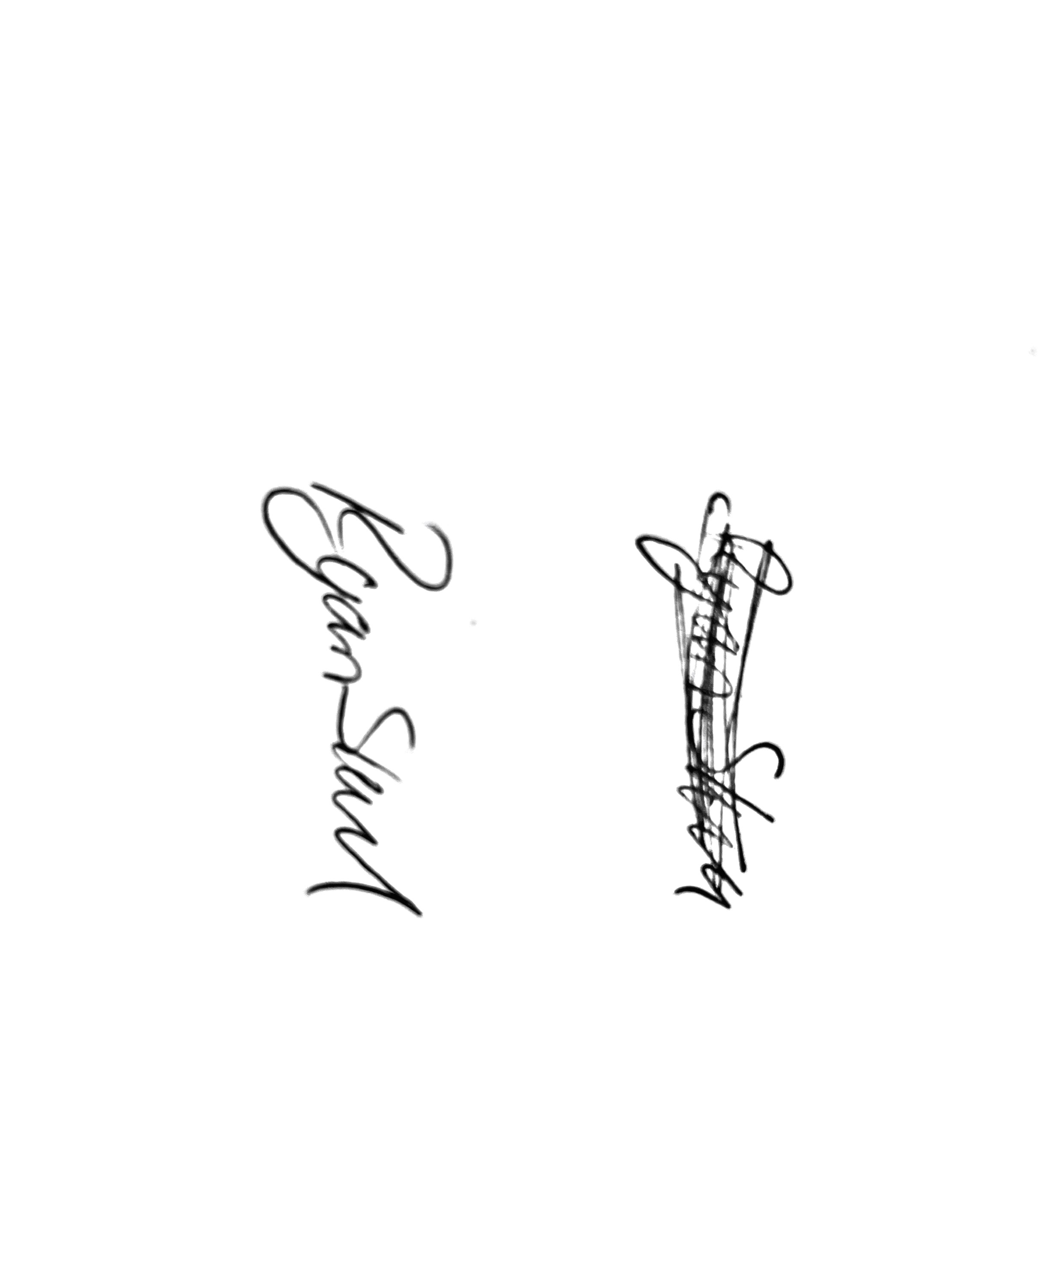
Mr. Ryan Slack
General Manager and Director
SEG Award, Cert Arb L2 (ABC)

