SPECIAL BRANCH
`

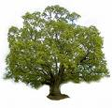
Tree Surgeons Ltd
Top O’th Meadow Farm
Meadowhead Lane
Norden, Rochdale
OL11 5UL
Tel: 01706 658771

Mini Tree Report Date: 13th August 2023

Mike Killackey
1 Tenterhill Lane
Norden
OL11 5TY
As requested, please see my mini tree report, as previously mentioned this offers no guarantees as trees are living organisms and can fail at any time. We would also like to point out no indemnity or insurance cover is offered. This report is in “my opinion” only and covers only the trees that have been inspected.

Trees in question subject to Tree Preservation Order TPO071

Work done

Site visit, arboricultural inspection, photography and report.

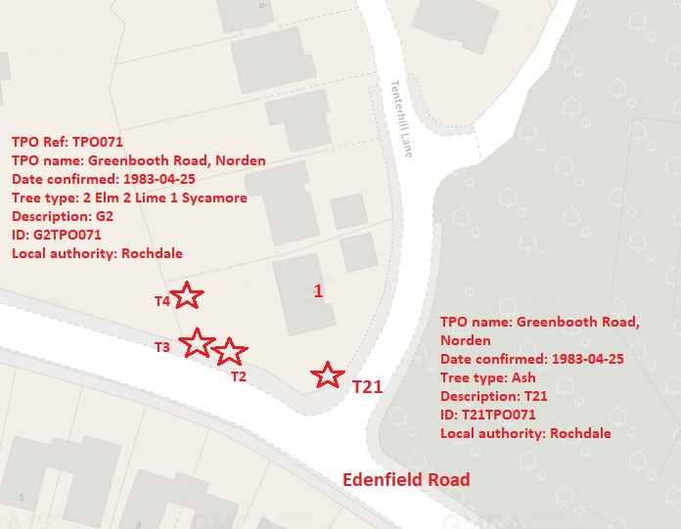

Tree in question

T21 Ash (Fraxinus excelsior) Mature tree approximately 16 meters high, deadwood present due to the Ash die back disease.
T2 Sycamore (Acer pseudoplatanus) Mature tree approximately 15 meters high with a good even spread crown Referenced T2 on the plan and annotated photography.
T3 Lime tree (Tilia x europaea) semi mature approximately 14 meters high Referenced T3 on the plan and annotated photography.
T4 Lime tree (Tilia x europaea) mature approximately 15 meters high, wide spread crown Referenced T4 on the plan and annotated photography.

Problem
The trees are quite dense and on a raised banking to the west of the property thereby blocking light into the garden, through the afternoon and evening.
Ash tree has succumb to the die back disease.

Recommendation

T21 – Remove, replant with three new trees.
T2 Crown thin by 5% to allow light penetration through to the garden.
T3 Crown thin by 10% and remove the unsightly epicormic growth, this will improve the appearance of the tree and allow more light into the garden.
T4 Crown thin by 15% and remove the unsightly epicormic growth, this will improve the appearance of the tree and allow more light into the garden.

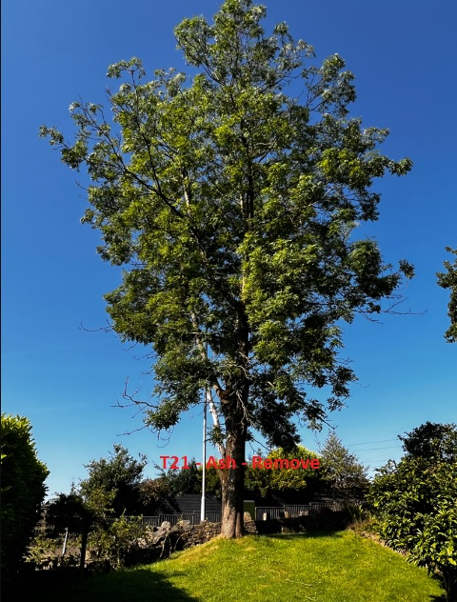

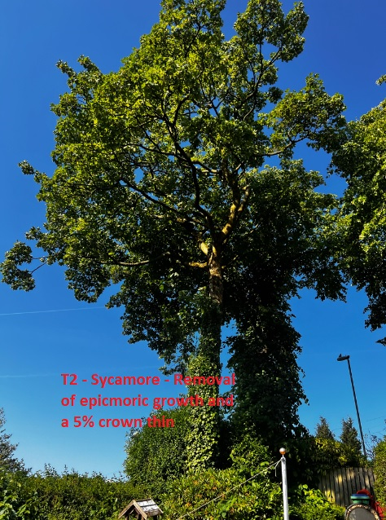

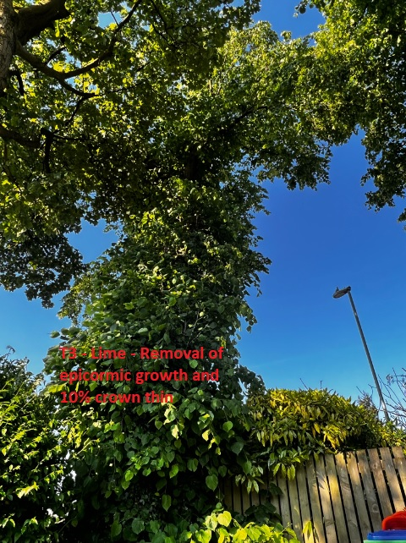

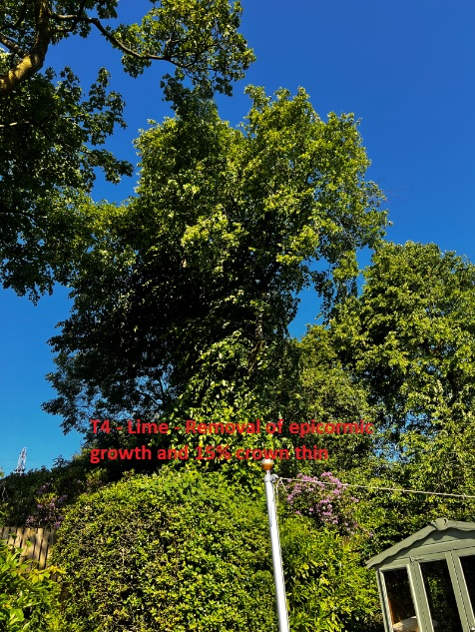

Tree health should not be affected these works.

Amenity value would be improved to the general public.

Regards

Ryan Slack
Mr R. Slack cert Arb L2 (ABC)

