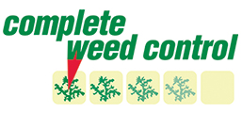
Steve Crozier
Complete Weed Control
10/14/2022
Japanese Knotweed Management Plan
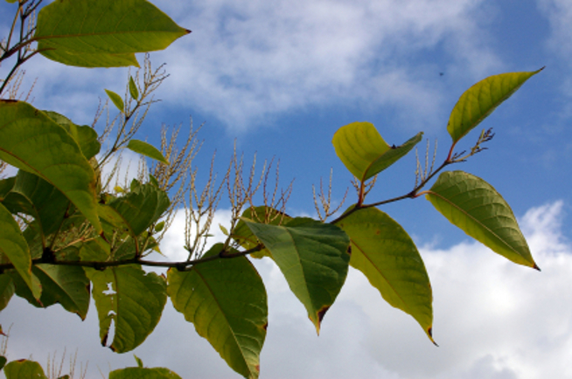
Seddon Construction Ltd
Plodder Lane
Bolton
BL4 0NN
Site: Nixon Street

Table of Contents
Site Overview 2
Site Description 2
Site Inventory 2
Threats 3
Management Plan 4
Management Plan Synopsis 4
Management Objectives 4
Management Protocol 4
Management Options 5
Recommended Program 6
Program Evaluation 7
Summary Information 8
Table 1: Priority Areas 8
Table 2: Control Methods 8
Table 3: Implementation Schedule 8
References 8
Appendices 9
Appendix 1: Site images 9
Appendix 2: Contacts 9
Appendix 3: Photographs of Japanese Knotweed at different stages of growth 9
Appendix 4: Useful Letters / Documentation 9
Appendix 5: Do’s and Don’ts of Japanese Knotweed 9
Appendix 6: Warning Sign 9
Appendix 7: Japanese Knotweed and the Law 9
Japanese Knotweed and the Law. 0

Site Overview

Site Description
The site is located at the end of Nixon Street and was a former car supermarket site.
Japanese Knotweed had previously been identified and had been fenced off and subject to a herbicide treatment program.
The location of the Japanese Knotweed is shown in green on the site plan below.

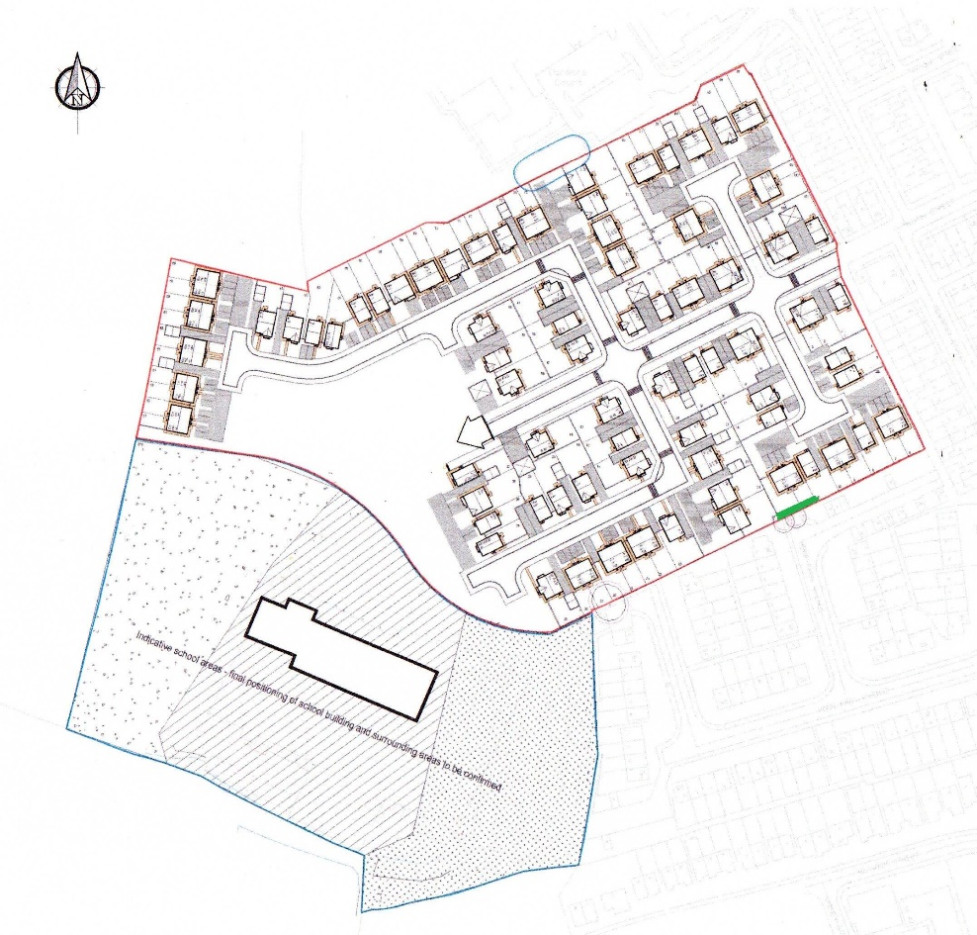

Threats
Specific problems caused by Japanese knotweed are:
- Damage to paving and tarmac areas
- Damage to flood defence structures
- Damage to archaeological sites
- Reduction of biodiversity due to out-shading native vegetation
- Restriction of access to riverbanks for anglers, bank inspection and amenity use
- Reduction in land values
- Increased risk of flooding through dead stems washed into river and stream channels
- Increased risk of soil erosion and bank instability following removal of established stands in riparian areas
- Accumulation of litter in well established stands
- Aesthetically displeasing
The presence of Japanese Knotweed on sites within the District will increase the financial burden on the Council in terms of the cost of treating the problem. If left untreated the problem will not go away and, should the Council not be able to provide the necessary finance to treat the sites of contamination, the future costs will be exponentially higher than if a treatment problem be adopted in the short term.
The presence of Japanese Knotweed on any sites of public access will eventually make the area unusable without significant risks of spreading the contamination.
The presence of Japanese Knotweed on this site will increase the financial burden on this property in terms of the cost of treating the problem.
If left untreated the Japanese Knotweed has the potential to damage the foundations of the building as well as others along the street if left untreated. The presence of Japanese Knotweed in the garden will also eventually make the garden / car parking area unusable because the plant is so invasive, it starves other plants of light and will eventually prevent the garden from being used for recreational purposes / car parking.
The aggressive growth pattern is capable of exposing weaknesses in structures such as brick walls and foundations, tarmac and concrete. Soil and waste containing Japanese Knotweed is deemed to have the potential to cause ecological harm.
So far only commercial developments have realised the significance of this invasive weed, but it is only a matter of time before domestic problems will emerge making this a matter for greater public concern.
Japanese Knotweed material is regarded as ‘controlled waste’ and not disposing of it properly would be an offence under the Environmental Protection Act, 1990. Allowing the spread of Japanese Knotweed into the wild is also an offence under the Wildlife and Countryside Act 1981.

Management Plan

Management Plan Synopsis

The Japanese Knotweed will be excavated under the supervision of Complete Weed Control and removed to a licenced waste tip.

Management Objectives

1. Immediately contain existing Japanese Knotweed on site
2. Prevention of further spread of Japanese Knotweed on site
3. Excavate the Japanese Knotweed
4. Monitor for any regrowth for the next 5 years

Management Protocol

The management of Japanese Knotweed on the site will be overseen by Complete Weed Control, who will undertake all supervision required, and be responsible to sign-off at the end of the excavation. When Complete Weed Control is not on site, it will be the responsibility of the site manager to ensure the correct management of the Japanese Knotweed area to prevent disturbance and spread of the problem. This Management Plan, appendices and revisions of this plan shall be kept for future house owners. Please see attached correspondence.

Management Options
Potential control options are:
- No treatment
Of the control options available, doing nothing is not a viable option.
- Herbicide treatment
A more economical option is to treat the JKW with herbicide to affect control. The proximity of desirable trees and more importantly any water course effect the choice of permissible herbicides. There are three options with regard to the means of treatment:
  - The first of which is to apply the herbicide to the leaf of the plant in order that it can translocate through the plant and into the rhizome system. This method is best performed in the late summer and autumn, the reason for this being that the natural senescence of the plant aids the movement of the herbicide into the rhizome. Additionally the leaf area is significantly greater at this time of year and as such provides a greater opportunity to absorb the chemical.
  - Stem injection is another means of getting herbicide into the plant. This involves cutting the stem above a node and then injecting concentrated product into the hollow inter-nodal cavity through the cuticle. This method can be carried out once the stem has reached a suitable size.
  - Stem cutting, then filling the resultant cavity with a herbicide solution. The cut canes need to be stored on site, allowed to dry and then burnt.
- Excavation and removal off site
The quickest option is to dig out the soil and all of the rhizomes and dispose of them to a landfill site that is licensed to accept this waste.
Whilst it is the swiftest method of removal it is almost the most costly, and is usually only an option for developers.
- Excavation and burial on site
The excavated material can also legally be buried on site so long as there is at least a five-metre depth of fill covering the contaminated material. Alternatively, if only 2 metre in-fill is possible then the excavated material may be buried on site within a membrane cell.
It is desirable to avoid burying under the footprint of an intended building.
Environmental Agency guidelines recommend that the position of such a cell is recorded on the deeds of the property
- Excavation and stockpiling for future treatment
If there is sufficient space on the site, then all the contaminated soil could first be excavated and dumped onto a suitable area of the site where it can remain undisturbed. The soil bund should be spread as thinly as possible to allow the JKW to grow and then future growth treated with herbicide as above.
As no development is planned for the area around and occupied by the Japanese Knotweed we recommend Herbicide application as the most cost effective solution for control.

As the area around and occupied by the Japanese Knotweed is part of the planned development / extension the only choice is to excavate the area of contamination. The costs will be mitigated, by minimising the amount of soil required to be excavated and removed to landfill, this will be done by tracking the rhizome through the soil

Japanese Knotweed rhizome is unlikely to extend below the house foundations and, as there are no plans to undertake any construction work, these options are unnecessary.

Recommended Program
- Excavation and removal off site

The Japanese Knotweed will be excavated under the supervision of Complete Weed Control. All excavated material will be loaded onto 8 wheel tipper trucks and removed to a licenced waste tip.
- Complete Weed Control will continue to monitor the area for a further 5 years following the excavation, to ensure that there is no regeneration of the Japanese Knotweed. Should any Japanese Knotweed regrowth be identified it will be treated with approved herbicides.

Program Evaluation
Monitoring will be carried out by CWC and all visits to the site will be recorded on CWC job cards which will be retained for either the duration of the contract, or as long as legally required, whichever is the longer.

The results of any individual treatment will not become apparent until the emergence or not of JKW in the year following the excavation.
This management plan will be reviewed on a regular basis.

Summary Information

Table 1: Priority Areas
List areas to be treated, any circumstances or considerations unique to that area, and its priority level
Area | Remarks | Priority Level
As identified on plan |  | 1

Table 2: Control Methods
List areas to be treated and their respective method of control
Area | Control Method | Carried Out By
As identified on plan | Excavation | Supervised by CWC

Table 3: Implementation Schedule
Schedule of the planning, surveying, execution and monitoring of the control program
Step | Date
- Supervised excavation | Completed 7th October 2022
- Monitoring visit | Completed 18th September 2023 No regrowth
- Monitoring visit | Due September 2024
- Monitoring visit | Due September 2025
- Monitoring visit | Due September 2026
- Monitoring visit | Due September 2027

References
Cite any references used in the writing of this document
- Environment Agency: The Knotweed Code of Practice
- RICS: Japanese Knotweed and Residential Property
- Code of Practice for the Use of Plant Protection Products
- Code of Practice for Suppliers of Pesticides to Agriculture, Horticulture and Forestry
- Centre for Ecology and Hydrology information sheet 5 – Japanese Knotweed
- Guidelines for the Use of Herbicides on Weeds in or Near Watercourses and Lakes
- General COSHH Approved Code of Practice
- Safe Use of Work Equipment Approved Code of Practice and Guidance
- Personal Protective Equipment at Work Guidance on Regulations
- The UK Pesticide Guide

- Client documentation …………………………………………………………….

……………………………………………………………

Appendices

Appendix 1: Site images

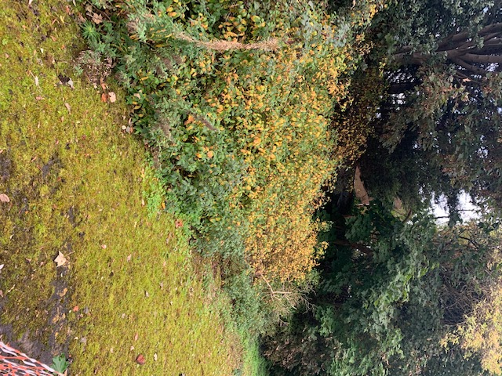

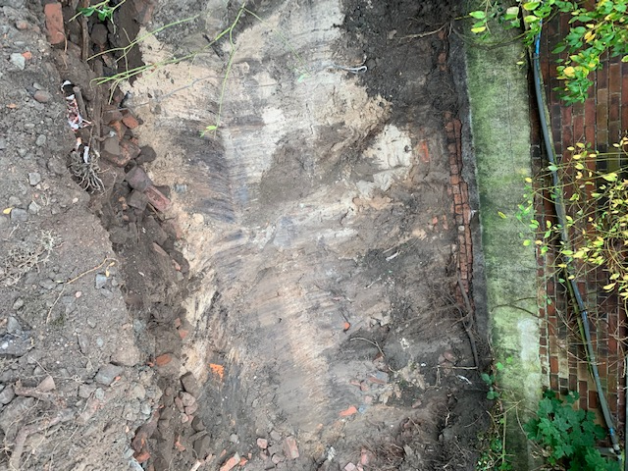

Appendix 2: Contacts
Kaine Bradley

Appendix 3: Photographs of Japanese Knotweed at different stages of growth
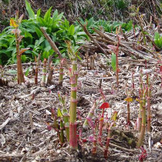
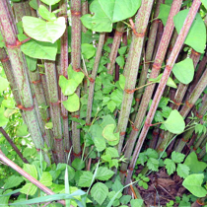
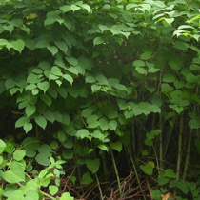

Appendix 4: Useful Letters / Documentation

Appendix 5: Do’s and Don’ts of Japanese Knotweed

Appendix 6: Warning Sign

Appendix 7: Japanese Knotweed and the Law

Dear Contractor
The site you are visiting has a problem with Japanese Knotweed.
Japanese Knotweed is a very aggressive plant damaging paving and tarmac as it spreads - on one occasion it found its way into a living room, coming up through the floorboards. Large areas are very dense and exclude all other plants. It is an extremely voracious weed capable growing at a rate of 100 to 120mm per day and reaching up to 3 metres in height and can spreading to an area the size of a tennis court in one year.
It’s quite attractive and very similar in appearance to bamboo, with stems which are red-brown at the base and mottled green toward the tip, with bright green heart-shaped leaves.
We have a duty to control it on our site, and wish to minimise its impact.
Unfortunately this is not an easy task, it cannot (without great expense) be dug out as it’s root system can reach a depth of 3m, The plant has an extraordinary ability to spread, even tiny amounts of cut stem, crown or rhizome (root) are capable of producing a new plant, as little as a fingernail size piece can regenerate into a new plant.
Although it is not poisonous, due to the destructive characteristics of Japanese Knotweed, strong legislation is in place to control the magnitude of the problem. Specifically, there are three main legal issues associated with Japanese Knotweed:
- The Wildlife and Countryside Act (WCA) 1981 states that it is an offence to plant or otherwise cause Knotweed to grow in the wild.
- The Environmental Protection Act (EPA) 1990, Duty of Care Regulations 1991, states that cut knotweed material and soil containing rhizomes must be disposed of as controlled waste if they are to be removed from their site of origin.
- Third Party litigation, where you can be sued for costs and damages if you allow Knotweed to spread from your property onto that of an adjacent landowner.
Failure to dispose of waste material containing Japanese Knotweed may lead to prosecution under section 34 of the Environmental Protection Act 1990.
As a contractor working on a site contaminated with Japanese Knotweed you have a responsibility under the above regulations to ensure that you do not spread it around the site or to other sites. You must remove the risk of cross-contamination on site and ensure all machinery and materials brought on to site are Japanese Knotweed free.
We have employed Complete Weed Control as contractors to manage this programme and you will see them on the site. We expect the programme to last for up to 5 years and would request your assistance in dealing with this problem. We have a few simple do’s and don’t that we hope you will follow:
Contractors Acceptance of obligations



Contractor’s Requirements

As a Company with concerns about the environmental impact of Japanese Knotweed we take our responsibilities very seriously.

As a contractor working on our site we require you to:
- Acknowledge that you are aware of the existence of Japanese Knotweed on our site
- Ensure you will not further spread Japanese Knotweed about our site by moving contaminated material about the site.
- Have systems in place to ensure you do not bring material onto the site that is contaminated by Japanese Knotweed

Name of Contracting Company:

Name of Person signing on behalf of Contractor:

Position:

Date:


Knotweed ‘Do’s’
- Do watch out for Japanese knotweed on the site
- Do report all Japanese knotweed to the main reception, so we can monitor all risings
Knotweed ‘Don’ts’
- Do not flail or mow Japanese Knotweed as this will cause it to spread. Cutting with sharp hooks, slashers etc is recommended.
- Do not spread Japanese Knotweed stem and crowns. If you cut down Japanese Knotweed, it is best disposed of on site. Material taken off site must be safely contained and disposed of at a licensed disposal site.
- Do not spread soil contaminated with Japanese Knotweed rhizome. Any soil that is obtained from ground within 7 m of a Japanese Knotweed plant could contain rhizome. The rhizome is highly regenerative and will readily grow into new plants.
- Do not chip Japanese Knotweed material. Mechanical chippers do not kill Japanese Knotweed. If you spread the chipped material on soil, Japanese Knotweed could regrow.
- Do not add Japanese Knotweed to compost. Compost Japanese Knotweed separately, so that you can be sure it is dead before you apply it to land.
- Do not waste time. If Japanese Knotweed appears in your area, treat it immediately.
- Do not allow it to become established. Do not break the law. Remember, if you cause Japanese Knotweed to spread you are guilty of an offence under the Wildlife and Countryside Act, 1981.
- Don't try to dig up Japanese Knotweed as this will lead to a significant increase in stem density. Even a tiny fragment of the cut rhizome is capable of regeneration.
- Don't take Japanese Knotweed to recycling centres that receive garden waste as it will contaminate the compost.
- Don't dump garden waste contaminated with Japanese Knotweed in the countryside.

Japanese Knotweed and the Law.
In the UK there are two main pieces of legislation that cover Japanese Knotweed. These are:
Wildlife and Countryside Act 1981
Listed under Schedule 9, Section 14 of the Act, it is an offence to plant or otherwise cause the species to grow in the wild.
Environmental Protection Act 1990
Japanese Knotweed is classed as ‘controlled waste’ and as such must be disposed of safely at a licensed landfill site according to the Environmental Protection Act (Duty of Care) Regulations 1991. Soil containing rhizome material can be regarded as contaminated and, if taken off a site, must be disposed of at a suitably licensed landfill site and buried to a depth of at least 5 m.
An offence under the Wildlife and Countryside Act can result in a criminal prosecution. An infringement under the Environmental Protection Act can result in enforcement action being taken by the Environment Agency which can result in an unlimited fine. You can also be held liable for costs incurred from the spread of Knotweed into adjacent properties and for the disposal of infested soil off site during development which later leads to the spread of Knotweed onto another site.
Advice for Landowners
Japanese Knotweed is one of Britain’s most invasive plants and the prevention of its spread is a legal obligation for landowners under the Wildlife and Countryside Act 1981. It is difficult and expensive to manage but non-intervention is not really an option. Early treatment of a new colony is quicker and cheaper and preferable to leaving it to get established.

