Curved Outdoor Wall Mounted Led Lights
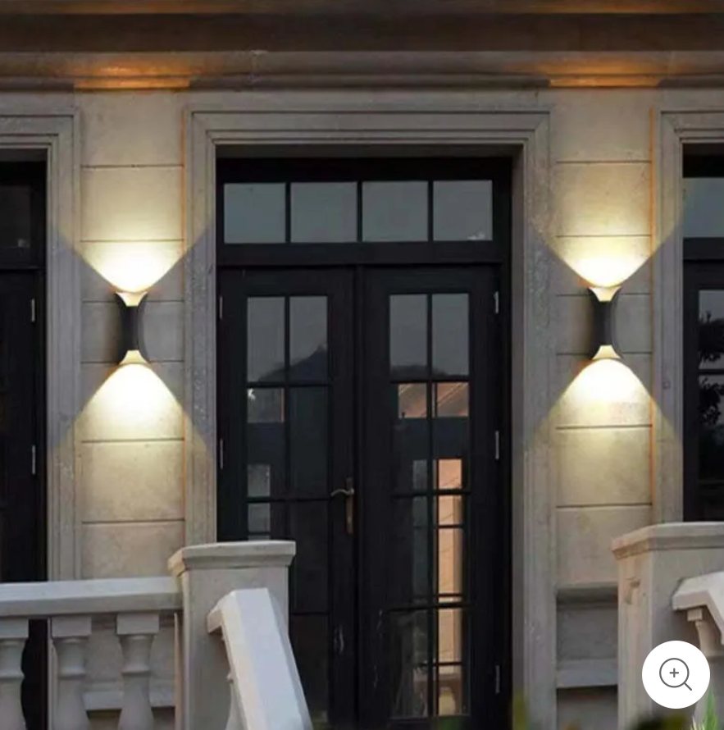

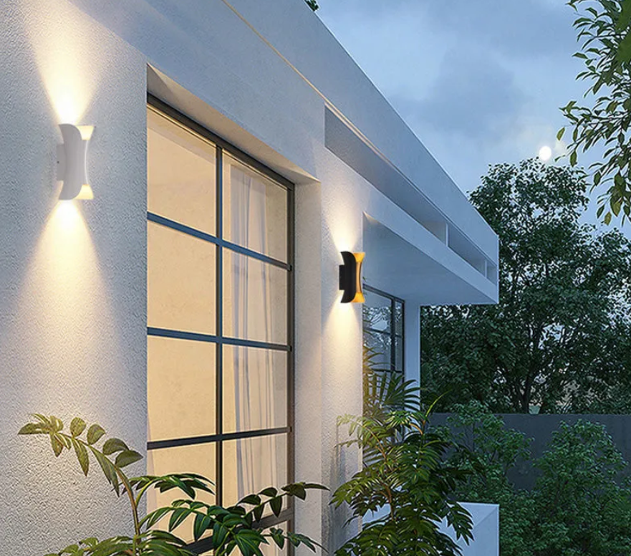

Feature
Type | Outdoor Wall Lamp
Style | Orr
Suggested Space Fit | Garden/Corridor
Suggested Room Size | 10㎡-15㎡
Indoor or Outdoor Use | Indoor or Outdoor Use
Dimmable | No
Colour Temperature | Warm Light/Cold Light/Natural Light
Smart Enabled | /
Need Assembly | Yes
IP Rate | IP65
Power Source | Hardwire
Bulb Information
Bulb Included | Yes
Bulb Type | LED
Bulb Base | SMD
Number of Bulb | 2
Voltage (V) | 110V-240V
Maximum Wattage(W) | /
Material
Primary Material | Metal+Acrylic
Fixture Material | Metal
Shade Material | Acrylic
Weights&Dimensions
Product Weight | /
Chain/Cord Adjustable or Not | No
Size | See Images
Package Contents
1* Outdoor Wall Lamp

