Building Design Services
M. Farooq
PLANNING STATEMENT
65 Oldham Road Rochdale OL16 5QR

PROPOSED CHANGE OF USE FROM SHOP AND STORAGE INTO TWO SELF CONTAINED FLATS TOGETHER WITH REAR DORMER

Content Page

- Introduction 2
- Site and surroundings 3
- Proposed development 6
- Involvement 7
- History 8
- Relevant planning policy 9
- Assessment 11
- Conclusion. 15

1.0 INTRODUCTION
1.1 This Planning Statement has been prepared for Building Design Services on behalf of the applicant Mr Leigh O’Reilly and Mr Oliver Bargh who is the current building owner of 65 Oldham Road, Rochdale, OL16 5QR. The building is two stories in nature. Currently the ground floor was used as a shop with ancillary storage on the first floor above. The applicant would like to secure full planning permission to refurbish the whole building with the change of use from shop and storage into two self-contained flats and rear dormer extension of the building and make a positive change to the local centre.
1.2 This Planning Statement, accompanying full floor layout and elevation plans submitted as part of this proposal make reference to the current land use, constraints, policy, guidance, and possible issues, and addresses these matters categorically.
1.3 Compared to other housing markets in the Northwest and Greater Manchester, the Rochdale and Northeast Manchester housing market is generally less attractive. The housing on offer in the borough has stark differences in terms of quality and price and fails to address the needs of existing or future residents. An oversupply of older terraced housing and a lack of high value housing across the borough results in detraction and retention residents with higher or above higher incomes.
1.4 An ambitious target of providing 460 additional homes per year is considered necessary to meet demand and to help regenerate the borough. The latest Housing Land Availability Assessment indicates that there is considerable scope to meet its housing target using previously developed sites, especially in the South, and with limited use of surrounding Greenfield sites.
1.5 Consideration is required from the Local Authority to focus on the right type of housing in the right areas, maintain the regeneration of older private housing estates and social housing estates and ensure that the community infrastructure necessary to support areas of housing growth is provided.
1.6 Further to the above, the NPPF states that Planning policies and decisions should support the vital role of town centres being at the heart of local communities, by taking a positive approach to their growth, management, and adaptation.
1.7 The applicant is seeking support / guidance from the Local Authority Planning department in order to secure full planning approval for the proposed use.

2.0 SITE AND SURROUNDINGS
2.1 The application relates to an end terrace property at 65 Oldham Road in Rochdale. The property is currently vacant and was trading a sports shop selling sports merchandise on the ground floor with upper floor used as ancillary storage which is also currently vacant.
2.2 The building occupies a corner plot at the junction of Wood Street and Oldham Road and is located within the Oldham Road Local Centre. The adjoining properties to the side are in commercial use with residential above. The application site is located at the end of a row of terraced properties which are predominantly commercial. On the opposite side of Oldham Road is the retail Park which consists of Halford Store, Argos Store, Matalan, and Pound Land Stores. Waiting restrictions prevent vehicle parking to the front and side of the building.
2.3 The application building is finished in red brick and does not have any striking characteristics. The building is two stories high. The property has a diagonal emphasis to the side with large square windows to the front and a window above, and with one window on the side elevation at first floor. There is a door and a window on the ground floor at the rear with one window above at first floor. The building is currently accessed through the retail shop from the front and an opening to the rear through an access which leads to a small yard area.
2.4 The UDP Proposals map shows that the site itself is allocated as being in the Oldham Road Local Centre and in the defined urban area, Oldham Road Local Centre is located approximately 300 metres from the main Rochdale Town Centre, with Oldham Road having direct links into Rochdale Town Centre. There is a high frequency of public buses that access Oldham Road.
2.5 The site is considered to be in a sustainable location being well served by public transport and well related to an adequate range of existing services and facilities within a short walking distance. The red edge location plan shows the building to have a small external curtilage area. There are two dedicated parking spaces which is shared with number 67 Oldham Road.

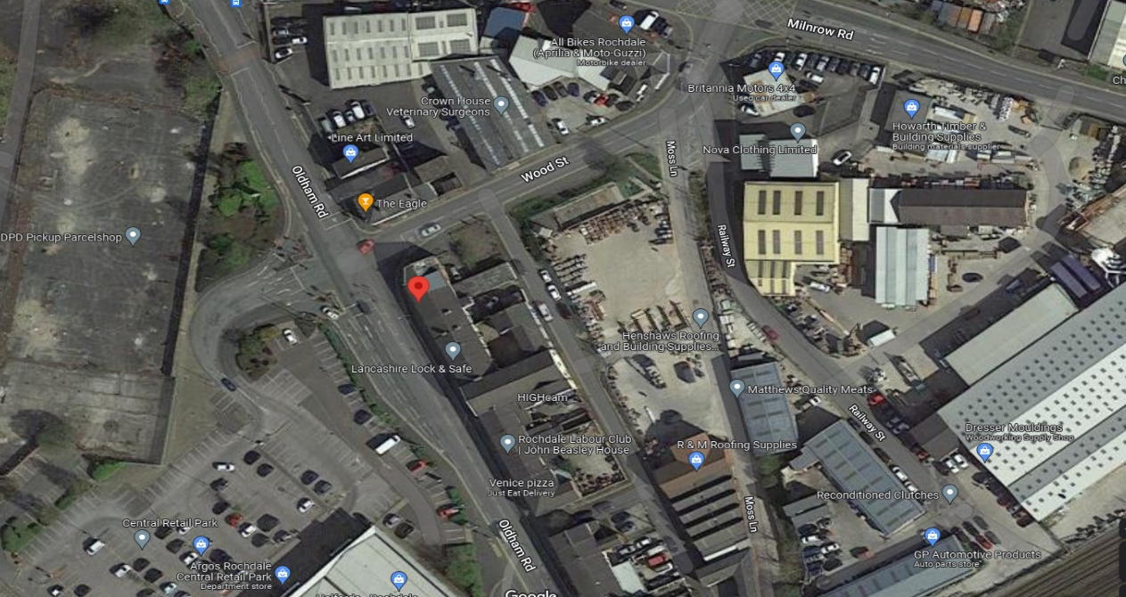

The site is located at 65 Oldham Road at the corner of Wood Street and Oldham Road as shown above.
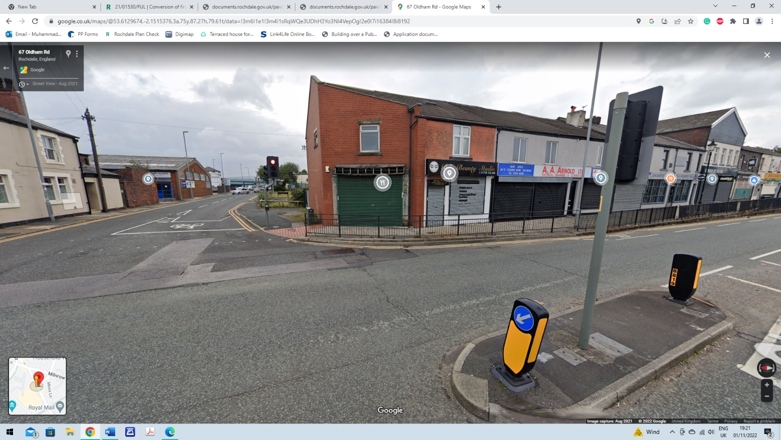

The image above is the front elevation of the application site property with Wood Street On the left side.

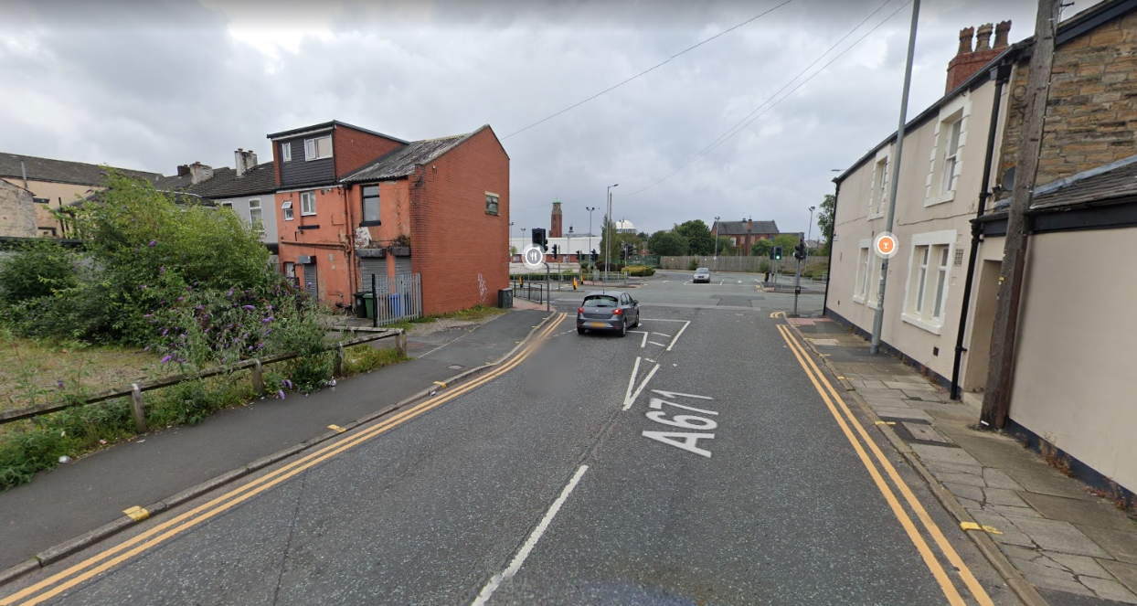

The image above is the rear elevation of the application property.

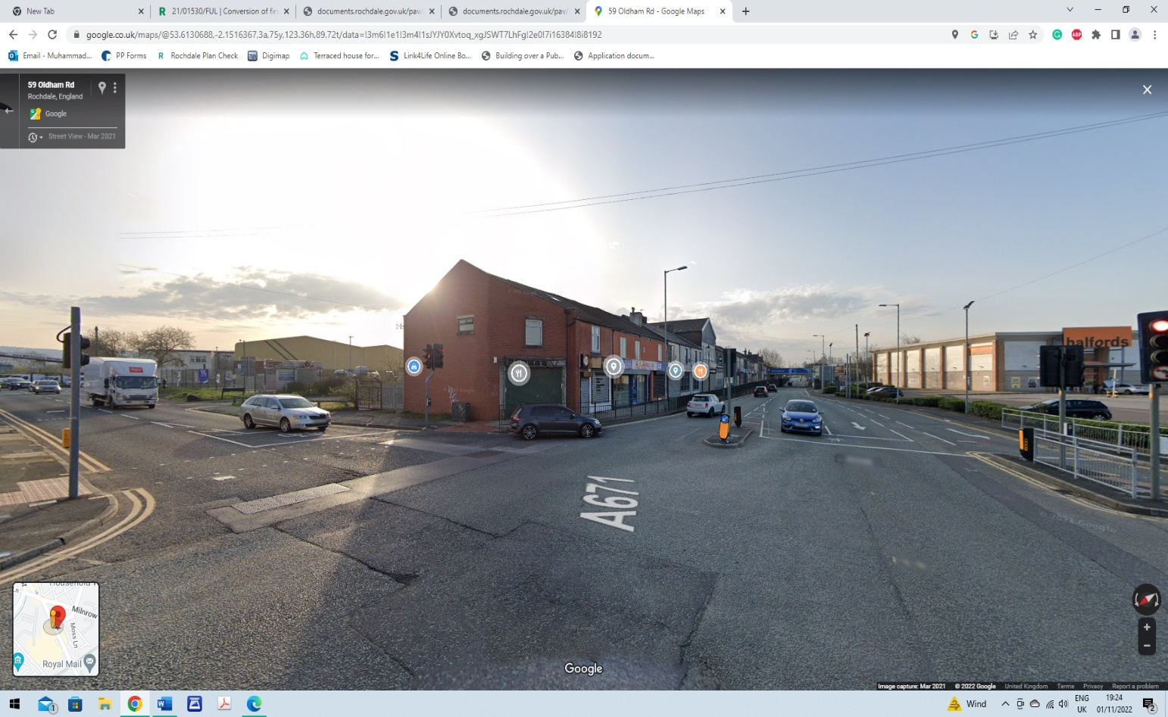

The above image is the front and side elevation of the application property

3.0 PROPOSED DEVELOPMENT
3.1 The applicant is applying for full planning permission to refurbish the existing building by changing the use of the building into two self-contained flats and a rear dormer to add to the living accommodation to create a separate apartment on the floor and roof space area. The upper floor area will consist of three-bedroom self-contained apartment, and the ground floor apartment will consist of one bedroom. The external changes to the building would be the insertion of a rear dormer to the elevation, insertion a window to the rear elevation, and partial brick up to the front elevation window. On the side elevation there is one window which will be removed and the insertion of two smaller windows would be inserted with also the addition of a new window above serving the landing on the second floor. The existing door to the rear would be retained providing access separately to the first-floor apartment and the front entrance would provide access to the ground floor apartment.
3.2 The yard area would provide bin storage which would contain Euro bins for easy servicing. The ground floor would provide 1 apartment whilst the first floor and roof space would also provide 1 apartment. Each apartment would consist of a kitchen, living room, bedrooms, and a separate bathroom.
3.3 This is a situation that the applicant would wish and as such seeks to ensure a sustainable future for the building. As previously stated, the applicant is willing to co-operate with the Local Authority Planning Department to secure full planning consent for the appropriate use of sufficient high-quality apartments as demonstrated by this Statement and the submitted drawings.
3.4 Residential uses within mixed use developments can introduce diversity, security and inject liveliness especially at evenings and weekends.
3.5 The conversion of the building would help in providing much needed accommodation close to the two local College’s as well as workers in this central location.

4.0 INVOLVEMENT
4.1 Although no formal pre-application advice in this instance has been sought from the Local Authority Planning Department, there have been informal discussions with the LA planning officers regarding the type of the accommodation provided and what would be acceptable. Early engagement with the planning department has influenced an acceptable design scheme which seeks to provide quality accommodation in this area.
4.2 Paragraph 39 of the NPPF states; “Early engagement has significant potential to improve the efficiency and effectiveness of the planning application system for all parties. Good quality pre-application discussion enables better coordination between public and private resources and improved outcomes for the community.”
4.3 I would like to forward my gratitude to the respective Planning Officer in taking the time and effort to engage in early discussions which has been extremely helpful to both me and the applicant.
4.4 This planning Statement has been submitted as part of this planning proposal to provide a reasoned justification of the proposal using local and national planning policy and guidance.
4.5 The issues of Highways safety, amenity of the surrounding area, design and the principle of the development are taken into consideration in the assessment below.

5.0 HISTORY

5.1 A history check has been undertaken which has revealed the below planning history
for the site, the relevant planning history includes: -

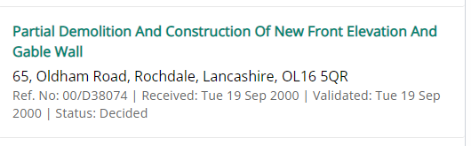

6.0 RELEVANT PLANNING POLICY
6.1 Section 38(6) of the Planning and Compulsory Purchase Act 2004 states that decisions should be made in accordance with the development plan unless material considerations indicate otherwise.
6.2 Rochdale’s Core Strategy was adopted in July 2016 and is the key Development Plan Document. It replaces significant elements of the existing Unitary Development Plan as the document that sets out the long-term strategic policies for Rochdale’s future development and will form the framework that planning applications will be assessed against.
6.3 The Core Strategy seeks to deliver sustainable development and growth in accordance with the objectives of the National Planning Policy Framework (NPPF). It aims to increase investment in the borough and to make it a more prosperous place by 2028. The Core Strategy will have a major role in guiding the regeneration of the borough, building on the extensive investment that has already taken place in some areas and identifying where to focus on next.
6.4 It looks to build on the borough's assets, heritage, and identity and on its connections and relationships with neighbouring towns. In particular, the borough’s needs.
6.5 The following Local Plan policies have relevance to the proposal: DM1 GENERAL DEVELOPMENT REQUIREMENTS P3 IMPROVING DESIGN OF NEW DEVELOPMENT E1 ESTABLISHING THRIVING TOWN, DISTRICT AND LOCAL CENTRES C3 DELIVERING THE RIGHT TYPE OF HOUSING G9 REDUCING THE IMPACT OF POLLUTION T2 IMPROVING ACCESSIBILITY Saved Unitary Development Plan (UDP) Policies: S/6 DISTRICT CENTRES LOCAL CENTRES AND LINEAR COMMERCIAL AREA SPD GUIDELINES & STANDARDS FOR RESIDENTIAL DEVELOPMENT NPPF (2021)
6.6 The NPPF clearly states ‘that the purpose of the planning system is to contribute to the achievement of sustainable development’ (paragraph 7). Paragraph 10 confirms that ‘in assessing and determining development proposals, local planning authorities should apply the presumption in favour of sustainable development’. Paragraph 11 states that a presumption in favour of sustainable development is at the heart of the NPPF. It goes on to say that ‘for decision-taking this means:
c) Approving development proposals that accord with an up-to-date development plan without delay; or
d) Where there are no relevant development plan policies, or the policies which are most important for determining the application are out-of-date, granting permission unless:

I. the application of policies in this Framework that protect areas or assets of particular importance provides a clear reason for refusing the development proposed; or ii. any adverse impacts of doing so would significantly and demonstrably outweigh the benefits, when assessed against the policies in this Framework taken as a whole. Paragraph 60 of the NPPF states:

“To support the Government’s objective of significantly boosting the supply of homes, it is important that a sufficient amount and variety of land can come forward where it is needed, that the needs of groups with specific housing requirements are addressed and that land with permission is developed without unnecessary delay”.
Paragraph 120 of the NPPF states that Planning policies and decisions should:
d) Promote and support the development of under-utilised land and buildings, especially if this would help to meet identified needs for housing where land supply is constrained, and available sites could be used more effectively.
Paragraph 124 of the NPPF states:
Planning policies and decisions should support development that makes efficient use of land, taking into account:
a) the identified need for different types of housing and other forms of development, and the availability of land suitable for accommodating it.
Paragraph 130 of the NPPF advises:
Planning policies and decisions should ensure that developments create places that are safe, inclusive and accessible and which promote health and well-being, with a high standard of amenity for existing and future users.

Paragraph 111 of the NPPF states:
Development should only be prevented or refused on highways grounds if there would be an unacceptable impact on highway safety, or the residual cumulative impacts on the road network would be severe.
The general perspective of the NPPF is that planning should proactively drive growth and support sustainable economic development. It also states that planning should make effective use of land by reusing land that has been previously developed and sets out a presumption in favour of sustainable development. The government is committed to ensuring that the planning system does everything it can to support sustainable economic growth.
In terms of retail uses the NPPF states at Paragraph 123;
“Local planning authorities should also take a positive approach to applications for alternative uses of land which is currently developed but not allocated for a specific purpose in plans, where this would help to meet identified development needs. In particular, they should support proposals to:
- use retail and employment land for homes in areas of high housing demand, provided this would not undermine key economic sectors or sites or the vitality and viability of town centres, and would be compatible with other policies in this Framework”.

6.7 National Planning Practice Guidance (NPPG) The government published its NPPG on 6th March 2014. This is intended to complement the NPPF and to provide a single resource for planning guidance, whilst rationalising and streamlining the material. Almost all previous planning Circulars and advice notes have been cancelled. Specific reference will be made to the NPPG or other national advice in the Analysis section of the report, where appropriate.

7.0 ASSESSMENT
7.1 The residential units proposed would be located within the Oldham Road Local Centre. Policy E1 of the Council Core Strategy is therefore relevant and which states ‘We will focus retail leisure, cultural, office, residential and other development to promote the viability and vitality of the boroughs town centres.
The application site is also in the Defined Urban Area as allocated under the Rochdale Unitary Development Plan. As such policy G/D/1 is relevant to any applications on the site and this establishes that development should be located in the urban area so as to support urban regeneration and protect the countryside.
Policy C1 of the Core Strategy establishes to; Maximise the potential of previously developed sites, including empty homes and buildings within the urban area to achieve a target of 80% of new housing of previously developed land; and ensure that sites are sustainable with good access to local services, facilities, green infrastructure, shops, jobs, schools and public transport.
Policy C3 of the core strategy is also relevant and its aims are to; Ensure new development provides housing types that take account of local needs and aspirations; Promote densities that make efficient use of land whilst delivering a range of housing to widen choice in the borough and reflect local character.
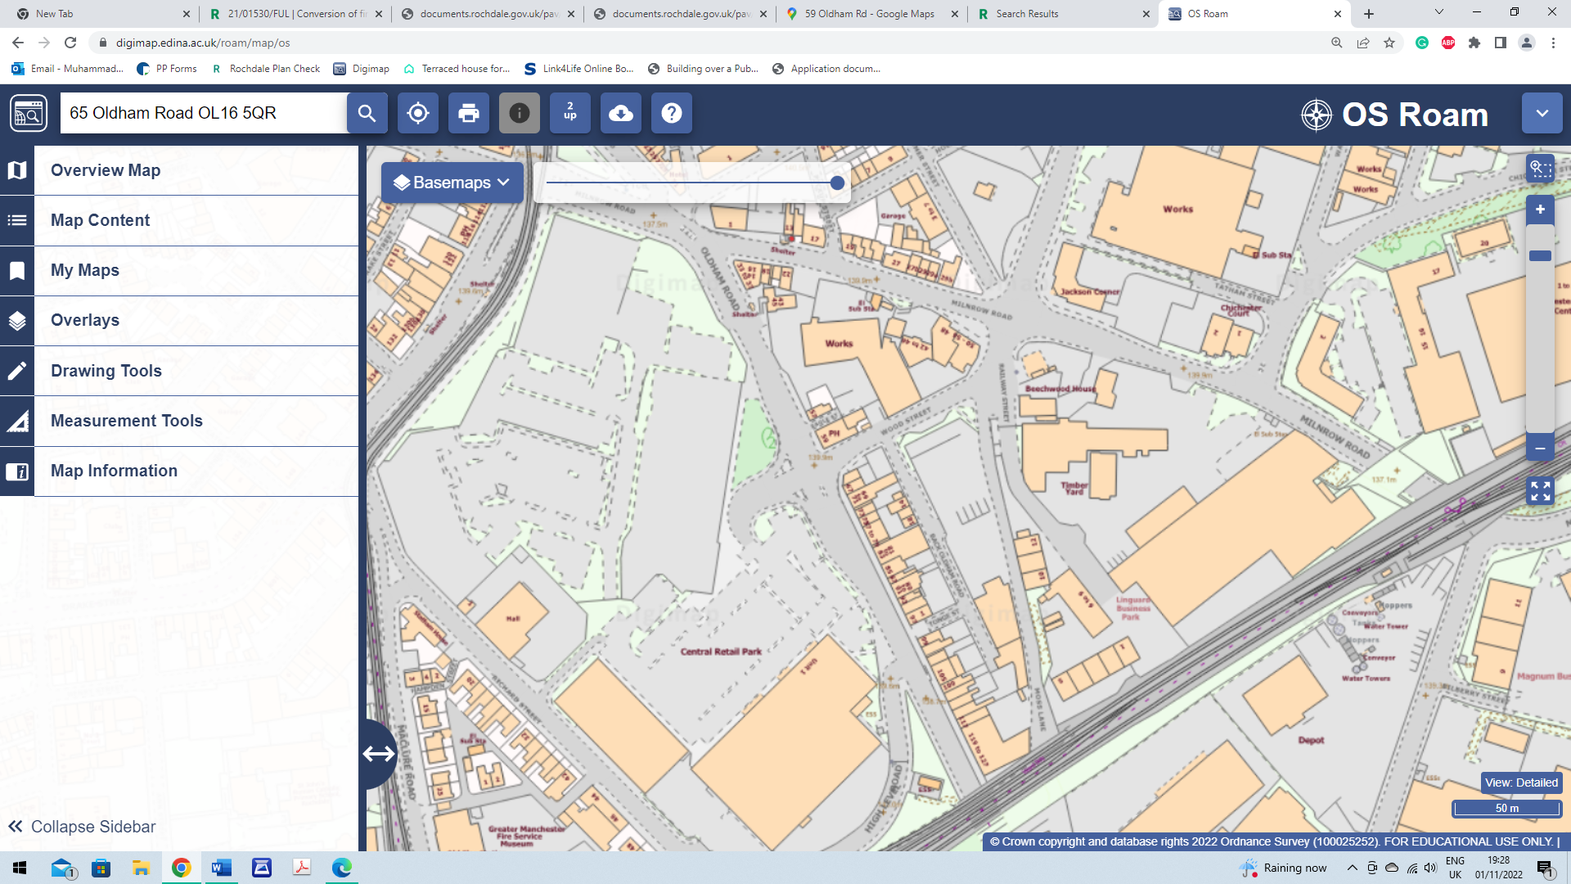










The UDP proposal map above shown is the site marked in red on Oldham Road.
Oldham Road and Milnrow Road is a key route into the town centre marked in yellow.

7.2 The proposed change of use of the building would reuse a site which has been underutilised for a number of months/years, and the site is becoming tired and unused in this prominent location close to Rochdale town centre. The building needs investment to bring the property back to a suitable functional use and where it would have a positive impact on the surrounding area.
7.3 The site is well located in relation to small and medium sized apartments as well as typical family housing accommodation in an urban area so as to support urban regeneration and protect the countryside.
7.4 The proposal would provide good housing accommodation which is much needed in this inner urban area. It would enhance the character of the area by bringing an existing site back into use; it would consider the needs of the local community, protect the surrounding built environment, and provide the future occupiers with services within walking distance and reducing the need to travel.
7.5 The effect on residential amenity by reason of noise or other nuisance would be minor given its location amongst other similar uses and by virtue of its location in the local centre. The openings which serve the main habitable rooms of the building would be a at a distance from noise generating uses and plant where they may give rise to nuisance, as such any noise would be limited and not impact on the amenity of future residents.
7.6 It is also considered that the proposal would not have a detrimental effect on the safe and efficient operation of the existing transport and road infrastructure. Highway’s safety is further discussed in the relevant section below.
7.7 The Oldham Road Local Centre is characterised by a number of smaller units with a number proportion of food and drink outlets down the road as well as residential flats and other businesses. The types of uses within the centre, along with its proximity to high density residential areas, create a vibrant local centre with few vacant premises. It is considered that the introduction of two additional residential units in this location would add to the vibrancy of the Local Centre and would be an appropriate use for the ground and first floor of this site.
7.8 In respect of part of the above policies, the area is predominantly mixed-use retail and residential, and therefore residential is considered as a complimentary use to the existing character of the area and is located in a sustainable area with good access and facilities and which makes efficient use of the land whilst delivering an appropriate use for the site.
7.9 In light of the above it is considered that the principle of providing residential units at the application site is acceptable.
7.10 Policy DM1 of the Core Strategy sets out a number of basic planning considerations that apply to all development. Further to this, paragraph 17 of the NPPF, containing the ‘core planning principles’, advises that planning should always seek to secure a good standard of amenity for all existing and future occupants of land and buildings. Policy G9 of the Core Strategy sets out that the Council will seek to reduce all forms of pollution by requiring that development does not have impacts that lead to an unacceptable increase in air, water, noise, light or other pollution.
7.11 It has already been established above that the principle of providing residential accommodation at the site is considered acceptable; The area is established as mixed use, and the proposal would therefore be in keeping with existing land uses around the area. It is however important to ensure that the proposal would not impact unduly on matters such as noise and other pollution effects, with regards given to the impact of each flat within the building as well as the impact of the development upon existing surrounding properties.

7.12 In relation to noise, it should be acknowledged that there would be some noise from neighbouring commercial land uses as well as road noise from the retail use from the neighbouring properties on Oldham Road. There are residential uses in the vicinity and by virtue of its location, the noise from neighbouring uses is not considered to have a significant impact on the amenity of future occupiers or from external noises.
7.13 In terms of internal noise between flats, the internal layout has been carefully designed so that bedrooms and living rooms are least affected by noise, however it should be noted that any new partitions required would have an acoustics barrier fitted where required to ensure future residents are adequately protected from unacceptable levels of noise, internal noise levels can be conditioned if required. Also, the retail shops would close early in the evenings where it would provide future residents with peace and quiet in the evenings and at night.
7.14 In respect of other matters, it is important that the development provides adequate space around the building. It is considered that there would be no concerns regarding the distance to the front of the building which would face the main highway and along Regent Street. The rear elevation would face the yard area and beyond is there is no property to the back of the site. As detailed, the residential units would not overlook neighbouring properties to its detriment.
7.15 The proposed development would adequately provide the level of amenity that would be expected at a residential property within this area. The proposal would be compatible with the density and character of the surrounding development.
7.16 With regard to the living conditions of future occupiers of the property, it is noted that each habitable room within the building would be provided with natural light and ventilation, with an outlook to the streets on the front, side and rear of the property. Each property would have its own WC and washing facilities.
7.17 A bin storage area would be provided in the rear yard area away from the main public vantage points of Wood Street and Oldham Road. It is considered a bin store with fencing should be provided to secure the bins in their proposed area.
7.18. All internal doors would be fire doors which would be soft close to limit the noise.
7.19 In light of the above, it is considered that the development would provide adequate space around the building, so as to protect future residents from any excessive levels of overshadowing.
The application is therefore acceptable in this respect and would meet with the expectations of Policies along with the relevant requirements of the National Planning Policy Framework.
7.20 Policy P3 of the adopted Core Strategy requires all new developments, regardless of location in the borough, to adhere to high standards of design. Policy DM1 of the Core Strategy states that all development proposals will be expected to demonstrate that they are of high-quality design and take the opportunity to enhance the quality of the area, in addition to requiring a number of other basic planning considerations. Paragraph 130 of the revised National Planning Policy Framework states that ‘decisions should ensure that developments will function well and add to the overall quality of the area and are visually attractive as a result of good architecture, layout and appropriate and effective landscaping’. Policies P2 and P3 of the Core Strategy set out a requirement for good design, improved image and protection and enhancement of character, landscape, and heritage.
7.21 The property externally would retain its main features but there would be changes to its external appearance which include the insertion of new windows to the side and rear of the building. The

changes are proposed so that the site can function in an effective manner, and which are thought to compromise safety and security at the site. The window frames proposed are to match those used on the existing building, the design of the door can be confirmed, and a condition attached if necessary. As such, given the positioning of the windows, they would enhance the appearance of the building
and improve its overall design in this prominent location. Changes and use of materials would have no detrimental impact on the character of the building or surrounding area.
7.22 Externally the building would provide some outdoor amenity space that is located to the back of the building for bin storage.
7.23 In light of the above, the proposal would result in no undue harm to visual amenity and would improve the overall character and appearance of the area and the street scene. The application would therefore accord in this regard with policies, the NPPF and SPD.
7.24 Policy T2 of the adopted Core Strategy relates to accessibility and Policy DM1 requires all development to provide satisfactory vehicular access with adequate parking and manoeuvring arrangements provided.
7.25 The upper floors of the site have been vacant for a number of months/years as such the proposed development would be quite intensive by comparison. The site is located in the local centre and therefore in an accessible location. Given its location close to a main route into the main town centre, with excellent bus links and parking available on side streets and in the vicinity, although no spaces are provided it would be sufficient provision for a development of this size in a location as sustainable as this (close to the main town centre and on a major bus route); as such no parking is justifiable.
7.26 It is not expected that this proposal would impact negatively upon the surrounding highway network.
7.27 Bin storage would be provided in the rear yard area where refuse would also be collected from.
7.28 Given the details, it is considered the proposed development can safely be provided without resulting in harm to pedestrian and highway safety. The proposed development as demonstrated would be in accordance with Policies T1 and T2 of the Councils Local Plan and the NPPF where the proposal would not have a severe cumulative impact to warrant refusal of the application.

8.0 CONCLUSION
8.1 It has been demonstrated that the proposed development is to be undertaken in full compliance with the Local Authorities polices contained within the Local Plan and the National Planning Policy Framework. The development would provide high quality residential accommodation at ground level and first floor level which would bring a positive contribution into the local area / local economy of Rochdale without creating a significant detrimental impact on the amenity of the local occupiers and residents.

