

Top O’th Meadow Farm
Meadowhead Lane
Norden, Rochdale
OL11 5UL
Tel: 01706 658771

9th October 2023

Michelle Hurst
Springhill Hospice
Broad Lane
Rochdale
OL16 4PZ

As requested, please see the completed tree report, as discussed this offers no guarantees as trees are living organisms and can fail at any time. We would also like to advise that no indemnity or insurance cover is offered. This report is in “my opinion” only and covers only the trees that have been inspected.

Tree in question is subject to a Tree preservation order TPO 045

TPO name: Springhill Hospice Rochdale (Broad Lane)

Date confirmed: 1977-12-12

Tree type: Ash

Description: T29

ID: T29TPO045

Local authority: Rochdale

TPO name: Springhill Hospice Rochdale (Broad Lane)

Date confirmed: 1977-12-12

Tree type: 2 Beech 1 Crab Apple 1 Ash Scrub/Holly

Description: G3

ID: G3TPO045

Local authority: Rochdale

Location

Rear of the property.

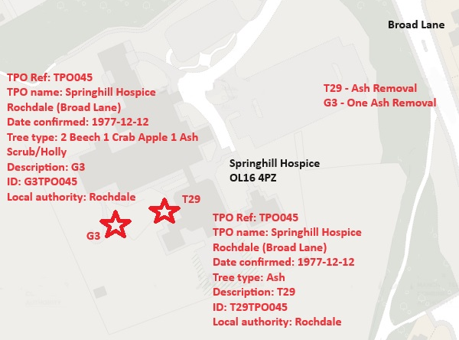
Work done

Site visit, arboricultural inspection, photography and report.

Trees in question

T29 Ash
G3 One Ash

Problem

- The trees are causing excessive twig/branch dropping into the gardens.
- The tree is now showing signs of the Ash die back disease and the hospice want to make the site safe for their staff, patients and visitors.
- The residents, staff and visitors are suffering anxiety over fears the tree will completely fail or a larger limb would snap off.

Recommendation

I strongly recommend the removal of T29 (Ash) and one Ash situated within G3 due to succumbing to the Ash die back disease. Unfortunately, there is no known cure for the disease and the trees health will begin to diminish more in the future. There is no vehicle or mewp access to this tree and currently the tree in question is still safe to climb and dismantle minimising damage to property, larger expenses to remove in the future and risk of arborists climbing to dismantle.
Michelle also agrees to replant four new trees if permission is granted for the removals.

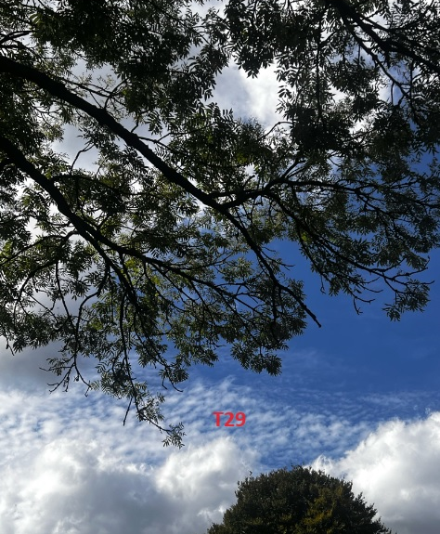

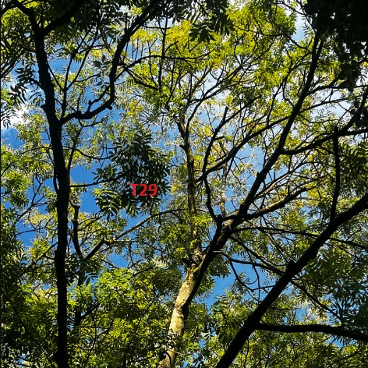

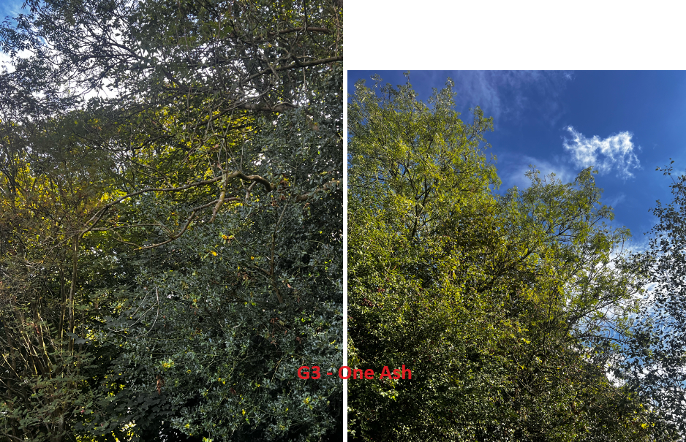

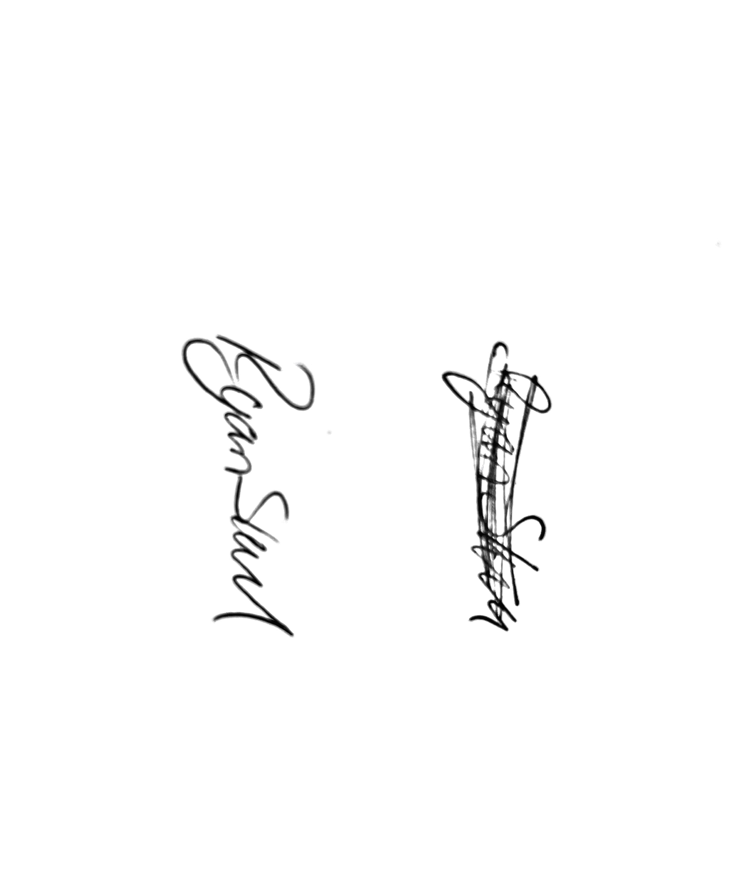
Kind regards,

Mr. Ryan Slack
General Manager and Director
SEG Award, Cert Arb L2 (ABC)

