Edgar Wood Trough Monument Restoration and Re-location
Design and Access Statement, Method Statement and Programme

The purpose of this statement is to detail the proposal to restore and move the monument from its current vulnerable location directly next to a busy main road to a position diagonally across the road where the monument will be set back and framed with railings. This will make it more of a feature of the monument for the village of Birch and be a safer location.
Edgar Wood Trough Monument
The monument is constructed of Ashlar gritstone, the monument is comprised of a depressed arch rising from gabled buttresses with a central square pillar supporting the arch at its centre and rising above the arch, flanking the main central pillar are stone gablets covering the arch and the pillar cap. A family crest also adorns the central pillar, this is now losing its definition as it is suffering from severe weathering. The monument was designated a grade 2 listing in 2001 by Historic England, but as it stands today, it can only be considered to be in a satisfactory condition considering its listing, it is also now out of plumb and has a slight lean. Consideration should be given to applying a chemical treatment water proofer to the structure, to protect it from further weathering and freeze/thaw action during the winter months.
The Proposal
The proposal is twofold, the first part is to carefully dismantle and catalogue each stone of the trough, then move it from its current position which is next to The White Hart Pub and the pedestrian crossing point. The reason this is to be done is that the trough has been damaged by a vehicle impact in the past and is now leaning. Due to the increase in the traffic on Heywood Old Road, the trough is now even more vulnerable. Therefore, dismantling the trough and relocating is the best solution for its future security. The trough will be moved to an area of land gifted by Gary Louden, a local Birch resident. This location is directly diagonal from where the trough was currently located near The White Hart Pub, on the corner of Langley Lane and Heywood Old Road. This area will provide a permanent position for the trough and is set back from the road, so it is less vulnerable to passing traffic. Is still central in Birch village for the residents to enjoy? When the trough is rebuilt any significant defects will be rectified, so once in its new position the trough will be in a restored condition. Around the area of gifted land heritage styled railings will be erected to make a feature of the trough.

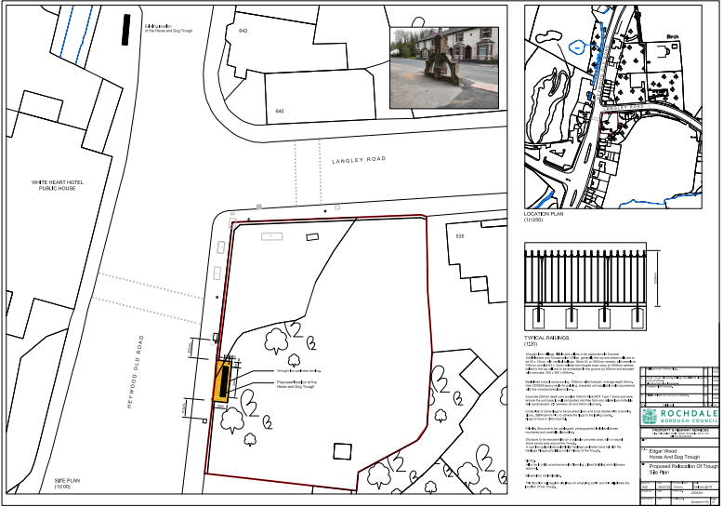
Proposal

Site Access and Egress
Access to the site will be directly from the junction of Langley lane and Heywood Old Road. It is a private grassed plot that has been gifted to us by a local resident, Gary Louden. The works in the area will be to reinstate the trough in its new position on new concrete raft foundation at a depth to ensure ground of adequate bearing strength. Stone sets will be laid to create an attractive paved area around the trough, so that the public can view and walk around the monument. The railings to the rear and sides of the trough will further protect it, and create a setting without restricting the view.
Parking
The site is accessible on foot, but there is no direct parking on the site. However, there is a public house directly across the road called the White Hart. Parking will be made available on site for the contractor during the works. There is parking bays on Heywood Old Road, although priority to use these will be given to the local residents.

Method Statement
Produced with the assistance of conservation contractors, Heritage Roofing & Maintenance
1/ Provide welfare facilities to comply with the CDM Regulations 2015 on the land owned by
Gary Louden on the corner of Langley Lane and Heywood Old Road.
2/ Secure the area around the new site for the Horse Trough with herras fencing.
3/ Excavate down to good ground, compact the sub-base and lay a 200mm thick C35 concrete raft foundation incorporating two layers of A142 steel mesh, one at the top and one at the bottom of the slab. Exact depth to be agreed on site.
4/ Secure the area around the Horse Trough monument with herras fencing and obtain a road/ pavement closure as necessary.
5/ Take a detailed photographic record of the Horse Trough and catalogue / identify each stone.
6/ Saw cut horizontal bed joints as necessary to allow the Horse Trough to be dis-assembled.
Note: It is thought that when the Horse Trough was moved the first time it was re-built using cementitious mortar, so will not easily be dis-assembled.
7/ Lift and move the stones using a small flat-back wagon with a HIAB crane. This will require a partial road closure and temporary traffic controls. Alternatively, it may be possible to utilise the car park of the White Hart.
8/ Make good the pavement to match the existing and to the approval of the LA Highways
Dept.
9/ The stones will stored securely in a steel shipping container located on the land adjacent to the new site, ready for re-assembling. No stones will be left un-secured overnight or over weekends.
10/ The Horse Trough will be re-assembled using hot lime mortar. The colour is to match the colour of the existing stone and to be agreed with the local conservation officer. The stone is currently discoloured due to having been under trees and will be Doff cleaned if the budget*allows.
The existing metal tie bars are corroded and are to be replaced with matching stainless steel bars.
Allow for covering and protecting the stonework from bad weather, rain and frost as it is rebuilt.
11/ Stone repairs will be carried where necessary to match the existing and provided budget* allows.
12/ Following re-construction stone setts (colour and finish to be approved by the conservation officer will be laid around the Horse Trough, as per the drawing.
13/ Erect 1.2m high heritage style wrought iron railings around the new location of the Horse Trough, as per the drawing.

*The budget for this project is limited and the primary objective is to move the stone Horse
Trough to a more secure location to reduce the risk of vehicle impact. Repairs and other improvements such as cleaning will be undertaken if budget constraints allow.
Anticipated Programme
Overall Contract Period 8 weeks
Site set up 2 days
New site preparation and foundation 1 week
Dismantle the Horse Trough 3 days
Move the Horse Trough Included above
Re-assemble the Horse Trough 3 – 4 weeks
Make good the pavement Included above
Lay stone sett surround 1 week
Erect 1.2m high railings 3 days
Clear site 2 days

pp Rochdale Council
Mark C Platt BSc MRICS

