Executive Summary:
In October 2022 Big Help Project (www.bighelpproject.com) (BHP) met with Rochdale Borough Council (RBC) to discuss mutually beneficial opportunities to provide sustainable homes for local people in the District of Rochdale.
One of the projects which captured the imagination of all stakeholders was the potential to build circa 30 new 100% affordable homes in Borrowdale, Langley as a community led housing scheme.
As a result of the above RBC facilitated a meeting between BHP and the Langley Community Benefit Society (LCBS) in which we collectively agreed to move forward with plans to create a company called Big Help Langley Developments CIC (BHLD) to achieve planning consent, deliver the construction project and then rent out affordable homes to local people from Langley in perpetuity at no greater than the Local Housing Allowance (LHA), which is the maximum rental sum that housing benefit is able to cover.
In January 2023 BHLD had its first board meeting (comprising 9x members- 4x from BHP, 1x from RBC and 4x from LCBS) and since then the group has made substantial progress which has culminated with the submission of the planning application for 30 new affordable homes for local people.
Scheme:
The Borrowdale scheme comprises 30 homes all for affordable rent in perpetuity for local people and a summary of the house types and the intended purpose are as follows:
House Type | Size (Sq M) Per Unit | Number | Intended Purpose
2 bed 4 person house | 79.6 | 4 | Local families with children
3 bed 5 person house | 93.4 | 2 | Local families with children
4 bed 5 person house | 97.8 | 2 | Local larger families with children
1 bed 2 person apartment block A | 51 | 12 | Couple or single downsizer or first home
1 bed 2 person cottage style  apartment block B GF | 50 | 2 | Couple or single downsizer or first home
1 bed 2 person cottage style  apartment block B 1F | 54 | 2 | Couple or single downsizer or first home
1 bed 2 person apartment block C | 50 | 6 | Over 55's single or couple
Totals |  | 30
The plan for our scheme is below:
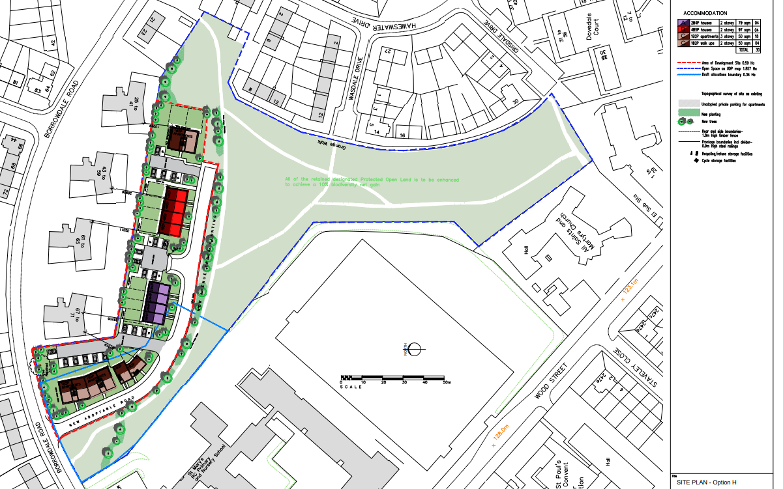
In addition to providing homes for local people the following wider aims and objectives will be achieve:
- We will undertake a fabric first approach to the construction ensuring that heat loss is minimal
- We have included the use of renewable technologies in the homes which alongside the thermal efficiency of the construction will keep the running costs of the homes at a sustainable level
- We will ensure that the appointment of the main construction contractor partner will promote the principles of social value around locally sourced subcontract labour and materials to reduced the embodied energy of the scheme
- We will promote the appointment of local people in the delivery of apprenticeships, trade provision and materials
- We have already done extensive consultation activities (included within this planning submission) with the local community. This has helped us to identify more than 30 Langley based volunteers committed to improving the vibrancy, biodiversity and accessibility of the surrounding parkland. Therefore, BHLD has already submitted grant applications to enhance the open space that surrounds this proposed development to improve the health and wellbeing of its users and grow the footfall of the persons using the open space
- Enhanced biodiversity and useability of the amenity with provision of a community orchards, flower meadows, rewilding areas and infrastructure (including solar lights, bins and community seating)
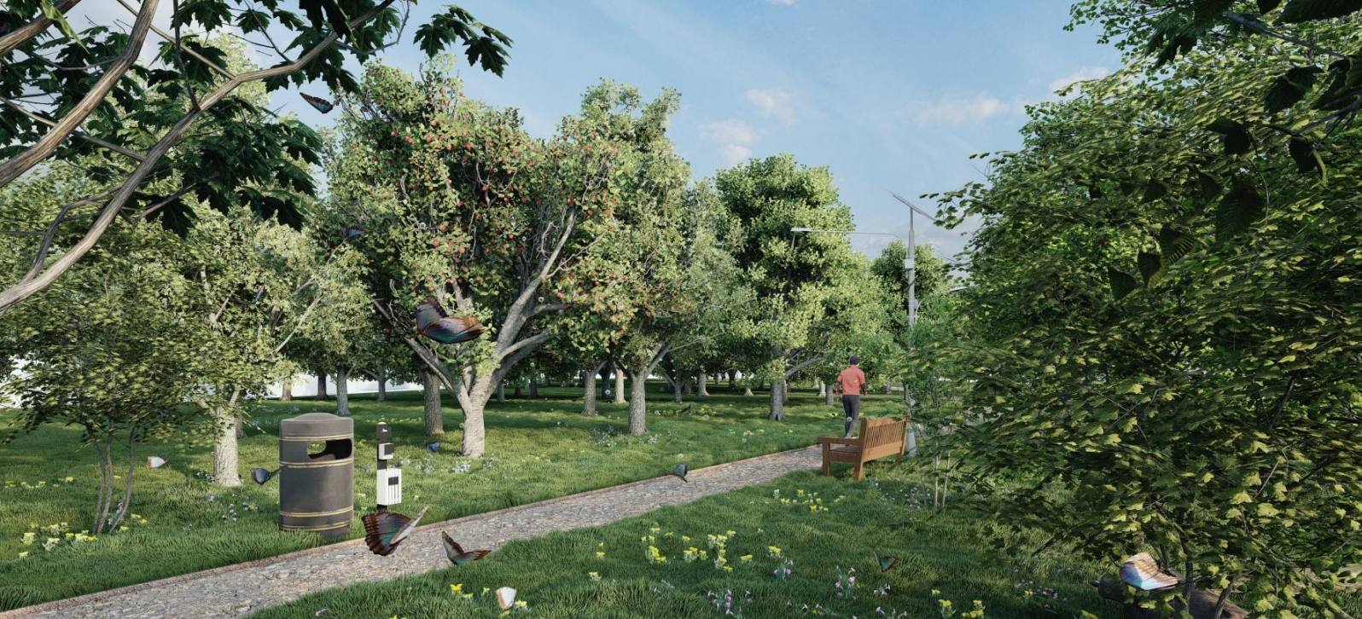
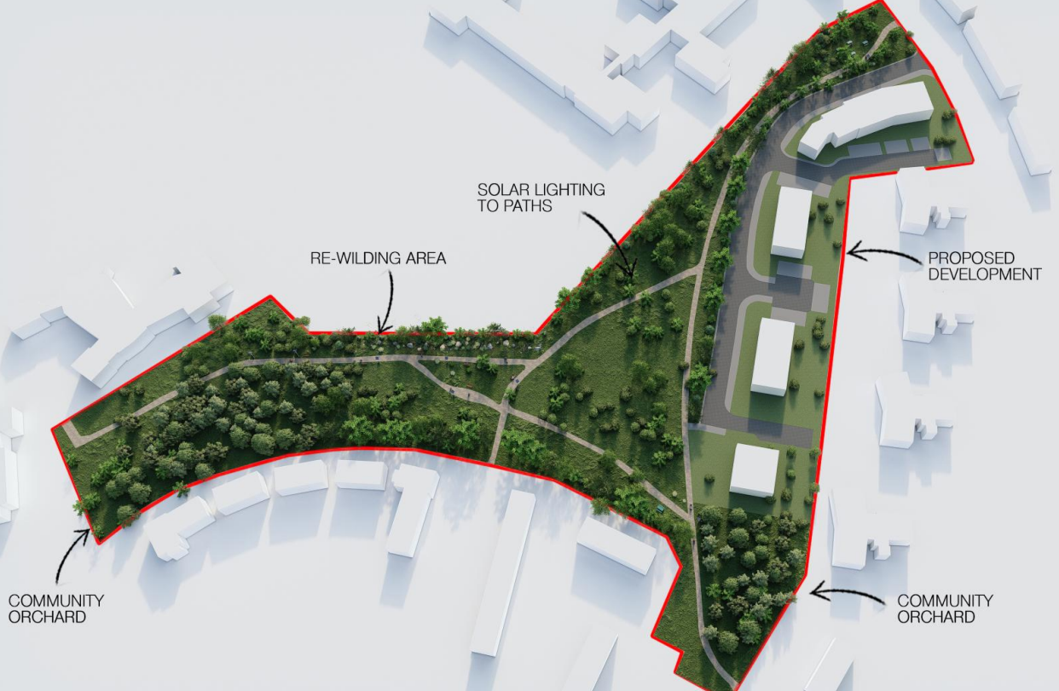
Financial Model:
The financial model has been constructed using a £2,250 per square meter build price which is the current level we are seeing in Greater Manchester. However, to protect against further build cost inflation we have inserted a contingency of 7.5%, which we believe will be needed in the next 24-30-month period, which is the likely timeline between now and practical completion/ handover to local people.
 |  |  |  | 80%
House Type | Size (Sq M) | Number | LHA Gross Rent  Per Annum | LHA: Net Rent Per Annum | Total Sq M
2 bed 4 person house | 79.6 | 4 | £31,114.72 | £24,891.78 | 318.4
3 bed 5 person house | 93.4 | 2 | £17,352.40 | £13,881.92 | 186.8
4 bed 5 person house | 97.8 | 2 | £22,737.52 | £18,190.02 | 195.6
1 bed 2 person apartment block A | 51 | 12 | £86,161.92 | £68,929.54 | 612
1 bed 2 person cottage style  apartment block B GF | 50 | 2 | £14,360.32 | £11,488.26 | 100
1 bed 2 person cottage style  apartment block B 1F | 54 | 2 | £14,360.32 | £11,488.26 | 108
1 bed 2 person apartment block C | 50 | 6 | £43,080.96 | £34,464.77 | 300
Totals |  | 30 | £229,168.16 | £183,334.53 | 1820.8
Build Cost @ £2250.00 Per Sq M | £ 4,096,800.00
Land | £ 1.00
Contingency of 7.5% of Build Cost | £ 307,260.00
Finance @ 7.5% of Build Cost | £ 307,260.00
Total | £ 4,711,321.00

We have also applied a cost of finance of 7.5% of the build cost. Plus we have assumed that any land transfer would be undertaken at £1 (subject to final approval was provided by the Rochdale Council officers and elected members).
The core aim of this community led housing scheme is to provide homes for local people at affordable levels directly linked to LHA to ensure that we can help to maintain a sustainable community.
Consequently LCBS will lead on letting of the units using the RBC Allocations Policy as the baseline from which to deliver this objective. Therefore, as part of this community led strategy we have undertaken a 20% reduction to the gross LHA rent to ensure that each year we have enough money to pay for property maintenance, compliance and the administration of the letting activities led by LCBS.
Conclusions:
BHLD and its constituent members are fiercely committed to delivering this community led housing scheme in Langley. No greater commitment is shown from the following entities:
- BHP intend to use its covenant strength to support the borrowing required to undertake the development of the site despite return on capital of 3.89%, which doesn’t even cover holding costs. Note: This is without any support from Homes England
- Subject to cabinet approval RBC are considering the prospect of putting the land into this community led housing scheme for the sum of £1
- The LCBS have already dedicated over 5 years of their time to the project and it is only since October 2022 that the required traction has been achieved to convert this concept into potential reality (subject to planning approval)
Given all of the information above including the cost of construction, financing and the low levels of income to support the repayment of the collective outlay we would like the Council to undertake the following:
- To support the BHLD schemes aims and objectives to provide a 100% affordable housing scheme for local people at no greater than the LHA
- To support the commitment of the stakeholders to deliver this community led housing scheme without adding additional S106 costs that could render the project unviable

