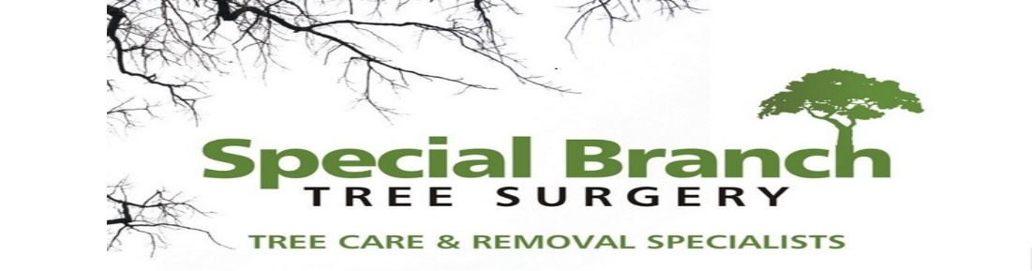

Top O’th Meadow Farm
Meadowhead Lane
Norden, Rochdale
OL11 5UL
Tel: 01706 658771

9th October 2024

Julie Willman
Holly Bank
Bradocks Close
Rochdale
OL12 9QU

As requested, please see the completed tree report, as discussed this offers no guarantees as trees are living organisms and can fail at any time. We would also like to advise that no indemnity or insurance cover is offered. This report is in “my opinion” only and covers only the trees that have been inspected.

Trees in question are subject to a Tree preservation order – TPO006

Local authority: Rochdale

Location
Holly Bank.

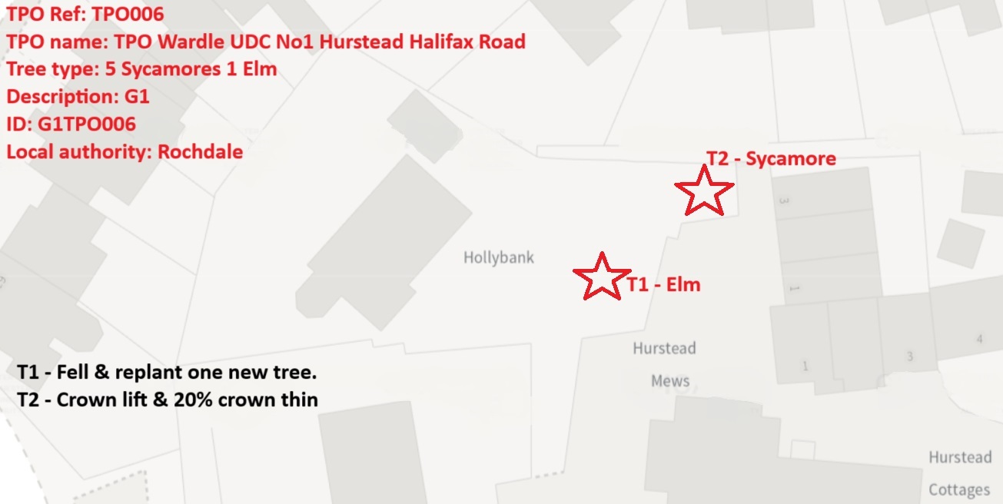

Work provided

Site visit, arboricultural inspection, photography, report, and quotation.
All trees have been thoroughly inspected and only the tree with any defects or concerns have been noted.

Trees included

T1 – Elm
T2 - Sycamore

Issues found

T1 – Upper crown evidently in decline (suspect Dutch Elm disease due to the height of the tree) T1 also has a large basal cavity/ root rot which will be subsequently lead to full tree failure.
T2 – Mature Sycamore within close proximity of neighbouring property. Reactive epicormic growth growing from the stem below the main canopy. The canopy is also very dense.

Recommendations

T1 – Elm, remove. Replant one new tree.
T2 – Sycamore. Removal of the low reactive growth, crown thin up to 20%

The presence of Dutch Elm disease (DED) in a tree, particularly combined with additional issues such as stem decay, raises significant concerns not only for the health of the tree itself, but also for the safety of its surroundings. In this case, the T1 Elm tree displaying suspected DED and stem decay at the base presents a clear and present danger that necessitates immediate attention. This article will delve into the reasons why it is imperative to remove this tree promptly to mitigate the risks it poses.
Key Points:
1. Dutch Elm Disease:
- Dutch Elm disease is a lethal fungal disease that affects Elm trees, causing wilting, yellowing of leaves, and ultimately tree death.
- The disease is highly contagious and can spread rapidly through root grafts and elm bark beetles, leading to the decimation of entire Elm tree populations.
- Infected trees cannot be effectively treated, and removing them is crucial to prevent the further spread of the disease to neighbouring trees.
2. Stem Decay and Stability Concerns:
- Stem decay at the base of the tree compromises its structural integrity, increasing the likelihood of limb breakage or complete tree failure.
- Trees with decay are prone to toppling, especially during storms or high winds, posing a significant risk to nearby structures, vehicles, and individuals.
- The combination of Dutch Elm disease and stem decay further weakens the tree, making it a ticking time bomb in terms of safety hazards.
3. Environmental Impact:
- Although removing a mature tree is never a decision taken lightly, in the case of a tree with suspected DED and stem decay, the potential environmental impact of not taking action outweighs the loss of the tree.
- Infected trees serve as a reservoir for the disease, endangering other Elm trees in the vicinity and perpetuating the cycle of infection.
- By removing the compromised tree promptly, the spread of Dutch Elm disease can be contained, protecting the health of the remaining Elm trees in the area.
Conclusion:
In conclusion, the presence of Dutch Elm disease coupled with stem decay at the base of the T1 Elm tree presents a clear and imminent danger that cannot be ignored. The risks to both the tree itself and its surroundings are too significant to delay removal. By taking proactive measures to remove the infected tree, we can prevent the spread of Dutch Elm disease, mitigate safety hazards, and safeguard the health of the surrounding tree population. It is imperative to prioritise the removal of the T1 Elm tree to protect both the environment and the community from potential harm.

Crown lifting and crown thinning are essential tree management practices that help maintain the health, safety, and appearance of trees, particularly T2 Sycamore. Crown lifting involves removing lower branches to provide clearance for structures, pedestrians, and vehicles. This reduces the risk of accidents and property damage caused by overhanging branches. Additionally, crown lifting allows more light to penetrate through the canopy, promoting healthy growth of grass and other vegetation under the tree.
Crown thinning, on the other hand, involves selectively removing branches within the canopy to reduce density. This helps improve air circulation and sunlight penetration, reducing the risk of disease and promoting overall tree health. By removing weak, diseased, or crossing branches, crown thinning also enhances the tree's structural integrity and reduces the risk of branch failure during storms or strong winds.
When it comes to T2 Sycamore, crown lifting and thinning up to 20% of the canopy can provide numerous benefits. Sycamores are known for their dense canopies and fast growth rate, which can lead to issues such as limited light penetration, poor air circulation, and increased susceptibility to diseases like anthracnose. By selectively lifting and thinning the crown, you can address these issues and improve the overall health and vigour of the tree.
It is important to note that these operations should be carried out by trained professionals to ensure that the tree's natural form and structure are preserved. Improper pruning techniques can result in stress, decay, and long-term damage to the tree. By adhering to best practices and limiting the amount of crown removed to 20%, you can achieve a balanced and aesthetically pleasing result while promoting the long-term health and sustainability of T2 Sycamore.
In conclusion, crown lifting and thinning are fundamental tree management practices that are particularly beneficial for T2. By implementing these techniques with care and precision, you can improve the tree's health, safety, and appearance, ensuring its longevity and vitality for years to come

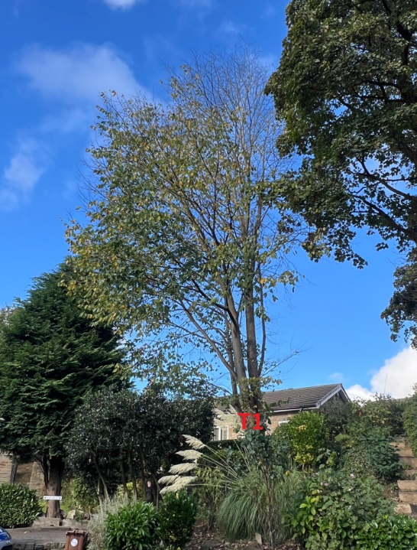
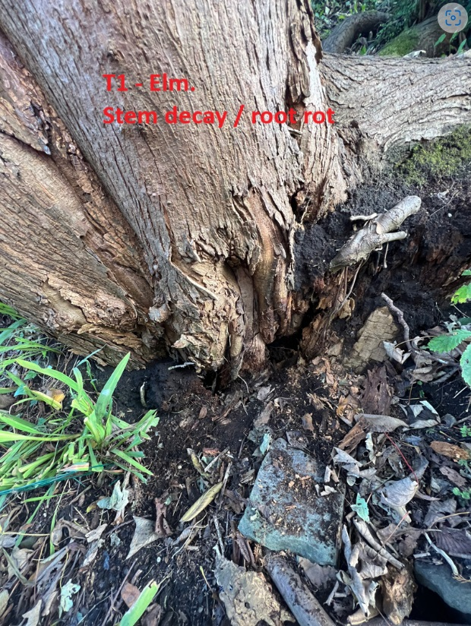

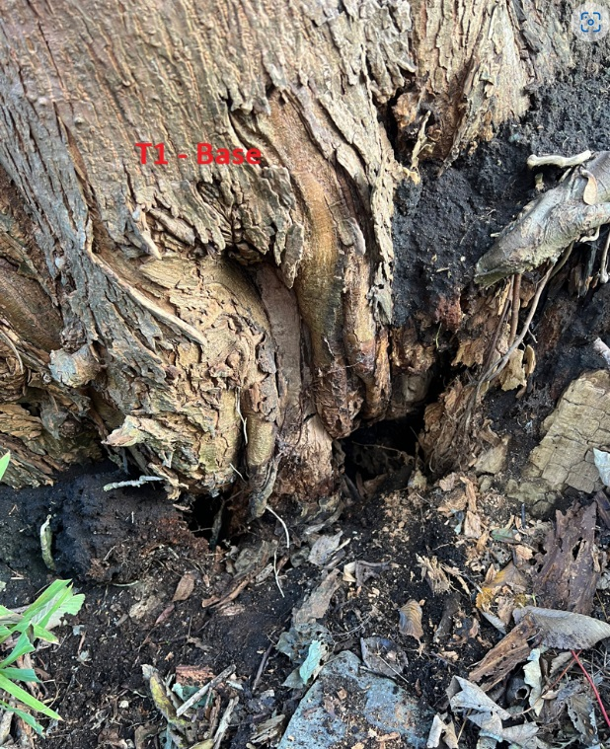
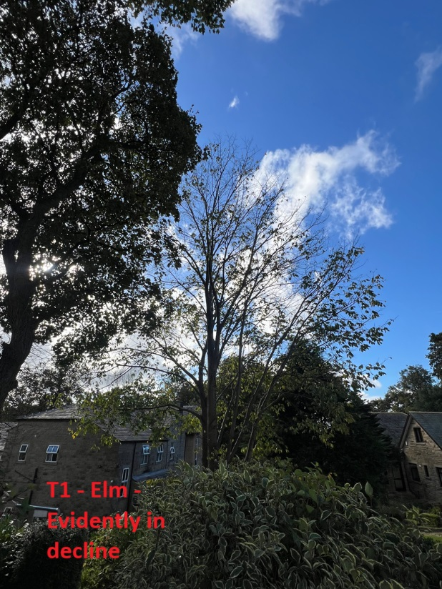

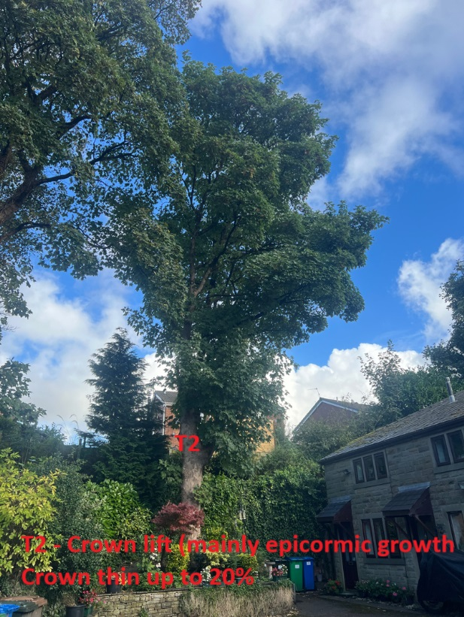

Tree planting and aftercare
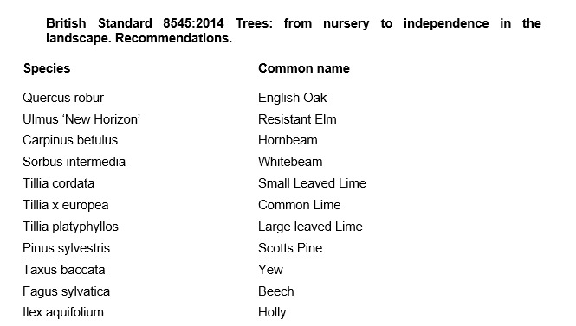

Aftercare

To ensure success when planting trees, providing good aftercare is as important as good planting practice. The first two to three years after planting are critical for a tree’s establishment. Planted well and cared for correctly, it should flourish and become a valuable feature in your garden. It is an investment of time and money, and it would be a shame to lose the benefit of a fine tree through post-planting neglect. The first challenge is moving the plant from the nursery to its new home: this can cause stress to any tree. Give it attention for the first few years to ensure re-establishment and survival in its new location. Watering, weeding, staking, mulching and formative pruning are important for successful establishment, but none are onerous or time consuming. Tree aftercare the guidelines on these pages apply primarily to ornamental trees: fruit trees are established in the same way, but pruned and managed differently to maximise fruit production. Newly planted trees ideally need regular watering in dry spells for three to five years to ensure good root growth. After planting a tree, pruning may be necessary to enhance the natural shape or improve its structure and strength. In the first few years, identify and correct problems with the main framework of the tree – prune early, as this helps avoid future complications. With a young tree, one of the most common tasks is to remove lower branches that begin to interfere with other gardening activities, create shade or block views. Look out, too, for pests such as aphids and diseases such as canker – they can reduce the vigour of your tree and make establishment slower. If you keep your tree vigorous and healthy, it is less likely to succumb to pests and disease

For the first two to three years, irrigate newly planted trees weekly during dry spells in spring and summer. Too much water, and roots will not extend in the search for moisture – but underirrigation results in slow establishment and symptoms of stress, such as canopy dieback and bark splits on the trunk. Water directly at the base of the tree and, particularly if the ground is dry, apply slowly to stop it running off. Make sure water has penetrated the soil; on our well-drained soil, we apply two to three full watering cans of water per week to new plantings.

From initial planting, mulch annually in spring or autumn to suppress weedy competitors and help retain soil moisture. ✤ Organic or inorganic materials can be used; composted wood chippings, leaf mould and well-rotted manure. ✤ Organic materials should be part composted: six-month-old wood chip is ideal. ✤ Mulch should be 7–10cm (3–4in) deep; avoid piling it round the trunk as this can soften the bark.

New trees should be staked until their roots provide good anchorage – this can take several years. If loose, the tree will rock in the wind and its root ball will move, which hinders plant establishment and could even result in death. ✤ Check ties are secure and a padded cushion is between the tree and stake. Rubbing against a stake can create a scar, which leaves the tree open to disease. ✤ Check regularly: ties left too tight cause serious bark damage. Fast-growing trees may need ties loosening every year.

Formative pruning trees
Formative pruning is the process of shaping a tree when it is young. Every variety has a different natural growth habit, but unpruned trees will for the most part produce a crown cluttered with branches. The aim is to develop an open, balanced network of strong, unshaded branches and at a height that allows for good management such as grazing livestock and machinery. This is achieved by creating a good height trunk and pruning young growth back to encourage the tree to grow in the right direction and develop thick branches.

Kind regards,
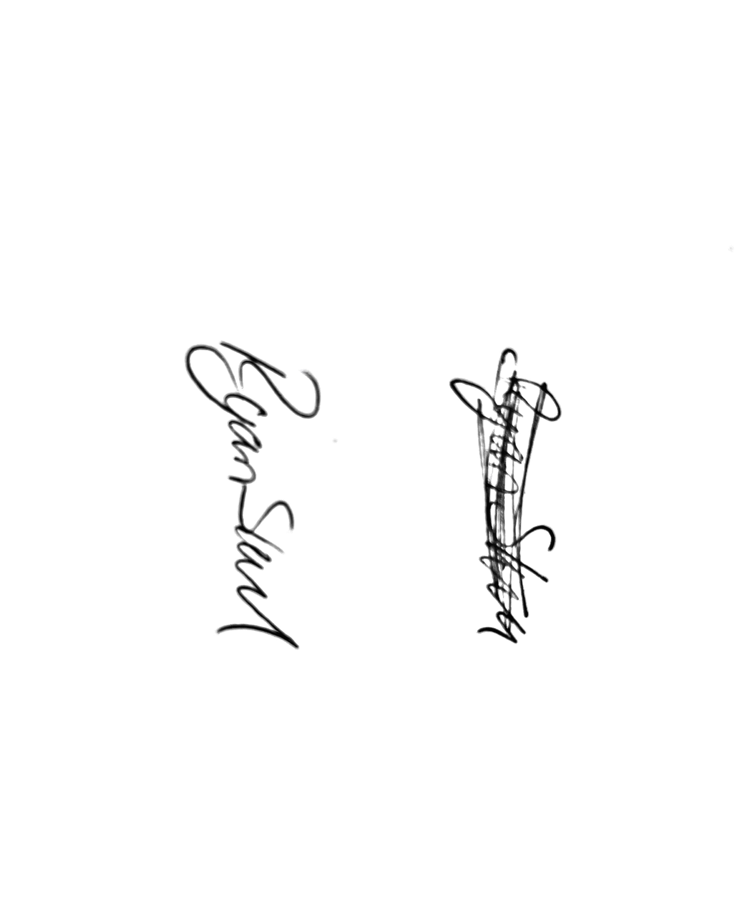
Mr. Ryan Slack
General Manager and Director
SEG Award, Cert Arb L2 (ABC)

