

Top O’th Meadow Farm
Meadowhead Lane
Norden, Rochdale
OL11 5UL
Tel: 01706 658771

16th April 2024

John Threlfall
Lower Green Cottage
453 Edenfield Road
Norden, Rochdale
OL11 5YR

As requested, please see the completed tree report, as discussed this offers no guarantees as trees are living organisms and can fail at any time. We would also like to advise that no indemnity or insurance cover is offered. This report is in “my opinion” only and covers only the trees that have been inspected.

Trees in question are subject to a Tree preservation order – TPO157

Local authority: Rochdale

Location
Lower Green Cottage, 453 Edenfield Road.

TPO Ref: TPO157
TPO name: Palatine Road/Palatine Avenue, Norden
Tree type: Sycamore
Description: T6
ID: T6TPO157
Local authority: Rochdale

Work provided

Site visit, arboricultural inspection, photography, report, and quotation.
All trees have been thoroughly inspected and only the tree with any defects or concerns have been noted.

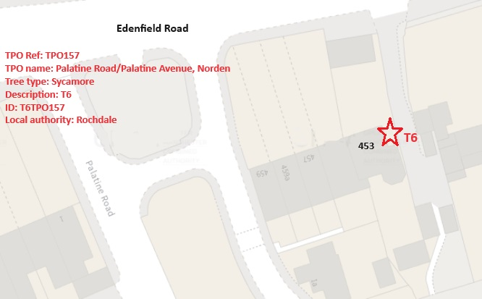
Trees included
T6 – Sycamore

Issues found

Mature Sycamore tree located within close proximity to the property, currently poses a high risk to the property and surroundings. T6 has two significant cavities located at 2.5 meters and 3 meters high on the stem, both cavities have a build-up of moisture and stem decay. A metal rod was used to measure the depth of each cavity (number one measured at a depth of 47cm and cavity number two measured at a depth of 64cm)

Recommendations

T6 – Sycamore - Remove

- Reasons to Remove a Poor Specimen Tree

- There are several reasons why it may be necessary to remove a poor specimen tree from a property. These reasons can range from the tree posing a safety hazard to it being diseased or damaged beyond repair. Here are some of the most common reasons for removing a poor specimen tree:

- Safety Concerns: One of the primary reasons for removing a poor specimen tree is when it poses a safety risk. This can occur if the tree is leaning precariously, has large dead branches, or shows signs of decay. Such trees can pose a danger to people and property, especially during storms or high winds. In such cases, it is crucial to remove the tree to prevent potential accidents and damage.
- Structural Issues: Poorly developed root systems, weak trunk structures, or other structural issues can make a tree unstable and prone to failure. In such cases, the tree may need to be removed to avoid potential hazards.
- Aesthetic Considerations: In some cases, a poor specimen tree may detract from the overall aesthetic appeal of a landscape due to its unattractive appearance or poor form. Removing such a tree can enhance the visual appeal of the surroundings.
- Tree root compaction issues can arise when the soil surrounding a tree's roots becomes densely packed or compressed. This compression limits the root's ability to absorb nutrients, water, and oxygen, leading to stunted growth or even the decline of the tree's health. It's crucial to avoid heavy machinery or excessive foot traffic around trees to prevent root compaction. Implementing techniques like mulching, aeration, or creating protective barriers can help alleviate this problem and support the tree's health.

The presence of two open cavities showing rotten wood and stem decay in a Sycamore tree (T6) poses a significant risk of branch failure or tree collapse, which could potentially cause property damage or injury to pedestrians using the footpath nearby

It is imperative that the Sycamore tree (T6) be promptly removed due to the presence of two cavities within the trunk at a height of approximately 2.5-3 meters, both of which are rotten. The proximity of the tree to a property and a well-used public footpath poses a significant safety risk and necessitates immediate action. The decay within the trunk compromises the structural integrity of the tree, making it susceptible to failure, particularly in adverse weather conditions. Falling branches or the entire tree itself could cause serious harm to individuals or property in the vicinity.
Additionally, the decay and presence of cavities provide an ideal habitat for pests and pathogens, which could further weaken the tree and potentially spread to surrounding vegetation. Removing the compromised Sycamore tree is not only a matter of safety but also crucial for the overall health of the ecosystem in the area.
Considering the potential hazards posed by the tree's deteriorating condition and its close proximity to human activity, it is recommended that swift action be taken to cut down the tree to mitigate any risks of harm or damage. Safety should be the top priority in such situations to ensure the well-being of all individuals and properties in the vicinity.

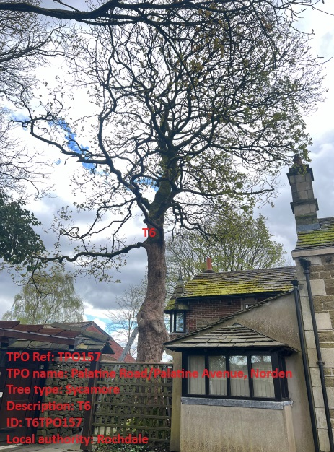
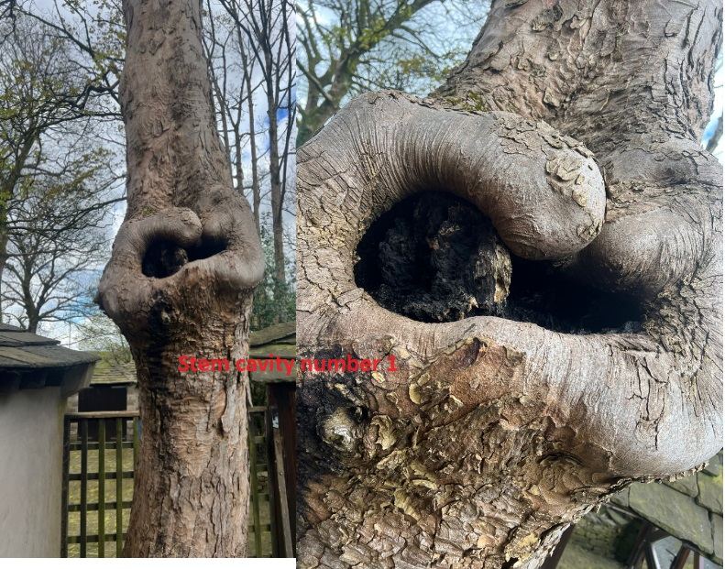
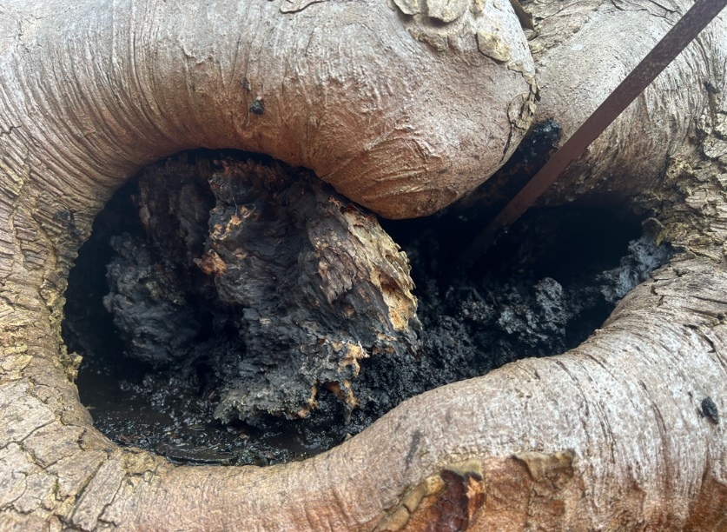
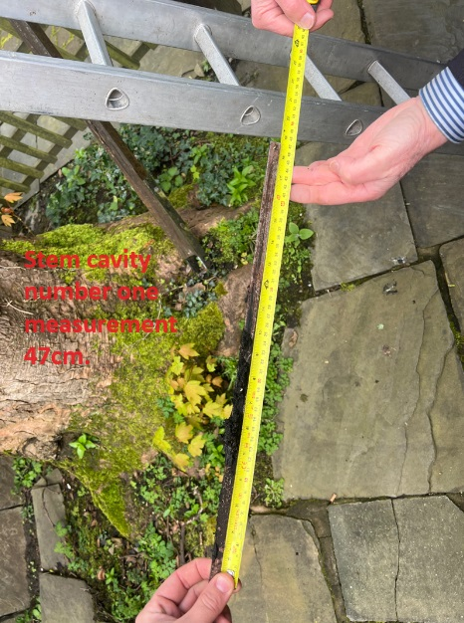
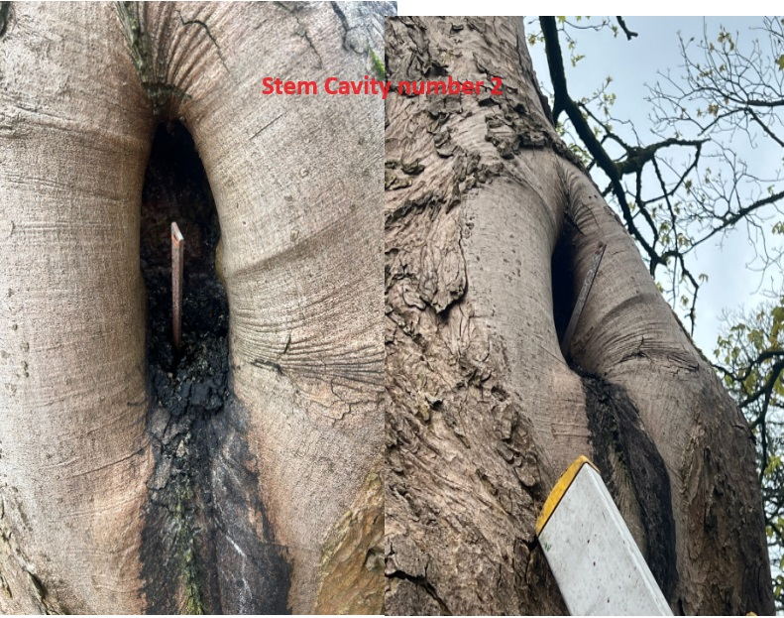
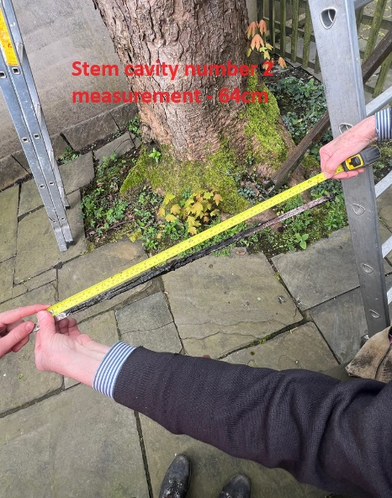

If permission is granted for the removal the property owner is willing to plant two new trees in his garden.
The property owner will choose from the list of which tree’s he will plant to replace the Sycamore removal from the list below.

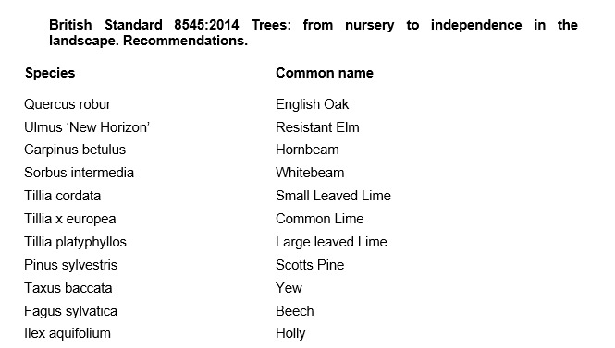

Aftercare

To ensure success when planting trees, providing good aftercare is as important as good planting practice. The first two to three years after planting are critical for a tree’s establishment. Planted well and cared for correctly, it should flourish and become a valuable feature in your garden. It is an investment of time and money, and it would be a shame to lose the benefit of a fine tree through post-planting neglect. The first challenge is moving the plant from the nursery to its new home: this can cause stress to any tree. Give it attention for the first few years to ensure re-establishment and survival in its new location. Watering, weeding, staking, mulching and formative pruning are important for successful establishment, but none are onerous or time consuming. Tree aftercare the guidelines on these pages apply primarily to ornamental trees: fruit trees are established in the same way, but pruned and managed differently to maximise fruit production. Newly planted trees ideally need regular watering in dry spells for three to five years to ensure good root growth. After planting a tree, pruning may be necessary to enhance the natural shape or improve its structure and strength. In the first few years, identify and correct problems with the main framework of the tree – prune early, as this helps avoid future complications. With a young tree, one of the most common tasks is to remove lower branches that begin to interfere with other gardening activities, create shade or block views. Look out, too, for pests such as aphids and diseases such as canker – they can reduce the vigour of your tree and make establishment slower. If you keep your tree vigorous and healthy, it is less likely to succumb to pests and disease

For the first two to three years, irrigate newly planted trees weekly during dry spells in spring and summer. Too much water, and roots will not extend in the search for moisture – but underirrigation results in slow establishment and symptoms of stress, such as canopy dieback and bark splits on the trunk. Water directly at the base of the tree and, particularly if the ground is dry, apply slowly to stop it running off. Make sure water has penetrated the soil; on our well-drained soil, we apply two to three full watering cans of water per week to new plantings.

From initial planting, mulch annually in spring or autumn to suppress weedy competitors and help retain soil moisture. ✤ Organic or inorganic materials can be used; composted wood chippings, leaf mould and well-rotted manure. ✤ Organic materials should be part composted: six-month-old wood chip is ideal. ✤ Mulch should be 7–10cm (3–4in) deep; avoid piling it round the trunk as this can soften the bark.

New trees should be staked until their roots provide good anchorage – this can take several years. If loose, the tree will rock in the wind and its root ball will move, which hinders plant establishment and could even result in death. ✤ Check ties are secure and a padded cushion is between the tree and stake. Rubbing against a stake can create a scar, which leaves the tree open to disease. ✤ Check regularly: ties left too tight cause serious bark damage. Fast-growing trees may need ties loosening every year.

Formative pruning trees
Formative pruning is the process of shaping a tree when it is young. Every variety has a different natural growth habit, but unpruned trees will for the most part produce a crown cluttered with branches. The aim is to develop an open, balanced network of strong, unshaded branches and at a height that allows for good management such as grazing livestock and machinery. This is achieved by creating a good height trunk and pruning young growth back to encourage the tree to grow in the right direction and develop thick branches.

Kind regards,
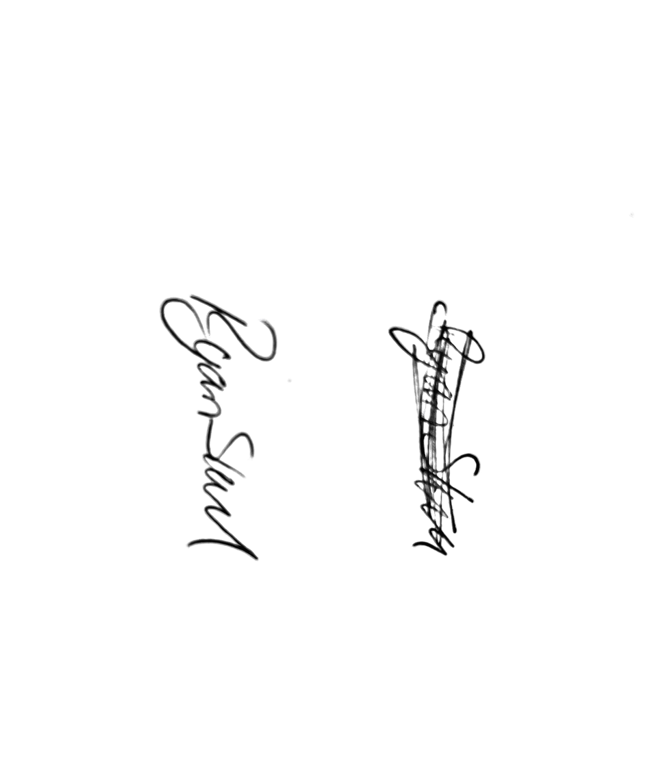
Mr. Ryan Slack
General Manager and Director
SEG Award, Cert Arb L2 (ABC)

