ARCHITECTS
SOLIDVOID

MATERIAL SCHEDULE

SITE ADDRESS 10 GREENMOUNT DRIVE, HEYWOOD, OL10 2LZ

CLIENT MS STEPHANIE MOSS

DATE DEC 2022

REVISION -

STAGE BUILDING REGULATIONS

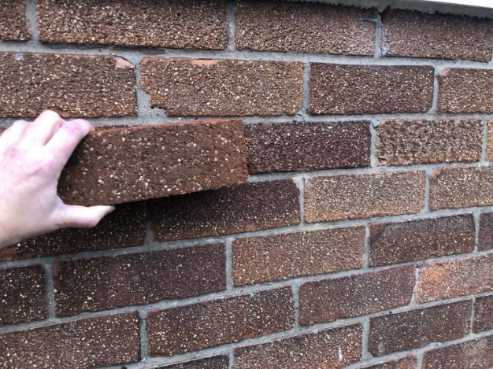
Main Facing Brick
Terca Weathered Sandblast

(Proposed brick being held against existing brick)

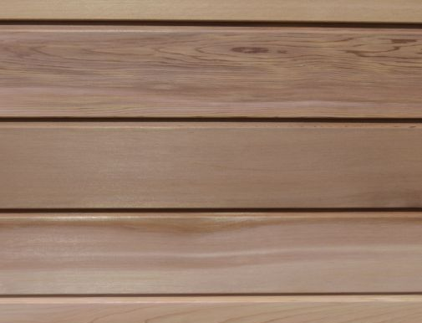
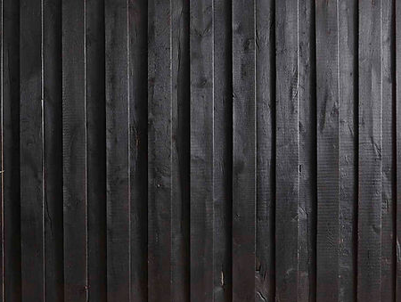
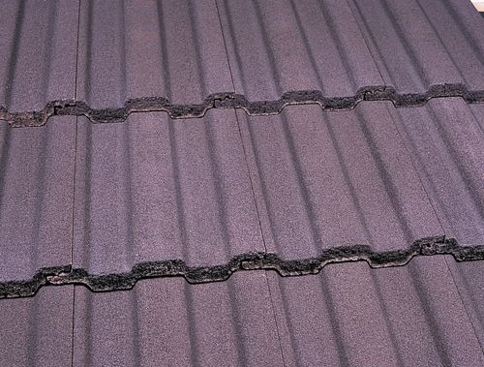

Shou Sugi Ban Timber Cladding

Cedar Timber Cladding

Marley Ludlow Major Interlocking Concrete Roof Tile
(Antique Briwn)

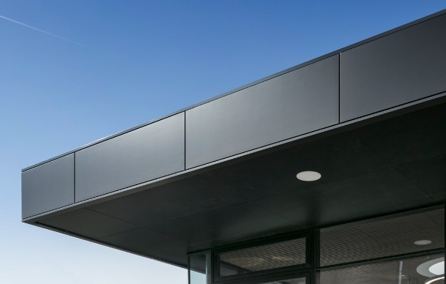

Aluminium Rainscreen Cladding
(Protues Anthracite Grey Pre-coated system)

