
Highways and Engineering Service - Economy and Environment

Drainage Consultation on Application – 24/01125/DOC - Mount Cottage Schwabe Street Middleton Rochdale M24 4TN
LLFA Consultation Response on behalf of Head of Highways and Engineering
Date of Response: 22nd April 2025
Location & Proposed Development
Mount Cottage Schwabe Street Middleton Rochdale M24 4TN
Submission of details to comply with conditions 3 (drainage), 7 (details of window and doors), 9 (scheme of biodiversity), 11 (earthwork clearance or demolition) and 12 (method statement) on planning permission 23/00603/FUL Demolition of existing dwelling and erection of replacement including the erection of a detached, single storey annexe.
Documents Reviewed
- Drainage Strategy Report XXXX-ADS-00-XX-RP-S-500 P1 Aug 2024
- Drainage Strategy Plan XXXX-ADS-00-XX-DR-C-500 P2 28/08/24
- Arboricultural Constraints Appraisal BTC27954 08/08/23
- UU Consultee Response DC/23/4181 11/12/23
- RBC LLFA Response 13/12/23
Drainage & Flood Officer Comments
- The proposals are to discharge attenuated surface water to a combined sewer. This is the bottom stage of the SuDS Hierarchy and is not acceptable in principle.
- Soils are identified as freely draining but infiltration has been discounted due to spatial constraints. However, the sketch below suggests there may be some availability. In addition, the assumption is based on the current layout. A reconfiguration may provide further opportunities.

- The strategy states that the nearest watercourse is approx 350m from the site. However, there is a watercourse approx 70m north of the site which has not been considered. It is noted that this would probably require 3rd party negotiation and a pumped solution but potentially this could still be more sustainable than discharge to a combined sewer.

- Green surface-based SuDS source control methods have been discounted due to spatial constraints. This should be reviewed similar to point 2 above.

- The drainage strategy is supported by hydraulic calculations, indicating that surface water runoff will be managed to a maximum of 4l/s and incorporates 45% climate change allowance. Whilst this would be acceptable in principle, it would need to be reviewed subject to a comprehensive assessment alternative discharge options.

- Foul water connection to public sewer is accepted, subject to approval from United Utilities.
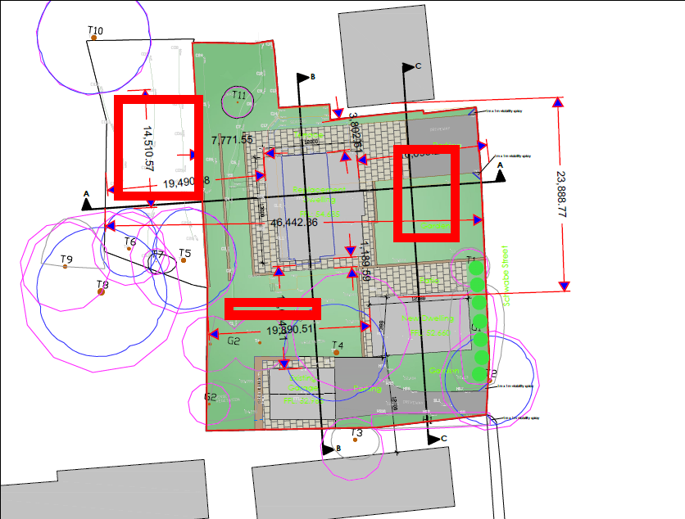
Drainage & Flood Officer Summary:
- The proposals to discharge surface water to an existing combined sewer are not acceptable.
- Infiltration or partial infiltration should be comprehensively investigated.
- If infiltration is found not to be feasible then discharge to the nearest watercourse should be investigated.
- The proposals are required to incorporate green surface-based SuDS source control.
- The above points should be addressed before the condition can be discharged.

Consultation by Keith Mealey
Drainage & Flooding Officer
keith.mealey@rochdale.gov.uk

