Residential Planning & noise ASSESSMENT

FOR

taylor wimpey strategic land

AT

Smithy bridge road, littleborough

N75330-1R2

5th September 2022

Prepared For | Prepared By
 | Thomas Jenkins  Ensafe Group  Unit 9  Orbital 24  Oldham Street  Denton  Manchester  M34 3SU
  Alex Crowther
  Taylor Wimpey Strategic Land
  Gate House
  Turnpike Road
  High Wycombe
  Buckinghamshire
  HP12 3NR

DISTRIBUTION LIST

Issued To | Title / Company / Location | Telephone No
Alex Crowther | Assistant Strategic Land Manager / Taylor Wimpey Strategic Lane / Sunderland | 07903 401650
Olivia Carr | Associate Director / Turley / Manchester | 0161 233 7676

QUALITY ASSURANCE

Issue / Revision | Issue 1 | Revision 1 | Revision 2
Remarks | First issue | Revised following layout update | Revised following layout update
Date | 31/03/2022 | 15/06/2022 | 05/09/2022
Prepared By | Thomas Jenkins | Thomas Jenkins | Ross Millington
Job Title | Graduate Acoustic Consultant | Graduate Acoustic Consultant | Senior Acoustic Consultant
Signature |  |  | 
Checked By | Jonathan Riley | Jonathan Riley | Jonathan Riley
Job Title | Senior Acoustics Consultant | Senior Acoustics Consultant | Operations Manager (Acoustics)
Signature | 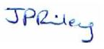
Authorised By | Steve Sheridan | Steve Sheridan | Jonathan Riley
Job Title | Acoustics Director | Acoustics Director | Operations Manager (Acoustics)
Signature | 
Project Number | N75330-1r0 | N75330-1r1 | N75330-1r2

EXECUTIVE SUMMARY 4
1.0 INTRODUCTION 5
1.1. Background 5
1.2. Site Location and Proposed Development 5
1.3. Limitations 5
1.4. Confidentiality 5
2.0 ASSESSMENT METHODOLOGY 6
2.1. National Planning Practice Guidance 6
2.2. British Standard 8233:2014 Guidance on Sound Insulation and Noise Reduction for Buildings 8
2.3. World Health Organisation’s (WHO) Guidelines for Community Noise 9
3.0 SURVEYS 10
3.1. Baseline Survey 10
4.0 RESIDENTIAL PLANNING & NOISE ASSESSMENT 11
4.1. Transport Noise 11
5.0 CONCLUSION 13
APPENDIX I – LIMITATIONS 14
APPENDIX II – GLOSSARY OF ACOUSTIC TERMINOLOGY 16
Appendix III – FIGURES 19
APpENDIX iV – bibliography 24

EXECUTIVE SUMMARY

Ensafe were commissioned by Taylor Wimpey Strategic Land to undertake a Residential Planning & Noise Assessment to support a planning application for a residential development at Smithy Bridge Road, Littleborough near Rochdale to the northeast of Manchester.

Noise Survey

Environmental noise surveys have been completed in order to establish how the noise environment varies across the site including an unattended noise logger installed on site to measure noise levels over several days including a weekend.

Residential Planning & Noise Assessment

The Residential Planning & Noise Assessment has been completed with due regard to the requirements of Rochdale Metropolitan Borough Council. A 3D CadnaA noise model has been constructed including all significant noise sources and with full topography. This has been used to predict the noise levels incident upon the facades of the proposed residential development due to road traffic and other minor noise sources around the site.

The assessment indicates that the assumed 30 dB R_{w} + C_{tr} attenuation of typical double-glazing configuration (6/12/6) will be sufficient to control sound ingress into dwellings, however some proposed dwellings along the northern border of the site will require passive ventilation as the assumed 15 dB R_{w} + C_{tr} attenuation provided by a partially open window would not be sufficient. The facades requiring alternative ventilation are identified in Figure 3 of Appendix III. Only two gardens are predicted to receive a noise level above the lower external amenity daytime criterion of 50 dB, stated within BS8233:2014, and these gardens do not exceed the upper criterion of 55dB.

- INTRODUCTION

- Background

Ensafe has been commissioned by Taylor Wimpey Strategic Land to provide a Residential Planning & Noise Assessment to support a planning application for a residential development at Smithy Bridge Road, Littleborough, to be referred to hereafter as “the site”.

- Site Location and Proposed Development

Smithy Bridge Road is located in Littleborough, Rochdale to the northeast of Manchester and is the site of a potential development proposed by Taylor Wimpey. The site is surrounded by residential areas to the north, east, and west of the site, while the south remains undeveloped. Key sources of noise include Smithy Bridge Road which runs along the eastern site boundary, and Halifax Road further to the north. The predominant source of noise noted on site during the attended surveys was road traffic noise from these carriageways.

This assessment has been undertaken with due regard to the supplied planning layout shown on the following planning drawing:

- P21-2628-003revQ – Proposed Site Layout (dated 31st August 2022)

- Limitations

Further limitations of this report are presented in Appendix I.

- Confidentiality

Ensafe has prepared this report solely for the use of the client and those parties with whom a warranty agreement has been executed, or with whom an assignment has been agreed. Should any third party wish to use or rely upon the contents of the report, written approval must be sought from Ensafe; a charge may be levied against such approval.

- ASSESSMENT METHODOLOGY

- National Planning Practice Guidance

National Planning Practice Guidance [1] states that noise needs to be considered when new developments may create additional noise and when new developments would be sensitive to the prevailing acoustic environment. When preparing local or neighbourhood plans, or taking decisions about new development, there may also be opportunities to consider improvements to the acoustic environment.

Local planning authorities’ plan-making and decision taking should take account of the acoustic environment and in doing so consider:

- Whether or not significant adverse effect is occurring or likely to occur
- Whether or not adverse effect is occurring or likely to occur; and
- Whether or not a good standard of amenity can be achieved.

In line with the Explanatory Note of the Noise Policy Statement for England [2], this would include identifying whether the overall effect of the noise exposure (including the impact during the construction phase wherever applicable) is, or would be, above or below the significant observed adverse effect level and the lowest observed adverse effect level for the given situation.

The Observed Effect Levels are as follows:

- Significant Observed Adverse Effect Level:
This is the level of noise exposure above which significant adverse effects on health and quality of life occur;

- Lowest Observed Adverse Effect Level:
This is the level of noise exposure above which adverse effects on health and quality of life can be detected;

- No Observed Effect Level:
This is the level of noise exposure below which no effect at all on health or quality of life can be detected.

Table 1 summarises the noise exposure hierarchy, based on the likely average response.

Table 1: Noise Exposure Hierarchy

Perception | Examples of Outcomes | Increasing Effect Level | Action
Not Noticeable | No Effect | No Observed Effect | No specific measures required
Noticeable and not Intrusive | Noise can be heard but does not cause any change in behaviour or attitude. Can slightly affect the acoustic character of the area but not such that there is a perceived change in the quality of life. | No Observed Adverse Effect | No specific measures required
Lowest Observed Adverse Effect Level

Noticeable and Intrusive | Noise can be heard and causes small changes in behaviour and/or attitude, e.g., turning up volume of television; speaking more loudly; where there is no alternative ventilation, having to close windows for some of the time because of the noise. Potential for some reported sleep disturbance. Affects the acoustic character of the area such that there is a perceived change in the quality of life. | Observed Adverse Effect | Mitigate and reduce to a minimum
Significant Observed Adverse Effect Level

Noticeable and Disruptive | The noise causes a material change in behaviour and/or attitude, e.g., avoiding certain activities during periods of intrusion; where there is no alternative ventilation, having to keep windows closed most of the time because of the noise. Potential for sleep disturbance resulting in difficulty in getting to sleep, premature awakening, and difficulty in getting back to sleep. Quality of life diminished due to change in acoustic character of the area. | Significant Observed Effect | Avoid
Noticeable and Very Disruptive | Extensive and regular changes in behaviour and/or an inability to mitigate effect of noise leading to psychological stress or physiological effects, e.g., regular sleep deprivation/awakening; loss of appetite, significant, medically definable harm, e.g., auditory and non-auditory. | Unacceptable Adverse Effect | Prevent

The subjective nature of noise means that there is not a simple relationship between noise levels and the impact on those affected. This will depend on how various factors combine in any particular situation.

These factors include:

- The source and absolute level of the noise together with the time of day it occurs. Some types and level of noise will cause a greater adverse effect at night than if they occurred during the day – this is because people tend to be more sensitive to noise at night as they are trying to sleep. The adverse effect can also be greater simply because there is less background noise at night;
- For non-continuous sources of noise, the number of noise events, and the frequency and pattern of occurrence of the noise; and
- The spectral content of the noise and the general character of the noise. The local topology and topography should also be taken into account along with the existing and, where appropriate, the planned character of the area.

More specific factors to consider when relevant:

- Where applicable, the cumulative impacts of more than one source should be taken into account along with the extent to which the source of noise is intermittent and of limited duration;
- Consideration should also be given to whether adverse internal effects can be completely removed by closing windows and, in the case of new residential development, if the proposed mitigation relies on windows being kept closed most of the time. In both cases a suitable alternative means of ventilation is likely to be necessary. Further information on ventilation and overheating can be found in the Building Regulations; and
- If external amenity spaces are an intrinsic part of the overall design, the acoustic environment of those spaces should be considered so that they can be enjoyed as intended.

- British Standard 8233:2014 Guidance on Sound Insulation and Noise Reduction for Buildings

Noise Criterion Limits

The scope of this standard [3] is the provision of recommendations for the control of noise in and around buildings. It suggests appropriate criteria and limits for different situations, which are primarily intended to guide the design of new buildings or refurbished buildings undergoing a change of use, rather than to assess the effect of changes in the external noise climate.

The standard suggests suitable internal noise levels within different types of buildings, including dwellings, as shown below.

Table 2: BS8223 Recommended Internal Noise Levels

Criterion | Typical Situation | Design Target L_{Aeq, T} (dB)
Criterion | Typical Situation | Daytime  (07:00-23:00) | Night-Time  (23:00- 07:00)
Suitable resting/sleeping conditions | Living Room (daytime only) | 35 | -
Suitable resting/sleeping conditions | Bedroom | 35 | 30
Dining | Dining room | 40 | -

BS8233 goes on to recommend noise levels for external amenity spaces (i.e., gardens, balconies etc.). According to BS8233;

It is desirable that the external noise level does not exceed 50 dB L_{Aeq,T}, with an upper guideline value of 55 dB L_{Aeq,T} which would be acceptable in noisier environments. However, it is also recognised that these guideline values are not achievable in all circumstances where development might be desirable. In higher noise areas, such as city centres or urban areas adjoining the strategic transport network, a compromise between elevated noise levels and other factors might be warranted.

BS8233 goes on to say:

In such a situation, development should be designed to achieve the lowest practicable levels in these external amenity spaces but should not be prohibited.

Ventilation Requirements

Where a partially open window cannot be relied upon to provide an adequate level of facade sound insulation performance, it is necessary to consider alternative ventilation for habitable rooms. Section 8.4.5.4 within BS8233 states:

The Building Regulations’ supporting documents on ventilation [4, 5, 6] recommend that habitable rooms in dwellings have background ventilation. Where openable windows cannot be relied upon for this ventilation, trickle ventilators can be used, and sound attenuating types are available. However, windows may remain openable for rapid or purge ventilation, or at the occupant’s choice.

Alternatively, acoustic ventilation units (see 7.7.2) are available for insertion in external walls. These can provide sound reduction comparable with double glazed windows. However, ducted systems with intakes on the quiet side of the building might be required in very noisy situations, or where appearance rules out through-the-wall fans.

Section 7.7.2 states:

NOTE 5: If relying on closed windows to meet the guide values, there needs to be an appropriate alternative ventilation that does not compromise the façade insulation or the resulting noise level.

- World Health Organisation’s (WHO) Guidelines for Community Noise

The WHO Guidelines for Community Noise [7] offers advice with regard to setting noise criteria applicable to sleep disturbance. Section 4.2.3 specifies:

If the noise is not continuous, L_{Amax} or SEL are used to indicate the probability of noise-induced awakenings. Effects have been observed at individual L_{Amax} exposures of 45 dB or less. Consequently, it is important to limit the number of noise events with a L_{Amax} exceeding 45dB.

The guidelines go on to state:

At night, sound pressure levels at the outside façades of the living spaces should not exceed 45 dB L_{Aeq} and 60 dB L_{Amax}, so that people may sleep with bedroom windows open. These values have been obtained by assuming that the noise reduction from outside to inside with the window partly open is 15 dB.

The sound insulation performance value of 15 dB for a façade containing a partially open window accords with the guidance offered in BS8233:2014. The guidelines reference a study by Vallet & Vernet [8] , which concluded that:

For a good sleep, it is believed than indoor sound pressure levels should not exceed approximately 45 dB L_{AFmax} more than 10-15 times per night.

Accordingly, this assessment has utilised the 10th highest measured maximum noise level from the night-time period and allows for an assessment of a typical maximum noise level in determining façade sound insulation performance.

- SURVEYS

- Baseline Survey

Ensafe has conducted a baseline noise survey over an entire weekday and weekend period. The survey was carried out over the following times:

- 12:00 on Thu 10th February to 10:30 on Mon 14th February 2022.

Noise Measurement Positions (NMPs) 1-3 are shown in Figure 1 of Appendix III. NMP1 is the location of the unattended roadside measurement while positions 2 and 3 were used for short-term attended measurements.

The noise survey was completed using the noise measurement equipment shown in Table 3.

Table 3: Noise Measurement Equipment

Equipment Description | Manufacturer & Type No. | Serial No. | Calibration Due Date
Meter | 01dB-Metravib Fusion | 11832 | 9 Dec 22
Microphone | 01dB Metravib MCE212 | 331198 | 9 Dec 22
Pre-amplifier | 01dB-Metravib PRE 21S | Internal | 9 Dec 22
Calibrator | 01dB-Metravib CAL-21 | 84915 | 7 Mar 23

The sound level meter was field-calibrated on-site prior to and following noise measurements. No significant drift was witnessed. Calibration certificates are available upon request.

A summary of the measured noise results from the unattended measurement at NMP1 is presented in Table 4 below.

Table 4: Summary of Measured Noise Levels

Time period (T) | Equivalent continuous sound pressure level  L_{Aeq,T} (dB) | Median  L_{A90,T} (dB) | 10th Highest Measured Noise Level  L_{Amax,F} (dB)
Daytime 07:00-23:00 | 61 | 31 | -
Night-time 23:00-07:00 | 53 | 20 | 78

- RESIDENTIAL PLANNING & NOISE ASSESSMENT

In order to accurately assess road traffic noise across the Site, a 3D Noise Model has been constructed using the modelling software CadnaA 2019 MR2.

The following assumptions, inputs and considerations have been included in the model:

- Planning Layout Drawing as described in Section 1;
- Terrain data taken from DEFRA Data Services Platform [9]
- Existing buildings have been included in the model;
- Noise Measurement Positions 1, 2, and 3 have been used to calibrate the noise model;
- A reflection order of 2 has been used in all calculations;
- Building heights are as supplied by the client; and,
- Noise levels generated using ISO 9613-1 [10]and ISO 9613-2 [11]as incorporated into CadnaA software.

A render of the CadnaA model with overlayed daytime noise grid at height of 1.5 m is shown in Figure 2 of Appendix III.

- Internal Noise Impact for Proposed Dwellings

In order to accurately determine the noise level within habitable rooms, noise levels immediately outside the façades have been calculated in the noise model for the proposed layout.

BS8233:2014 suggests that a standard double-glazing unit with configuration 6 mm glass/12 mm air space/6 mm glass affords sound insulation performance of the order of 33 dB; this however this is for a pink noise spectrum. The same unit, weighted for road traffic noise using the '+C_{tr}' correction, has a sound insulation performance of approximately 30 dB and so this value has been used to determine internal noise levels. BS8233:2014 also goes on to recommend that a partially open window provides approximately 15 dBA attenuation, and this value is also used in the following.

To assess which internal noise criterion is most onerous for this site, predicted noise levels at the façade of each proposed dwelling are compared with their relevant criterion. With an open window, the daytime criterion is predicted to be exceeded by 5dB, the night-time level is predicted to match the criterion, and the night-time max level is predicted to fall below the criterion by 3dB. The daytime noise levels therefore result in the most onerous facade sound insulation criteria, so sound insulation performances are specified to meet this daytime criterion. Some facades along the northern border of the site will require more than the 15 dB of façade attenuation assumed to be provided by a partially open window. Colours on the facades in Figure 3 of Appendix III show these facades. In these instances, the required performance still falls below the R_{w} + C_{tr} 30 dB provided by standard thermal double glazing. This means openable windows cannot be relied upon for ventilation for these facades and alternative ventilation, such as trickle vents, should be installed. This alternative ventilation should have a sound insulation performance of D_{n,ew} + C_{tr} ≥ 30 dB so as not to undermine the performance of the glazing. Note that daytime criteria apply only to sensitive rooms used for daytime amenity such as living rooms and bedrooms, and not kitchens/bathrooms etc.

Night-time L_{Aeq,8hr} and L_{Amax,F} façade levels were also calculated, the latter using a moving point source calibrated to the 10th highest L_{Amax,F} surveyed during the night, but as stated above, daytime façade levels present the worst-case scenario in this instance and therefore only daytime façade levels are presented.

- External Amenity

Most garden spaces, as labelled within the Planning Layout Drawing described in Section 1, are subject to noise levels below the lower criterion of 50 dB L_{Aeq,16h} (BS8233 [3]). Gardens of plots 40 and 26 do exceed this 50dB L_{Aeq,16h} criterion, however these gardens are not subject to noise levels exceeding the upper criterion of 55dB L_{Aeq,16h} and therefore the proposed external amenity locations will be suitable for their intended use. Appendix III Figure 4 shows a render of the proposed development with an overlay showing noise levels at a height of 1.5 m with a comparison to the external amenity criteria of BS8233:2014.

- CONCLUSION

Ensafe has been commissioned by Taylor Wimpey Strategic Land to provide a Residential Planning & Noise Assessment to support a planning application for a residential development at Smithy Bridge Road, Littleborough.

The Residential Planning & Noise Assessment has been completed with due regard to the requirements of Rochdale Metropolitan Borough Council.

Background and ambient sound surveys have been undertaken to quantify the prevailing noise environment in the vicinity of the site.

These noise surveys have been used to develop and validate a 3D computer model of noise propagation across the site including all significant noise sources and to inform a scheme of mitigation measures required to ensure a commensurate level of protection against noise for future occupants.

This assessment has indicated that the assumed 30 dB R_{w} + C_{tr} attenuation of typical double-glazing configuration (6/12/6) will be sufficient to control sound ingress into dwellings, however some proposed dwellings along the northern border of the site will require passive ventilation as the assumed 15 dB R_{w} + C_{tr} attenuation provided by a partially open window would not be sufficient. The facades requiring passive ventilation are identified in Figure 3 of Appendix III.

No identified garden space is subject to levels in excess of the upper external amenity criterion of BS8233:2014. Consequently, it is found that the proposed external amenity locations will be suitable for their intended use.

The assessment is based upon robust and worst-case assumptions and demonstrates that, in principle and subject to the incorporation of the identified façade attenuation enhancement measures, there should be no adverse impact at the proposed dwellings as a result of existing noise, and the site is suitable for the promotion of residential development.

END OF REPORT

APPENDIX I – LIMITATIONS
Appendix I - LIMITATIONS

LIMITATIONS

- This report and its findings should be considered in relation to the terms of reference and objectives agreed between Ensafe and the Client as indicated in Section 1.2.

- The executive summary, conclusions and recommendations sections of the report provide an overview and guidance only and should not be specifically relied upon without considering the context of the report in full.

- Ensafe cannot be held responsible for any use of the report or its contents for any purpose other than that for which it was prepared. The copyright in this report and other plans and documents prepared by Ensafe is owned by them and no such plans or documents may be reproduced, published or adapted without written consent. Complete copies of this may, however, be made and distributed by the client as is expected in dealing with matters related to its commission. Should the client pass copies of the report to other parties for information, the whole report should be copied, but no professional liability or warranties shall be extended to other parties by Ensafe in this connection without their explicit written agreement there to by Ensafe.

- Where a noise survey is required to inform the assessment, Ensafe will endeavour to ensure that all noise measurements taken are robust, representative and reliable in order to inform an accurate noise impact assessment. Where limitations or constraints exist which prevent a suitable noise survey being completed, Ensafe will take all reasonable steps to make the client fully aware of any such limitations or constraints with a view to achieving the best possible outcome for the client. Where additional sound surveys are required, over and above those specified in our scope of works, then Ensafe reserves the right to charge additional fees.

- Where mitigation measures are specified in our report, it should be noted that these measures are relative to a specific sound source, both in terms of the measured sound pressure level and the character of the source. Where either the sound pressure level or the character of the sound varies following completion of the sound survey, Ensafe cannot be held responsible for any subsequent variations in the proposed mitigation performance.

APPENDIX II – GLOSSARY OF ACOUSTIC TERMINOLOGY

Appendix II – GLOSSARY OF ACOUSTIC TERMINOLOGY

NOISE

Noise is defined as unwanted sound. Human ears are able to respond to sound in the frequency range 20 Hz (deep bass) to 20,000 Hz (high treble) and over the audible range of 0 dB (the threshold of perception) to 140 dB (the threshold of pain). The ear does not respond equally to different frequencies of the same magnitude but is more responsive to mid-frequencies than to lower or higher frequencies. To quantify noise in a manner that approximates the response of the human ear, a weighting mechanism is used. This reduces the importance of lower and higher frequencies, in a similar manner to the human ear.

Furthermore, the perception of noise may be determined by a number of other factors, which may not necessarily be acoustic. In general, the impact of noise depends upon its level, the margin by which it exceeds the background level, its character, and its variation over a given period of time. In some cases, the time of day and other acoustic features such as tonality or impulsivity may be important, as may the disposition of the affected individual. Any assessment of noise should give due consideration to all of these factors when assessing the significance of a noise source.

The most widely used weighting mechanism that best corresponds to the response of the human ear is the ‘A’-weighting scale. This is widely used for environmental noise measurement, and the levels are denoted as dB(A) or L_{Aeq}, L_{A90} etc., according to the parameter being measured.

The decibel scale is logarithmic rather than linear, and hence a 3 dB increase in sound level represents a doubling of the sound energy present. Judgement of sound is subjective, but as a general guide a 10 dB(A) increase can be taken to represent a doubling of loudness, whilst an increase in the order of 3 dB(A) is generally regarded as the minimum difference needed to perceive a change under normal listening conditions.

An indication of the range of sound levels commonly found in the environment is given in the following table.

Table A1: Typical Sound Pressure Levels

Sound Pressure Level dB(A) | Location/Example
0 | Threshold of hearing
20-30 | Quiet bedroom at night
30-40 | Living room during the day
40-50 | Typical office
50-60 | Inside a car
60-70 | Typical high street
70-90 | Inside factory
100-110 | Burglar alarm at 1m away
110-130 | Jet aircraft on take off
140 | Threshold of pain

Table A2: ACOUSTIC TERMINOLOGY

Descriptor | Explanation
Ambient noise | Encompassing sound, at a given place, being usually a composite of sounds from many sources near and far.
C_{tr} | Sound insulation performance spectrum adaptation term that accounts for the A-weighted urban traffic noise spectrum.
dB (decibel) | The scale on which sound pressure level is expressed. It is defined as 20 times the logarithm of the ratio between the root-mean-square pressure of the sound field and a reference pressure (2 x 10⁻⁵ Pa).
dB(A) | A-weighted decibel. This is a measure of the overall level of sound across the audible spectrum with a frequency weighting (i.e., ‘A’ weighting) to compensate for the varying sensitivity of the human ear to sound at different frequencies.
D_{n,e,w} | Weighted element normalized level difference. A single-number quantity that describes the sound insulation of ventilators.
L_{Aeq, T} | A-weighted, equivalent continuous sound pressure level. L_{Aeq} is defined as the notional steady sound level which, over a stated period of time (T), would contain the same amount of acoustical energy as the A-weighted fluctuating sound measured over that period.
L_{Amax} | L_{Amax} is the maximum A-weighted sound pressure level recorded over the period stated. L_{Amax} is sometimes used in assessing environmental noise where occasional loud noises occur, which may have little effect on the overall L_{eq} noise level but will still affect the noise environment. Unless described otherwise, it is measured using the 'fast' sound level meter response.
L_{A,rT} | Sound rating level. The A-weighted, L_{eq} sound level of an industrial noise during a specified time period, adjusted for tonal character and impulsiveness.
L₁₀ & L₉₀ | If a non-steady noise is to be described, it is necessary to know both its level and the degree of fluctuation. The L_{n} indices are used for this purpose, and the term refers to the level exceeded for n% of the time. Hence L₁₀ is the level exceeded for 10% of the time and as such can be regarded as the 'average maximum level'. Similarly, L₉₀ is the ‘average minimum level’ and is often used to describe the background noise. It is common practice to use the L₁₀ index to describe traffic noise.
Free-field Level | A sound field determined at a point away from reflective surfaces other than the ground with no significant contributions due to sound from other reflective surfaces. Generally, this is measured outside and away from buildings.
Fast | A time-weighting used in the root mean square section of a sound level meter with a 125-millisecond time constant.
Pink noise spectrum | Noise whose power spectral density is inversely proportional to frequency.
Residual noise | The ambient noise remaining when the specific sound is suppressed.
R_{w} | Weighted Sound Reduction Index. A single number quantity which characterises the airborne sound insulation performance of a material or building element over a range of frequencies, based on laboratory measurements.
Slow | A time-weighting used in the root mean square section of a sound level meter with a 1000-millisecond time constant.
Specific sound | Noise from the sound source under investigation as defined in BS 4142, method for rating industrial noise affecting mixed residential and industrial areas.

Appendix III – FIGURES
Appendix III – FIGURES

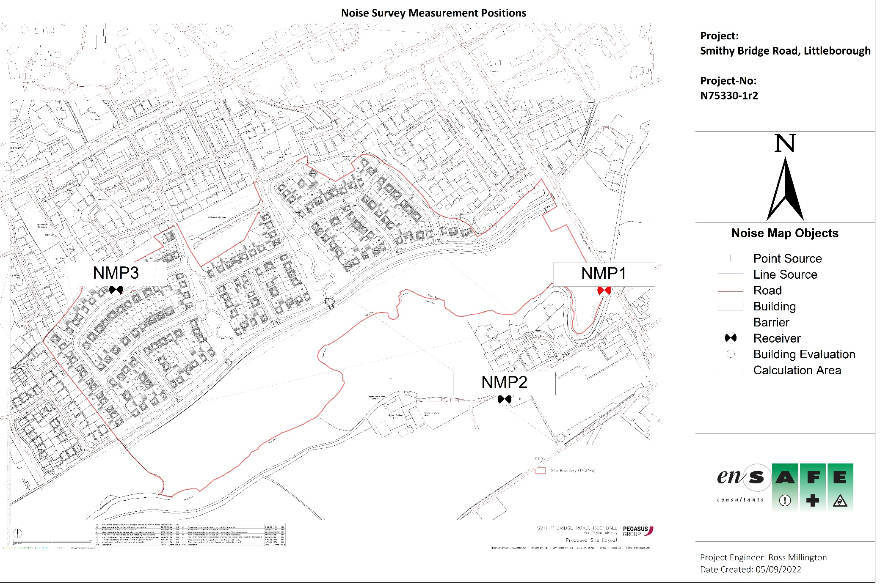
Figure 1: Noise Survey Measurement Positions
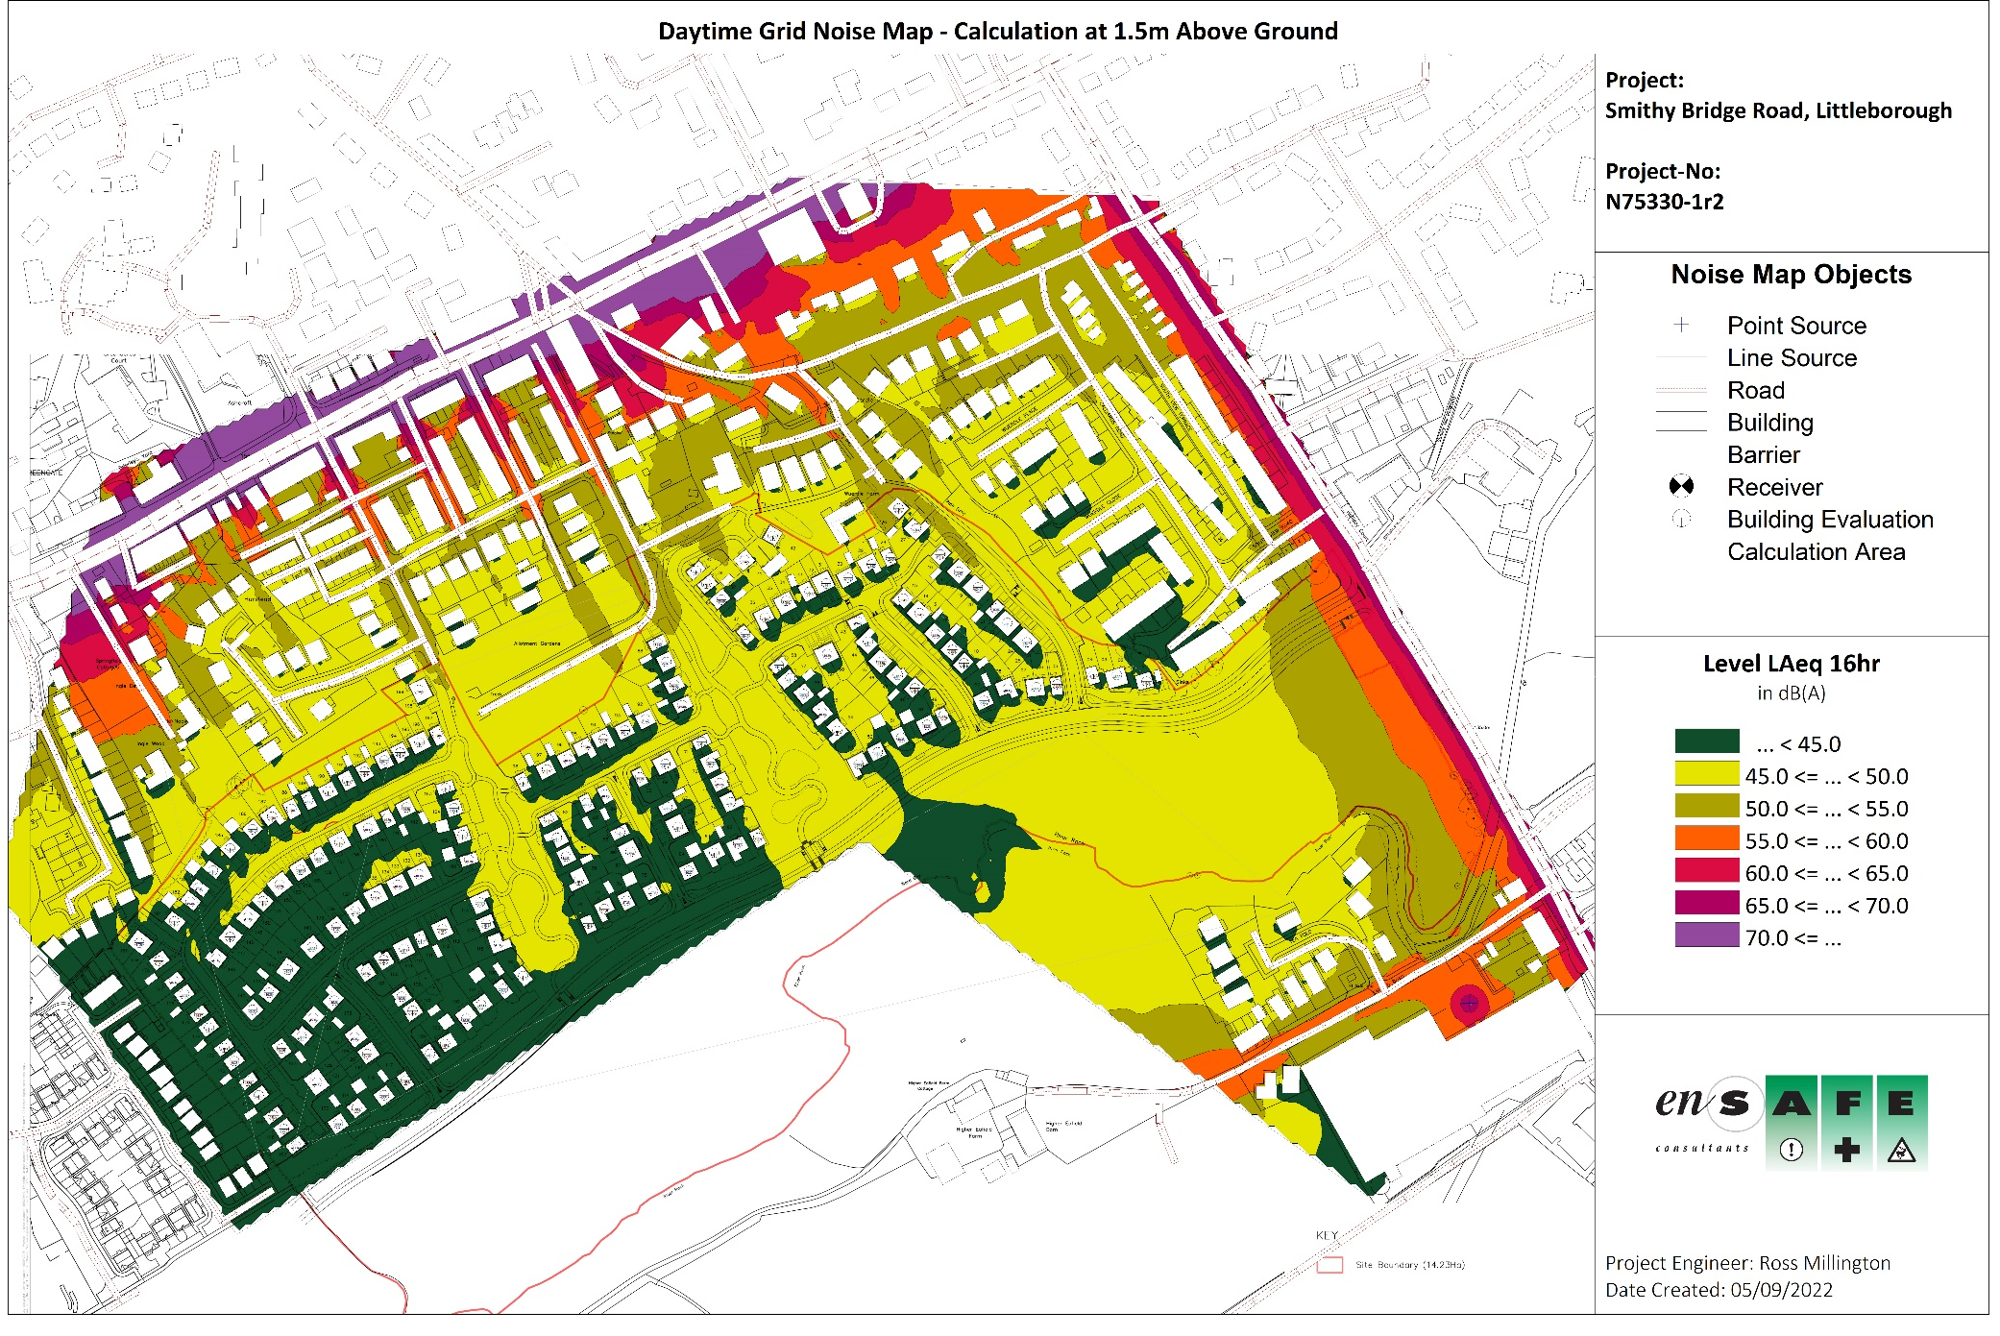
Figure 2: Daytime Grid Noise Map – Calculated at 1.5m Above Ground
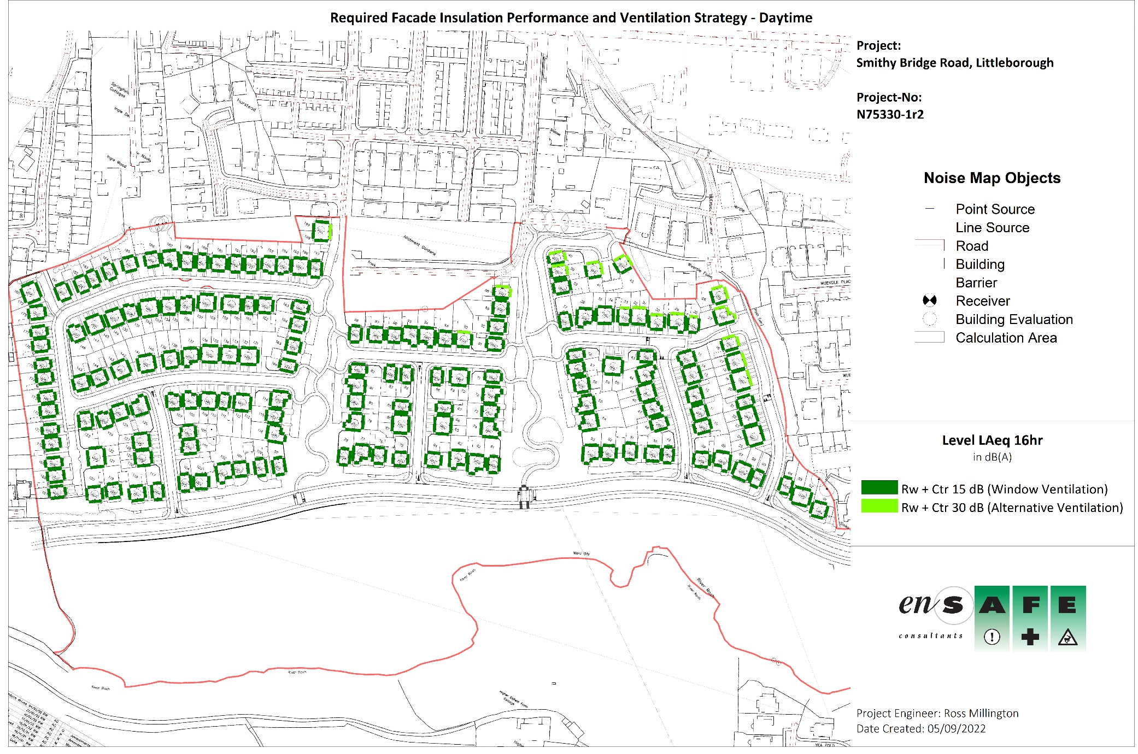
Figure 3: Façade Insulation Performance and Ventilation Strategy
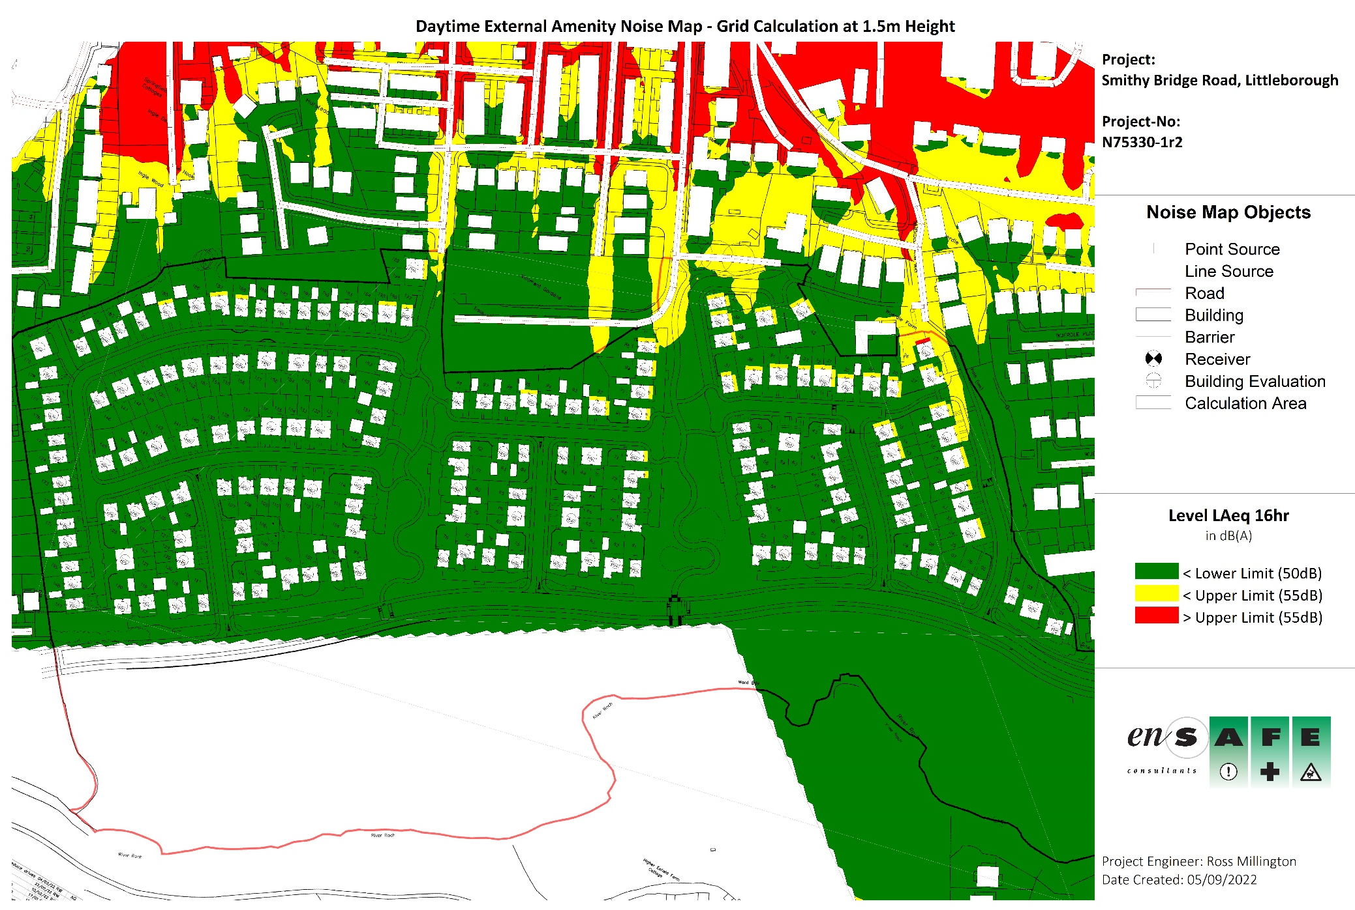
Figure 4: Daytime External Amenity Noise Map – Calculated at 1.5m Above Ground

APpENDIX iV – bibliography

Appendix IV – BIBLIOGRAPHY

Bibliography

[1] | Ministry of Housing, Communities & Local Government, National Planning Policy Framework, London: UK Government, 2021.
[2] | Noise and Nuisance Team, Noise Policy Statement for England, London: Department for Environment, Food and Rural Affairs, 2010.
[3] | British Standards Institution, Guidance on sound insulation and noise reduction for buildings, London: BSI Standards Limited, 2014.
[4] | The Building Regulations 2010, Approved Document F: Ventilation, HM Government, 2015.
[5] | The Building Standard Advisory Committee, Building Standards Technical Handbook - Domestic Buildings, Scottish Government, 2020.
[6] | The Department of the Environment, Technical Booklet K: Ventilation, 2012.
[7] | B. Berglund, T. Lindvall and D. H. Schwela, “Guidelines for community noise,” World Health Organisation, Geneva, 1999.
[8] | M. Vallet and I. Vernet, “Night noise index and sleep disturbance,” in Proceedings of the Internoise Congress, Sydney, 1991.
[9] | Department for Environment, Food, & Rural Affairs, “DEFRA Data Services Platform,” [Online]. Available: https://environment.data.gov.uk/DefraDataDownload/?Mode=survey. [Accessed 6 May 2022].
[10] | Technical Committee ISO/TC 43, Acoustics, Sub-Committee SC 1, Noise, Acoustics - Attenuation of sound during propagation outdoors - Part 1: Calculation of the absorption of sound by the atmosphere, International Organization for Standardization, 1993.
[11] | Technical Committee ISO/TC 43, Acoustics, Sub-Committee SC 1, Noise, Acoustics - Attenuation of sound during propagation outdoors - Part 2: General Method of Calculation, International Organization for Standardization, 1993.

