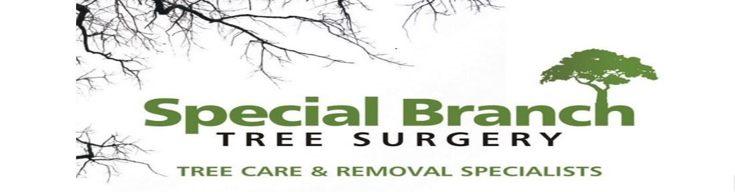

Top O’th Meadow Farm
Meadowhead Lane
Norden, Rochdale
OL11 5UL
Tel: 01706 658771

17th March 2025

Report for
Bill Ronnie
1 Old Rectory Gardens
Mellalieu Street, Middleton
M24 5DN

As requested, please see the completed tree report, as discussed this offers no guarantees as trees are living organisms and can fail at any time. We would also like to advise that no indemnity or insurance cover is offered. This report is in “my opinion” only and covers only the trees that have been inspected.

Trees in question are subject to a Tree preservation order – TPO177

Local authority; Rochdale

Location
Garden of 1 Old Rectory Gardens.

TPO Ref: TPO177
- TPO name: The Old Rectory, Mellalieu Street, Middleton
- Date confirmed: 1999-03-17
- Tree type: Silver Birch 5 Laburnum 1
- Description: G1
- ID: G1TPO177
- Local authority: Rochdale
- T1 – Silver Birch

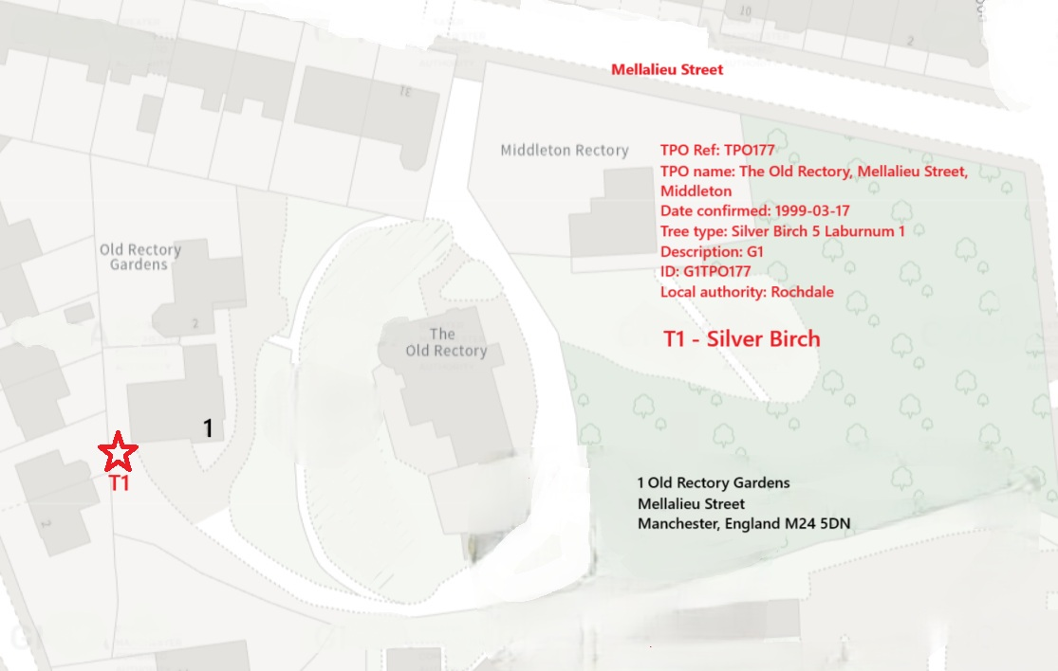

Work provided

Site visit, arboricultural inspection, photography, report, and quotation.
All trees have been thoroughly inspected and only the tree with any defects or concerns have been noted.

Trees included

T1 Silver Birch.

Issues found

T1 Silver Birch. This tree is severely in decline. Branches are currently breaking off and causing damage to the residents roof.

Recommendations

T1 – Silver Birch. Fell to ground level.

The removal of T1 - Silver Birch should be allowed due to the tree being in a state of decline with clear signs of dieback. Dieback is a progressive decline in the health of a tree, often caused by various factors such as disease, pests, or environmental stressors. In the case of T1 - Silver Birch, the presence of dieback not only compromises the structural integrity of the tree but also poses a safety risk by increasing the likelihood of branches falling.

Furthermore, the fact that this tree has already dropped branches onto the roof, causing damage to existing tiles, underscores the urgent need for its removal. It is crucial to prioritise the safety of individuals and property when dealing with trees exhibiting signs of decline and potential hazards.

Allowing the removal of T1 - Silver Birch in this situation is not only justified but necessary to prevent further damage and mitigate risks. By addressing the issue promptly, appropriate measures can be taken to ensure the safety of the surrounding area and prevent any further incidents of falling branches causing damage.

In conclusion, the removal of T1 - Silver Birch due to its decline and the associated risks is a responsible course of action that prioritizes safety and the protection of property. It is essential to act decisively in such circumstances to prevent potential harm and ensure the well-being of all individuals involved.

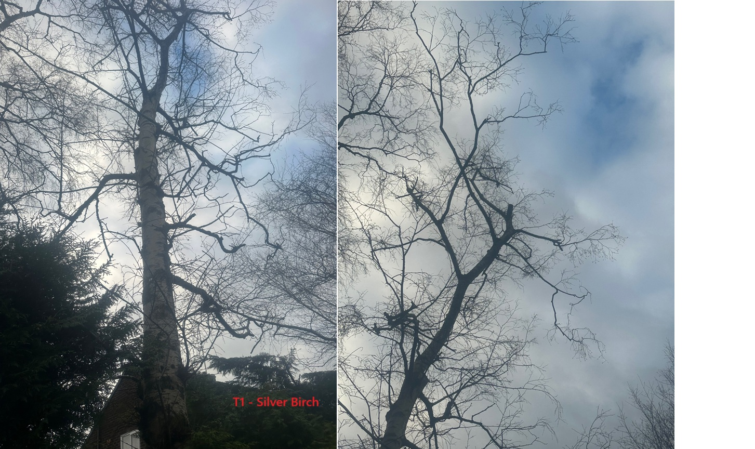

Kind regards,
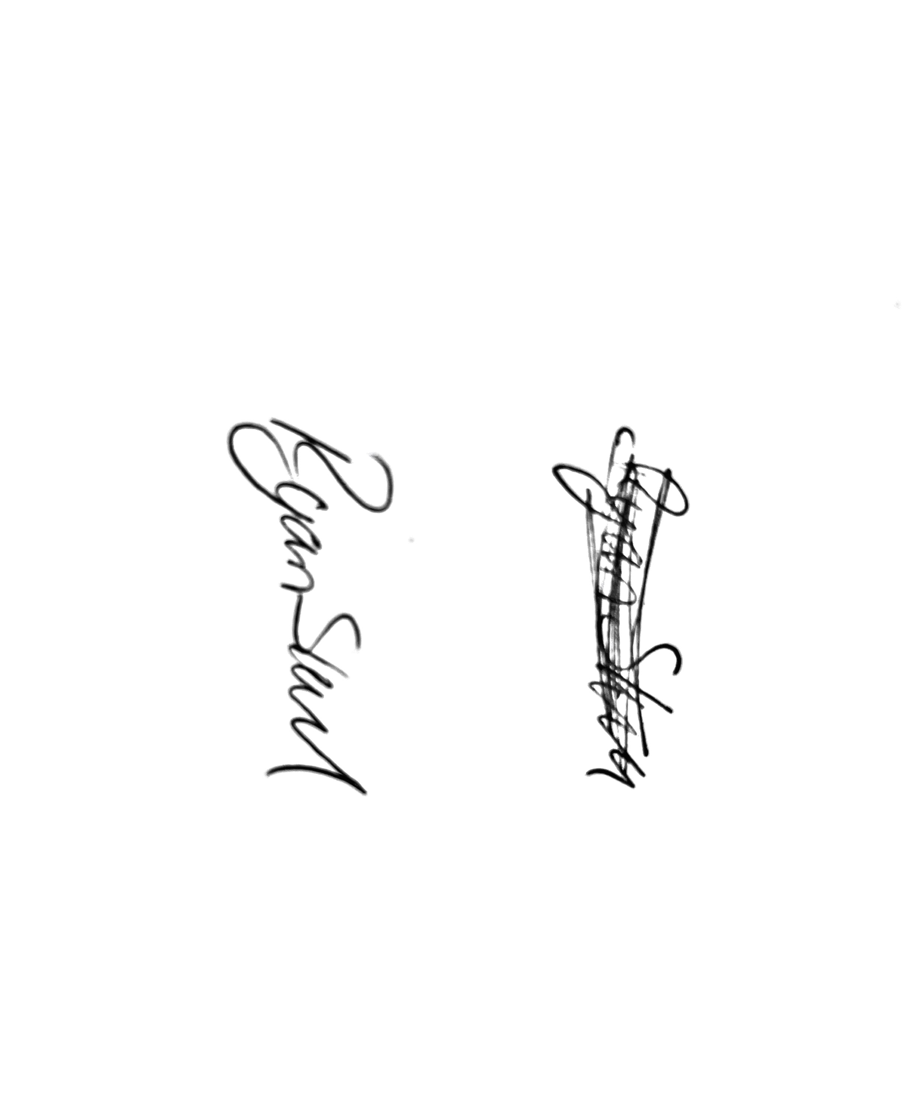
Mr. Ryan Slack
General Manager and Director
SEG Award, Cert Arb L2 (ABC)

