Planning Statement

114 Drake Street Rochdale
OL16 1PS

Proposed Change of Use at First Floor (Use Class E) to One Self-Contained Apartment and External Front and Rear Alterations to the Elevations

January 2024

Building Design Services (BDS)

CONTENTS

Page

    - INTRODUCTION - 2

    - SITE AND SURROUDINGS - 3

    - PROPOSED DEVELOPMENT - 5

4 INVOLVEMENT- 8

- HISTORY - 9

- RELEVANT PLANNING POLICY - 10

- ASSESSMENT - 12

- CONCLUSION -20

Prepared by: Building Design Services (BDS), 418 Bury Road, Rochdale, OL11 5EU.

E-mail: bds2000@live.co.uk

1.0 INTRODUCTION

  - Building Design Services submit this Planning Statement on behalf of the applicant who owns the property at 114 Drake Street in Rochdale. The building is three stories high. Currently, the building is occupied on the ground floor by Accountants. The upper floors of the building are also used as office space; however, more recently. The applicant would like to secure planning permission towards the upper floors of the building as residential. The delivery of the scheme would make a positive change to the area linking to the town centre.

  - This Planning Statement, site plans, full floor plans, and elevation plans submitted as part of this proposal make reference to the land use, constraints, policy, guidance and possible issues. The Statement addresses these matters categorically.

  - Compared to other housing markets in the Northwest and Greater Manchester, the Rochdale and Northeast Manchester housing market is generally less attractive. The housing on offer in the borough has stark differences in terms of quality and price, and it fails to address the needs of existing or future residents. An oversupply of older terraced housing and a lack of high-value housing across the borough means that it fails to attract and retain residents with higher incomes.

  - An ambitious target of providing 460 additional homes per year is considered necessary to meet demand and to help regenerate the borough. The latest Housing Land Availability Assessment indicates that there is considerable scope to meet its housing target using previously developed sites, especially in the south, and with limited use of greenfield sites.

  - The Council needs to focus the right type of housing in the right areas, maintain the regeneration of older areas of housing and social housing estates and ensure that the community infrastructure necessary to support areas of housing growth are provided.

  - Further to the above, the NPPF states that Planning policies and decisions should support the role that town centres play at the heart of local communities, by taking a positive approach to their growth, management and adaptation.

  - The applicant would like to work with the Council in order to secure approval for the proposed use.

2.0 SITE AND SURROUNDINGS

  - The application relates to a mid-terrace building fronting Drake Street. The building is three storeys high, positioned 80 metres outside of the Rochdale town centre boundary and within to the Rochdale Town Centre Conservation Area. The building is also located within the Physical Regeneration Area of Drake Street.
  - The neighbouring terraces along Drake Street are occupied by a variety of shops/commercial properties at ground floor and on both sides of this part of Drake Street. The building is located close to the Drake Street Tram Stop and towards the road intersection of Drake Street and Milnrow Road.

  - The building apparently dates from the late C19th, with a single frontage shopfront. The upper floor consists of vertical windows. Access into the building is provided from both the front elevation and rear elevations facing Back Drake Street—the building a cream rendered, like the neighbouring buildings.

  - The site is considered to be in a sustainable location, being well served by public transport and well related to an adequate range of existing services and facilities within a short walking distance. The red edge location plan shows the building has substantial external curtilage with parking provided to the rear of the site from Back Drake Street.

  - The site is located in a close-knit urban area outside Rochdale town centre. Servicing is provided from the rear.

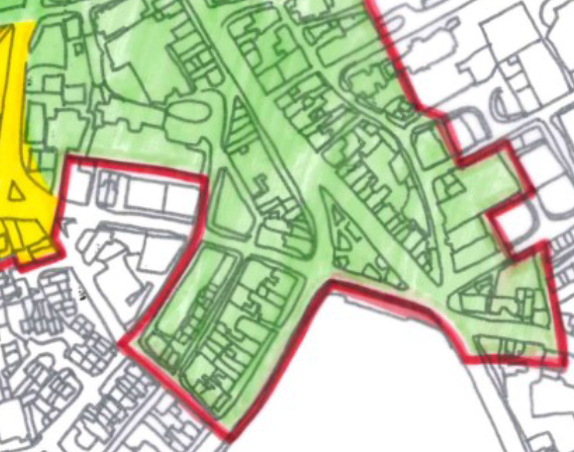
Map above taken from the Rochdale Town Centre Conservation Area Appraisal Map. Site outlined blue in Regency Drake Street (Green). Town Centre to the north.

3.0 PROPOSED DEVELOPMENT

  - The applicant is applying for full planning permission to change the use of the first and second floor of the building from office use to residential consisting of a two-bedroom self-contained flat.

  - The flat above 114 Drake Street would be accessed from the rear of the building. The apartment would consist of a kitchen, living room, two bedrooms and separate bathroom and en-suite. The yard area would also provide bin storage for the proposed flat and retained office. The units would provide the following floor space;

  - The Town Centre/local centre, in particular, represents an appropriate location for such initiatives, offering the prospect of increased diversity, security and a general revitalisation, especially at nights and weekends. The Town Centre has the potential to provide unique housing opportunities which cannot easily be found elsewhere in the town, or indeed in the surrounding region. Such opportunities are likely to be particularly suitable for the young, couples and students. All represent groups whose housing needs are projected to expand considerably.

  - Residential uses within mixed use developments can introduce diversity, security and life especially at night and weekends.

  - The conversion of the upper floor of the building would help in providing much needed accommodation close to the Town Centre as well as commercial uses in this central location.

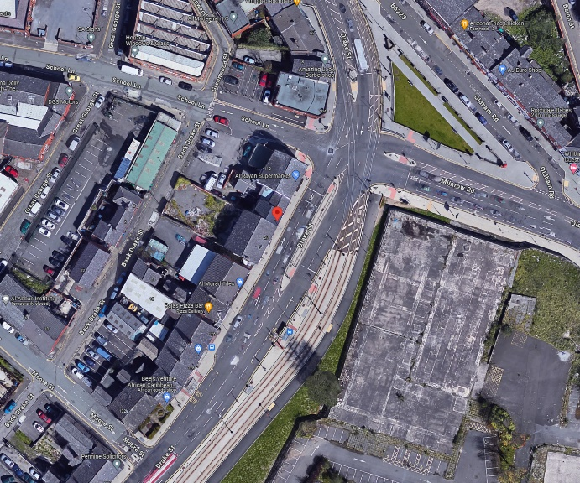

Above plan shows the property on Drake Street. (114 Drake Street)

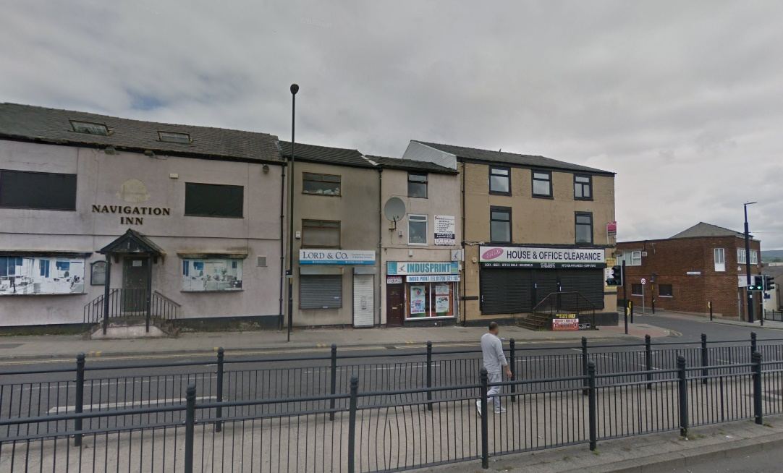

Above image shows the front elevation of the building.

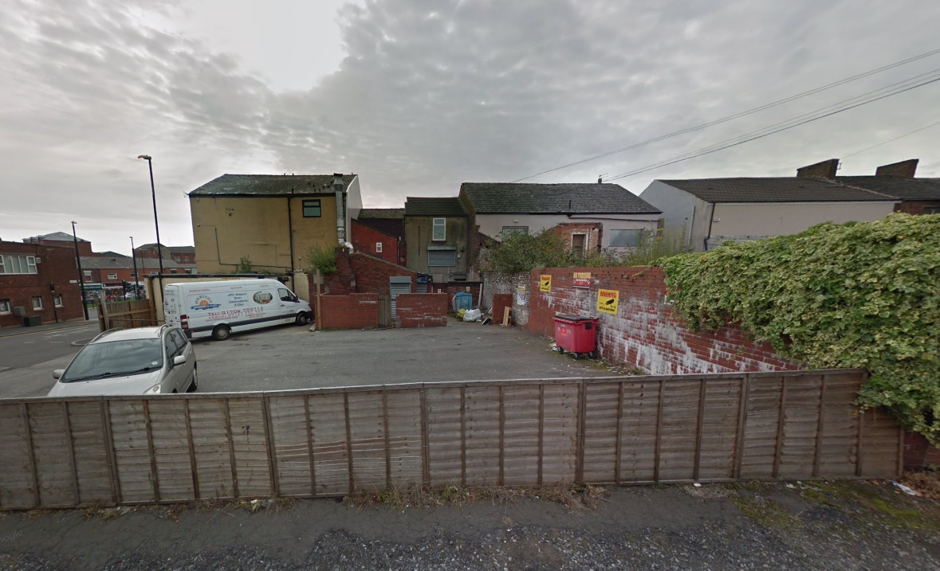

Above image shows the rear of the building and yard area for bin storage.

4.0. INVOLVEMENT

  - It was not considered necessary in this instance for a formal pre-application advice to be sought from the Councils planning officers regarding the type of the accommodation provided. It is considered the scheme put forward is an acceptable proposal that would provide quality accommodation in this local centre area further increasing growth in Rochdale.

  - Paragraph 39 of the NPPF states;

“Early engagement has significant potential to improve the efficiency and effectiveness of the planning application system for all parties. Good quality preapplication discussion enables better coordination between public and private resources and improved outcomes for the community.”.

  - This Statement has been submitted as part of this planning proposal to provide a reasoned justification of the proposal using local and national planning policy and guidance.

  - The issues of Highways safety, amenity of the surrounding area, design, heritage and the principle of the development are taken into consideration in the assessment below.

5.0 HISTORY

5.1 A history check has been undertaken, which has revealed the below planning history for the site, the relevant planning history includes;

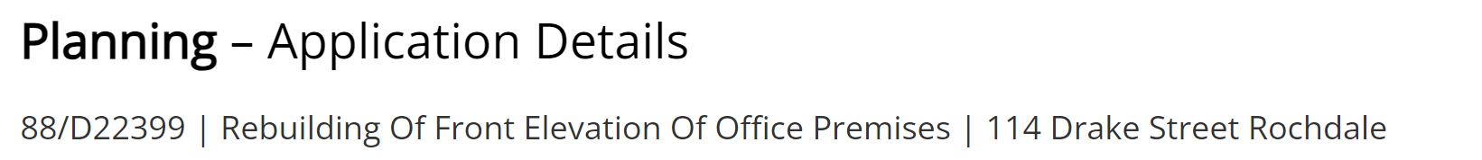

6.0 RELEVANT PLANNING POLICY

  - Section 38(6) of the Planning and Compulsory Purchase Act 2004 states that decisions should be made in accordance with the development plan unless material considerations indicate otherwise.

  - Rochdale’s Core Strategy was adopted in July 2016 and is the key Development Plan Document. It replaces significant elements of the existing Unitary Development Plan as the document that sets out the long-term strategic policies for Rochdale’s future development and will form the framework that planning applications will be assessed against.

  - The Core Strategy seeks to deliver sustainable development and growth in accordance with the objectives of the National Planning Policy Framework (NPPF). It aims to increase investment in the borough and to make it a more prosperous place by 2028. The Core Strategy will have a major role in guiding the regeneration of the borough, building on the investment that has already taken place in some areas and identifying where to focus on next.

  - It looks to build on the borough's assets, heritage and identity and on its connections and relationships with neighbouring towns. In particular, the borough needs.

  - The following Local Plan policies have relevance to the proposal: DM1 GENERAL DEVELOPMENT REQUIREMENTS
P3 IMPROVING DESIGN OF NEW DEVELOPMENT

E1 ESTABLISHING THRIVING TOWN, DISTRICT AND LOCAL CENTRES C3 DELIVERING THE RIGHT TYPE OF HOUSING
G9 REDUCING THE IMPACT OF POLLUTION

T2 IMPROVING ACCESSIBILITY

Saved Unitary Development Plan (UDP) Policies:

G/D/1 DEFINED URBAN AREA

G/S/1 TOWN CENTRES

(R/3) PHYSICAL REGENERATION AREA SPD
GUIDELINES & STANDARDS FOR RESIDENTIAL DEVELOPMENT

NPPF (2021)

  - The NPPF clearly states ‘that the purpose of the planning system is to contribute to the achievement of sustainable development’ (paragraph 7). Paragraph 10 confirms that ‘in assessing and determining development proposals, local planning authorities should apply the presumption in favour of sustainable development’. Paragraph 11 states that a presumption in favour of sustainable development is at the heart of the NPPF. It goes on to say that ‘for decision-taking this means:

    - approving development proposals that accord with an up-to-date development plan without delay; or

    - where there are no relevant development plan policies, or the policies which are most important for determining the application are out-of-date, granting permission unless:

- the application of policies in this Framework that protect areas or assets of particular importance provides a clear reason for refusing the development proposed; or

- any adverse impacts of doing so would significantly and demonstrably outweigh the benefits, when assessed against the policies in this Framework taken as a whole.

Paragraph 130 of the NPPF, advises that Planning policies and decisions should ensure that developments create places that are safe, inclusive and accessible and which promote health and well-being, with a high standard of amenity for existing and future users.

Paragraph 111 of the NPPF states that Development should only be prevented or refused on highways grounds if there would be an unacceptable impact on highway safety, or the residual cumulative impacts on the road network would be severe.

The general perspective of the NPPF is that planning should proactively drive growth and support sustainable economic development. It also states that planning should make effective use of land by reusing land that has been previously developed and sets out a presumption in favour of sustainable development. The government is committed to ensuring that the planning system does everything it can to support sustainable economic growth.

In terms of retail uses the NPPF states at Paragraph 123;

“Local planning authorities should also take a positive approach to applications for alternative uses of land which is currently developed but not allocated for a specific purpose in plans, where this would help to meet identified development needs.

  - National Planning Practice Guidance (NPPG)

The government published its NPPG on 6 March 2014. This is intended to complement the NPPF and to provide a single resource for planning guidance, whilst rationalising and streamlining the material. Almost all previous planning Circulars and advice notes have been cancelled. Specific reference will be made to the NPPG or other national advice in the Analysis section of the report, where appropriate.

7.0 ASSESSMENT

  - The residential units proposed would be located on the edge of Rochdale Town Centre and within the Drake Street local centre, it is also within the key regeneration area of Drake Street identified under saved Policy R/3 of the UDP. Policy E1 of the Councils Core Strategy is therefore relevant and which states ‘We will focus retail leisure, cultural, office, residential and other development to promote the viability and vitality of the boroughs town centres.

  - The application site is located in the Defined Urban Area as allocated under the Rochdale Unitary Development Plan. As such policy G/D/1 is relevant to any applications on the site and this establishes that development should be located in the urban area so as to support urban regeneration and protect the countryside.

  - Policy E1 of the Core Strategy states that;

We will focus retail, leisure, cultural, office, residential and other development to promote the viability and vitality of all the borough's town centres to maintain them as thriving and sustainable centres and the preferred shopping and leisure destinations for people living, working and visiting the borough. We will also ensure the provision of a hierarchy of accessible district and local centres and shops that meets people’s daily shopping needs.

  - Saved Policy R/3 States that ;

Within the Drake Street Physical Regeneration Area, the Council will support, facilitate and implement, in partnership with other agencies and landowners proposals that:

v. Maximise the opportunity that Metrolink provides to regenerate the area and improve environmental conditions;

- Strengthen links with the town centre shopping and commercial core and adjoining areas; and

- Fall within the following use classes:

  - retail (A1) (within the town centre boundary)

  - leisure and entertainment (D2) (within the town centre boundary)

  - financial and professional services (A2)

  - food and drink outlets (A3)

  - housing (C3) at first / upper floor level

  - Policy C1 of the Core Strategy establishes to;

Maximise the potential of previously developed sites, including empty homes and buildings within the urban area to achieve a target of 80% of new housing of previously developed land; and Ensure that sites are sustainable with good access to local services, facilities, green infrastructure, shops, jobs, schools and public transport.

  - Policy C3 of the core strategy is also relevant and its aims are to;

    - Ensure new development provides housing types that take account of local needs and aspirations; Promote densities that make efficient use of land whilst delivering a range of housing to widen choice in the borough and reflect local character;
    - Ensure that sites are sustainable with good access to local services, facilities, green infrastructure, shops, jobs, schools and public transport.

  - The application site is Defined Urban Area as allocated under the Unitary Development Plan. As such policies establish that development should be located in the urban area so as to support urban regeneration and protect the countryside.

  - The site is sustainably located within the local centre of Drake Street and on the fringe but outside the town centre and in a regeneration area and provides easy access to local facilities, the college and public transport connections. It is not considered that the proposal would compromise the ability to achieve the Local Plan’s strategic objective of sustainable development as set out in Policy. Neither are there any direct conflicts with the development strategy for the Town as set out in Policy resultant from the proposal by virtue of its location within the defined development boundary, close to the Town centre providing links and an allocated regeneration area.

  - The proposed change of use of the first and second floor of the building would reuse a part of the property which is empty and disused, and the site is starting to appear unsightly in this prominent location. The site needs investment to bring the property back to a suitable functional use and where it would not have a negative impact on the surrounding area.

  - The site is well located in a mixed-use urban area so as to support urban regeneration and protect the countryside. The proposal would provide good housing accommodation as well as offices at ground floor which is much needed in this inner urban area close to the town centre. It would enhance the character of the area by bringing an existing site back into use, it would consider the needs of local and residing students, protect the surrounding built environment and provide the future occupiers with services close to the town centre within walking distance and reducing the need to travel.

  - The proposal for residential development would be appropriate within this close to town centre location where it would not lead to a concentration of residential uses which undermines the overall mix of main town centres uses. In addition, the development would not prejudice the lawful operating conditions or viability of adjacent land uses.

  - The effect on residential amenity by reason of noise or other nuisance would be minor given its location amongst other noise generating uses and the general make up and character of the area which in themselves produce a level of noise. Noise is further discussed below.

  - An NIA has not been submitted as part of this application. It is considered suitable internal noise levels can be achieved by providing double glazing to the existing single glazed windows. As such the proposed residential units would achieve suitable noise levels inside habitable rooms. Some changes to the windows would be visible externally. A condition can be submitted as part of any approval for a suitable verification report to be submitted where necessary.

  - Furthermore, the development would provide adequate and carefully designed storage for bins and recycling containers. This would be located to the rear of the building, which is easily accessible to future residents but placed away from the public vantage points.

  - It is also considered that the proposal would not have a detrimental effect on the safe and efficient operation of the existing transport and road infrastructure. Highway’s safety is further discussed in the relevant section below.

  - For the reasons set out above, the principle of development is considered to be acceptable subject to consideration against the following (main) matters including the impact on visual amenity (design and appearance); highway safety and parking; the impact on neighbouring amenity; and the living conditions of the future occupiers. Other matters include refuse and recycling arrangements.

  - Considering the above it is considered that the principle of providing an office at ground floor, residential unit on the upper floors the application site is acceptable.

Residential Amenity

  - Policy DM1 of the Core Strategy sets out a number of basic planning considerations that apply to all development. Further to this, paragraph 17 of the NPPF, containing the ‘core planning principles’, advises that planning should always seek to secure a good standard of amenity for all existing and future occupants of land and buildings.

Policy G9 of the Core Strategy sets out that the Council will seek to reduce all forms of pollution by requiring that development does not have impacts that lead to an unacceptable increase in air, water, noise, light or other pollution.

  - The NPPF (paragraph 48) indicates that local planning authorities should identify and bring back into residential use empty homes and buildings in line with empty homes strategies and, where appropriate, acquire property by compulsory purchase.

  - It has already been established above that the principle of providing residential accommodation at the site is considered acceptable. The area is established as mixed use, and the proposal would therefore be in keeping with existing land uses around the area. It is however important to ensure that the proposal would not impact unduly on matters such as noise and other pollution effects, with regards given to the impact of each room within the building as well as the impact of the development upon existing surrounding properties.

  - In relation to noise, it should be acknowledged that there would be some noise from neighbouring commercial land uses as well as road noise from the busy Drake Street and the Tram Line adjacent. However, given its location amongst existing noise generating uses, the noise from neighbouring uses is not considered to have a significant impact on the amenity of future occupiers, or from external noises.

  - In terms of noise from the neighbouring retail units, these would probably open from 8am until 6pm at the latest each day. As such the future residents of the proposed building would still enjoy peace and quiet during the evening and night where they can relax and sleep in a quiet environment with little disturbance.

  - In terms of internal noise between flat and the office below, the internal layout has been carefully designed so that bedrooms and living rooms are least affected by noise; however it should be noted that any new partitions required would have an acoustics barrier fitted to ensure future residents are adequately protected from unacceptable levels of noise, internal noise levels can be conditioned if required as stated.

  - In respect of other matters, it is important that the development provides adequate space about buildings, it is considered that there would be no concerns regarding the distance to the front of the building which would face the main highway. The rear elevation would face the manufacturers signage store on the opposite side of Back Drake Street at more than 30m, this is considered acceptable in this close-knit town centre locations where longer distances cannot be achieved, and similar relationships exist on nearby properties.

  - Therefore, with regard to the living conditions of future occupiers of the property, it is noted that each habitable room within the building would be provided with natural light and ventilation, with an outlook to the streets on the front of the property. The windows would all provide an outlook and ventilation which would be sufficient. Each property would have its own WC and washing facilities. The flat should exceed the Nationally Described Space Standards in terms of habitable space provided.

  - In light of the above, it is considered that the development would provide adequate space about buildings, so as to protect future residents from any excessive levels of overshadowing and/or loss of privacy and a good standard of living accommodation. The application is therefore acceptable in this respect and would meet with the expectations of Policies along with the relevant requirements of the National Planning Policy Framework.

Design and Heritage Impact

  - Policy P3 of the adopted Core Strategy requires all new developments, regardless of location in the borough, to adhere to high standards of design. Policy DM1 of the Core Strategy states that all development proposals will be expected to demonstrate that they are of high-quality design and take the opportunity to enhance the quality of the area, in addition to requiring a number of other basic planning considerations.

Paragraph 130 of the revised National Planning Policy Framework states that ‘decisions should ensure that
developments will function well and add to the overall quality of the area and are visually attractive as a

result of good architecture, layout and appropriate and effective landscaping’. Policies P2 and P3 of the Core Strategy set out a requirement for good design, improved image and protection and enhancement of character, landscape and heritage.

  - In light of the above, the proposal would result in no undue harm to visual amenity and would improve the overall character and appearance of the area and the street scene by virtue of the reuse of the building. The application would therefore accord in this regard with policies, the NPPF and SPD.

Parking and Accessibility in the Town Centre

  - Policy T2 of the adopted Core Strategy relates to accessibility and Policy DM1 requires all development to provide satisfactory vehicular access with adequate parking and manoeuvring arrangements provided.

  - As part of the strategy to reduce reliance on the private car, the Town Council is keen to encourage the use of sustainable modes of transport. Walking, particularly over shorter distances, is an important mode of transportation for journeys such as visiting shops and going to school. It is beneficial to personal health and is environmentally friendly. There is a need to ensure that routes for pedestrians are pleasant and direct as well as safe. Encouraging walking can reduce the number of car journeys made and thus contribute to reducing congestion and pollution levels.

  - It should be noted that the town centre is served by a train station, where it is only a 5min walk from the site which has recently undergone infrastructure and service improvements. The railway station is well integrated into the town centre. The role of the bus to enhance linkages to the rail stations, as well as its role as a transport mode more generally is also important.

  - The current site at first floor has been vacant, as such the proposed development would be quite intensive by comparison. The site is located close to the town centre and within a local centre, and therefore in an accessible location. Given its location along a main road, with excellent bus links and parking available on side streets and in the surrounding vicinity, and in car parks, this would be sufficient provision for a development in a location as sustainable as this (in a town centre and on a major bus route); as such the parking provided is justified and adheres with the aims of Rochdale Plan.

  - It is not expected that this proposal would impact negatively upon the surrounding highway network by future occupiers, parking restrictions are in place where poor and awkward parking would be avoided.

  - In addition, the occupancy of the building will mainly be from professionals who work within a walking distance or students who would in most cases not be relying on a car or have car ownership. As such the need to provide dedicated parking in this location is further reduced. A push towards greener methods of transport such as walking, and cycling is the aim for this proposal.

  - Given the details, it is considered the proposed development can safely be provided without resulting in harm to pedestrian and highway safety. It is anticipated that not every resident will have access to a car. As set out above, the site is located within a highly sustainable and accessible location, amongst town centre amenities and rail and bus public transport facilities and within reasonable walking distance of public car parks and these factors would be considered favourably in determining the acceptability of the scheme. The presence of parking restrictions in the area would also control any potential increases in on-street parking.

  - As demonstrated, this would be in accordance with Policies of the Councils Local Plan and the NPPF where the proposal would not have a severe cumulative impact to warrant refusal of the application.

  - It is not expected that this proposal would impact negatively upon the surrounding highway network.

  - Bin storage would be provided in the rear storage area where refuse would also be collected from.

  - Therefore, it is considered the proposed development can safely be provided without resulting in harm to pedestrian and highway safety. The proposed development as demonstrated would be in accordance with Policies T1 and T2 of the Councils Local Plan and the NPPF where the proposal would not have a severe cumulative impact to warrant refusal of the application.

8.0 CONCLUSION

  - It has been demonstrated that the proposed development can be carried out in full compliance with the Council’s polices in the adopted Local Plan, including SPD’s and the National Planning Policy Framework. The development would provide good quality residential accommodation which would bring a positive contribution into local centre of Drake Street and the town centre of Rochdale without creating a significant detrimental impact on the amenity of the local occupiers and residents. In addition, the development would bring an existing empty property back into an appropriate use.

  - Given the above, the proposal should be supported in full by the Council.

APPENDIX

