SPECIAL BRANCH
`

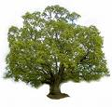
Tree Surgeons Ltd
Top O’th Meadow Farm
Meadowhead Lane
Norden, Rochdale
OL11 5UL
Tel: 01706 658771

Mini Tree Report Date: 1/03/23

Andrew Woodhead
Crimble Hall Farm,
Bamford, OL11 4AB
As requested, please see my mini tree report, as previously mentioned this offers no guarantees as trees are living organisms and can fail at any time. We would also like to point out no indemnity or insurance cover is offered. This report is in “my opinion” only and covers only the trees that have been inspected.

Trees in question subject to Tree Preservation Order TPO004

Work done

Site visit, arboricultural inspection, photography and report.

Map

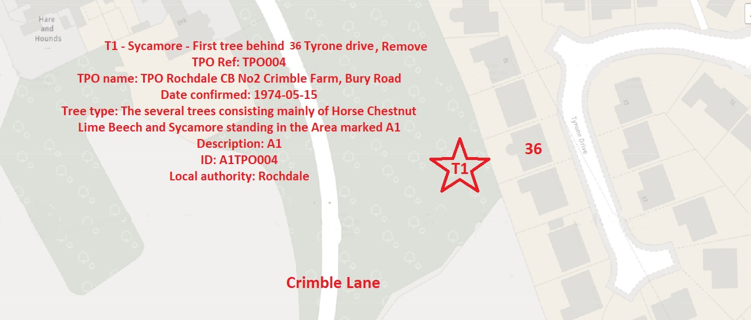

Tree in question

T1 Sycamore (Acer pseudoplatanus) Mature tree approximately 20 meters high with a good even spread crown Referenced T1 on the plan and annotated photography.

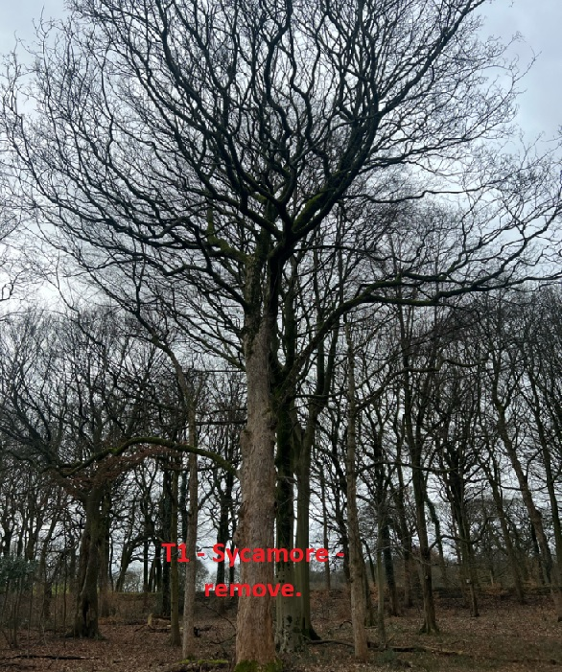

Problem
The tree in question is within close proximity to residential property. Both tree owner and local residents fear if the tree was to fail. The main problems with the tree is down to the major basal cavity which seems to have took effect on the trees health. Whilst studying the tree it became apparent that a lot of branches did not have buds on whilst some areas of the tree did, please see photo attached. Also there has been previous wounds that have not healed over correctly leading to a large build up of rot and standing water.

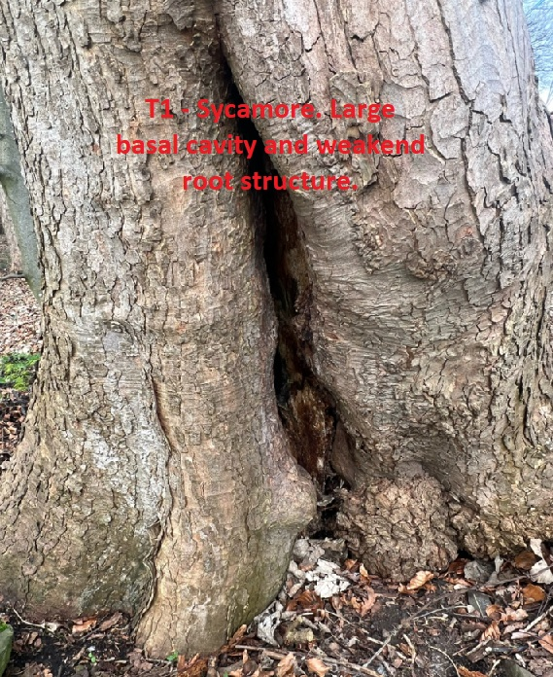

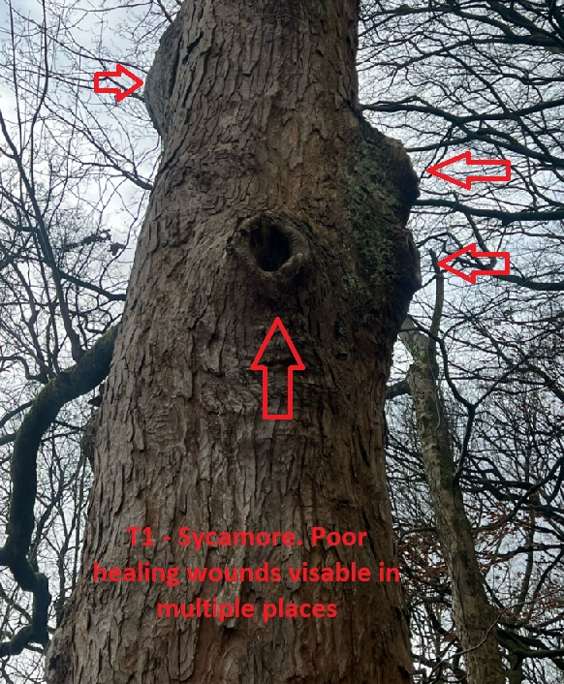

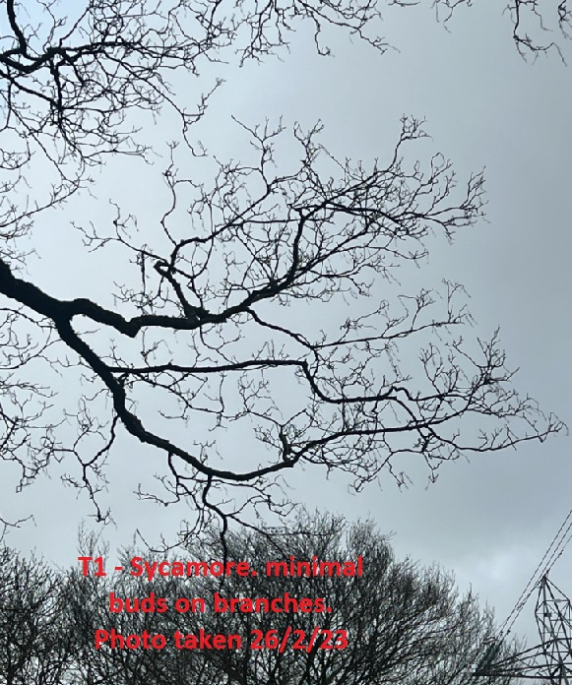

Recommendation

T1 – Removal. We expect this removal to have minimal impact on the surrounding area as the woodland is full of many healthy mature trees and the tree in question is situated close to target areas if it was to fail.
Amenity value should not be affected to the general public.

Regards

Ryan Slack
Mr Ryan Slack cert Arb L2 (ABC)

