1) Ashlar Yorkshire Sandstone Stone,
York Walling Sandstone
Rand and Asquith, Brighouse,
Tuckroyd Quarry,
Halifax Road,
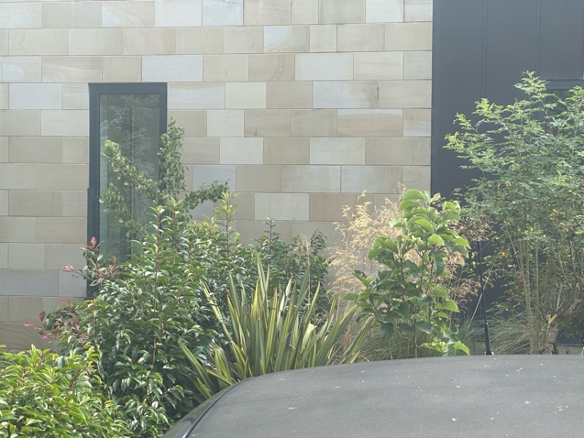
Brighouse, HD6 2PE

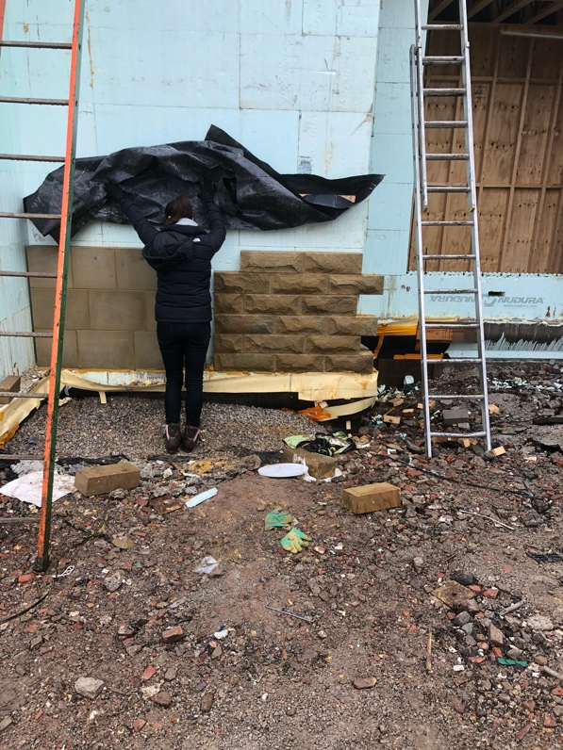

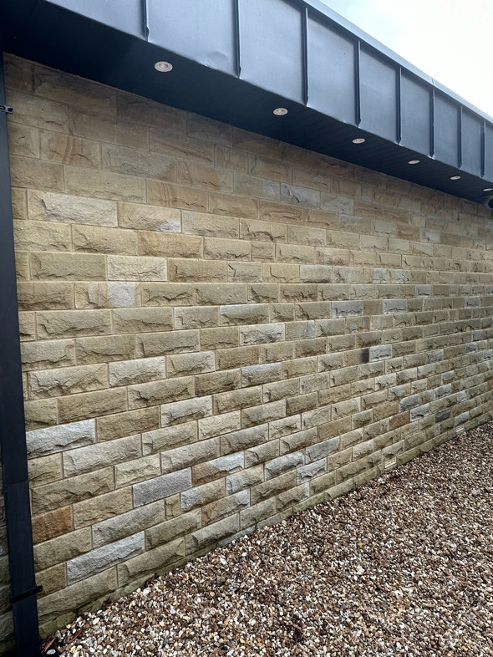

Sample panels built on site. 22.12.17

2) VMZINC
Zinc Panels Anthra-Zinc supplied by VMZINC,
Collier House,
Mead Lane,
Hertford SG13 7UZ
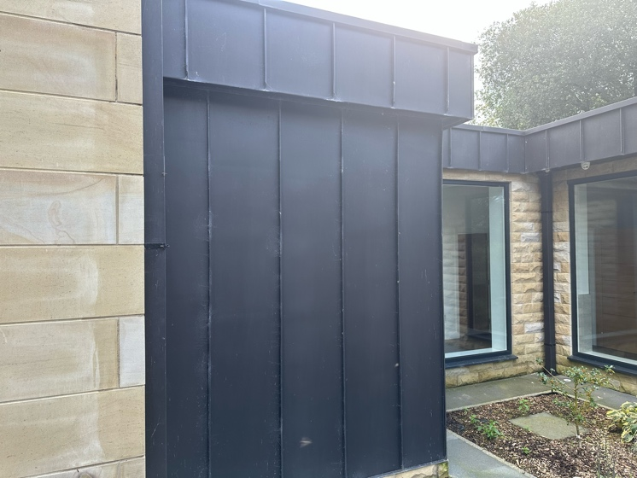
Fitted by J.Hemstock

3) Rainwater Goods,
VMZINC Anthra Box Section Downpipes
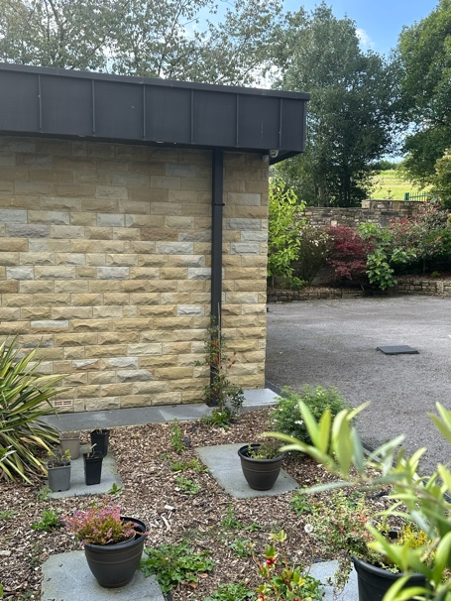

4) Windows
Capital Windows,
Smart Architectural Aluminium Window Systems,
Supplied and fitted by Capital Windows,
Smart Aluminium Extrusions LTD,
Arnott Way, Yatton,
North Somerset BS49 4QN
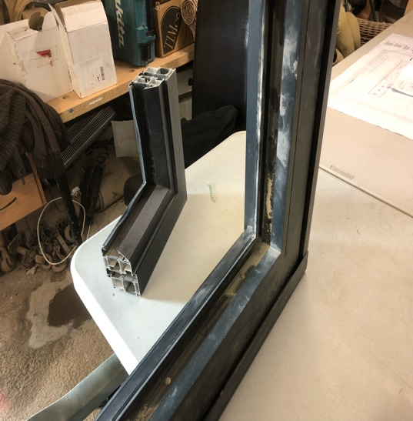
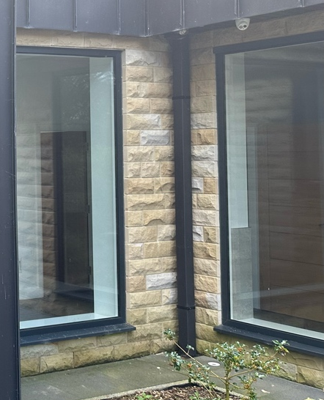

5) External & Balcony Paving Flags,
Marshalls Argent smooth paving 600 x 600
Marshalls Mono Ltd,
Landscape House,
Premier Way, Lowfields Business Park,
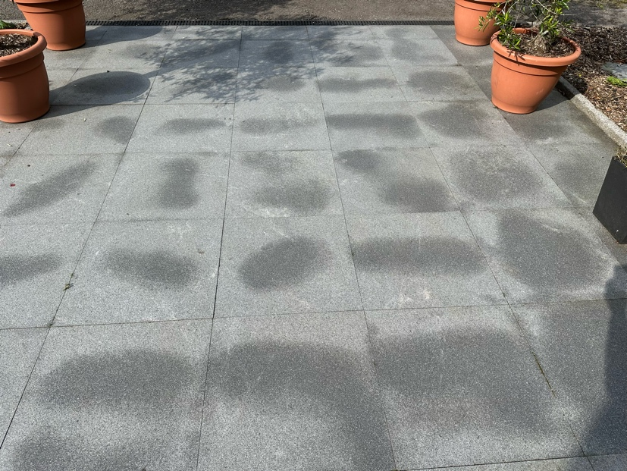
Elland HX5 9HT

6) Roof
Sika Sarnafil single ply flat roofing product
Welwyn Garden City
Watchmead, AL7 1BQ

7) Glass Balcony Rail,
Aluminium base and top rail with laminated 22mm glass,
CR Lawrence,
Kingsway Business Park,
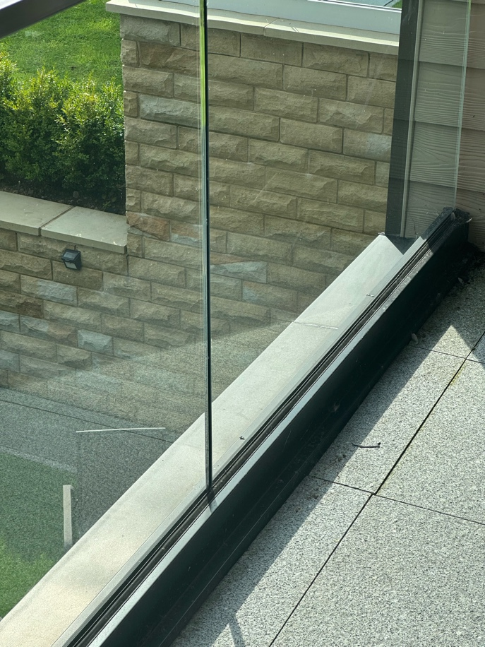
Rochdale OL16 4NW

8) Garage Door, Black electric,
Supply and install 1 Linear l-Rib 40mm thick insulated sectional door in black
Maintenance free finish,
DR Garage Doors,
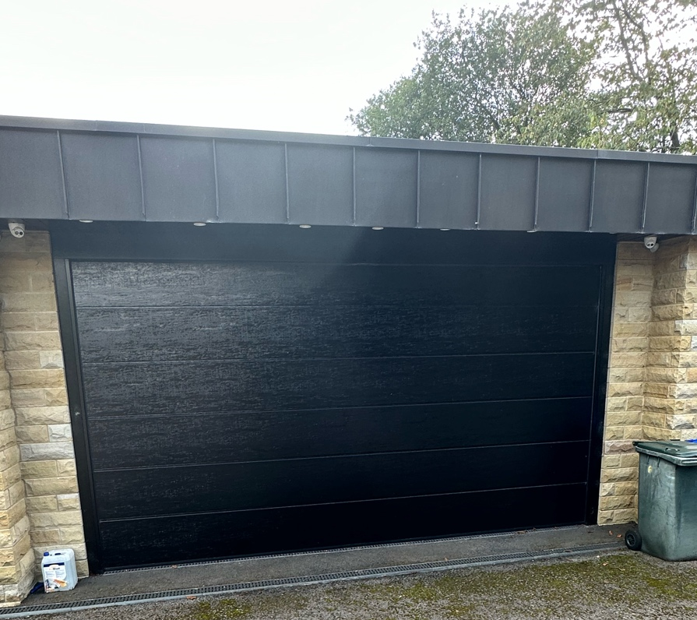
Rochdale OL12 7LQ

