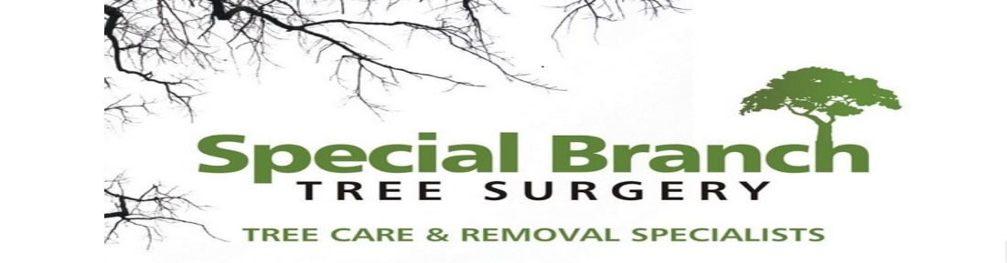

Top O’th Meadow Farm
Meadowhead Lane
Norden, Rochdale
OL11 5UL
Tel: 01706 658771

22nd April 2024

Christine Swailes .
Church Warden .
St.Leonard's Church .
New Lane.
Middleton

As requested, please see the completed tree report, as discussed this offers no guarantees as trees are living organisms and can fail at any time. We would also like to advise that no indemnity or insurance cover is offered. This report is in “my opinion” only and covers only the trees that have been inspected.

Trees in question are subject to being in a conservation area.

Local authority:Middleton, Rochdale

Location
St.Leonard’s Church.

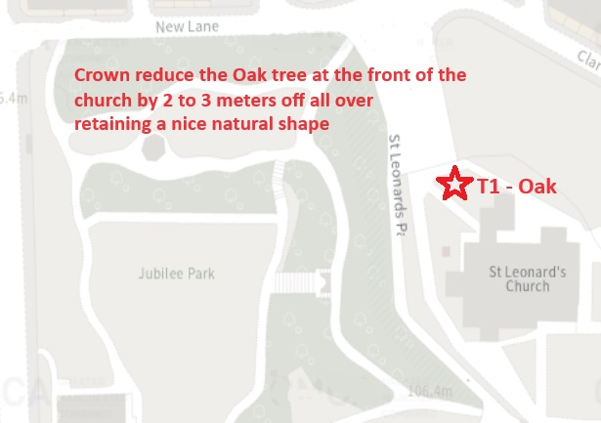

Work provided

Site visit, arboricultural inspection, photography, report, and quotation.
All trees have been thoroughly inspected and only the tree with any defects or concerns have been noted.

Trees included

T1 - Oak

Issues found

Oak tree reaching a excessive height and span.

Recommendations

T1 – Oak – Crown reduce complete crown by 2-3 meters retaining a nice sympathetic canopy.

Crown Reduction of a Mature Tree
Crown reduction is a pruning technique used to reduce the size and shape of a tree’s canopy. This process involves selectively removing branches and foliage from the outer edges of the crown, resulting in a more compact and balanced tree structure. There are several reasons why crown reduction may be necessary for a mature tree:
1. Safety One of the primary reasons for crown reduction is to mitigate potential safety hazards. Overgrown trees with large, heavy branches can pose a risk of falling during storms or high winds. By reducing the overall size of the crown, the weight and leverage on individual branches are decreased, making the tree less susceptible to structural failure.
2. Health Crown reduction can also benefit the overall health of a mature tree. Removing dead, diseased, or damaged branches can improve the tree’s vitality and longevity. Additionally, reducing the density of the canopy allows for better air circulation and sunlight penetration, which can help prevent fungal diseases and promote new growth.
3. Aesthetic Purposes In some cases, crown reduction is performed to enhance the visual appeal of a tree. By shaping the canopy and maintaining a more uniform silhouette, the tree can complement its surroundings and contribute to an aesthetically pleasing landscape.

Crown reduction of an oak tree by 2-3 meters can be beneficial for several reasons:
1. **Safety**: By reducing the size of the canopy, you can minimize the risk of branches falling and causing damage or injury. This is especially important in urban areas or near buildings where large branches could pose a hazard. 2. **Health**: Removing excess weight from the canopy can improve the tree's overall health by reducing stress on branches and promoting better air circulation and light penetration. This can help prevent diseases and promote new growth.
3. **Aesthetics**: Crown reduction can enhance the tree's appearance by creating a more balanced and visually appealing shape. This can be particularly important in landscaping or public spaces where aesthetics are a priority. 4. **Light and Space**: By reducing the size of the canopy, you can allow more light to reach the ground below, benefiting other plants in the area. It also creates more space around the tree, which can be useful for pedestrians or vehicles.
5. **Long-term Maintenance**: Regular crown reductions can help manage the size of the tree over time, reducing the need for more drastic pruning or removal in the future. When considering crown reduction for an oak tree, it is essential to consult with a certified arborist or tree care professional to ensure that the pruning is done correctly and in a way that promotes the long-term health of the tree. Proper techniques and timing are crucial to minimize stress and potential damage to the tree. In conclusion, sympathetically crown reducing an oak tree by 2-3 meters can have numerous benefits for safety, health, aesthetics, and long-term maintenance. By approaching this pruning method thoughtfully and with expert guidance, you can effectively manage the size and appearance of the tree while preserving its well-being.

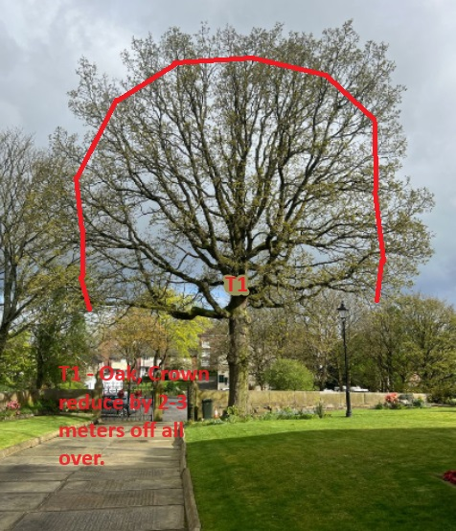

Kind regards,
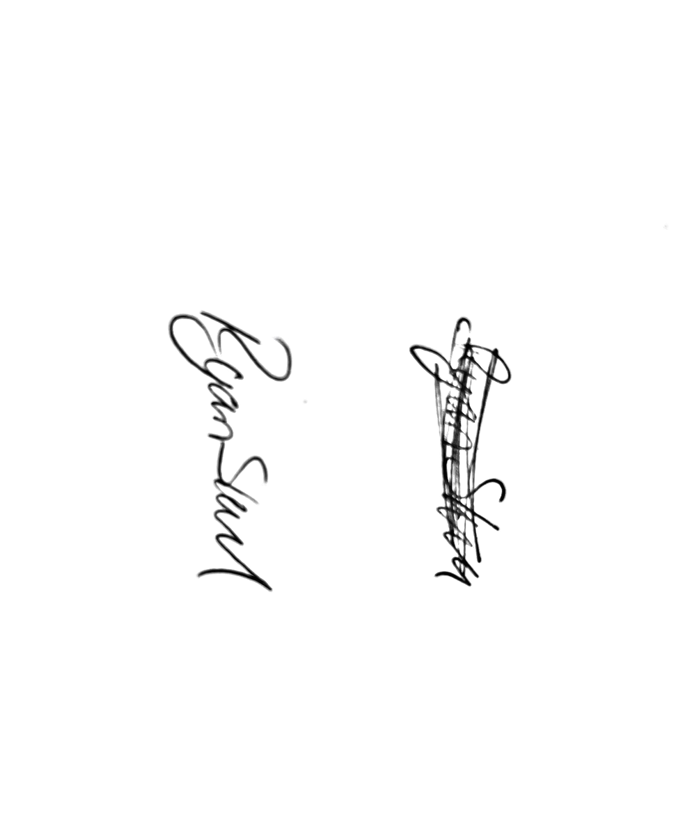
Mr. Ryan Slack
General Manager and Director
SEG Award, Cert Arb L2 (ABC)

