

BIODIVERSITY NET GAIN ASSESSMENT
SUMMARY REPORT

LAND AT HANSON SPRINGS, ROCHDALE





Biodiversity Net Gain Assessment
Summary Report

Land at Hanson Springs, Rochdale

A report for

Hanson Springs,
Gorrells Way,
Rochdale
OL11 2PX

Report by



PENNINE ecological
24 The Highgrove
Heaton
Bolton
BL1 5PX

Tel: (01204) 844545

email: bob@pennineecological.co.uk

web: www.pennineecological.co.uk

Report Author:

Hugh Richards, MSci

Reviewer:

Robert N. Leatham B.Sc. (Hons.), P. dip.

February 2025

ConteNTS

1. Introduction 1
1.1 Background 1
1.2 Site Context 1
2. Biodiversity Net Gain Results 3
3. BNG Conclusion 6
4. BNG Proposal 7
References 8
Appendix A: Figures 9

Terms of Use

This report has been compiled by Pennine Ecological with all reasonable skill, care and diligence within the terms of the instruction and permissions granted by the client. The results, conclusions and recommendations of this report are proportionate and in line with the British Standard 42020:2013.

This is a technical report and does not represent legal advice/opinion.

The report is for the sole use of the commissioning client in connection with the development project described in the report, and must not be used for any other purpose, copied, re-produced or sent to any other party other than the Local Planning Authority without the permission of Pennine Ecological.

This report remains the property of Pennine Ecological and cannot be relied upon until full payment has been made. Pennine Ecological reserve the right to retract any survey reports submitted to planning where payments are outstanding.

Pennine Ecological will retain the right to re-publish data obtained, and to forward data collected during all its ecology surveys to the local wildlife records centre.

Introduction

Background
This report provides the results of the BNG Assessment for the proposed construction of a new building, the extension of an existing building, and associated infrastructure, at Hanson Springs, Rochdale.
The information provided within this report should be read in conjunction with the following documents:
- Pennine Ecological (2024a). 004 Hanson Springs dv3 - The_Statutory_Biodiversity_Metric_Calculation_Tool_-_Macro_enabled_02.24
- Pennine Ecological (2024b). 004 Hanson Springs dv2 - Statutory_Biodiversity_Metric_Condition_Assessments-_Feb24
- Hawthorn Design Partnership (2024) Location Plan. (Drawing No.: 188-PLN-L-16-A).
- Hawthorn Design Partnership (2024) Block Masterplan. (Drawing No.: 188-PLN-L-10-B).

Site Context
The site is situated in the outskirts of Rochdale, within a primarily urban setting. Green corridors along the railway and Rochdale Canal are present to the northwest and southeast, respectively. The site’s central National Grid Reference is SD 8895 1153.
The site is shown below, outlined in red.
Figure 1.1: Land at Hanson Springs, Rochdale
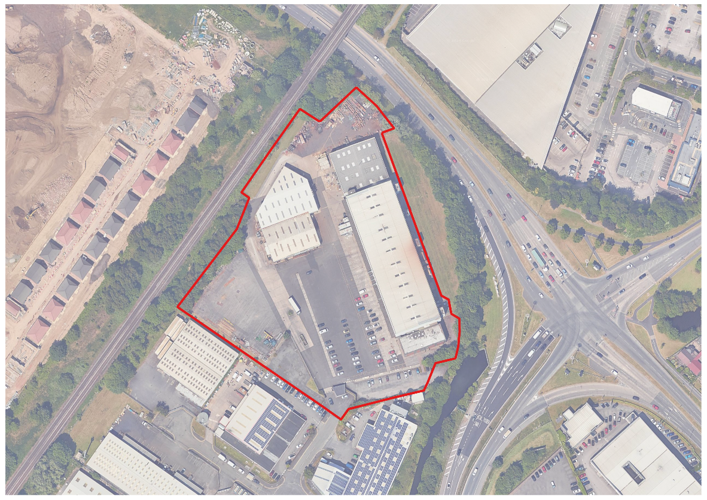

Biodiversity Net Gain Results

Habitat BNG Results
The biodiversity calculation concluded that the current proposal would result in a biodiversity net gain in habitat units and would satisfy trading rules.
The current proposal would result in a 0.12 habitat unit gain / 12.28% net gain. A summary of the habitat calculations is provided in Tables 2.1 and 2.2 below. Refer also to Appendix A, Figures 1 and 2.
Table 2.1: Habitat baseline calculations
Habitat | Habitat Condition | Habitat Area (ha) | Habitat Unit Value | Area Retained (ha) | Area Enhanced (ha) | Habitat Unit Loss
Bare ground | Poor | 0.008677 | 0.02 | 0 | 0 | 0.00
Developed land; sealed surface | N/A - Other | 0.607274 | 0.00 | 0.607274 | 0 | 0.00
Developed land; sealed surface | N/A - Other | 1.517889 | 0.00 | 1.333286 | 0 | 0.00
Modified grassland | Poor | 0.051559 | 0.10 | 0 | 0.051559 | 0.00
Modified grassland | Moderate | 0.005833 | 0.02 | 0.005833 | 0 | 0.00
Other woodland; broadleaved | Moderate | 0.026730 | 0.21 | 0.02673 | 0 | 0.00
Other neutral grassland | Moderate | 0.024280 | 0.19 | 0 | 0 | 0.19
Ruderal/Ephemeral | Moderate | 0.004913 | 0.02 | 0 | 0 | 0.02
Urban tree | Moderate | 0.041 | 0.38 | 0.041 | 0 | 0
TOTAL | - | 2.25 (excl. urban tree) | 0.95 | 2.01 | 0.05 | 0.22
Table 2.2: Proposed / created on site habitats
Habitat | Area (Ha) | Distinctiveness | Condition | Strategic Significance | Standard Time to Target Condition (Years) | Habitat Units Delivered | Assessment Comments
Developed land; sealed surface | 0.2084 | V.Low | N/A | Area/compensation not in local strategy/ no local strategy | 0 | 0 | New building and building extension.
Urban tree | 0.0082 | Medium | Moderate | Formally identified in local strategy | 27 | 0.03 | Young native tree planting (two trees) in grassland enhancement area.
Introduced shrub | 0.0086 | Low | N/A | Area/compensation not in local strategy/ no local strategy | 1 | 0.02 | Ornamental mixed-species planting beneath line of trees at eastern boundary.
TOTAL | 0.22 |  |  |  |  | 0.05

2.2.1 Linear Habitat (Hedgerow) Results
The biodiversity calculation concluded that the current proposal would result in a 0.04 habitat unit gain / 21.99% net gain in linear (hedgerow) units, and would satisfy trading rules.
A summary of the habitat calculations is provided in Table 2.3 and 2.4 below. Refer also to Appendix A, Figures 1 and 2.

Table 2.3: Habitat baseline calculations
Habitat | Habitat Condition | Length (km) | Habitat Unit Value | Length Retained (ha) | Length Enhanced (ha) | Habitat Unit Loss
Line of trees | Poor | 0.058737 | 0.12 | 0.058737 | 0 | 0
Line of trees | Moderate | 0.020247 | 0.08 | 0.020247 | 0 | 0
TOTAL | - | 0.058737 | 0.12 | 0.058737 | 0 | 0

Table 2.4: Habitat baseline calculations
Habitat | Length (km) | Distinctiveness | Condition | Strategic Significance | Standard Time to Target Condition (years) | Habitat Units Delivered | Assessment Comments
Native hedgerow | 0.0226 | Low | Poor | Formally identified in local strategy | 1 | 0.04 | New hedgerow comprising four native shrub species.
TOTAL | 0.0226 | - | - | - | 1 | 0.04

BNG Conclusion
The current proposals would result in an overall net gain with all habitat trading rules satisfied. The headline results taken from the BNG assessment (Pennine Ecological, 2024a), can be found below.
Table 3.1: Summary of BNG Assessment taken from BNG calculation tool headline results.
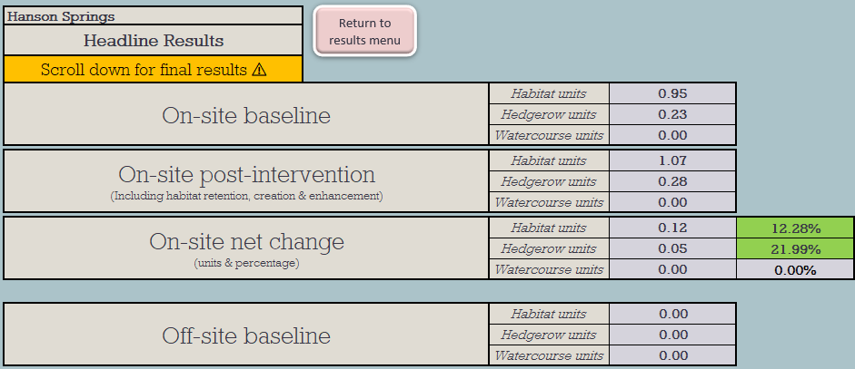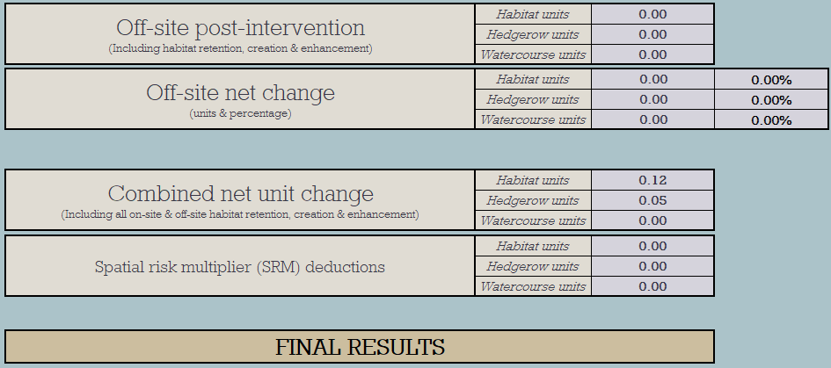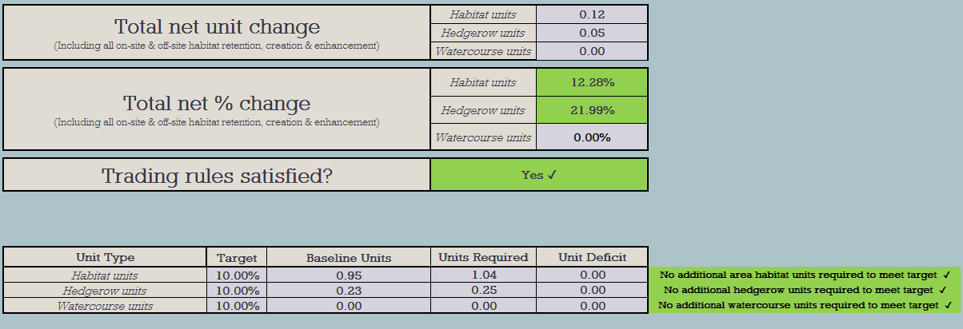

BNG Proposal
The proposal will result in the loss of small areas of other neutral grassland and ruderal / ephemeral habitat to the southwest and southeast of the proposed new building, respectively.
To compensate for this loss and deliver a 10% net gain in habitat units, an area of modified grassland at the site’s northern boundary will be enhanced from poor condition modified grassland to good condition other neutral grassland. Furthermore, two young native trees will be planted in this area. These habitats will deliver 0.41 and 0.03 habitat units, respectively.
To deliver good condition other neutral grassland, the area (currently supporting poor condition modified grassland) will be scarified, rotavated, and covered with opaque tarpaulin to prevent regrowth of modified grassland species. The area will then be sown with an appropriately diverse wildflower seed mix. Sufficient quantities of seed will be used to establish in excess of 10 species per square metre. Sufficiently regular mowing will take place to maintain a varied sward height throughout spring and summer. At the end of the growing season, the entire grassland will be mown and arisings removed. Presence of scrub, bracken, and invasive species will be controlled.
Whilst no linear (hedgerow) habitat units are lost under the proposals, the proposed new native hedgerow planting is sufficient to exceed 10% net gain in hedgerow units. The hedgerow will comprise four woody species, namely Crab Apple, Blackthorn, Holly, and Dog-rose, and will achieve at least poor condition.

References
Baker, J. Hoskin, R. Butterworth, T. (2019). Biodiversity Net Gain. Good practice principles for development. Part A: A practical guide.
Department for Environment, Food & Rural Affairs (DEFRA) (2023) - The Statutory Biodiversity Metric: User Guide (draft). Date: February 2024.
Hawthorn Design Partnership (2024) Block Masterplan. (Drawing No.: 188-PLN-L-10-B).
Hawthorn Design Partnership (2024) Location Plan. (Drawing No.: 188-PLN-L-16-A).
Pennine Ecological (2024a). 004 Hanson Springs dv3 - The_Statutory_Biodiversity_Metric_Calculation_Tool_-_Macro_enabled_02.24
Pennine Ecological (2024b). 004 Hanson Springs dv2 - Statutory_Biodiversity_Metric_Condition_Assessments-_Feb24
UKHab Ltd (2023). UK Habitat Classification Version 2.0 (at https://ukhab.org/)

Appendix A: Figures
Figure 1: Existing Habitat Plan
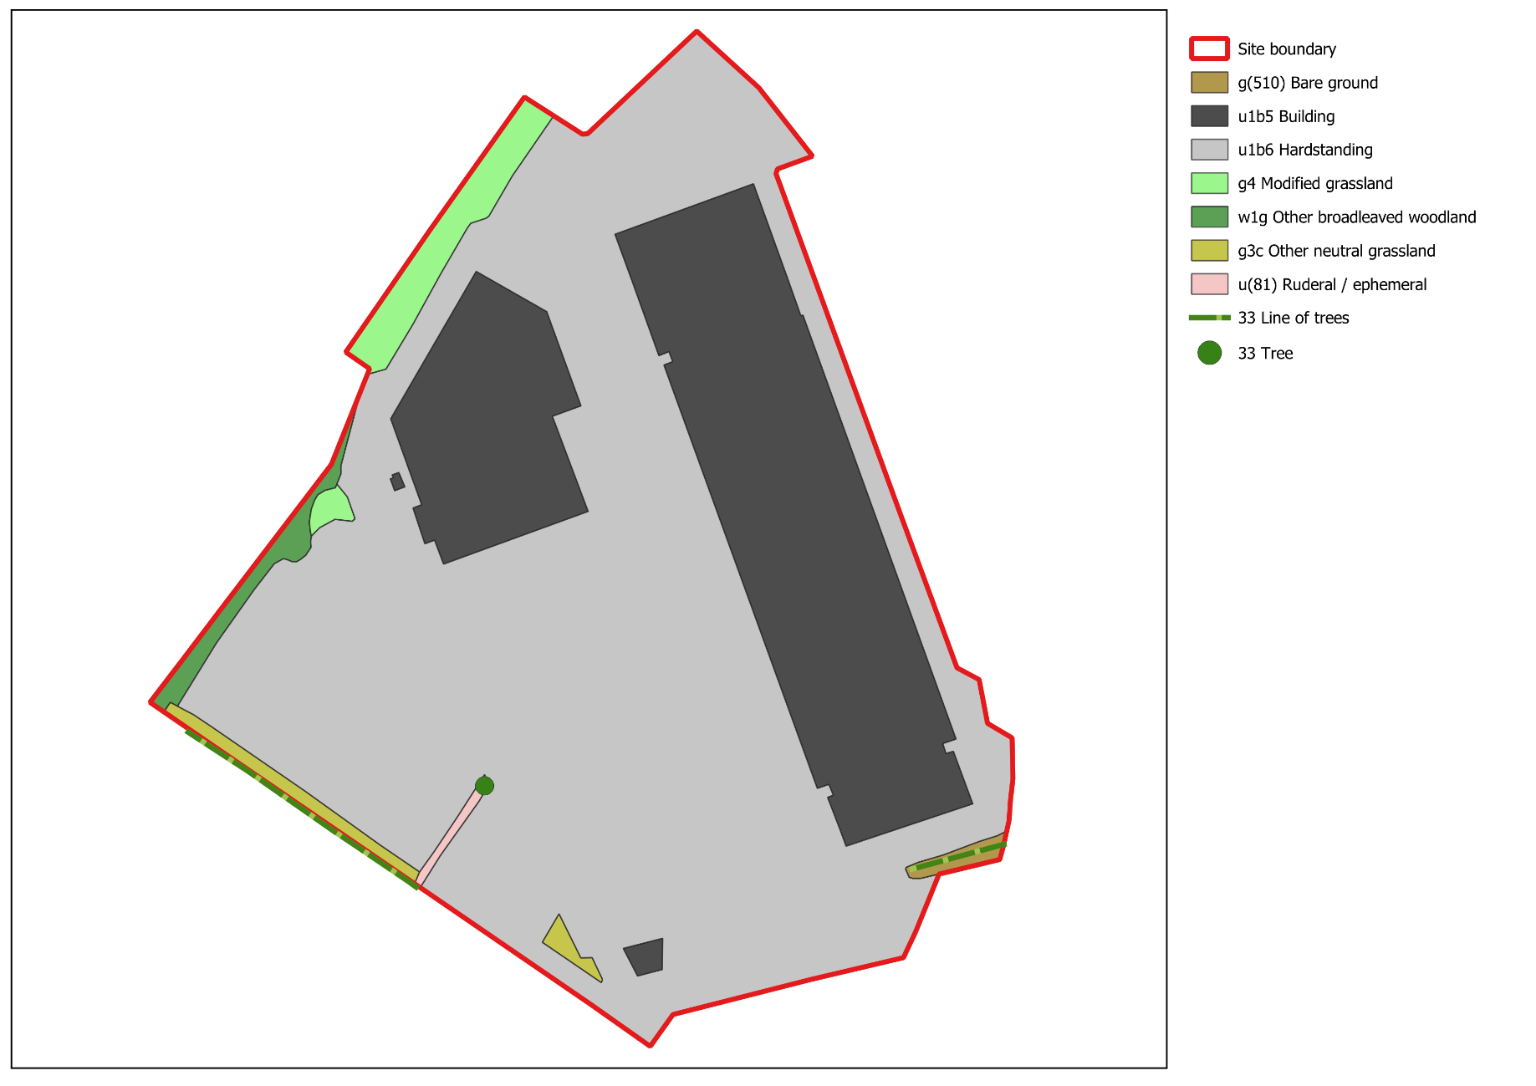

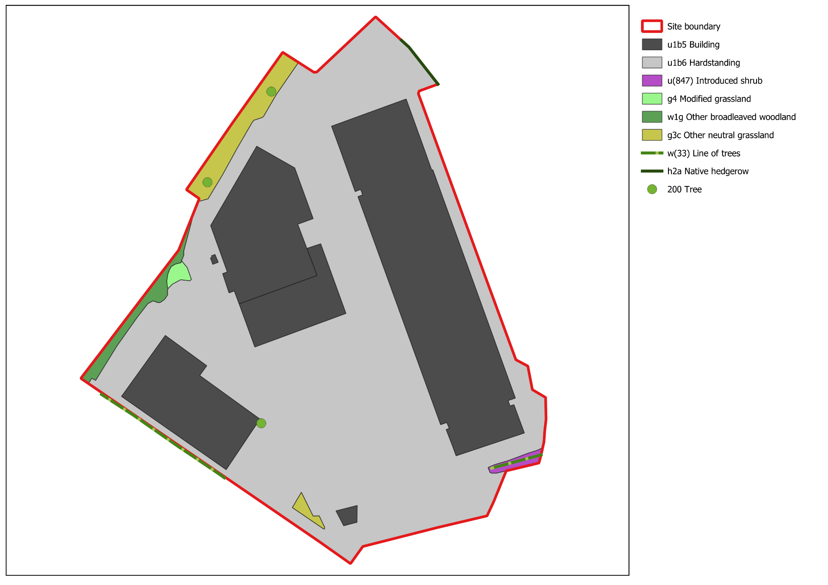
Figure 2: Proposed Site Plan

