Proposed agricultural building, Leaches Farm, Ashworth Road, Rochdale OL11 5UN
Application no. 23/00909/FUL

Ecology Report

Ref: LS.010124.A

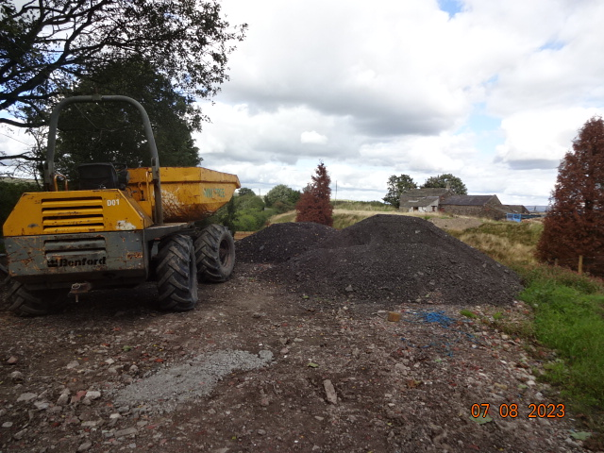

The proposed agricultural building and manoeuvring area would be sited on land which is already hard surfaced.
The agricultural building would have a floor area of 120m2 and the associated hard surface would be of a comparable area

Moreover, the General Permitted Development Order 2021 (GPDO), Schedule 2 , Part 6,Class B, permits the establishment of a hard surface of up to 1,000m2 on agricultural units of up to 5 hectares, subject to this being reasonably necessary for the purposes of agriculture within the unit, and subject to various other conditions.

Given the existing hard surface area disturbed part of the proposed site, there would be no significant or discernible adverse ecological impact., Any change would be limited in consequence of the limited extent of the proposed agricultural storage building of 120m2 and associated manoeuvring area.
Biodiversity enhancement
The proposed plans include the addition of two bat boxes, one on each gable of the proposed building.
