

Top O’th Meadow Farm
Meadowhead Lane
Norden, Rochdale
OL11 5UL
Tel: 01706 658771

26th October 2023

Monica Walczak
5 Burwell Close
Rochdale
OL12 6DQ

As requested, please see the completed tree report, as discussed this offers no guarantees as trees are living organisms and can fail at any time. We would also like to advise that no indemnity or insurance cover is offered. This report is in “my opinion” only and covers only the trees that have been inspected.

Tree in question is subject to a Tree preservation order TPO 005
- TPO name: Thrum Hall, Whitworth Road
- Date confirmed: 1973-08-29
- Tree type: The several trees of whatever species standing in the area marked A2 on the map. These include Lime and Sycamore which are predominant Birch Willow Oak Horse Chestnut Mountain Ash Elm silver Birch Ash Whitebeam
- Description: A2
- ID: A2TPO005
- Local authority: Rochdale

Location

Rear garden of 5 Burwell Close.

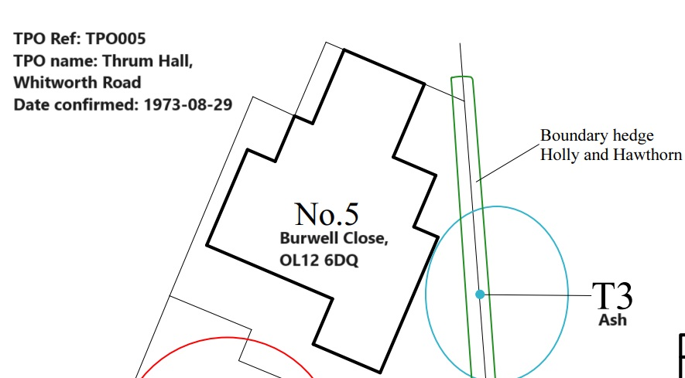
Work provided

Site visit, arboricultural inspection, photography and report.

Trees in question

T3 Ash

Problem

- The tree is causing excessive twig/branch dropping into 5 Burwell Close and to the gardens immediately next to it.
- The tree is now showing moderate signs of the Ash die back disease and the residents has been collecting twigs and branches weekly for the majority of this year.
- The residents are suffering anxiety over fears the tree will blow over or a larger limb would fail.

Recommendation

I strongly recommend the removal of T3 (Ash) due to succumbing to the Ash die back disease. Unfortunately, there is no known cure for the disease and the trees health will begin to diminish more in the future. There is no vehicle or mewp access to this tree and currently the tree in question is still safe to climb and dismantle minimising damaging to property, larger expenses to remove and risk of arborists climbing to dismantle.
Monica Walczak also agrees to replant one new tree if permission is granted for the removal.
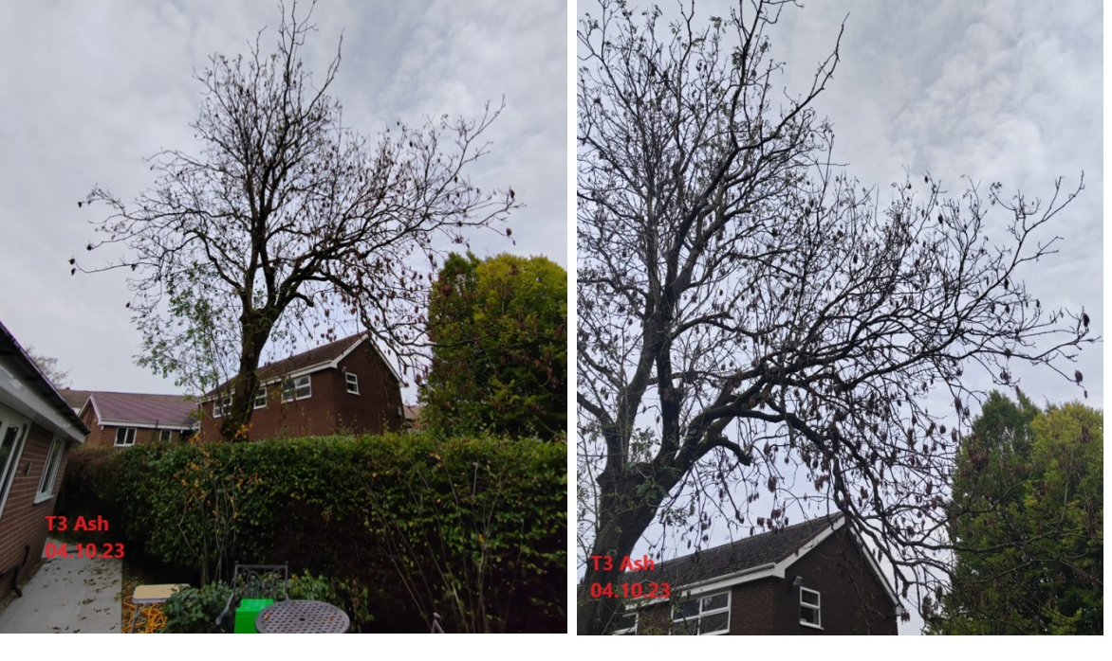

Kind regards,

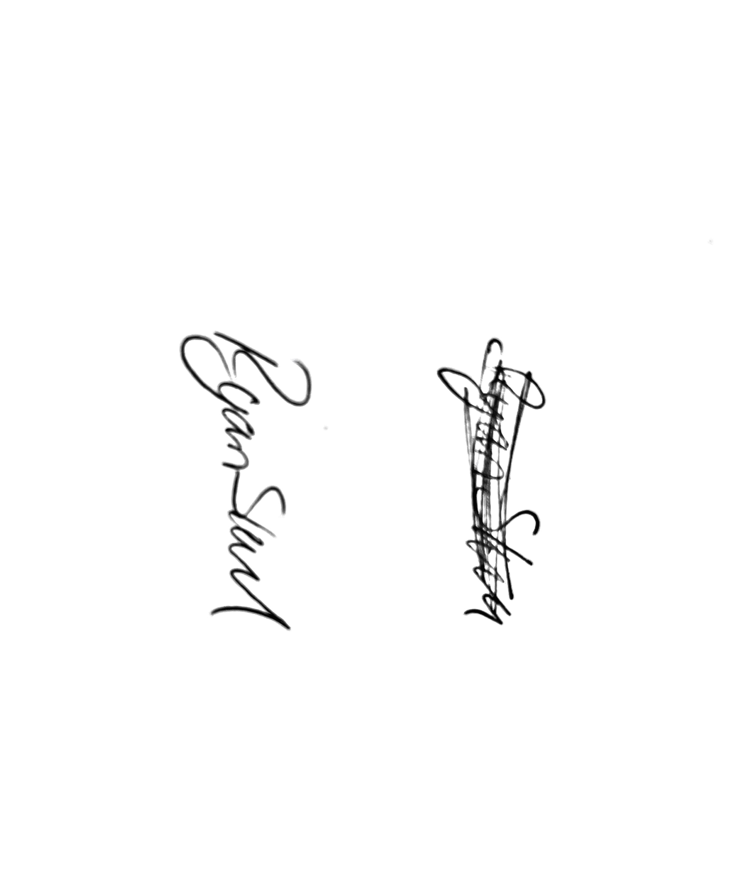
Mr. Ryan Slack
General Manager and Director
SEG Award, Cert Arb L2 (ABC)

