

Top O’th Meadow Farm
Meadowhead Lane
Norden, Rochdale
OL11 5UL
Tel: 01706 658771

19th October 2023

Linda Brown
16 Spring Bank Lane
Rochdale
OL11 5SF

As requested, please see the completed tree report, as discussed this offers no guarantees as trees are living organisms and can fail at any time. We would also like to advise that no indemnity or insurance cover is offered. This report is in “my opinion” only and covers only the trees that have been inspected.

Tree in question is subject to a Tree preservation order TPO 061

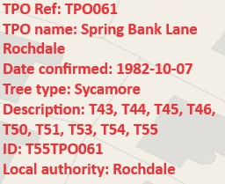
Location

Surrounding the full property.

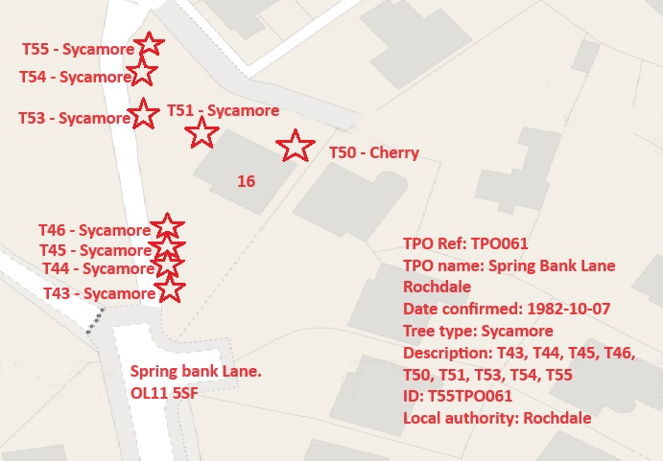
Work done

Site visit, arboricultural inspection, photography and report.

Trees in question

T43, T44, T45, T46, T51, T53, T54, T55 – Sycamore trees.
T50 - Cherry

Problem

- The trees are causing excessive dead twig/branch dropping into the gardens.
- The trees are quite dense at throughout the property thereby blocking light into the garden, they are also fairly intrusive through their lower branches.
- The trees are now growing very close to the property with branches almost touching the building.

Recommendation

T43, T44, T45 & T46 – Crown lift four Sycamore trees to 5.2 meters and crown thin all trees by a maximum of 20%.
T50 – Crown lift to 4.5 meters and reduce from the building by 2-3 meters.
T51 – Crown reduce from the property by 2-3 meters and removal of any present deadwood.
T53 – Crown thin by a maximum of 20%
T54 & T55 – Removal of any present deadwood and epicormic growth.

Application Statement

All trees are within the full protected order. I have identified these trees with the supporting evidence to request permission to carry out minor pruning works on. We are requesting permission to work on these trees as part as a maintenance plan. This application is being planned for maintenance work to look after the trees so they are not as intrusive lower down and so that they also look aesthetically pleasing. The works requested will not have any detrimental effects to the trees health nor should it affect the amenity values these trees pose. All works will be completed in accordance to BS3998.

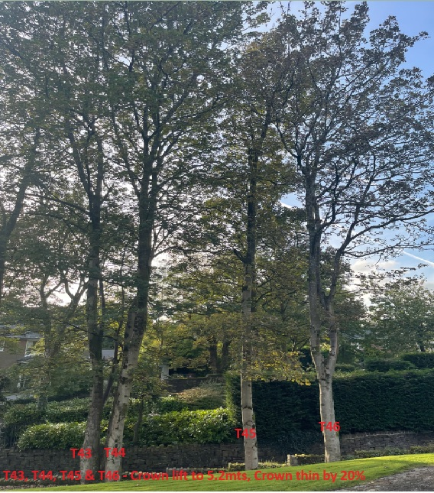

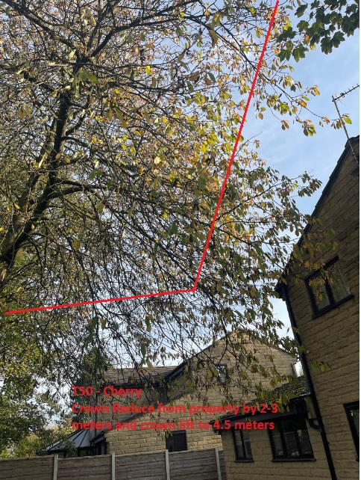

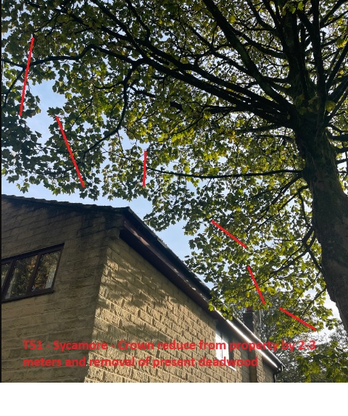
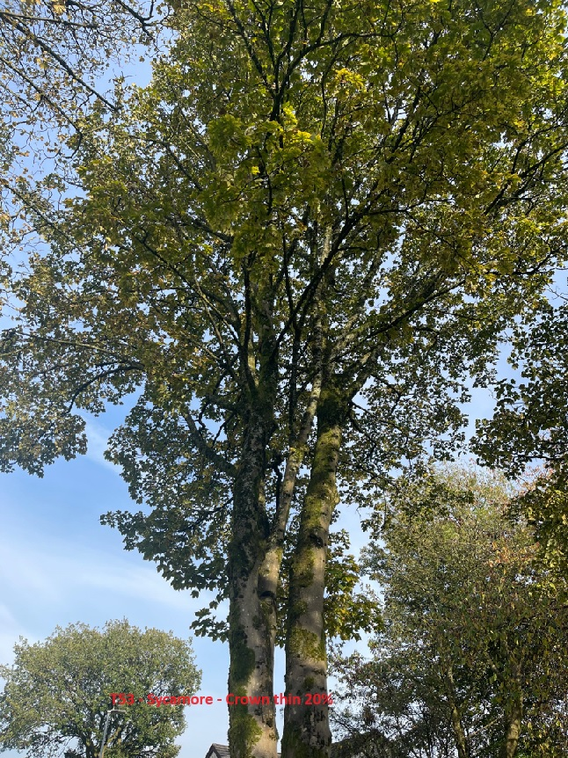
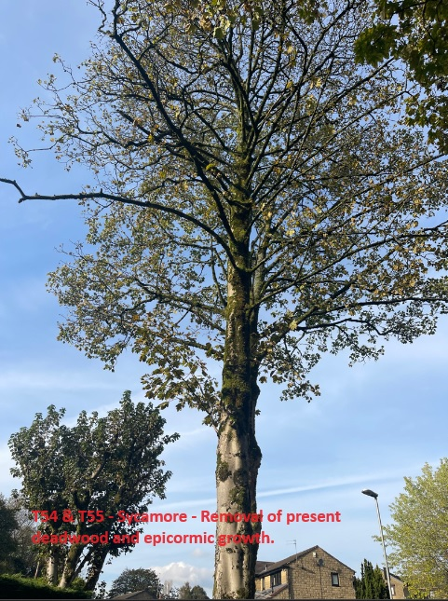

Kind regards,

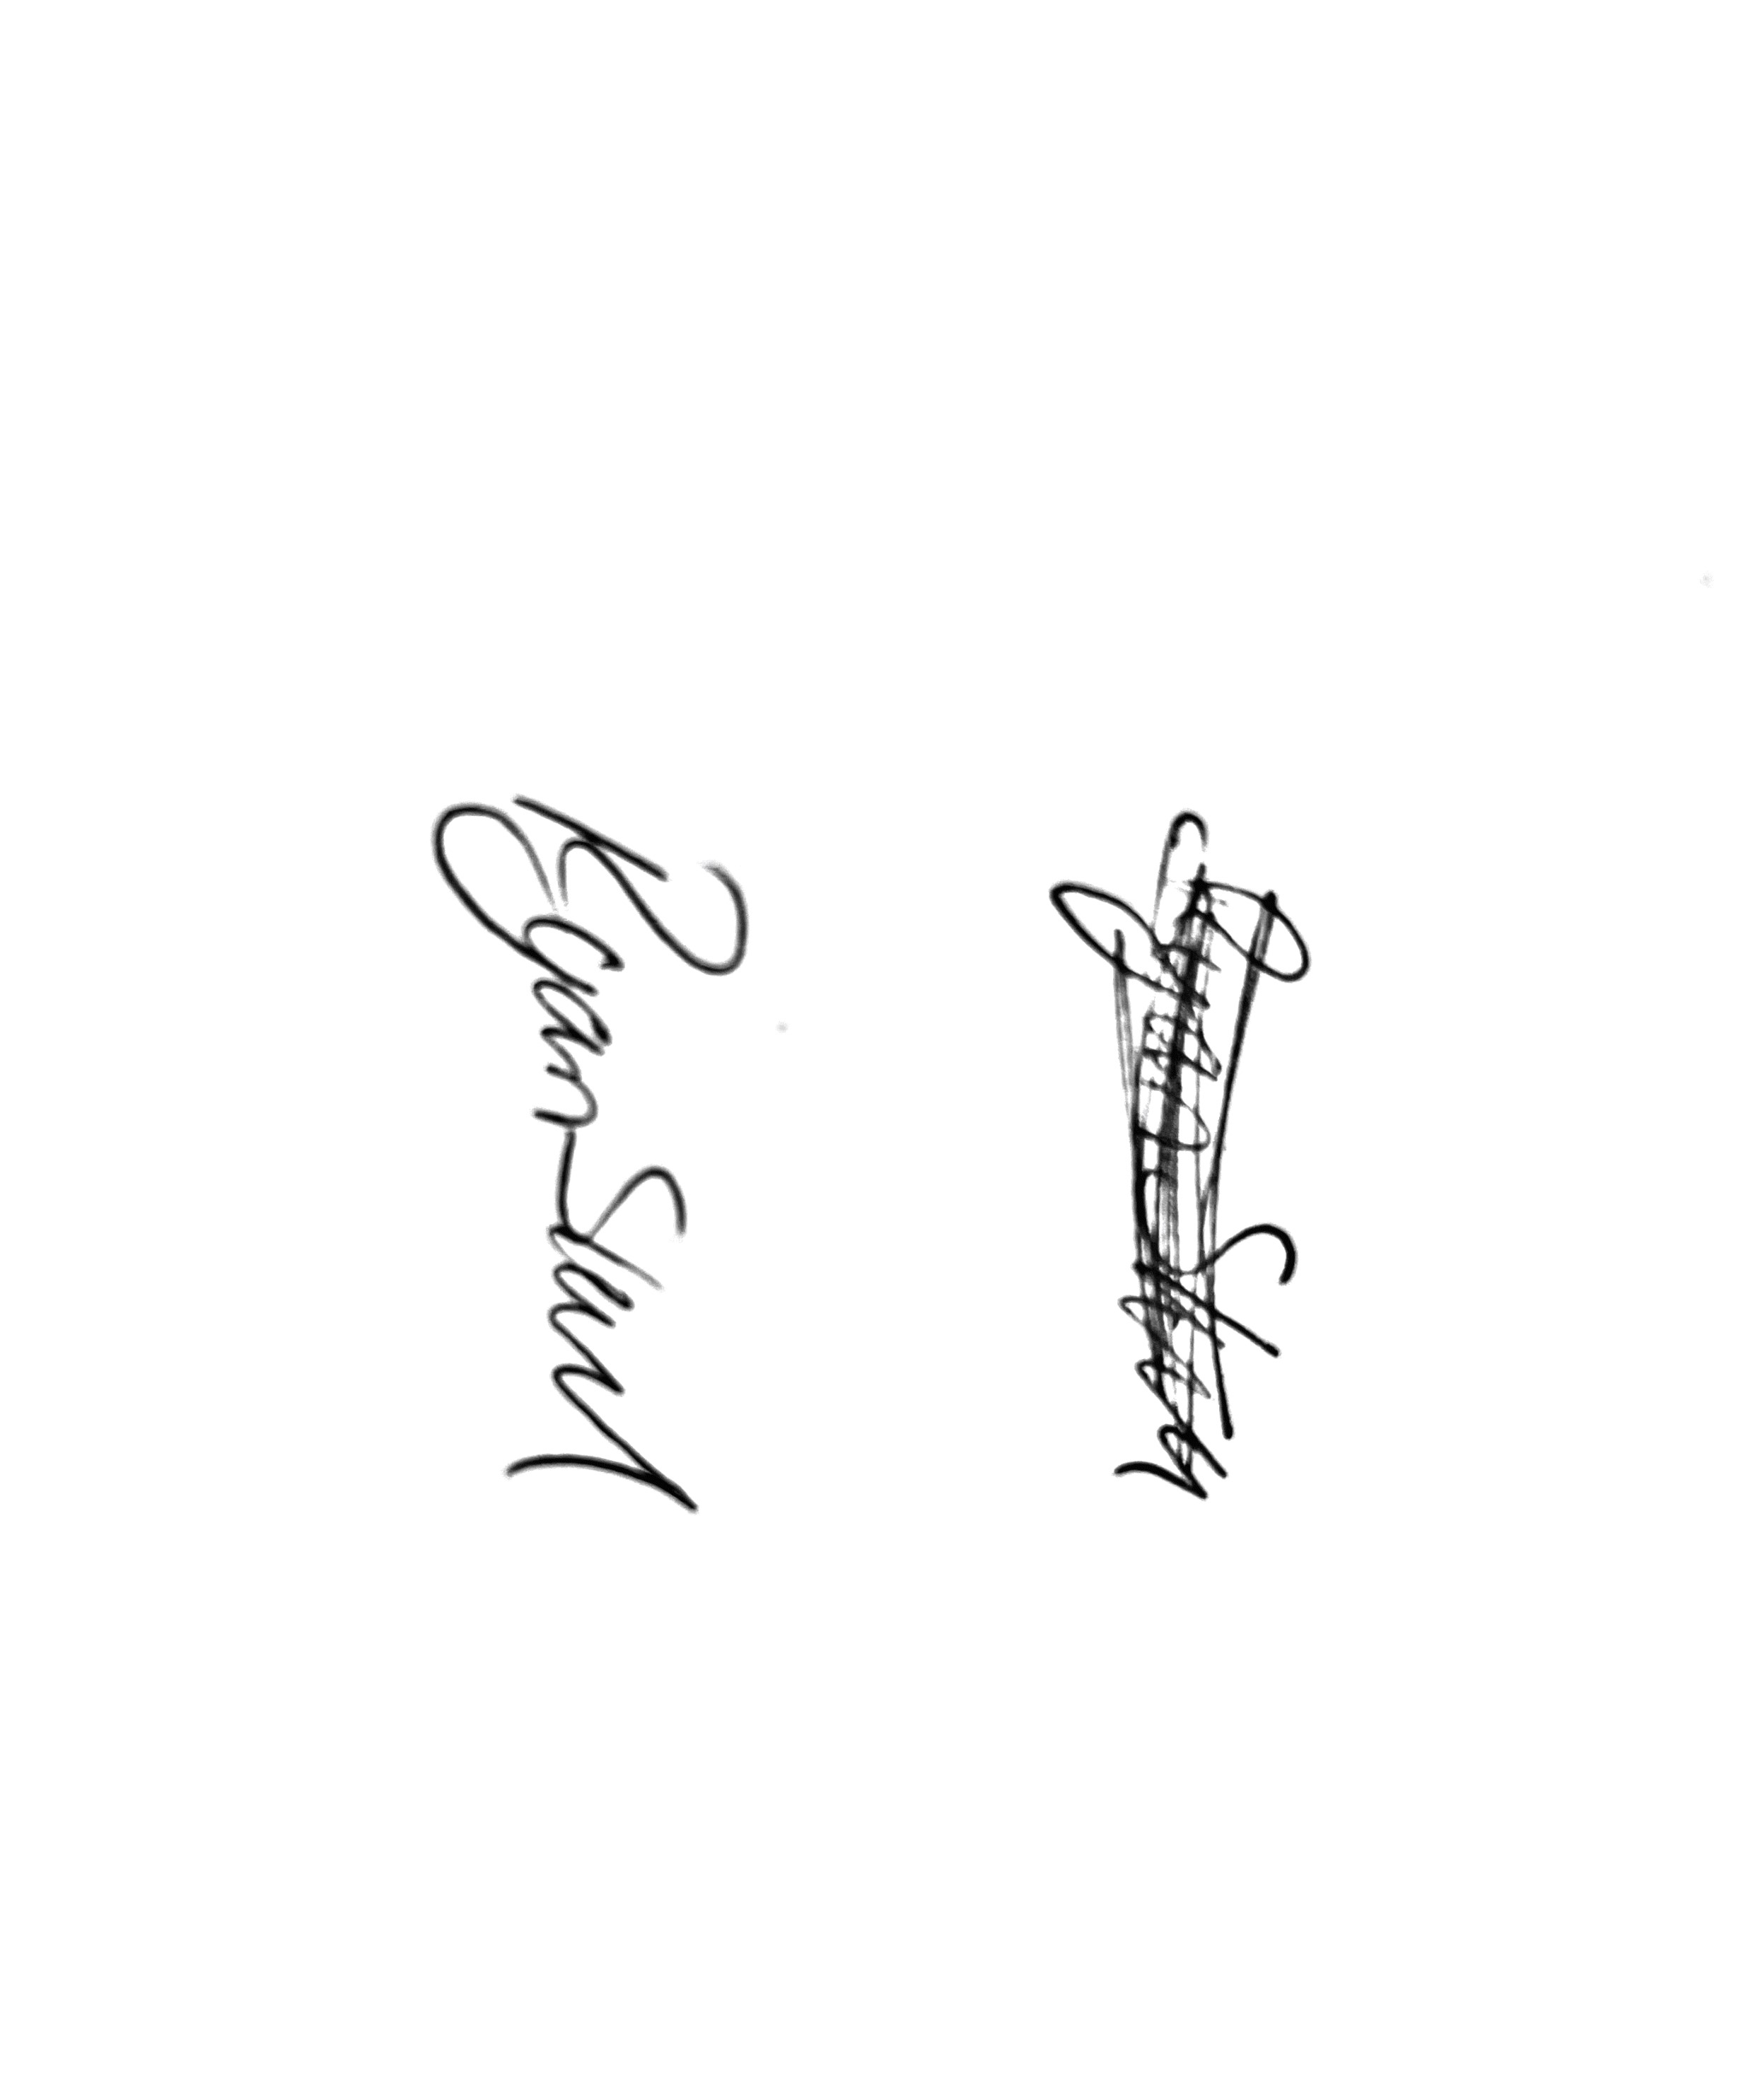
Mr. Ryan Slack
General Manager and Director
SEG Award, Cert Arb L2 (ABC)

