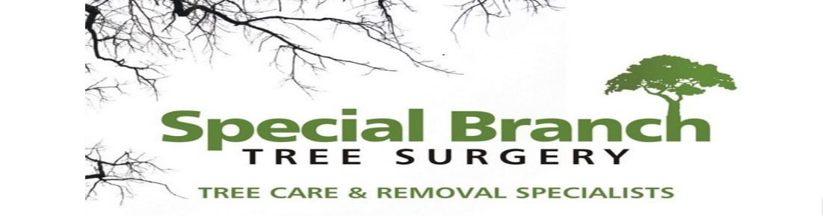

Top O’th Meadow Farm
Meadowhead Lane
Norden, Rochdale
OL11 5UL
Tel: 01706 658771

Mini Tree Report Date: 5th August 2023

Mr D Craddock
1 St Anne’s Mews
Heywood OL10 1HQ
As requested, please see my mini tree report, as previously mentioned this offers no guarantees as trees are living organisms and can fail at any time. We would also like to point out no indemnity or insurance cover is offered. This report is in “my opinion” only and covers only the trees that have been inspected.

Trees in question subject to Tree Preservation Order 212

Work done

Site visit, arboricultural inspection, photography and report.
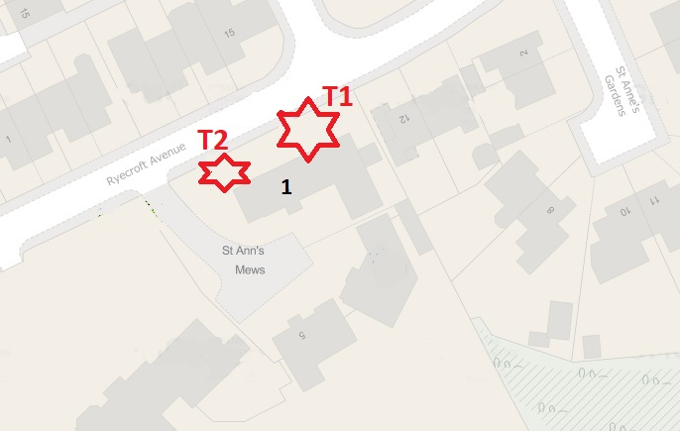

Tree in question

T1 Ash (Fraxinus excelsior ) Mature tree approximately 18 meters high with a good even spread crown Referenced T1 on the plan, annotated photography and TPO schedule
T2 Lime tree (Tilia x europaea) semi mature approximately 17 meters high Referenced T1 on the plan, annotated photography and TPO schedule

Problem

The Ash (T1) A mature Ash tree situated within very close proximity of property and highways. I strongly recommend the removal of T1 (Ash) due to succumbing to the Ash die back disease. Unfortunately, there is no known cure for the disease and the trees health will begin to diminish more in the future.
Mr Craddock also agrees to replant three new trees if permission is granted for the removal.

The tree T2 is very dense and close to the property thereby blocking light into the garden, the tree is encroaching on the house.

Recommendation

T1 Tree removal, replant 3 new trees.
T2 Side reduction on the crown by 1-2 meters to give some clearance from the house. Crown thin by 15%.

T2 health should not be affected these works.

Amenity value would be unaffected to the general public.
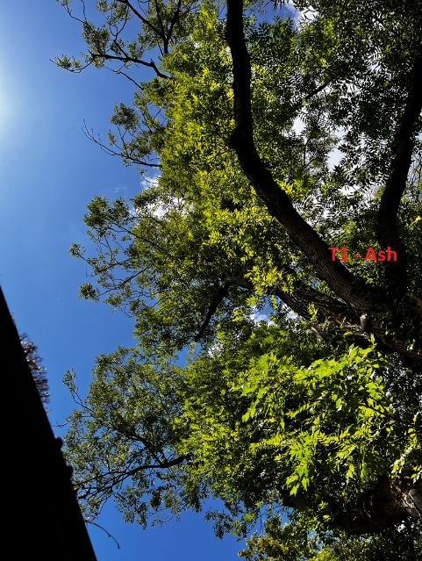

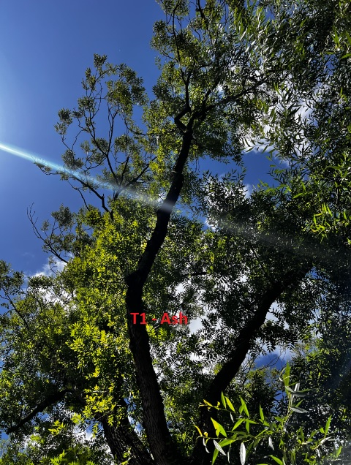

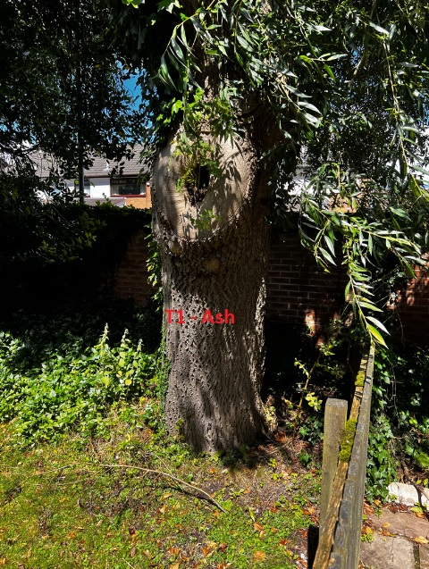

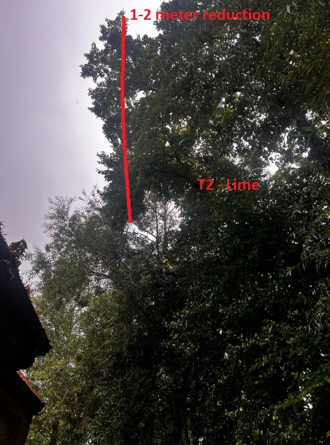

Regards,
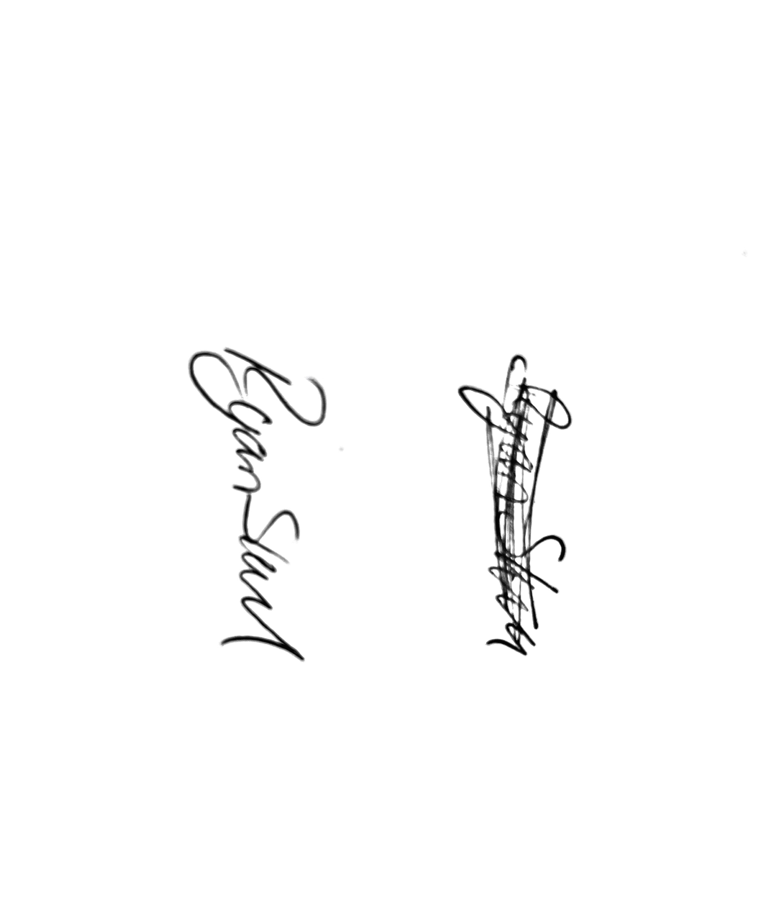
Mr. Ryan Slack
General Manager and Director
SEG Award, Cert Arb L2 (ABC)

