SPECIAL BRANCH
`

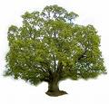
Tree Surgeons Ltd
Top O’th Meadow Farm
Meadowhead Lane
Norden, Rochdale
OL11 5UL
Tel: 01706 658771

Mini Tree Report Date: 27/03/2023

David Foley
37 Birchfield Drive,
Marland, Rochdale
OL11 4NY

As requested, please see my mini tree report, as previously mentioned this offers no guarantees as trees are living organisms and can fail at any time. We would also like to point out no indemnity or insurance cover is offered. This report is in “my opinion” only and covers only the trees that have been inspected.

Tree in question is subject to a Tree Preservation order 036

- TPO name: High Birch School Rochdale
- Tree type: Horse Chestnut Sycamore Elm Beech Hawthorn Ash Silver Birch
- Description: A2
- ID: A2TPO036
- Local authority: Rochdale

Location
37 Birchfield Drive,
Marland, Rochdale
OL11 4NY
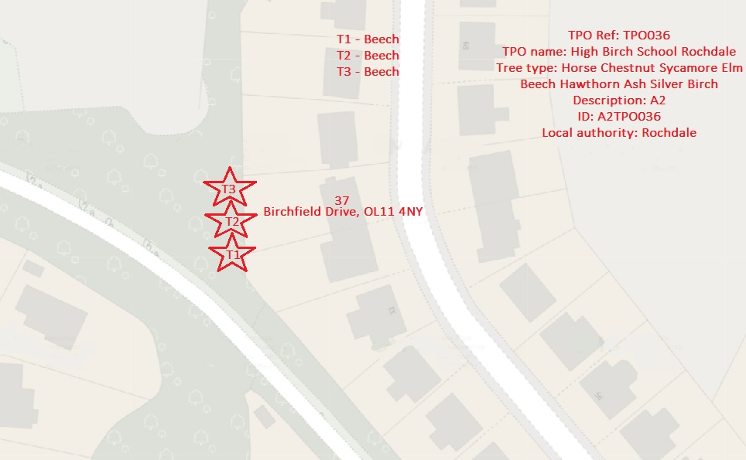

Work done

Site visit, arboricultural inspection, photography and report.

Trees in question

3 trees shown as T1, T2 and T3 in the plan, Beech

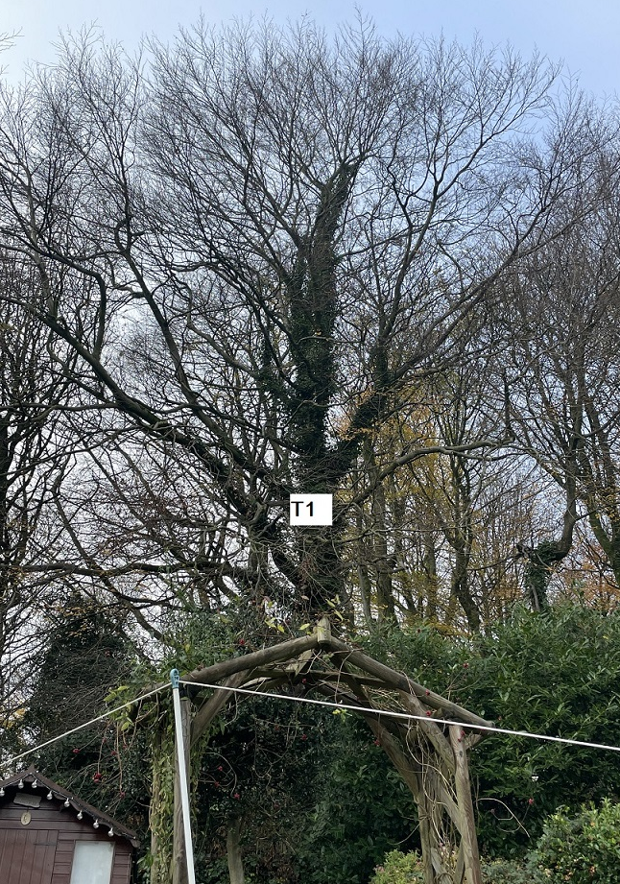
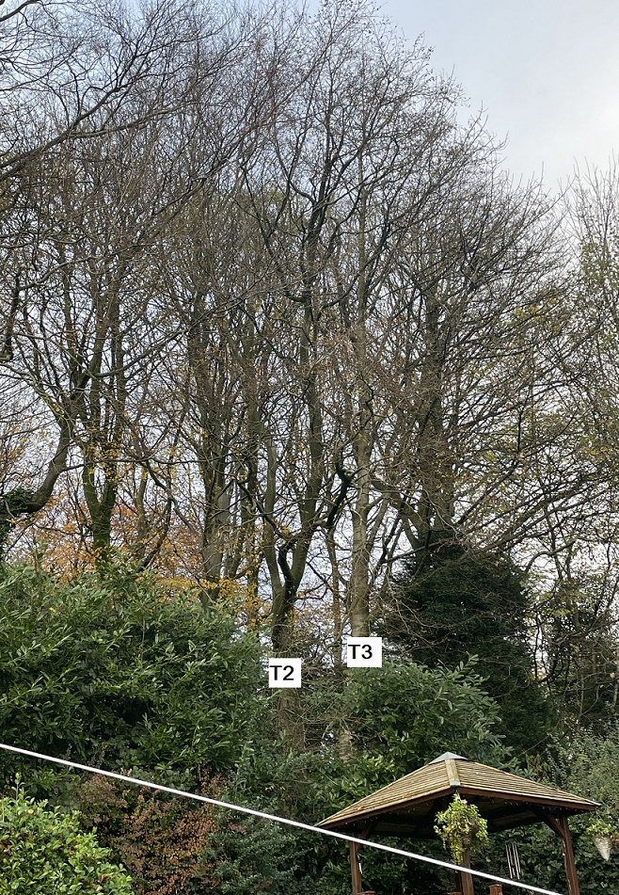

Problem

The tree has grown from the neighbouring property to the rear of 37 Birchfield Drive and overhangs the garden causing excessive shading and if left will carry on growing towards the property. Also, a large limb snapped out into the rear garden of 37 Birchfield Drive. The property owner lives in fear in case of any future failures.

Recommendation

We would recommend removal of the branches up to 4” diameter that overhangs the garden from the three Beech trees closest to the fence line from the property, this will reduce the overhang and allow some more light into the garden. We do not expect this to have a detrimental effect on the tree’s health or amenity value.

Regards

Ryan Slack
Mr R. Slack cert Arb L2 (ABC)

