Client: | Rochdale MBC
Project: | MCF Castleton
Subject: | Manchester Road / Nixon St - Traffic Impact Assessment
Doc: | MCFNixonSt_TIA_CAT_050321
Author: | Charles Taylor
Date: | 5th March 2021
Ref: | X5/043
Contact: |  |  | E-Mail: | Tel:
Ed Coventry |  |  | ed.coventry@TfGM.com | 0161 244 1876
Charles Taylor |  |  | charles.taylor@TfGM.com | 0161 244 1800
- Introduction
  - The following report considers the traffic impact resulting from the proposed changes to the layout and operation of the junction of Manchester Road / Nixon St, as illustrated in Appendix A.
  - The proposals involve modification of the Manchester Road / Nixon St junction, to incorporated controlled segregated pedestrian and cycling facilities on all arms.
  - To achieve the above arrangement, the left turn flare lane on Nixon St northbound has been omitted.
  - The following considers the likely operational efficiency of the junction during the morning peak and evening peak periods, in the assessment year.
- Junction Layout and Signal Stage Sequences
  - The proposed junction layout is included in Appendix A.

  - Manchester Rd / Nixon St – Existing Staging
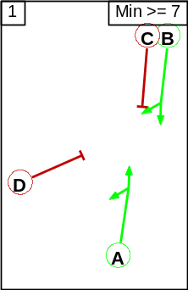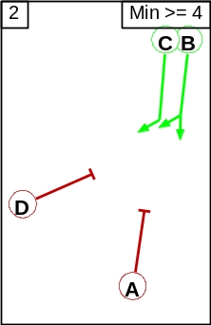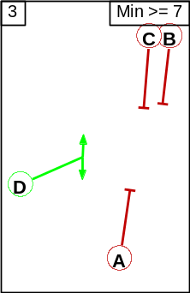

  - Manchester Rd / Nixon St – Proposed Staging
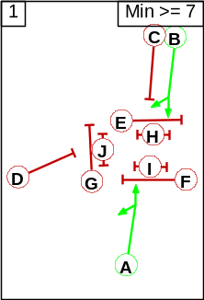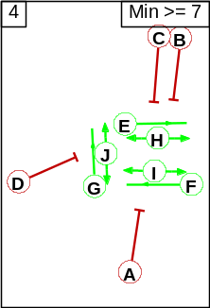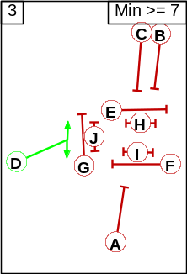

Phases E, F, G are cycle phases; phases H, I, J are pedestrian phases.
- Traffic Flows
  - The counts have been derived from surveys commissioned by Highways Forecasting and Analytical Services (HFAS) on 28th November 2019.
- Modelling Details
  - The junction has been modelled using LINSIG (version 3.2.4) for the weekday morning and evening peak periods, in the assessment year.
  - The existing maximum cycle time of 72 seconds has been used throughout.
  - The following scenarios have been modelled:
    - Existing junction layout and staging.
    - Proposed junction layout and staging.
- Results of Modelling
  - The table below indicates the predicted degree of saturation, queue length and delay for each modelled scenario.
  - The degree of saturation is a measure of how close to capacity a link is predicted to operate, with 90% taken to be the maximum practical level (between 90% and 100% delay begins to increase exponentially).
  - Queues are mean maximums and will be exceed for half the modelled period (where a link is at practical capacity the queue could be up to twice indicated).

  - Morning Peak Period
Link Description | Existing  Cycle Time 72s |  |  | Proposed  Cycle Time 72s
Link Description | Degree of saturation (%) | Delay  (s/pcu) | Queue length (metres) | Degree of saturation (%) | Delay  (s/pcu) | Queue length (metres)
Nixon Street Right and Left | 62 | 45 | 24 | 75 | 59 | 28
Manchester Road Southbound Ahead and Right | 42 | 8 | 29 | 60 | 20 | 49
Manchester Road Northbound Ahead and Left | 61 | 15 | 58 | 80 | 26 | 80
Total Delay (pcu-hours) | 7 |  |  | 11

  - Evening Peak Period
Link Description | Existing  Cycle Time 72s |  |  | Proposed  Cycle Time 72s
Link Description | Degree of saturation (%) | Delay  (s/pcu) | Queue length (metres) | Degree of saturation (%) | Delay  (s/pcu) | Queue length (metres)
Nixon Street Right and Left | 57 | 53 | 16 | 57 | 53 | 16
Manchester Road Southbound Ahead and Right | 32 | 6 | 18 | 47 | 17 | 34
Manchester Road Northbound Ahead and Left | 62 | 12.4 | 59 | 83 | 27 | 91
Total Delay (pcu-hours) | 5 |  |  | 10

- Conclusion
  - The results of the modelling indicate that the proposed changes to the layout and operation of the junction of Manchester Road with Nixon Street would result in a small reduction to junction efficiency in both peak periods.
  - This should, however, be balanced against the significant qualitative benefits afforded to pedestrians and cyclists.
  - The modelling assumes that the pedestrian stage appears in every signal cycle - this represents a worst-case scenario. In reality the stage may be called less frequently.
  - There are additional delay benefits afforded by adaptive signal control such as SCOOT or MOVA that have not been considered by this fixed-time modelling.
  - The above assessments are based on surveys undertaken prior to the COVID crisis. It is not yet clear what the long-term effects of COVID will be on traffic demand and distribution in this location.

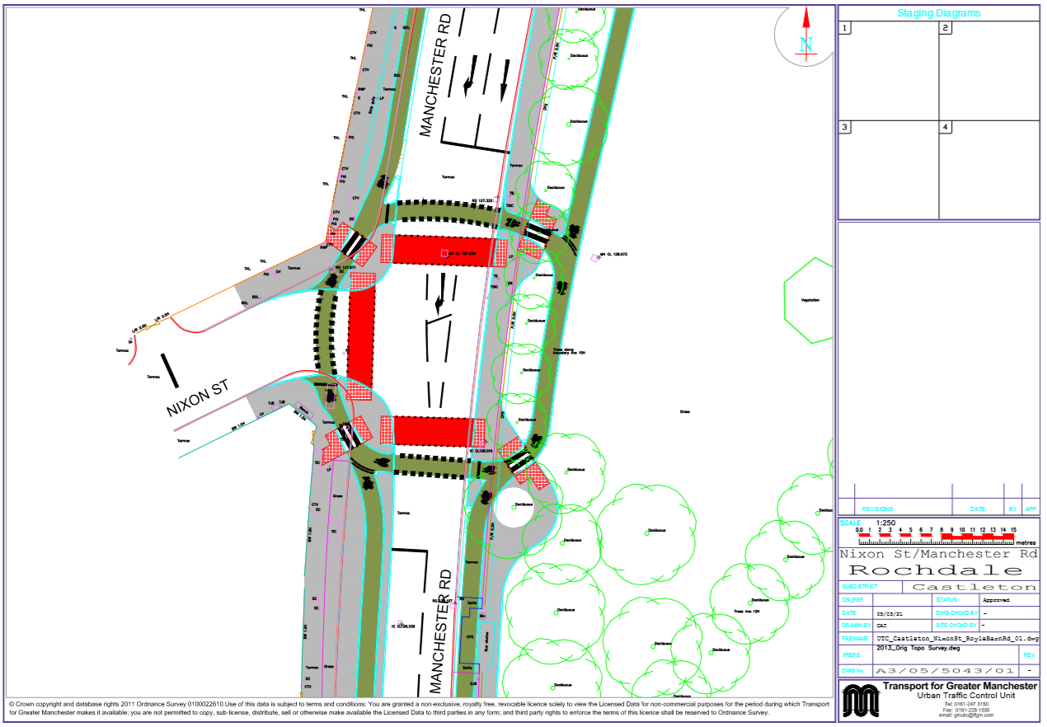
Appendix A – Manchester Rd / Nixon St – Proposed Layout

