Materials Schedule

PROPOSED RESIDENTAIL DEVELOPMENT
Rochdale Road East / Roeacre Street.Heywood

Project Details

Client:
Challenger Building Services Ltd
Postal address:
140 Lee Lane,
Horwich,
Bolton,
BL6 7AF

Application reference: 125993/FO/2020

Brief description of the works:
Redevelopment of the site to provide 40 no. one and two bedroom affordable apartments, together with associated parking, amenity space and site infrastructure.

List of the Proposed Materials
Brickwork
Type – Wiesenberger
Tuscan Red
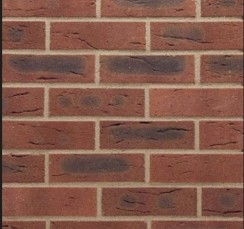

With solider course details as approved drawings

Parapet Roof Coping
Type – wall coping
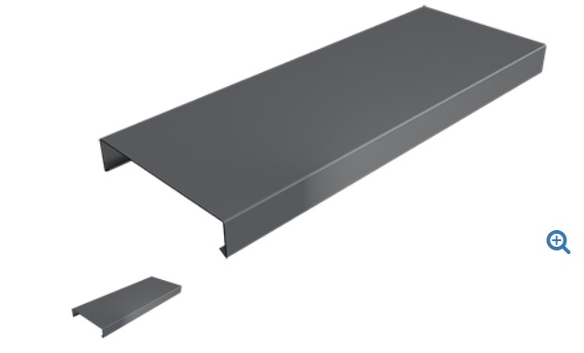

Windows
Type –UPVC – Grey
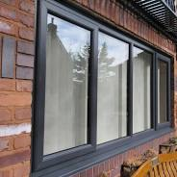

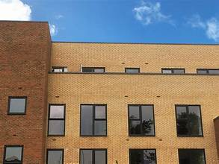

GRP Window Surround
Grey to match windows C

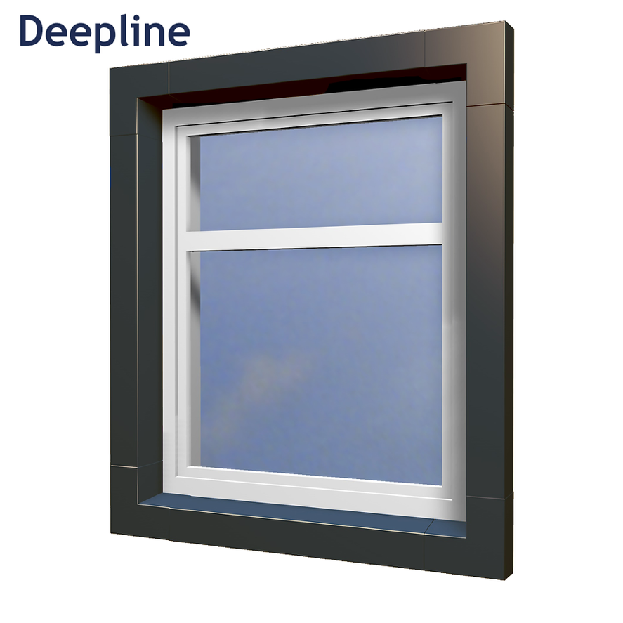
Cement Fibre Board / GRP Boarding between windows
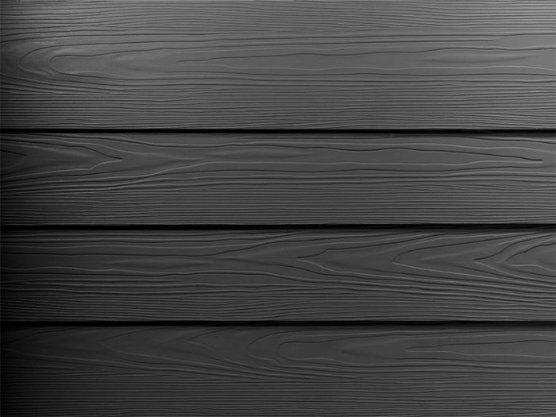

Rainwater Goods
Gutter detail within single ply roofing system
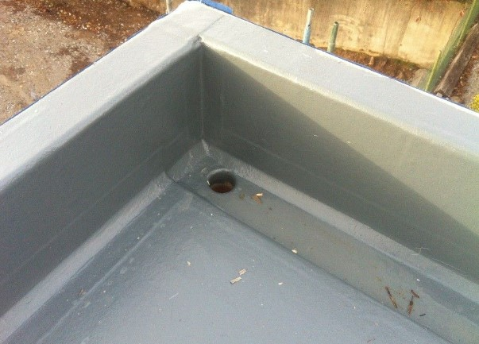

Marley anti vandal RWP and hopper

