Planning consultation response
Officer: Kuiama Thompson
Position: Director of Public Health and Communities
Contact details: Kuiama.thompson@rochdale.gov.uk
Planning Ref: 25/00312/FUL
Premises Address: Land at the junction of Water Street and Molesworth Street, Rochdale
Date of Response: 27th May 2025

Comments:
Re: Public Health observations on the proposal for planning application 25/00312/FUL Development of a drive-thru restaurant (Use Class E/Sui Generis) with associated access, servicing, car parking, hard and soft landscaping, substation, engineering works and other associated works.

Health Impacts

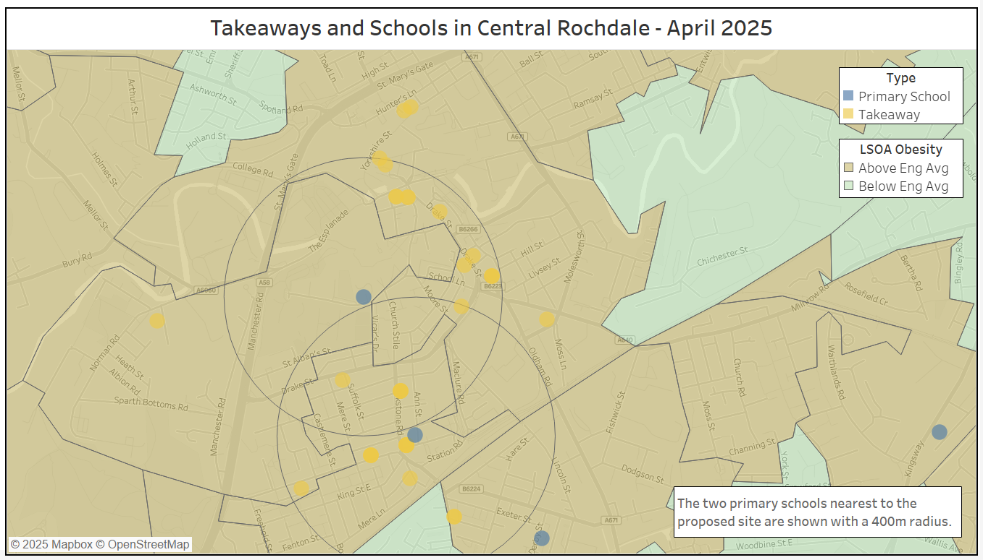
Proposed McDonalds Site

This application should be assessed against the policies set out in Rochdale Borough Council’s Guidelines and Standards for Hot Food Takeaway Uses Supplementary Planning Document (adopted April 2015 and updated February 2017). Relevant sections are summarised below:

Although hot food takeaways do not directly cause obesity, there is a growing body of evidence that recognises the impact that they can have on health. Supported by the evidence that if obesity develops in adolescence, it is likely to continue into adulthood, both the Chartered Institute for Environmental Health and the Department for Health advise that local authorities should limit the opening of new outlets, particularly in sensitive areas such as around schools. It is important to support and establish healthy eating habits from an early age.

Research indicates that the most popular time for purchasing food from shops is after school and many secondary school children may also leave school premises at lunchtime. Furthermore, fast food outlets in close proximity to, and surrounding schools, have been found to be an obstacle to secondary school children eating healthily.

In an effort to establish healthy eating habits and reduce the rate of childhood obesity in the local population, then the establishment of new hot food takeaways around secondary schools will not normally be supported. A 400m restriction buffer is considered to be a reasonable distance given that it broadly represents a 10 minute walk, taking into account physical barriers on any route. The buffer will be measured from the boundary of the grounds of each school.

DM1 -General development requirements: All development proposals, including changes of use of land and buildings, extensions and alterations, will be expected to demonstrate that they:
f. Do not have an adverse impact on health, through its impact or the effect of existing problems e.g. land contamination, or poor air quality

C6 -Improving Health and Wellbeing: We will improve people’s health and wellbeing and reduce health inequalities by:
d. Not allowing the over concentration of takeaway food premises where they may impact adversely on the amenity of residents and/or encourage unhealthy eating habits
f. Seeking high quality design of buildings, streets and spaces to create neighbourhoods that are safe to use, easy to move through, adaptable and sustainable (Policy P3);
i. Identifying and implementing measures to reduce traffic movements and congestion to reduce air and noise pollution (Policy T1);
j. Encouraging development that promotes active living by making places more accessible by walking, cycling and public transport (Policy T2);

Where appropriate we will seek a Health Impact Assessment for major planning applications and consider the use of section 106 agreements or Community Infrastructure Levy (CIL) to deliver measures to improve the health impacts of development.

Appropriate concentrations of hot food takeaways and clustering (HF3): to ensure that shopping areas are diverse and balanced, applications for hot food takeaway uses shall not normally result more than 5% of the total ground floor units within a defined Primary Shopping Area being hot food takeaways.

Health Impacts – Children and Young People
The proposed development sits in the electoral ward of Central Rochdale. The ward has a total population of 13,164 and 33% of the population are aged 0-19 (Source: ONS MYE 2022). Research shows that access to the food environment around a child can significantly influence their eating habits. Increased availability of food which is high in fat, salt and sugar can exacerbate existing overweight and obesity. #BeeWell neighbourhood data 2023 reported that only 54% of children in Rochdale are eating a piece of fruit or vegetable every day. 52% are eating unhealthy snacks often (once a day every day or every day more than once). Easier access to foods less nutritious has been shown to ‘normalise’ and increase less nutritious food choices.

There is already a saturation of fast food outlets in the Central Ward (41) and the neighbouring Milkstone and Deeplish ward (43) with at least 12 being within 400m of the proposed McDonalds site (see map 1 Takeaways and Schools in Central Rochdale). Hot food takeaways often serve energy dense and nutritionally poor food which, although not the sole cause of obesity, can be a contributing factor. In 2024 Rochdale borough registered 347 fast food outlets (151 per 100,000 population), ranking the 18th highest local authority in England.

The proposed development site is not in close proximity to any secondary schools but it is within 800m of 3 primary schools and is also close to the town centre where young people often congregate. It is only half a mile or an 11 minute walk from Hopwood Hall College Rochdale Campus and approximately a 4 minute walk from the central bus and tram station, also spaces where young people congregate.

There are concerning rates of childhood obesity in the borough. Obesity in reception year (aged 5-6 yrs) rose from 10.5% in 2022/23 to 11.7% in 2023/24 plus severe obesity in reception year rose from 3.5% in 2022/23 to 4% in 2023/24. Rochdale borough has the highest obesity rates in our 5-6 year olds than any other local authority across Greater Manchester plus they are significantly worse than the national average. In the Central Rochdale ward specifically 17.6% of pupils in reception (aged 4/5) are overweight or obese (NCMP 2021/22 -2023/24) increasing to 42.4% of pupils in year 6 (aged 10/11). This is below the Rochdale Borough average in Reception (23.3%) but above the Borough average in Year 6 (39.8%). These high percentages are significant as overweight and obesity increases the risk of health conditions including diabetes, cardiovascular disease and some cancers.

The proposed development will also serve neighbouring wards of Milkstone and Deeplish and Spotland and Falinge which have high rates of overweight and obesity (Reception: 20.2%; Year 6: 41.0% in Milkstone and Deeplish and Reception: 24.4%; Year 6: 37.2% in Spotland and Falinge). Source: National Child Measurement Programme 2021/22 to 2023/24.

The health of children is in decline and whilst many factors influence this, what is critical is both how much food our children are eating but also what they are eating as these are playing a huge part in the rise of preventable illness in children.

Health Impacts - Adults

Rochdale is the 15th most deprived borough in England. In tackling this issue, it is vital that community needs are supported through appropriate physical and social infrastructure. Rates of Type 2 diabetes, cardiovascular conditions, and common cancers are significantly higher in parts of the Rochdale borough compared to the national average. 73.3% of Rochdale adults are classified as having excess weight, this is greater than the North West (66.5%) and England (64.0%) and is increasing annually (Source: OHID/Sport England 2022/23).

Only 23.4% of residents over the age of 16 meet the recommended 5 portions of fruit and vegetables per day, compared to 27.3% in the North West and 31.0% in England (Source: OHID/Sport England 2022/23).

As currently presented, we have concerns regarding the potential negative impact on the health and well-being of Rochdale boroughs adult residents living or working in the vicinity, or regularly passing by the proposed facility. Residents in adjacent wards also experience considerable health inequalities and needs (see appendix 1).

There is already a McDonalds drive-thru on Sandbrook Retail Park (3.37km away) and Kingsway Retail Park (2.25km away). The proposed location, on Water St, means that many Rochdale residents are likely to pass the facility during their everyday journeys, including commuting to work, resulting in the potential of a wide-reaching negative health impact from the development. The Operator Statement submitted includes details regarding the socio-economic, climate and community impact of the development but the Statement does not include a health impact assessment.

Rochdale Borough Health Context and Health Improvement Approach

Creating and maintaining a healthy food environment is crucial for enabling people to make health positive food choices and maintain a healthy weight. This is recognised and supported through both the Rochdale borough Core Strategy and the Hot Food Takeaway Supplementary Planning Document, which addresses fast food outlets.

A healthy food environment requires an accessible and supportive food offer, without routine exposure to unhealthy food options, particularly during everyday activities and travel. We are concerned that the proposed development may undermine this effort. The services and programs most likely to be affected include:

- Rochdale Sustainable Food Borough Programme, Food Partnership and developing Good Food Strategy
- Rochdale Borough Physical Activity and Healthy Weight Plan
- Healthy Schools Programme
- Raising Rochdale – The Children and Young People’s Partnership Plan 2024-27
- Living Well Health Improvement Service / Your Trust Tier 2 Healthy Weight Programme

Furthermore this proposed development will contradict the aims and ambitions of several key local and national policies adopted by the borough including:

- Greater Manchester Interim Travel plan
Active Travel is a key priority in the Rochdale Borough Physical Activity and Healthy Weight Plan and the Greater Manchester Moving in Action 2021-2031 strategy. Physical activity rates in the borough are below the England average. The rationale for the drive-through element of this application is questionable, given the site’s accessibility to public transport and active travel modes:

- Bus stops and the main bus station within a short walking distance
- A well-developed footpath network
- Proximity to advisory cycle routes, making the site accessible to cyclists

The Interim Travel Plan provided outlines plans to encourage staff to travel by alternative modes of transport and reduce the number of journeys by car but there is very little mention of a similar approach being implemented for customers. We are concerned about the overall impact on the local health environment.

- Rochdale Borough Core Strategy
In line with national policy, the Core Strategy (adopted 2016) promotes health through better physical access to facilities, stronger Local Centre’s, safer environments and accessible routes and transport. We are keen to turn round the borough’s poor health record, particularly in the most deprived areas. We aim to make the whole borough a healthier and safer place where people live longer, have healthy lifestyles and have good access to quality health facilities. The poor levels of health and well-being in our deprived communities are due to a number of factors. These include individual lifestyles, social and community influences and general socio-economic, cultural and environmental conditions. Therefore, promoting health and wellbeing is cross cutting and requires a multidisciplinary approach. Residents need to feel they have real choices and are included and offered help to enjoy good health.

- Heywood, Middleton and Rochdale Locality Plan 2025-2030
The Heywood, Middleton and Rochdale (HMR) Locality Plan sets out how we will work together to improve the health, wellbeing and life chances of our population through the HMR Integrated Care Partnership Committee (ICPC). The Plan sets out our vision, strategic objectives, priorities and the outcomes we aim to achieve for the residents of HMR. It is the boroughs Health and Wellbeing Strategy. The strategic objectives include strengthening our communities, helping people stay well and detect need earlier and addressing poverty and grow the wealth of our communities. We have a number of outcomes, the difference we want to see, one of them being that ‘where our residents live will improve their health, wellbeing and life chances.

- Rochdale Borough All-Age Prevention Strategy
Through the All-age Prevention Strategy, partners in the borough have committed to focus on prevention by shifting more of the focus towards enabling people to be well and preventing ill health, and to address health inequalities through working for good health and wellbeing for everyone, by tackling root causes of ill health. Increasing availability of foods high in fat, salt and sugar to children and young people is counter to these principles.
The plan includes a statement highlighting that the submission of Health Impact Assessments for development proposals will help ensure that the effects of development on both health and wellbeing are considered and responded to during the planning process. Health Impact Assessments should aim to enhance the potential positive aspects of a proposal while avoiding or minimising any negative impacts, with particular emphasis on disadvantaged sections of communities that may be affected.

- GM Places for Everyone Joint Development Plan 2022 to 2039
Adopted in 2024 the Places for Everyone Joint Development Plan of Bolton, Bury, Manchester, Oldham, Rochdale, Salford, Tameside, Trafford, and Wigan Councils sits at the foundations of proposals to improve employment opportunities for our communities, build the right homes in the right places, rejuvenate green spaces and reshape town centres. As a long-term plan for jobs, new homes, and sustainable growth it tackles the inequalities experienced by so many of our communities.

- National Planning Policy Framework (NPPF)
The NPPF states that planning decisions should be supportive of healthy lifestyles, through promoting good health, especially where this would address identified local health and wellbeing needs to improve access to healthy food. This proposal increases accessibility and availability of foods high in fat, salt and sugar, which is not in line with this framework. NPPF makes reference to refusal of fast food outlets within walking distance of schools and other places where children congregate (Appendix 2). The proximity to local schools and the town centre, passing footfall and bus stops to this proposed development means that the Director of Public Health’s advice is that this application is not supported.

Conclusion:
From a public health perspective, we should be refusing applications for fast food outlets in locations where there is evidence that a concentration of such uses is having an adverse impact on local health, pollution or anti-social-behaviour, or where they are within walking distance of schools and other places where children and young people congregate.

As outlined above, I believe there is sufficient evidence to demonstrate just cause to reject this application because:

- this proposed development contradicts what is set out in our SPD, section DM1; it will have an adverse impact on health.
  - Rochdale has the 19th highest concentration of fast food outlets per 100,000 population
  - Our childhood obesity rates in the borough and the specific wards affected by this application are significantly higher than regional and national averages and they are worsening.
- this proposed development does not align with NPPF recommendations in that it is within 400m of the town centre/bus station area which is a key area for young people to congregate.
- there is already a dearth of hot food takeaways in this area which may already have pushed us beyond the 5% concentration limit as set out in our Hot Food Takeaway SPD. We would like to seek advice/analysis from the planning and licensing teams in the council to see if we could assess this concentration and recommend this informs the application decision.
- accepting this proposal contradicts the efforts of our council and wider system and its aims to improve the health and wellbeing of our residents. This application would be counter to all the aims and objectives in the strategies outlined earlier along with the services we commission around healthy eating and physical acidity.
- this proposed development, as a drive-thru promotes sedentary behaviour and therefore contradicts the physical activity and active travel strategies for our city region and borough.
- there are already 2 drive thru sites from this application less than 5km from the proposed site.

In conclusion, the proposed drive-through outlet will increase the availability of food high in fat, salt, and sugar, additionally a health impact assessment has not been carried out, and as such I request that the development is not approved on these grounds.

Yours Sincerely

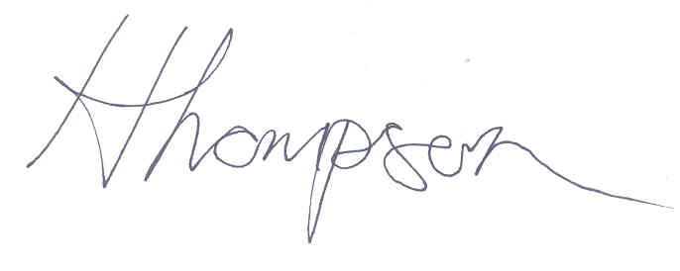

Kuiama Thompson
Director of Public Health and Communities
Rochdale Borough Council

Appendix 1 – Health Profiles

Central and Falinge Ward

- Male Life expectancy (3 year average 2020-22) - 73.2 years
- Female Life expectancy (3 year average 2020-22) – 78.5 years
- Child Excess weight – Reception Year (2021/22-2023/24) – 17.6%
- Child Excess weight Year 6 (2021/22-2023/24) – 42.4%
- Circulatory Disease Under 75 Mortality SMR – 214.8 (England 100, Rochdale 147.6) (2016-20)

Milkstone and Deeplish Ward

- Male Life expectancy (3 year average 2020-22) – 74.6 years
- Female Life expectancy (3 year average 2020-22) - 77.0 years
- Child Excess weight – Reception Year (2021/22-2023/24) – 20.2%
- Child Excess weight - Year 6 (2021/22-2023/24) – 41.0%
- Circulatory Disease Under 75 Mortality SMR – 219.3 (England 100, Rochdale 147.6) (2016-20)

Spotland and Falinge Ward

- Male Life expectancy (3 year average 2020-22) – 75.8 years
- Female Life expectancy (3 year average 2020-22) - 81.4 years
- Child Excess weight – Reception Year (2021/22-2023/24) – 24.4%
- Child Excess weight - Year 6 (2021/22-2023/24) – 37.2%
- Circulatory Disease Under 75 Mortality SMR – 127.8 (England 100, Rochdale 147.6) (2016-20)

Appendix 2 NPPF

National Planning Policy Framework - December 2024
• Paragraph 96 (c) - Planning policies and decisions should aim to enable and support healthy lives, through promoting good health and preventing ill-health. This includes supporting access to healthier food, particularly in areas with health inequalities.
• Paragraph 97 - Local planning authorities should refuse applications for hot food takeaways and fast-food outlets:
(a) within walking distance of schools and other places where children and young people congregate, unless the location is within a designated town centre.
(b) in locations where there is evidence that a concentration of such uses is having an
adverse impact on local health, pollution, or anti-social behaviour.

