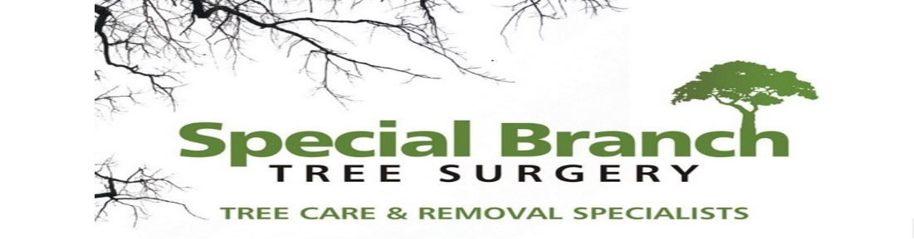

Top O’th Meadow Farm
Meadowhead Lane
Norden, Rochdale
OL11 5UL
Tel: 01706 658771

12th August 2024

Gareth Evans
Hopwood Hall College, Middleton Campus
Rochdale Road, Middleton
M24 6XH

As requested, please see the completed tree report, as discussed this offers no guarantees as trees are living organisms and can fail at any time. We would also like to advise that no indemnity or insurance cover is offered. This report is in “my opinion” only and covers only the trees that have been inspected.

Trees in question are subject to a Tree preservation order – TPO050

Local authority: Rochdale

Location
Hopwood Hall College, Middleton Campus.

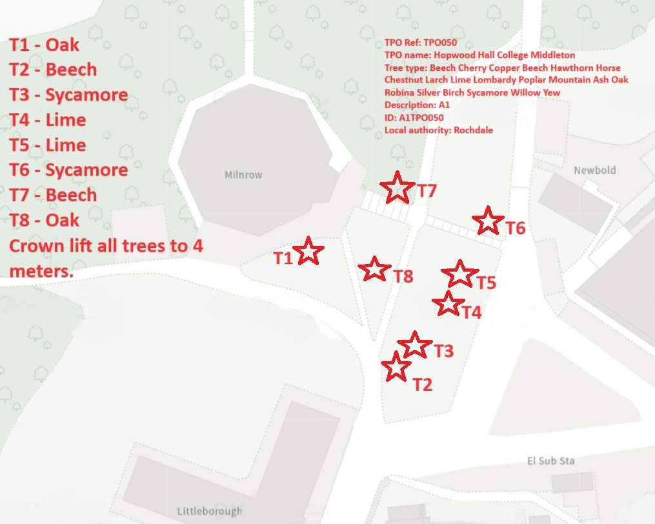

Work provided

Site visit, arboricultural inspection, photography, report, and quotation.
All trees have been thoroughly inspected and only the tree with any defects or concerns have been noted.

Trees included

T1 – Oak
T2 – Beech
T3 – Sycamore
T4 – Lime
T5 – Lime
T6 – Sycamore
T7 – Beech
T8 - Oak

Issues found

Group of eight healthy mature trees, all eight trees do not show any visible signs of previous pruning works. All the trees currently have low intrusive branches which effect the visibility to the Milnrow building which is currently being re-furbished and causing obstructions to the grounds maintenance team.

Recommendations

Crown lift all the trees to a minimum 4 meter ground clearance.

Crown lifting mature trees to a height of 4 meters is a strategic arboricultural practice that offers numerous benefits for both the health of the tree and the surrounding environment. By selectively removing lower branches to achieve this specific clearance, several key objectives are accomplished.
1. Increased Light Penetration: Crown lifting allows more sunlight to reach the lower sections of the tree, as well as the surrounding vegetation. This enhanced light penetration promotes photosynthesis in the tree and encourages the growth of understory plants, improving overall ecosystem productivity.
2. Enhanced Air Circulation: Elevating the crown of the tree improves air circulation within the canopy, reducing the risk of fungal diseases and stagnant air pockets that can harbor pests. This increased airflow also benefits the tree by promoting transpiration and moderating temperature fluctuations.
3. Improved Aesthetic Appeal: Crown lifting to 4 meters can create a more visually appealing tree structure by providing a clear view of the trunk and creating a well-defined canopy line. This aesthetic enhancement is particularly important in urban and landscaped environments.
4. Structural Stability: Removing lower branches through crown lifting can help to reduce the risk of limb failure, especially during storms or high winds. By elevating the canopy, the tree's weight distribution is optimized, minimizing the potential for branch breakage and improving overall structural stability.
5. Management of Access: Crown lifting to 4 meters allows for better access beneath the tree for maintenance activities such as mowing, landscaping, and pedestrian passage. This improved access facilitates ongoing care and helps reduce potential conflicts between trees and surrounding structures or utilities.
Overall, crown lifting mature trees to a height of 4 meters represents a proactive approach to tree management that addresses multiple objectives, from enhancing tree health and ecosystem function to improving safety and aesthetics. By understanding the importance of crown lifting and implementing this practice judiciously, arborists and land managers can promote the long-term vitality and sustainability of mature trees in diverse landscapes.

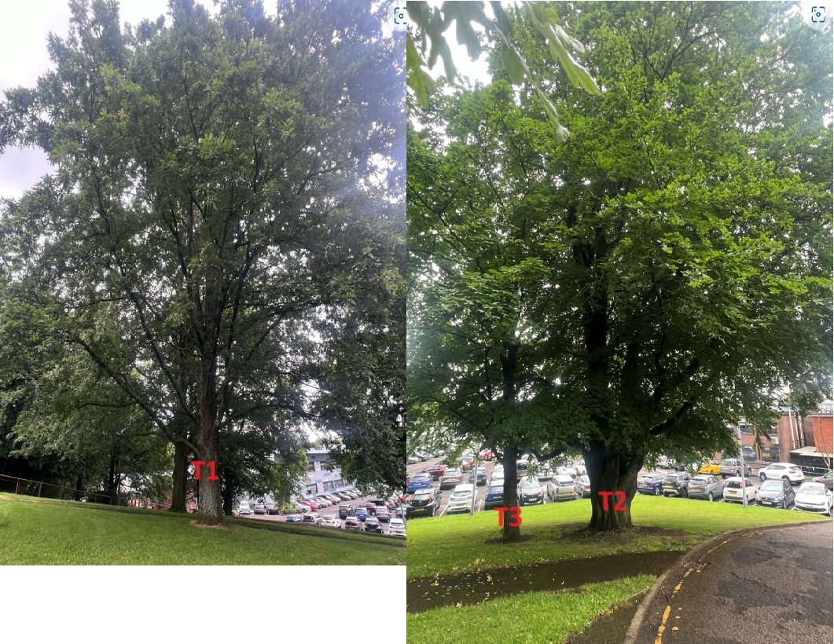

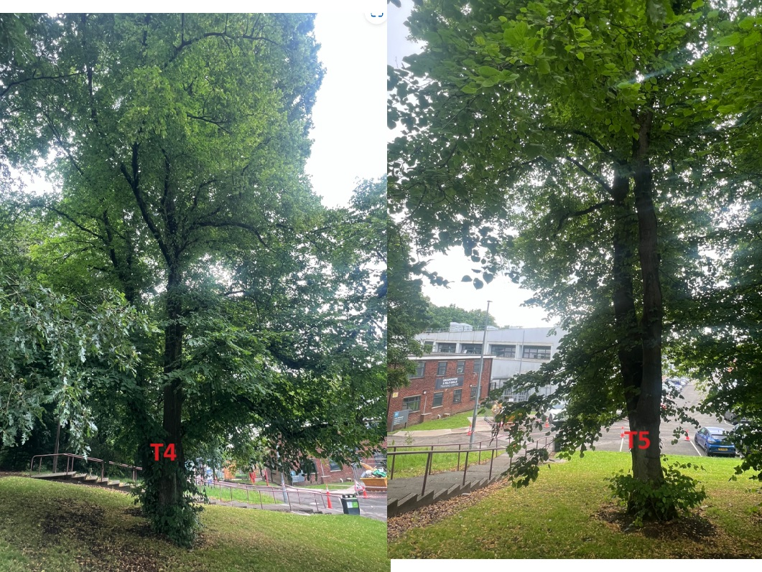

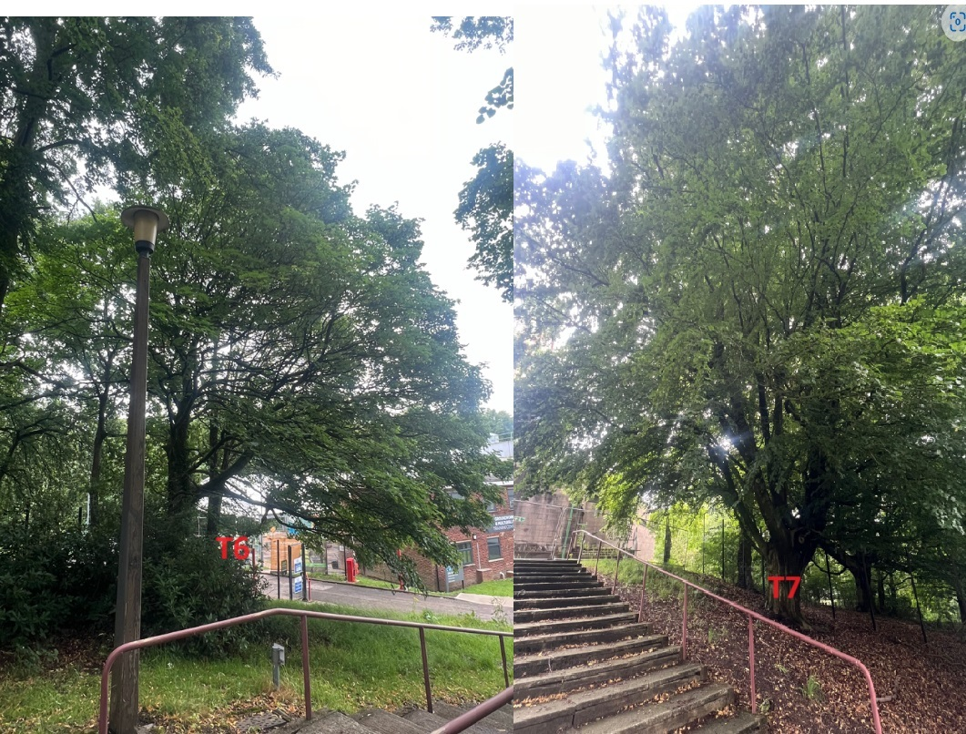

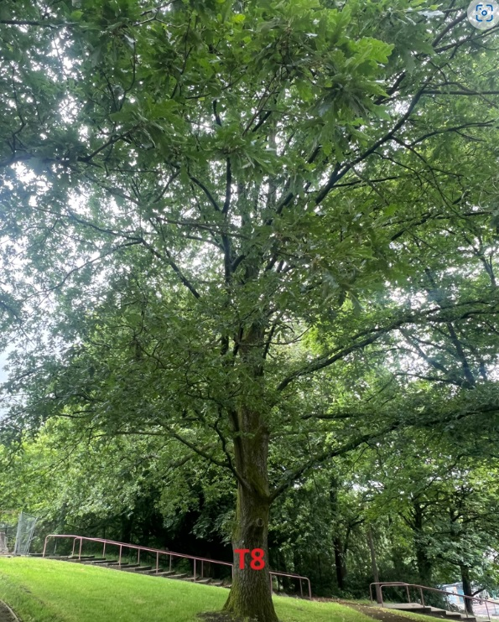

Kind regards,

Mr. Ryan Slack
General Manager and Director
SEG Award, Cert Arb L2 (ABC)

