Conversion and extension of part of an existing stables building (inc. demolition of the remainder of the stable block and associated structures) to form one dwelling
Harwood Fields Farm, Castle Hill Road, Heywood, BL9 6UL

Application for the Discharge of Conditions to planning approval Ref:24/00225/FUL

Planning statement for Discharge of conditions

H | P
D | A

November 2024
Prepared by Hartley Planning and Development Associates Ltd
Planning approval for the above development was granted on 25 July 2024 under number 24/00225/FUL subject to various conditions.

Application is now made for the discharge of the following, shown in italics: -

4 No above ground works shall take place until a scheme of biodiversity enhancements for the site including, but not limited to, the provision of bird boxes, bird bricks, bat boxes and bat bricks to be integrated to the fabric of the buildings hereby approved, bug hotels, hibernaculum, wildflower seeding and hedgehog habitat (including provision of 'Hedgehog Highways') has been submitted to and approved in writing by the Local Planning Authority. The duly approved scheme shall be implemented in full prior to first occupation of the dwelling and retained thereafter.

Applicant comments
The Bat Preliminary Roost Assessment and Bird Survey, carried out in December 2023 and submitted with the original application for the proposed dwelling proposes by way of biodiversity enhancements that at least 3 bat boxes and at least 3 bird boxes should be provided.
Therefore, 3 no. bat boxes, as below, are to be integrated into the stonework, as shown on the following plan, facing South and to be faces in stone to match the elevation of the building. Bats prefer a South facing wall.
Bat box
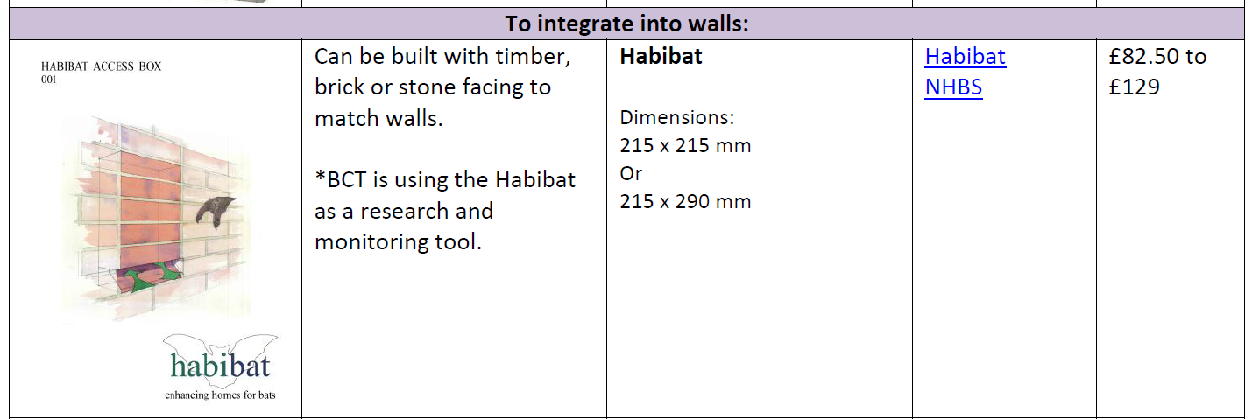
Habibat, 21 High Green, Great Ayton, North Yorkshire TS9 6BJ
enquiries@habibat.co.uk
01642 724 626
In addition, 3 no sparrow boxes are included, to be positioned on the North facing elevation. Sparrows prefer a North facing wall.

Integrated Sparrow Box
Wildcare Ltd,
Eastgate House, Moreton Road,
Longborough, Gloucestershire
GL56 0QJ
01451 833 181

sales@wildcare.co.uk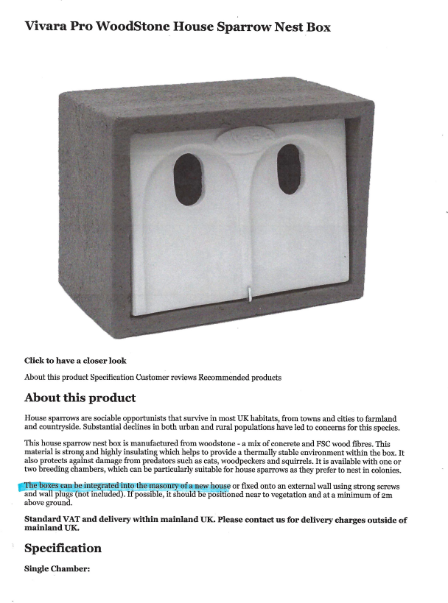

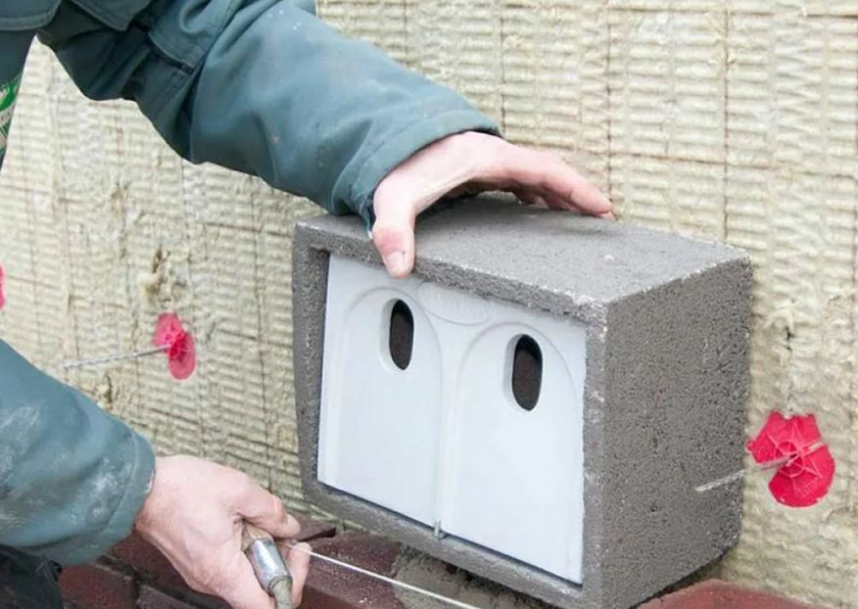
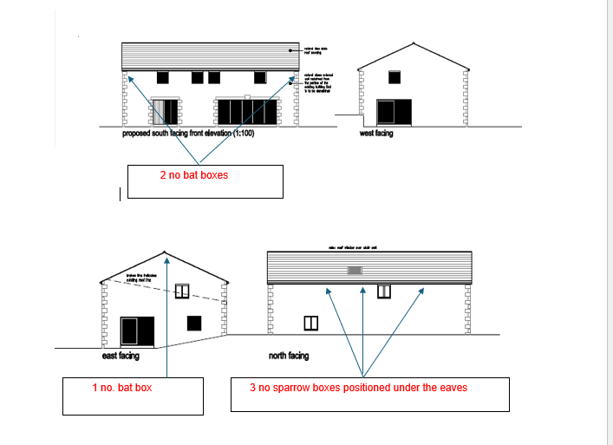
NTS
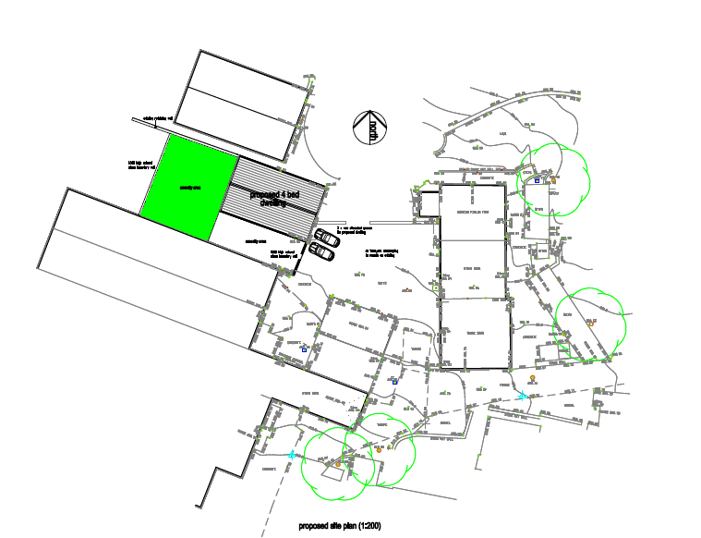
NTS

5 Notwithstanding the details shown on the approved plans, the development hereby permitted shall not be occupied until full details of both hard and soft landscaping works have been submitted to and approved in writing by the Local Planning Authority. The details shall include the formation of any banks, terraces or other earthworks, hard surfaced areas and materials, planting plans, specifications and schedules (including planting size, species and numbers/densities), existing plants / trees to be retained and a scheme for the timing / phasing of implementation works.. The landscaping works shall be carried out in accordance with the approved scheme for timing / phasing of implementation or within the next planting season following first occupation of the development hereby permitted, whichever is the sooner. Any trees or shrubs planted or retained in accordance with this condition which are removed, uprooted, destroyed, die or become severely damaged or become seriously diseased within 5 years of planting shall be replaced within the next planting season by trees or shrubs of similar size and species to those originally required to be planted.

Applicant comments
Please see separate report

7 No external lighting shall be installed on the building or elsewhere on the site unless a scheme for such lighting has first been submitted to and approved in writing by the Local Planning Authority. The approved details shall thereafter be fully implemented.
Reason: In the interests of amenity and the conservation of protected species and in compliance with Policies P3, G9, DM1 and G7 of the adopted Rochdale Core Strategy and the National Planning Policy Framework.

Applicant comments
No external lighting is proposed

9 No works to the elevations of the building (except demolition) shall take place until plans to show the extent of necessary rebuilding and repair works having regard to the submitted Engineering Report 9179 ref 24.11.2024 MP/CH - Prepared by Michael Pooler Associates Limited have been submitted to and approved in writing by the Local Planning Authority. Thereafter the development shall be carried out in accordance with the approved details.
Reason: Insufficient detail is provided on the submitted drawings, and in order to comply with Green Belt policy G4 of the Rochdale Core Strategy, JP-G9 of Greater Manchester Places for Everyone and the National Planning Policy Framework.

Applicant Comments
The Structural report of 24 November 2023 by Michael Pooler Assocs.(ref 9179) concludes that the external walls and overall structure of the building are in good order and there are no recommendations for any rebuilding. Should any such necessary rebuilding arise during the conversion and extension, then existing stonework would be re-used, and the pattern of stonework and the mortar would match the existing building to be converted.

There will be of course, a requirement to rebuild the north -western facing elevation when the currently adjoining building is demolished. Again, stonework on the site following the demolition will be reused in the rebuilding of the gable. Any additional stonework which might have to be imported would match that of the rest of the building being converted, as will the mortar

11 No works to the elevations of the building (excluding demolition) shall commence until full details of existing and proposed ground levels and proposed building finished floor levels (all relative to ground levels adjoining the site) shall have been submitted to and approved in writing by the Local Planning Authority, notwithstanding any such detail shown on previously submitted plan(s). The development shall be carried out strictly in conformity with the approved details.
.

Applicant comments
The existing and proposed site plans show ground levels.
The existing site plan, based upon an electronic digital topographic survey, shows the levels around the perimeter of the existing building
The proposed site plan shows a finished floor level of xxxxxx

3 Notwithstanding any description of materials in the application, no works to the elevations or roof of the building shall take place until samples (on site) and full specifications of materials to be used externally on the building(s) have been submitted to and approved in writing by the Local Planning Authority, including:
- Windows to be timber or aluminium
- Doors to be timber
- Roof lights to be conservation style (set flush with roof)
- Rainwater goods to be cast metal painted black
- Cladding to be timber such as larch
- Roof to be natural slate
Such details shall include the type, colour and texture of the materials and samples shall be displayed on the site for inspection. The development shall be carried out in accordance with the approved details.

Applicant comments

The applicant will provide samples of those materials on site which are not to be bespoke if this is necessary, though it has not been necessary to do so with regard to the several other conversions to dwellings at the farm.

Windows and doors
The proposal is to match the Upvc doors and windows in terms of their shape and style and set back with to those approved by the LPA in the adjoining barn conversions, as below: -

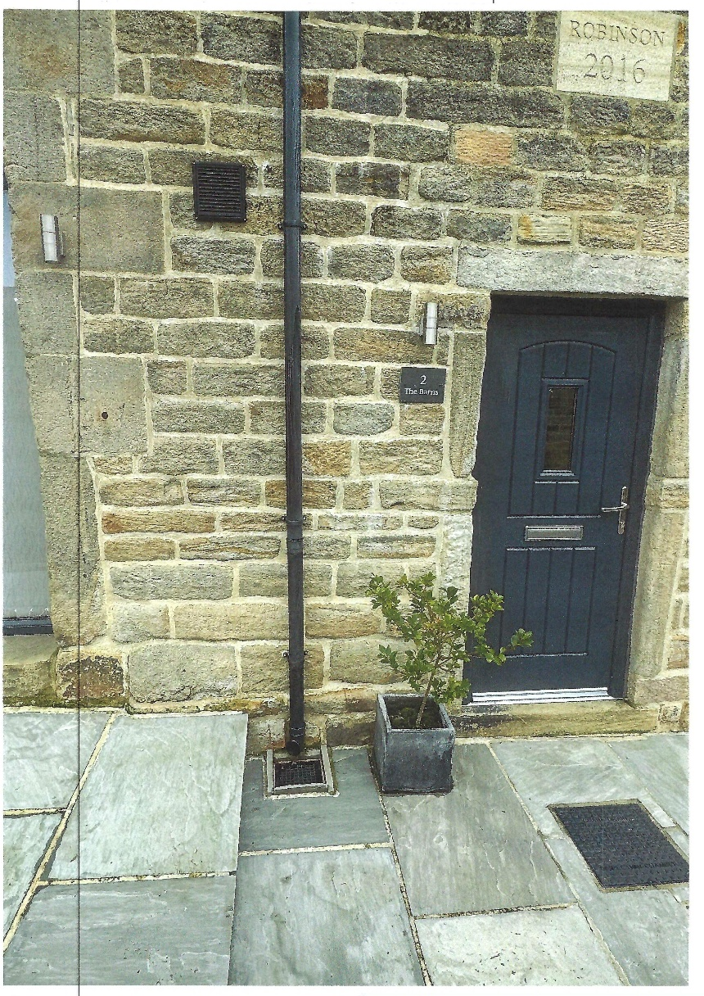

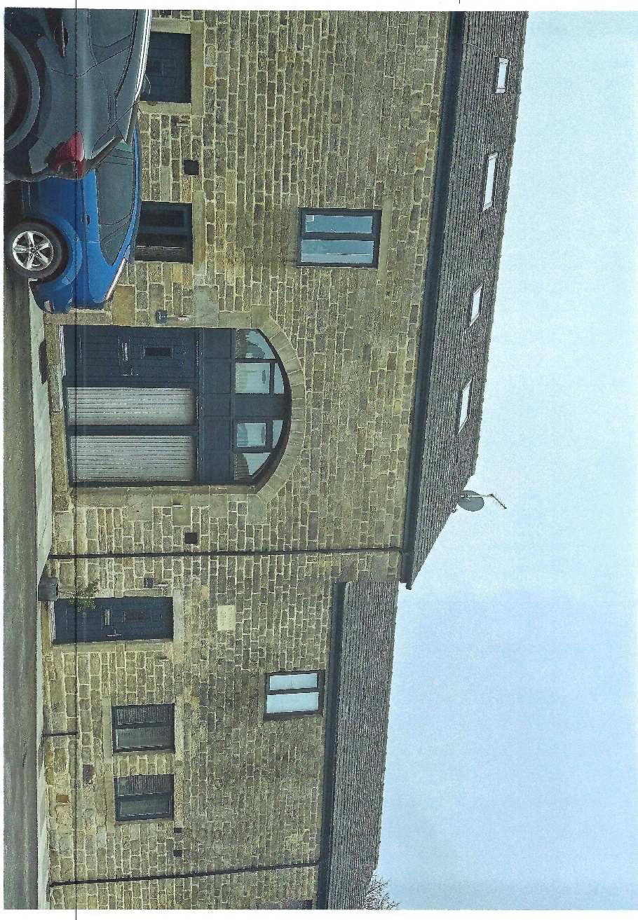

These are available to view on site

Roof Light
The roof light to be Velux Conservation style (flush) to the dimensions as shown on the approved plans and elevations for the dwelling.

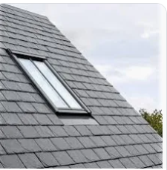

Rainwater goods

The proposal is to use Marley black plastic, conservation style rainwater goods to match those of the adjoining barn conversions.

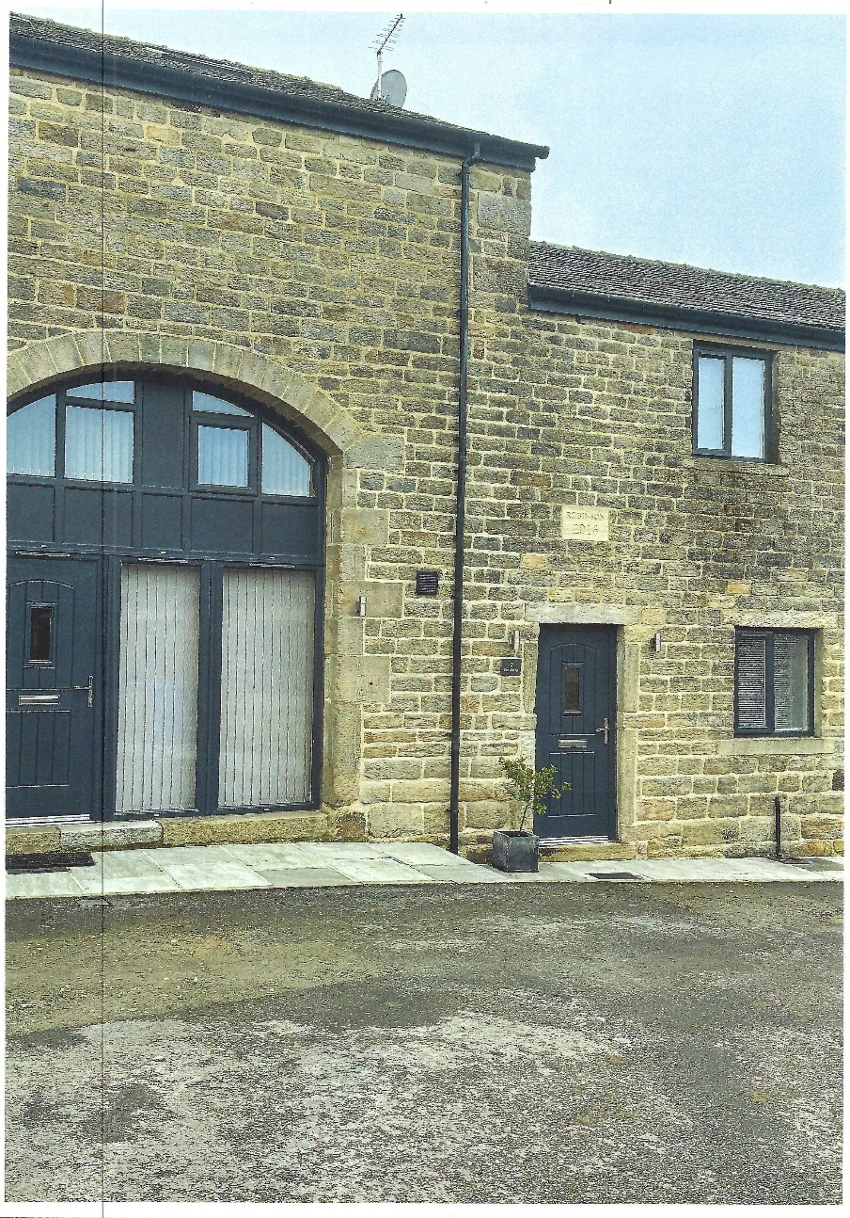

Roof
Roof to be natural blue slate to match that on the adjoining barn conversions and which can be seen on site: -

