CONSERVATION CONSULTATION RESPONSE
Conservation Officer | Catherine Fenghour
Date

Application Reference | 23/00972/VRCON and 23/00958/LBC
Address | Waterside House , Water Street, Rochdale, OL16 1TL
Proposal | Section 73 application to vary condition 2 of planning permission 19/01468/FUL to include amendments to internal layout, relocation of cycle store and removal of proposed light well to lower ground floor apartment  Amendments to Listed Building Consent 20/00601/LBC to include amendments to internal layout comprising removal of proposed WC adjacent to Apartment 4, relocation of electrical cupboard, relocation of cycle store and removal of proposed light well to lower ground floor apartment.

Heritage Assets Impacted

Designated Heritage Assets | ☒ | - Waterside House (grade II)  - Rochdale Town Centre Conservation Area
Non-Designated Heritage Assets | ☐

Summary

Please see comments below.

Significance Assessment

Waterside House, a Grade II listed building located within the Rochdale Town Centre Conservation Area, is comprised of the former engine house and warehouse to the early steam powered Water Street Mill, now demolished. The mill and engine house were constructed during the 1820’s with the later warehouse being built in 2 phases during the mid and later 19th century. The significance of the listed building is embodied within the architectural and historical interests of the building, being an early surviving example of a steam-powered beam engine and the only surviving remnant of a mill in central Rochdale.

Planning permission and listed building consent were granted in May 2021 (19/01468/FUL and 20/00601/LBC refer) for the conversion of the building into 14 apartments with associated cycling and refuse stores. The current applications seek to vary the approved plans. The key changes are as follows:

- Changes to the internal layouts of each apartment to comply with building regulations and coordination of stud partitions location to avoid existing columns upon cross referencing with digital survey scan.
- Removal of communal elect cupboard and WC adjacent to apartment 4 and electrical cupboard relocated.
- Internal cycle store relocated under the archway.
- Removal of previously proposed external lightwell to the Lower Ground Floor apartment.
- Submission of details of internal walls, doors, and new rooflights.

Layout changes:

The proposed internal changes are relatively minor and largely relate to the position of stud walls. On the whole, these internal changes would not change the level of harm to the significance of the listed building. However, I do have the following comments/queries on the plans:

- Lower ground – where new openings into original walls are proposed, nibs should be retained. This should be reflected on the plans. Noted (Drawing 040211 rev 03 reflect nib addition to new wall openings.)

- First floor – a window is shown on the floor plans along the front elevation which was not shown on the existing plans. It is assumed that this is because it sits between levels and no changes are proposed? Please can the applicant confirm this? This is correct, EWFF-09 is an existing window

- First floor – wherever possible existing internal walls should be retained rather than rebuilt – see the walls adjacent the entrances to apartment 9 / 10. Noted (please see the attached revised drawings)

- Looking at the front (south) elevation, the first floor windows are shown in different locations to the approved. It looks like it is the approved plans which are incorrect (the first floor windows as drawn appear too tall). Can the applicant please confirm this is the case - have the elevations been updated following a survey? Correct, we do not propose any alteration to the existing window size or location. (KLA confirm that all existing window/door sizes are reflected from the latest digital survey information and do not propose any alterations to existing size or location.)

- North elevation – lower ground floor windows are a different size to those shown on the previous plans. Again, have these plans been updated following a survey? It seems like they were incorrectly shown before. Correct, we do not propose any alteration to the existing window size or location. (KLA confirm that all existing window/door sizes are reflected from the latest digital survey information and do not propose any alterations to existing size or location.)

- West elevation – Can the applicant advise why render is proposed to the new courtyard window? A brick infill would appear to be more appropriate. We are happy to change this to brick. The brick will be carefully chosen to complement the existing brickwork and will be approved by site sample. (drawing 040312 E-02 – Proposed west elevation amended)

Additional details:

Proposed windows

Courtyard window details – see note above regarding render infill. Please can the applicant confirm the material for the window. Timber to all new window frames.

Lightwell window – Please confirm the material for the window. Our preference is for timber. However these 2 windows are below ground level and susceptible to damp conditions and rot. Could an alternative be considered just for these 2 windows? Aluminium or UPVC? (KLA would agree to the proposed material for the lightwell windows)

The proposed window details for the existing sash windows are acceptable in principle. Please can the applicant provide an image of the proposed trickle vents – these are labelled on the elevations but not shown. Please see below image as sample. It is important that background ventilation is considered if the internal walls are to be insulated.

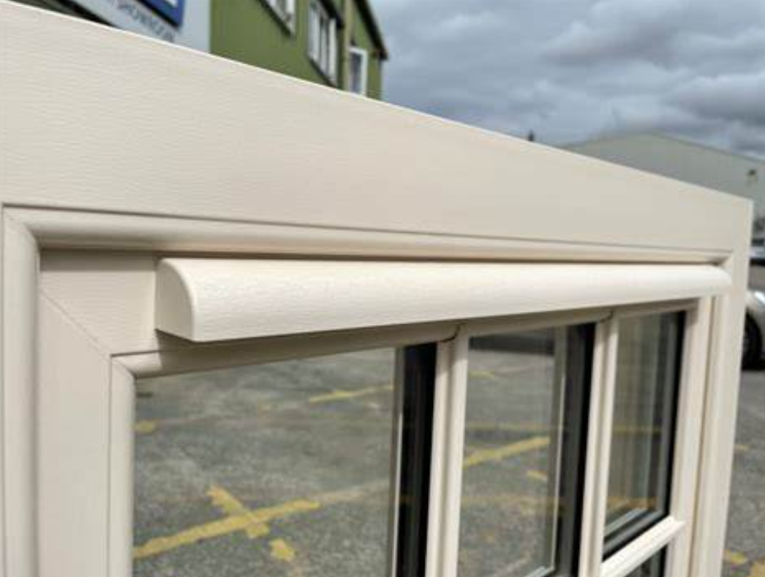

Design changes are proposed to the existing arched window on the front (south) elevation. Please can the applicant provide a visual of how the frameless window would look, along with product specification – it is not that clear from the elevations. If the timber sections are too obvious then this could undermine the frameless look which they are hoping to achieve. Could this detail be requested as a condition? We are yet to develop the technical design.

Proposed doors

External door details plan acceptable as shown on DIA drawings.

Proposed internal doors

The principle doors to the apartments and hallways are of a more traditional design and considered appropriate. The internal apartment doors are simpler but this is considered acceptable given that they will be in new walls in internal, non-public spaces.

Proposed gate

The plans show the existing modern gate to be replaced with a timber gate. It would be helpful to have a more detailed design for this. Was there a gate there originally and does the applicant have any images of it? A cast iron gate may be more appropriate. Could this detail be requested as a condition? We are yet to develop the technical design.
We have undertaken background research and we cannot find evidence of a gate in this location prior. Below images were provided by the local archives:
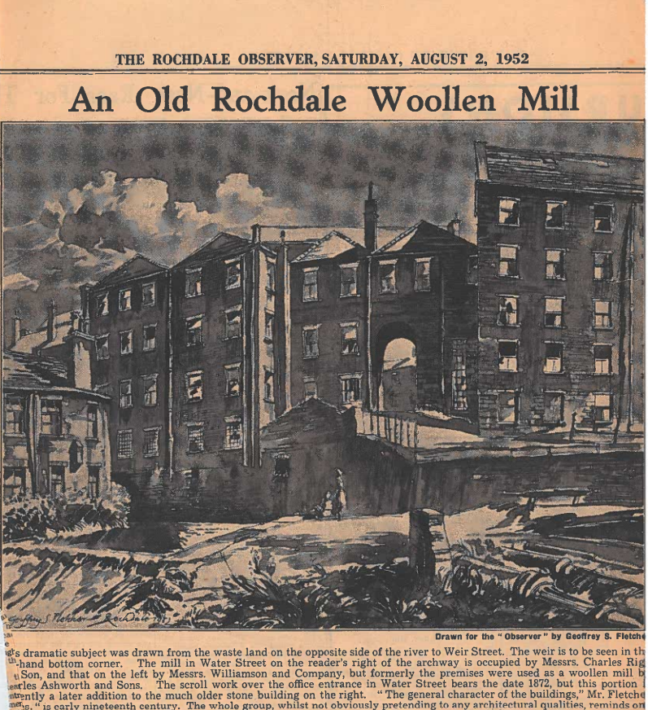

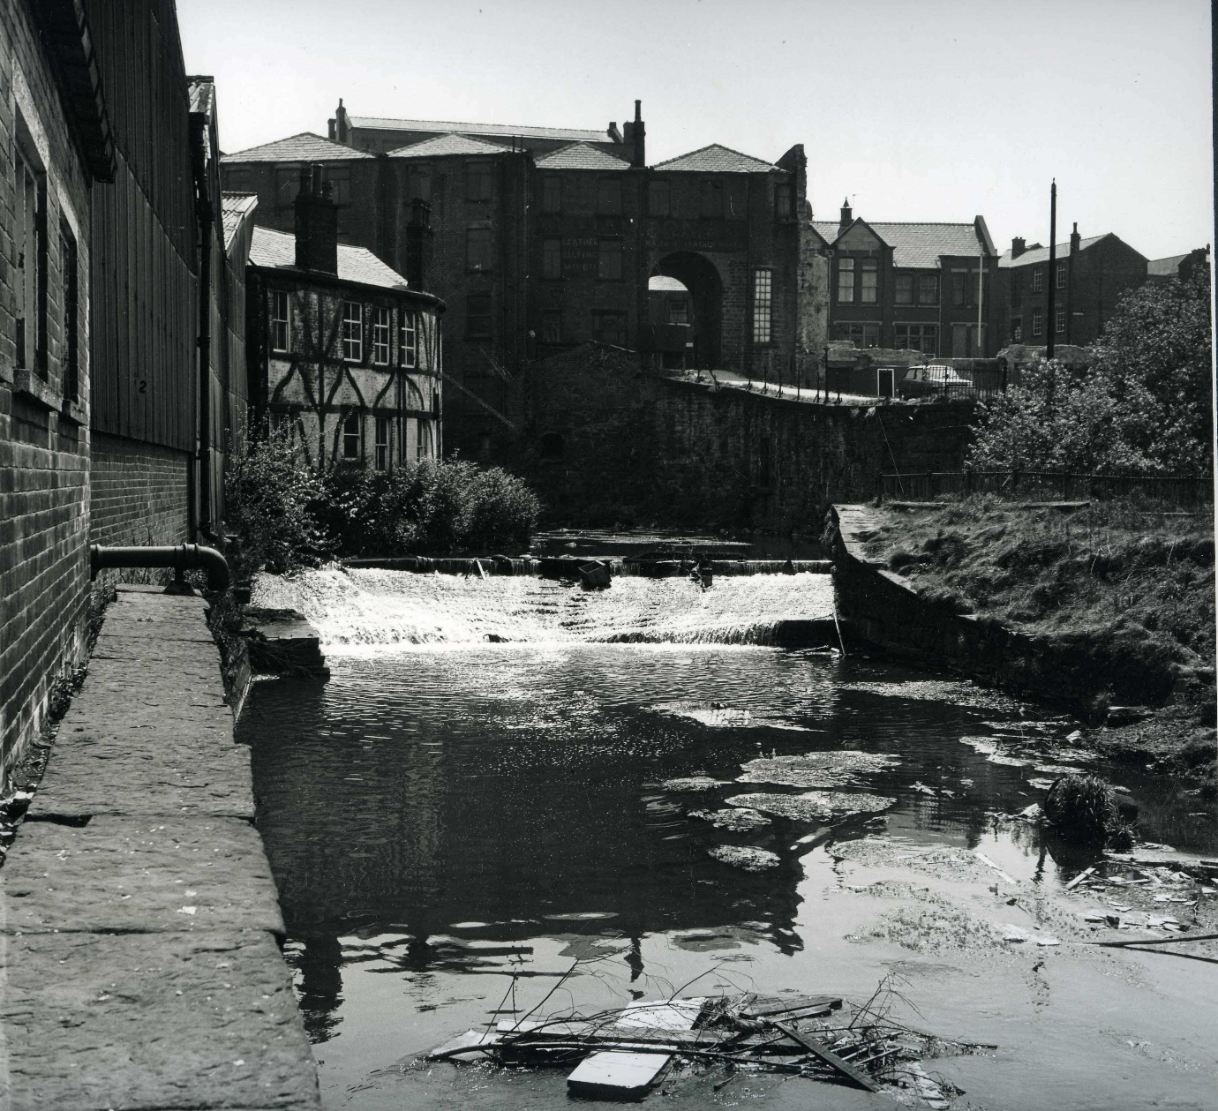

Internal wall details

These details are acceptable in principle. Please can the applicant confirm the lime plaster specification for external/existing walls? Could this detail be requested as a condition? We are yet to develop the technical design and greater understanding of the existing lime plaster and masonry is required by site investigation prior to writing this specification.

Vestibule works

These details/methodology for the works are acceptable.

Roof repairs

The proposed details appear acceptable in principle but a detailed make up should be provided once the condition is known. Details and samples of new roof coverings should also be required by condition.

Metal work

Proposed details are acceptable

Roof vent details

These details are ok

Other

Floor details show tbc on the plans. Existing timber floors should be retained wherever possible and upgraded as required. Please can the applicant provide details of the proposed floor build up? This can also cover the unknown floor area in the vestibule which is also tbc.
We completely agree, existing floor timbers should be retained where possible. However, this is difficult to capture on a drawing and will need more survey once the building works commences. Could this be conditioned? Or stipulate it need site inspection and clarification prior to work commencing?

