
Highways and Engineering Service - Economy and Environment

Drainage Consultation on Application – 25/00116/FUL -

Land Rear Of 83 Marland Fold Rochdale
LLFA Consultation Response on behalf of Head of Highways and Engineering
Date of Response: 25th March
Location & Proposed Development
Land Rear Of 83 Marland Fold Rochdale
Erection of 6no. detached dwellings with associated access, gardens and parking
Documents Reviewed
- Existing Site Plan & Topographical Survey - Drawing No: 7164 001​EXISTING SITE PLAN&TOPO
- Foul and Surface Water Drainage Strategy - Report No: 24.1540​FOUL AND SURFACE WATER …
- Location Plan - Drawing No: 7164 L01F​LOCATION PLAN
- Proposed Site Plan - Drawing No: 7164 002 A​
Drainage & Flood Officer Comments
- The site is under 1 hectare and not within Flood Zone 2 or 3. Therefore, a full FRA is not required.
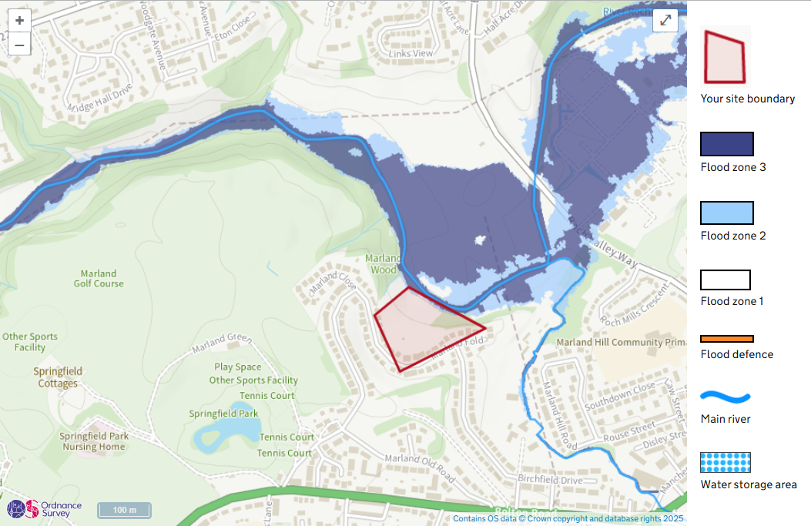
A comprehensive drainage strategy has been provided, which meets the minimum requirements for surface water and foul water drainage management​.
- Calculations are included to justify the surface water discharge rate (Qbar) at 4.7 l/s. This discharge rate is accepted as it matches the existing pre-development greenfield runoff rate.
- The aim should be to discharge surface run off as high up the following hierarchy of drainage options as reasonably practicable: The ordered drainage techniques to be assessed with the aim to reduce or omit lower techniques:
- Control at Source (Infiltration / Recycling)
- On Site Treatment (Basins, Swales, Rain gardens, Tree pits)
- Local Treatment (Adoptable Ponds, Basins, Swales etc)
- Regional Treatment (ditto usually to a larger scale)
- Discharge to Watercourses / Bodies
- Discharge to SW Sewers
- Discharge to Combined Sewers

- Whilst the strategy report indicates the use of infiltration techniques, such as permeable surfacing in the car park areas and gravel strips and plant beds, these are not shown on the drainage layout.
The site's ground conditions are described as freely draining, slightly acidic sandy soils, which are generally favourable for infiltration However, the scheme does not include site-based infiltration assessment / testing. The applicant is required however to conduct infiltration testing to show feasibility of the proposed drainage design.

If site based testing is not currently feasible then the design should assume a worst case rate subject to further investigation and be revised accordingly with the discharge to public SW sewer as a backup contingency.

- If infiltration or partial infiltration is found to be viable then this should be the primary option for roof and highway drainage as well as the private parking. In addition, drainage from these areas should also incorporate SuDS source controls within their design.

- The adoption strategy for the drainage and access road should be clarified. Diversion of the public sewer will require UU approval in principle. If the road is to remain private, then it will require an easement.

- Flows are proposed to be attenuated via a buried storage tank. If infiltration is found to be viable then could this be revised to a soakaway. Buried tanks are considered to be less sustainable than green surface-based components such as ponds, basins etc. The site appears to have sufficient space to accommodate such features.

In addition, the tank is located within the main access road, which is potentially an issue, especially if the road is to be offered for adoption.

- The design has used 1-in-100-year storm event with a 45% allowance for climate change, which is appropriate.
- The pumped foul water will be conveyed from the on-site pumping station to the public foul sewer network located in Marland Fold. There is no mention of obtaining specific consent or approval from United Utilities for this connection, which is required.
- No specific maintenance plan for the SuDS components has been provided in the documents reviewed, but this information may be required to ensure ongoing functionality, eg, the maintenance for proposed foul water pumping station, flow controls, attenuation structures etc.
Drainage & Flood Officer Summary:
- Overall, the general principles of the drainage scheme are acceptable.
- Infiltration potential should be fully assessed and if viable should be the primary option for all areas of the site.
- The attenuation tank should be reviewed with regards to requirements and location.
- Adoption strategies for drainage and highways should be clarified.
- United Utilities approval in principle will be required for the proposed diversion.
- A management and maintenance strategy should be provided.
- Summary Points ii, iii & iv should be addressed before the application is approved. The remaining points could be conditioned.

Consultation by Keith Mealey
Drainage & Flooding Officer
- Mob 0787 2500 722 / Office 01706 924657
keith.mealey@rochdale.gov.uk

