The Oaks @ West Hopwood-phase 6 Planning application
Reserved Matters Planning Application No. 20/01524/REM

External materials

21-03-2023

Condition 2:-
- Micklemarsh sterling Grey with a standard mortar

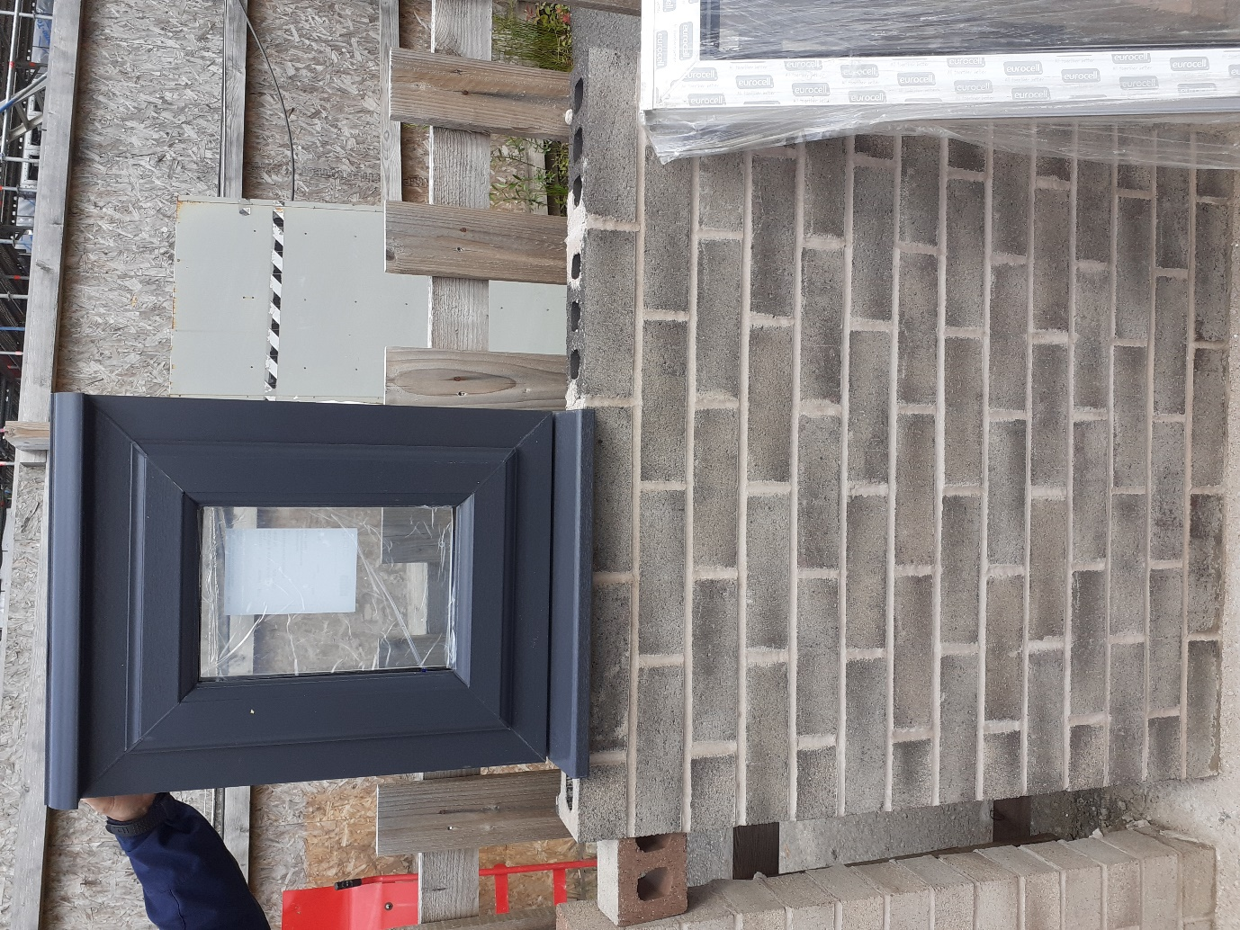

Roof coverings :-
The proposed roof tile is the Northstone Causeway Grey:-
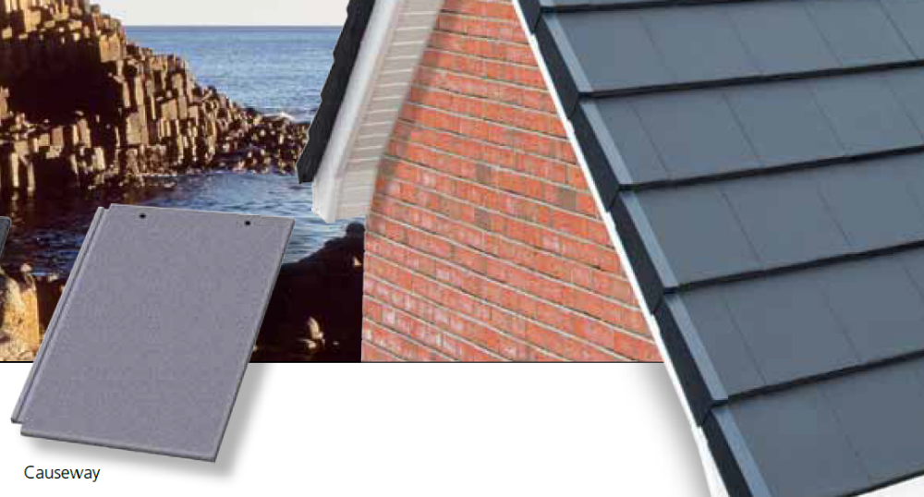
The external door is Bowater Elm range finished in black

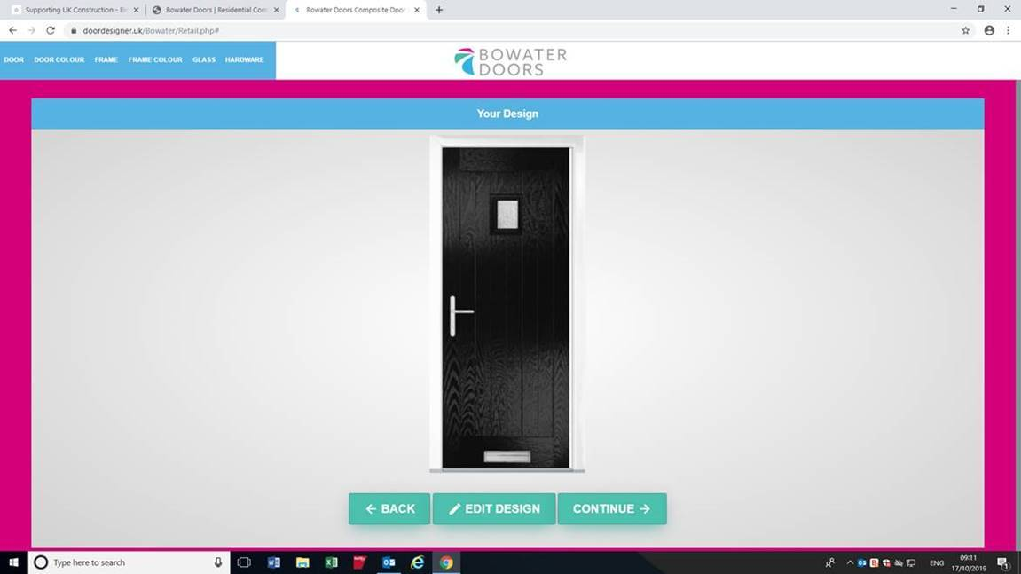

Garage Doors:-Steel profile colour Black to match the front door(image below is for the style)

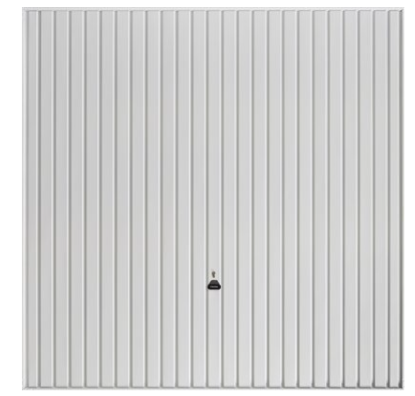

Window profile;-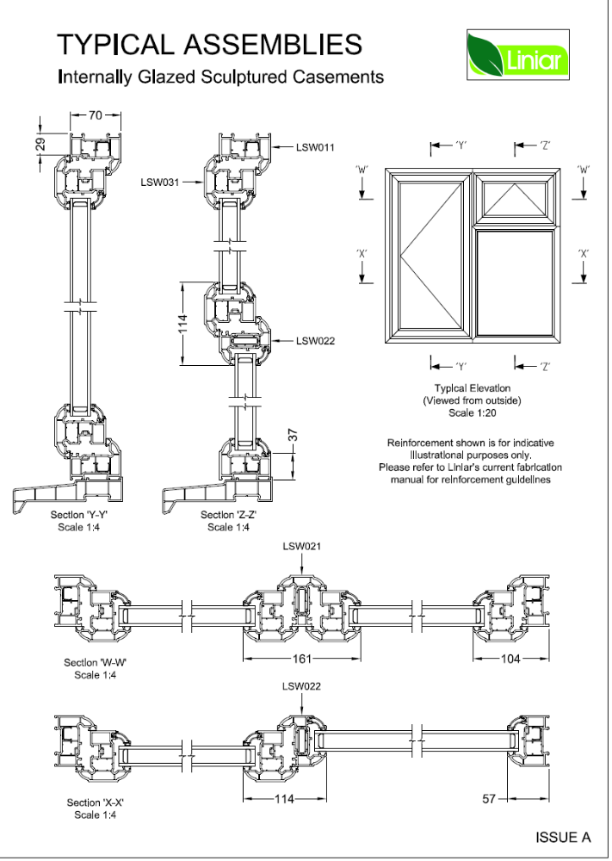
External paving:-
The proposed flagging to the plots is Marshall Urbex riven natural 450*450*38
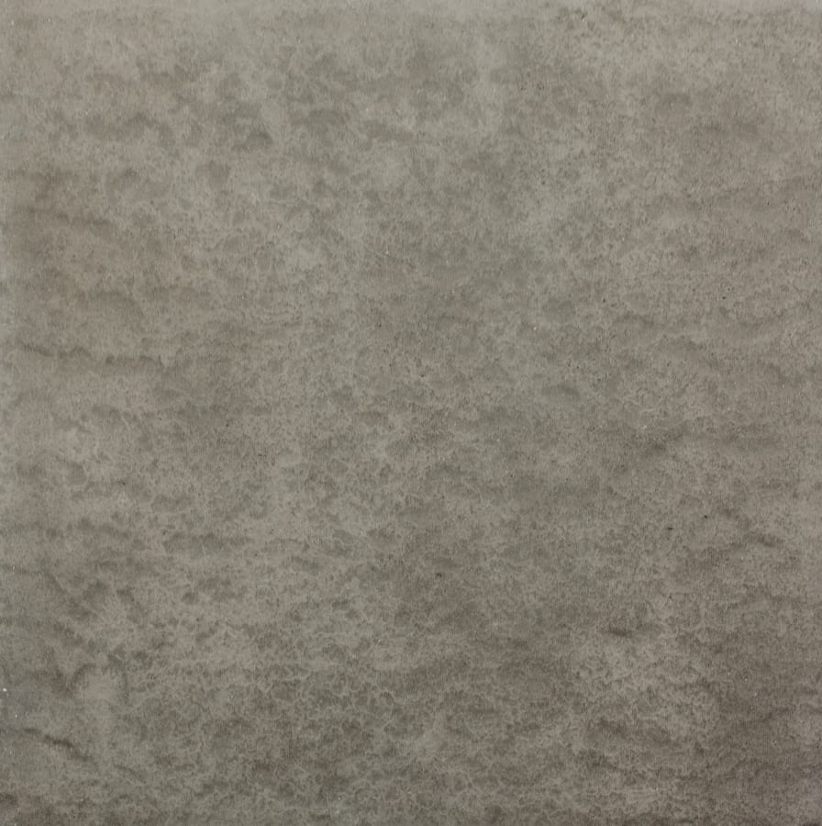

Adopted footpath and roads :- Tarmac


