SITE SPECIFIC SUPPLEMENTARY INFORMATION

- Site Details

Site Name: | Sheriff Street | Site Address: | Sheriff Street  Rochdale  Greater Manchester  OL12 6QR
NGR: | E: 389291 N: 413833 | Site Address: | Sheriff Street  Rochdale  Greater Manchester  OL12 6QR
Site Ref Number: | NTQ 95986 | Site Type: Macro | Replacement – NTQ (Notice to Quit)

- Pre-Application Check List

Site Selection

Was an LPA mast register used to check for suitable sites by the operator or the LPA? |  | No
If no explain why:

After a phone call to the LPA it was felt that the industry database was a more up to date source of information.

Was the industry site database checked for suitable sites by the operator: | Yes
If no explain why:

N/A

Pre-application consultation with LPA

Date of written offer of pre-application consultation: | 22nd September 2023
Was there pre-application contact: |  | No
Date of pre-application contact: | N/A
Name of contact: | The Director of Planning
Summary of outcome/Main issues raised:

At the time of preparing this submission, and despite our attempt to engage in pre-application dialogue with the LPA, no comments had been received in respect to the proposals.

Ten Commitments Consultation

Rating of Site under Traffic Light Model: | Green
Prior to the submission of this application the applicant initiates pre-consultation discussions with the local planning authority. This provides an opportunity for the LPA to discuss development proposals and identify site specific issues.

Summary of outcome/Main issues raised:

No responses had been received at the time of submission.

School/College

Location of site in relation to school/college:

Howard Street Nursery is in close proximity to the site.

Outline of consultation carried out with school/college:

Howard Street Nursery was notified prior to submission.

Summary of outcome/Main issues raised:

No response at the time of submission.

Civil Aviation Authority/Secretary of State for Defence/Aerodrome Operator consultation

Will the structure be within 3km of an aerodrome or airfield? |  | No
Has the Civil Aviation Authority/Secretary of State for Defence/Aerodrome Operator been notified? |  | No
Details of response:

N/A

Developer’s Notice

Copy of Developer’s Notice enclosed? |  | Yes
Date served: | 16th January 2024

- Proposed Development

The proposed site:
It is imperative to consider that this proposal is to replace an existing installation and is not a new additional mast. The need for this new mast stems from MBNL having been issued with an NTQ (Notice to Quit). The NTQ is located off College Bank Way on the rooftop of the high rise blocks. Due to the site provider declaring plans to demolish 4 of the 7 high rise blocks due to inadequacies in the construction to meet modern standards and the costs of maintenance, improvement and refurbishment a new site is required to continue delivering essential coverage to the area.

The proposed telecommunications mast has been strategically placed on a wide grass verge to avoid impact on pedestrian flow and ensuring the safety and convenience of the public. The strategic location not only allows for easy access but also avoids hindering the movement of pedestrians along sidewalks. Additionally, the mast has been thoughtfully positioned against tall, mature trees, providing a natural screening backdrop. This careful integration into the surrounding environment helps mitigate any visual impact on the landscape, ensuring that the telecommunications infrastructure blends seamlessly with the existing natural elements as much as possible. The proposed site and its surroundings can be seen below in Figures 1-3.

Figure 1(Proposed – Green Marker):

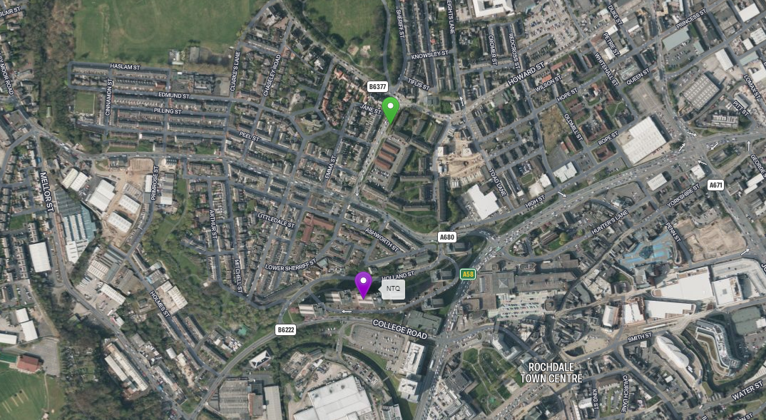

Figure 2:
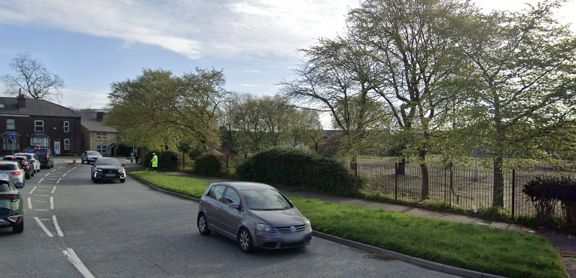

Figure 3:
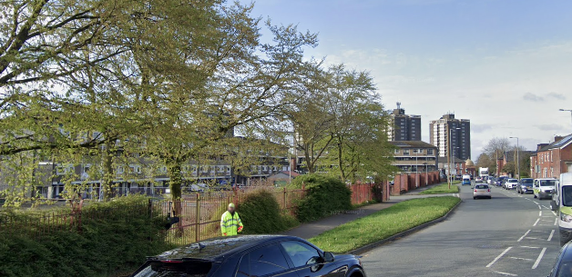

The proposal is for the installation of a new 20m monopole that will provide new coverage for EE and has the potential for H3G LTE. The proposed new facility will require the installation of a limited number of equipment cabinet housing radio equipment at ground level and in close proximity to the base of the pole. The cabinet equipment are however, permitted development (without Prior Approval) and thus do not form part of this application.

The site has been carefully selected in a position that benefits from some screening effects so as to provide the required new coverage to the area whilst minimising visual intrusion for residential properties. The monopole style design has been specified in order to allow the proposal to merge with the numerous street lighting columns distributed around the vicinity of the site.

Local Planning Authority: Rochdale Council
Development Plan: Rochdale Core Strategy (2016) / Rochdale UDP (saved policies)
(2006)

Policy Relevant to the Development Site:

The site is designated as being in the settlement boundary, with urban uses to the north, east, south and west. The site has no statutory designations, and the site is not considered to be material constrained.

Rochdale Council does not have a specific telecoms policy. Therefore, the NPPF is of relevance. The National Planning Policy section of this supporting statement goes into detailed analysis of why this site is in compliance with the NPPF.

Policy Analysis:

The proposed works at the site would not result in demonstrable harm to the character or amenity of the area, yet would provide the requisite coverage needed in the area, so according with the principles of the policy. The proposal fully accords with the requirements of the NPPF.

The sharing of base stations between multiple operators is one of the key strategic policy principles contained within the NPPF. H3G and EE and ESN (Emergency Services Network) have a network sharing agreement and thus these installations are fully compliant with the NPPF.
Central Government attaches great importance to the design of the built environment and outlines this within Section 12 (para. 124) of the National Planning Policy Framework. It states:

“Good design is a key aspect of sustainable development, creates better places in which to live and work and helps make development acceptable to communities.”

In keeping with the National Planning Policy Framework (NPPF). guidelines of using: “high quality communications” (Section 10), the proposed design has been selected to minimise visual impact upon the street scene by integrating with the existing built environment and the existing street furniture, having similar vertical lines and overall appearance to the street lighting columns that are common feature in the built environment. As stated above the National Planning Policy Framework advocates site sharing, and as such we believe that there are no sequentially preferable locations within the defined site search area.
The design of the proposed equipment is considered to be the least visually intrusive option available.

RADIO PLANNING AND PROPAGATION
When planning cellular telecommunications networks it is important for engineers to predict, with a high degree of confidence, the behaviour of cellular transmissions. This then enables the operator to calculate how many cell sites are needed to provide the level of coverage required by the services they offer under the terms of their licence.
The strength of radio signals detected at a receiving device naturally reduces the further away it is from the transmitter. In general the reduction (or decay) in signal power is affected by a number of variables. The main factors are

- frequency,
- distance (from transmitter),
- terrain (such as hills),
- clutter (such as buildings, foliage, vehicles, and water)
- and atmospheric conditions (such as rain).

A reduction in the strength of the radio signal increases the likelihood of dropped calls and reduced data rates for internet browsing, for example.
Clutter
Any physical object obstructing the propagation of radio signals causes a reduction in signal strength reaching a customer’s device. A common term for these objects is ‘clutter’. The more obvious examples are buildings and geographical terrain such as hills and trees.
Buildings cause a varying amount of signal reduction depending on their height, construction, thickness of walls, amount of windows etc. Glass causes a lower reduction in signal than brick/concrete walls.
Customers will inadvertently be aware of this by finding that sometimes they need to go near windows, a higher floor of a building or even outside in order to achieve a stronger signal for their mobile devices.
Tree Clutter
The effects of trees on signal degradation should never be underestimated. Signal absorption and shadowing effects vary according to vegetation and density, and are caused by the main tree trunk, branches and leaves.
Cell sites located in or near trees will have signals significantly reduced. As a result a number of extra sites may need to be built locally in order to counter-effect this.
Signal variation throughout the seasons is also a practical concern. Leaves on trees in the spring and summer can cause shadowing and reduce radio voice quality and increase the number of dropped calls.
As a result the bottom of an antenna should be a) above the top level of the trees, b) allow greater height due to the antenna downtilt at build or for future requirements and c) allow some room for future growth of the trees.
In the case where the cell site utilises point-to-point microwave backhaul transmission the microwave dish should not be obscured at all.
Propagation Models
In essence these are mathematical formulae used to characterise radio wave propagation, in order to determine the received signal strength at a receiving device.
The most well-known propagation model used for mobile telecommunications is ‘Okamura-Hata’. More specific studies have been performed to investigate specific clutter and terrain such as dense-urban and urban environments. Resulting from these are propagation models for specific clutter types.
Coverage Planning Tools
Radio planning engineers plan cellular networks using highly sophisticated computer programs that incorporate the above propagation models. Armed with data on cell site location, cell site configuration, maps, terrain etc they are used to predict areas of coverage deficiency (so called ‘coverage holes’), new site requirements and configurations.
Network Changes
Over time the topography and clutter in an area is subject to change. For example, building developments, housing and tree growth can all change. As a consequence the signals received from local phone masts can degrade, as they are dependent on these factors. These reasons along with customer complaints, network consolidation (mast sharing) and new technologies (4G) require a re-evaluation of a network operator’s telecommunications infrastructure.
Mast sharing can result in some masts no longer being needed. As a result they are decommissioned and physically removed.
Technical surveys undertaken for reasons above may highlight that antenna height increases are required – this is more likely for sites with low antenna heights around 15m AGL, particularly street furniture sites. More details on these reasons below.
While thus far this document is generic to mobile telephony masts it should be noted that each mast has to be dealt with on a case-by-case basis.
Site Height increases
There are a number of reasons why an operator may request a height increase on existing structures. The main ones are described below.
Maintaining existing coverage
The antennas inside, for example, street furniture sites are generally of 2 physical build designs – ‘Single Stack’ and ‘Dual Stack’. The former describes when the set of antennas are all at the same height. The latter describes a site with 2 sets of antennas one above the other.
The ‘Dual Stack’ is by far the preferred option. This is due to a number of factors including greater flexibility & control for different technologies and providing optimum service performance to customers.
Network Consolidation between H3G LTE and EE and new 4G technologies facilitate a Single Stack structure being upgraded to a Dual Stack structure. In a straight swap scenario at equal height the new lower aperture antennas would be lower than they were originally - resulting in significantly reduced coverage. To ensure existing coverage is maintained the whole structure needs to be increased in height.
Clutter changes
A more extreme example is when the local clutter or tree lines have changed, or are such that the mobile signals are blocked, resulting in lower quality calls and downloads for mobile device users. To provide sufficient services to customers height increases on existing masts or additional new masts are required. The former is the preferred option in many cases.
ICNIRP Compliance
The addition of new technologies and mast sharing affects ICNIRP compliance – a higher minimum mast height is required in some cases.
Enclose map showing the cell centre and adjoining cells:
This can be emailed to the LPA upon request.

Type of Structure
Description:

PROPOSED H3G 1No. GPS NODE.
PROPOSED EE 1No. GPS NODE.
PROPOSED H3G 3No. APERTURES.
PROPOSED EE 3No. APERTURES.
PROPOSED EE/H3G 3No. SHARED APERTURES.
PROPOSED EE/H3G 2No. 600mmØ DISHES.
PROPOSED EE/H3G VALMONT 20m HIGH PHASE 7 MK2 STREETWORKS POLE ON ROOT FOUNDATION.
PROPOSED EE/H3G WRAP-AROUND CABINET.
PROPOSED H3G UNILATERAL CABINET ON ROOT FOUNDATION.
PROPOSED H3G BOWLER CABINET ON ROOT FOUNDATION.
PROPOSED EE WILTSHIRE CABINET ON ROOT FOUNDATION.
PROPOSED EE UNILATERAL CABINET ON ROOT FOUNDATION.
PROPOSED EE/H3G MK5B LINK AC CABINET ON ROOT FOUNDATION.

Overall Height: 20.0m AGL
Height of existing building |  | N/A
Equipment Housing:
Length:
Width:
Height:
Materials
Tower/mast etc – type of material and external colour: | See Drawings
Equipment housing – type of material and external colour: | See Drawings

Reasons for choice of design:
The proposed installation is an EE Ltd and H3G LTE Phase 7 20.0m Streetwork Pole which will house both EE and H3G LTE. The sharing of base stations between multiple operators is one of the key strategic policy principles contained within the NPPF.

In keeping with the National Planning Policy Framework (NPPF July 2021). guidelines of using high quality communications infrastructure the proposed design has been selected to minimise visual impact upon the street scene by integrating with the existing street furniture, having similar vertical lines and overall appearance to the numerous street lighting columns.

- Technical Information

ICNIRP Declaration attached  ICNIRP public compliance is determined by mathematical calculation and implemented by careful location of antennas, access restrictions and/or barriers and signage as necessary. Members of the public cannot unknowingly enter areas close to the antennas where exposure may exceed the relevant guidelines.  When determining compliance the emissions from all mobile phone network operators on the site are taken into account. | Yes

- Technical Justification

Reason(s) why site required
The National Planning Policy Framework clearly states that authorities should not question the need for the service, nor seek to prevent competition between operators. Notwithstanding this fact, the Applicant considers it to be important to explain the technical justification for the site and how the facility fits into the overall network.

Notwithstanding this fact, the Applicant considers it to be important to explain the technical justification for the site and how the facility fits into the overall network.

Further detail regarding the general operation of the network can be found in the accompanying document entitled ‘General Background Information on Radio Network Development for Planning Applications’. This information is provided to assist the local planning authority in understanding any technical constraints on the location of the proposed development.

- Site Selection Process – alternative sites considered and not chosen

Discounted Options
In accordance with the sequential approach outlined in the National Planning Policy Framework (NPPF) following search criteria have been utilised. Firstly, consideration is always given to sharing any existing telecommunication structures in the area, secondly consideration is then given to utilising any suitable existing structures or buildings and thirdly sites for freestanding ground-based installations are investigated.

This sequential approach is outlined below:

- Mast and Site Sharing
- Existing Buildings Structures
- Ground Bases Installations

In compliance with its licence and the sequential approach outlined in the NPPF all attempts to utilise any existing telecommunication structures where they represent the optimum environmental solution have been employed. The Ofcom Site Finder mast register is always examined prior to the submission of an application.

Discounted options.

D1 Falinge Park GF E: 389275 , 413929. Public park discounted due to low planning approval %. Options available which do not impact the existing landscape to the same extent.

D2 Falinge Road SW E: 389181 , 413976. The pavement is not wide enough for the equipment. The equipment would block the cycle lane, so is therefore discounted.

D3 Sheriff Street SW E: 389268 , 413789. Recent refusal. 21/01378/TELE. Site is situated on the border St Edmunds Conservation Area. Option discounted due to better sites available, which do not impact designations to the same extent.

D4 St Edmunds Church RT E: 389137 , 413840. Grade II listed building within a Conservation Area. Option available which do not impact heritage assets.

D5 Chasley Road SW. E: 389040 , 413875. Site discounted due to the same principles as the recently refused location – within a Conservation Area..

D6 Hebron Church. E: 389355 , 413896. A Greenfield installation would occupy over 50% of the car parking spaces, which is unfeasible for the Church.

D7 Rochdale Infirmary. E 389428 , 414039. Hospital parking, there is no scope for a ground-based installation. There are also no suitable rooftops which will provide the required height. The hospital is therefore discounted.

D8 Spotland Road. E: 389172 , 413703. Site directly outside shops with residential on the upper floors - would cause coverage issues. There is also evidence of scarring on the pavement which would indicate underground services.

D9 Edmund Street. E 389121 , 413793. Site discounted due to the same principles as the recently refused location - on/within the Conservation Area.

D10 College Bank. All the towers blocks are being demolished so there is no scope to relocate onto an adjacent block.

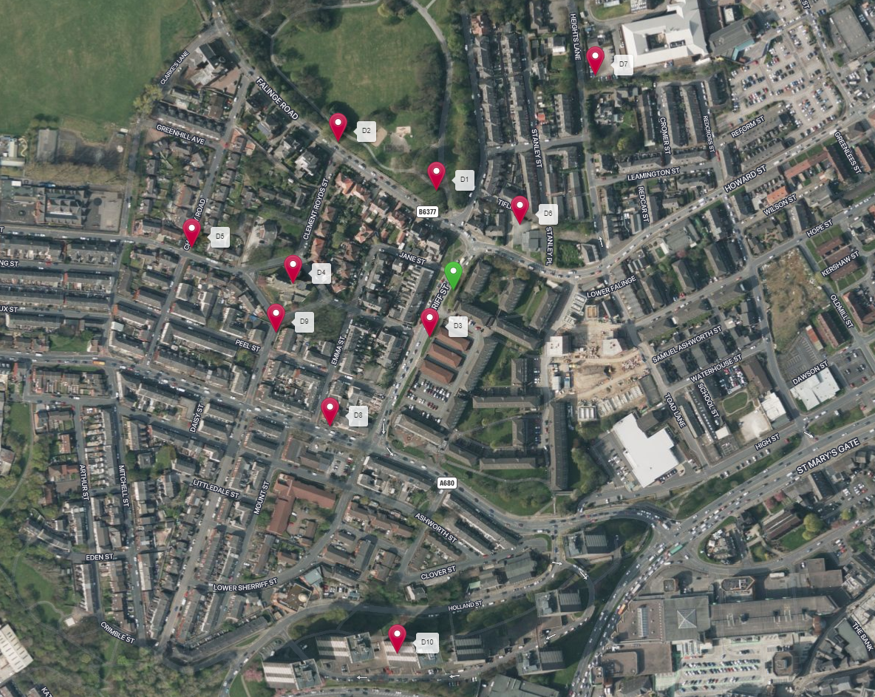

If no alternative site options have been investigated, please explain why:

N/A

- Additional Relevant Information

Background to the Proposal
This specific proposal forms part of an integral requirement for EE Ltd, ESN and H3G LTE to expand their respective telecommunications network across Rochdale specifically in this instance to enhance coverage levels and network capacity within the OL12 area.

This partnership has resulted in the development and production of an array of “dual user” structures and cabinets, which have the ability to accommodate both operator’s antenna systems and radio equipment.

Mobile phone base stations operate on a low power and accordingly base stations therefore need to be located in the areas they are required to serve. Increasingly, people are also using their mobiles in their homes, and this means we need to position base stations in, or close to, residential areas.

A further limiting factor is that the position has to be one that fits in with the existing network. Sites have to form a patchwork of coverage cells with each cell overlapping to a limited degree with the surrounding base stations to provide continuous network cover as users move from one cell to the other. However, if this overlap is too great unacceptable interference is created between the two cells.

DEVELOPMENT PLAN POLICY.

Development plan considerations have a special significance in law. Section 54A of the Town and Country Planning Act 1990 (The Act), and re-iterated in Section 38 of the Planning and Compensation Act 2004, it is stated that:

“Where in making any determination under the Planning Acts regard is to be had to the Development Plan, determination shall be made in accordance with the Development Plan unless material considerations indicate otherwise.”

NATIONAL PLANNING POLICY

The Government remain committed to promoting telecommunications and place emphasis on the importance of telecommunications to the wider economy. The National Planning Policy Framework (NPPF July 2021) sets out the Government’s planning policies for England and how these are expected to be applied at the Local level. It provides a framework within which local people and their accountable Councils can produce their own distinctive local and neighbourhood plans, which reflect the needs and priorities of their communities.

The purpose of the planning system is to contribute to the achievement of sustainable development. There are three dimensions of sustainable development, each of which give rise to the need for the planning systems to perform a number of roles including: -

- Economic Role – contributing to building strong, responsive and competitive economy;
- Social Role – Supporting strong vibrant and healthy communities; and
- Environmental Role – Contributing to protecting and enhancing our natural, built and historic environment.
The NPPF contains at its core a presumption in favour of sustainable development which runs through both plan-making and decision-making processes. The NPPF recognises the vital importance of high-quality telecommunications and dedicates a whole chapter to this. Chapter 10 of the NPPF outlines the Governments support for high quality communications. The paragraphs below clearly outline the overarching support from Central Government for telecommunications and how Local Planning Authorities should embrace this vital infrastructure:

NPPF Paragraph 114 states:

“Advanced, high quality and reliable communications infrastructure is essential for economic growth and social well-being. Planning policies and decisions should support the expansion of electronic communications networks, including next generation mobile technology (such as 5G) and full fibre broadband connections. Policies should set out how high-quality digital infrastructure, providing access to services from a range of providers, is expected to be delivered and upgraded over time; and should prioritise full fibre connections to existing and new developments (as these connections will, in almost all cases, provide the optimum solution).”

It continues in Paragraph 115:

“The number of radio and electronic communications masts, and the sites for such installations, should be kept to a minimum consistent with the needs of consumers, the efficient operation of the network and providing reasonable capacity for future expansion. Use of existing masts, buildings and other structures for new electronic communications capability (including wireless) should be encouraged. Where new sites are required (such as for new 5G networks, or for connected transport and smart city applications), equipment should be sympathetically designed and camouflaged where appropriate.”

Operators always follow the sequential site selection process. Where an existing site can be shared or upgraded this will always adhered to before a new proposal is put forward for consideration.

The support for telecoms and the need not to constrain Operators is laid out in Paragraph 118:

“Local planning authorities must determine applications on planning grounds only. They should not seek to prevent competition between different operators, question the need for an electronic communications system, or set health safeguards different from the International Commission guidelines for public exposure.”

Conclusion

We consider that the development is complaint with the council’s policy and that in accordance with Section 38 (6) of the Planning and Compensation Act 2004 permission should be granted for the installation.

We consider the development complies with both central government and local planning policy guidance where the underlying aim is to provide an efficient and competitive telecommunication system for the benefit of the community while minimising visual impact.

Taking into account the factors of technical constraints, available sites and planning constraints we consider that this site and design clearly represents the optimum environmental solution.

On the basis of a recognised need to expand and promote telecommunications networks across the region, it is considered that the proposal fully accords with the requirements of the National Planning Policy Framework and Council’s Local Plan Policies.

Ryan Marshall
Planning Manager
Email: r.marshall@whptelecoms.com

Contact Details

Name: (Agent) | Ryan Marshall | Telephone:
Operator: | EE and H3G LTE | Fax no: | N/A
Address: | WHP Telecoms Ltd  1a Station Court Station Road  Guiseley  Leeds  LS20 8EY | Email Address: | r.marshall@whptelecoms.com
Signed: | 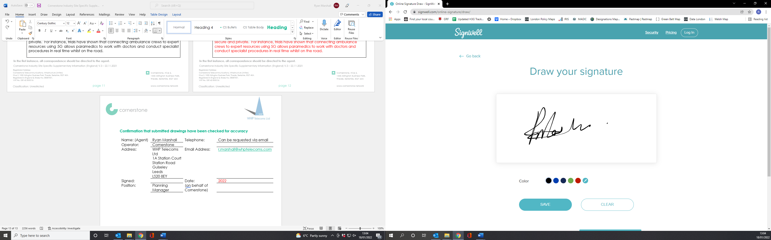 | Date: | 17th January 2024
Position: | Planning Manager | Company:  (on behalf of above operator) | WHP

