Conversion and extension of part of an existing stables building (inc. demolition of the remainder of the stable block and associated structures) to form one dwelling
Harwood Fields Farm, Castle Hill Road, Heywood, BL9 6UL

Application for the Discharge of Conditions to planning approval Ref:24/00225/FUL

Planning statement for Discharge of conditions
Ref:SR.110325.A

H | P
D | A

March 2025
Prepared by Hartley Planning and Development Associates Ltd
Planning approval for the above development was granted on 25 July 2024 under number 24/00225/FUL subject to various conditions.

Certain of the conditions have already been discharged under application ref: 24/01145/DOC.
These include the following: -
Condition no 4 (Biodiversity enhancement)
Condition no5 (Landscaping

Application is now made for the discharge of the following conditions, shown in italics, and which were not discharged under application 24/01145/DOC: -

9 No works to the elevations of the building (except demolition) shall take place until plans to show the extent of necessary rebuilding and repair works having regard to the submitted Engineering Report 9179 ref 24.11.2024 MP/CH - Prepared by Michael Pooler Associates Limited have been submitted to and approved in writing by the Local Planning Authority. Thereafter the development shall be carried out in accordance with the approved details.
Reason: Insufficient detail is provided on the submitted drawings, and in order to comply with Green Belt policy G4 of the Rochdale Core Strategy, JP-G9 of Greater Manchester Places for Everyone and the National Planning Policy Framework.

Applicant Comments

When refusing the first application to discharge this condition under application 24/01145/DOC, the LPA did so for the following reason: -

‘ No elevation plans have been submitted to show the extent of the necessary rebuilding and repair works, as such the condition cannot be discharged. A further submission will be required for details of this to be provided prior to works to elevations of the building’.

However, the Structural report of 24 November 2023 by Michael Pooler Assocs.(ref 9179) concludes that the external walls and overall structure of the building are in good order and there are no recommendations for any repairs or rebuilding.

His report states that ‘the unit is part of a larger stable complex (to be demolished in the overall scheme of the development). See plan.

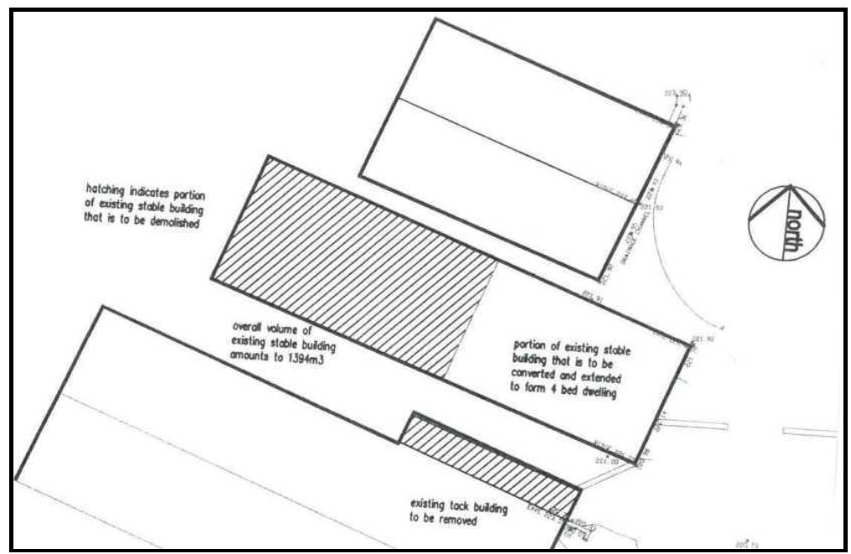

His report notes that so far as the party wall is concerned ‘the blockwork party wall is completed with well-maintained blockwork and pointing with good horizontal and vertical alignment to the wall supports, the structural purlin seatings onto the main roof rafters. There are no signs of any separation where the party wall adjoins the front masonry’.

The condition states that ‘no works to the elevations of the building (except demolition) shall take place until plans to show the extent of necessary rebuilding and repair works having regard to the submitted Engineering Report 9179 ref 24.11.2024 MP/CH - Prepared by Michael Pooler Associates Limited have been submitted to and approved in writing by the Local Planning Authority’.

The only part of the development which might be considered to be repair work or rebuilding is that to the current party wall and which would become an external gable – but as the existing blockwork party wall would remain, even this would not be technically repair or rebuilding work.

The proposal is to clad the exposed and retained former party wall (now as the external gable to the proposed dwelling) in natural stone to match the stone in the rest of the retained building, using a matching mortar.

There would, of course, be additional building work to add an additional floor to the property, but this would not be rebuilding or repair works as referred to in the condition, but rather would be new construction work.

The above plan shows the position of the additional stone cladding to the retained structure.

While the LPA, when refusing the earlier application for the discharge of the condition, states that no elevations were submitted to show any repair or rebuilding work, such an elevation of the west facing gable (ie the exposed party wall, to be clad with stonework) forms part of the approved plans, and where the following elevation is an excerpt: -

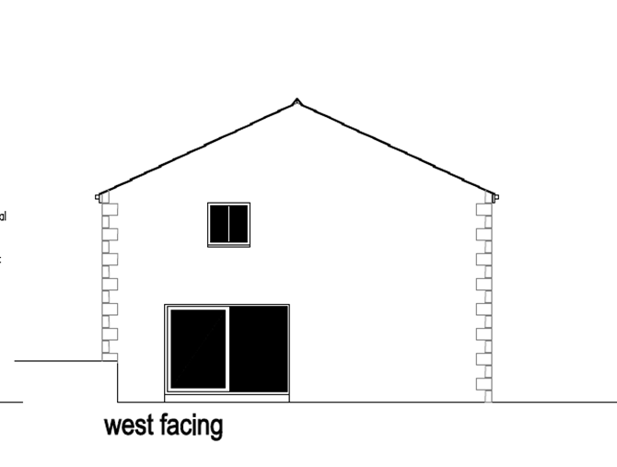

11 No works to the elevations of the building (excluding demolition) shall commence until full details of existing and proposed ground levels and proposed building finished floor levels (all relative to ground levels adjoining the site) shall have been submitted to and approved in writing by the Local Planning Authority, notwithstanding any such detail shown on previously submitted plan(s). The development shall be carried out strictly in conformity with the approved details.
.
Applicant comments
The existing and proposed site plans show ground levels.

The existing site plan, based upon an electronic digital topographic survey, shows the levels around the perimeter of the existing building

This application is the second attempt to obtain the discharge of this condition. The first attempt under application 24/01145/DOC stated that ‘the existing and proposed site plans show ground levels. The existing site plan, based upon an electronic digital topographic survey, shows the levels around the perimeter of the existing building
The proposed site plan shows a finished floor level of xxxxxx’ .

The application was refused for the following reason: -

‘The submitted information does not provide details of the ground levels to the adjoining site. Additionally, the proposed site plan submitted does not show the approved whole site of the amenity area and is as such inaccurate. Surrounding proposed ground levels are required’.

There are no plans to alter the levels around the building including those of the proposed amenity area

We now submit as part of the current application, a plan showing the FFL for the building, and the existing and proposed surrounding levels which remain the same.

3 Notwithstanding any description of materials in the application, no works to the elevations or roof of the building shall take place until samples (on site) and full specifications of materials to be used externally on the building(s) have been submitted to and approved in writing by the Local Planning Authority, including:
- Windows to be timber or aluminium
- Doors to be timber
- Roof lights to be conservation style (set flush with roof)
- Rainwater goods to be cast metal painted black
- Cladding to be timber such as larch
- Roof to be natural slate
Such details shall include the type, colour and texture of the materials and samples shall be displayed on the site for inspection,

When refusing the first attempt to have the condition discharged (under application ref : 24/01145/DOC) the LPA concluded as follows: -

‘The proposed materials, with the exception of the conservation style rooflight and natural blue slate roof tiles, are not in accordance with the details provided within the condition and are unacceptable. The submitted details are not approved.
No justification has been provided for the use of UPVC and plastic rainwater goods. It is noted that the neighbouring property at No 4 was approved under 14/00700/FUL and a condition was secured for details of materials, however no evidence is available of this being discharged’.

Applicant comments

The applicant will provide samples of those materials on site which are not to be bespoke if this is necessary, though it has not been necessary to do so with regard to the several other conversions to dwellings at the farm.

While the LPA gives no good reason for its aversion to Upvc windows and doors we now make the following proposals

Windows
Windows to be anthracite grey aluminium frames (RAL 7016) and to match the shape and style and set back with those approved by the LPA in the adjoining barn conversions, as below: -

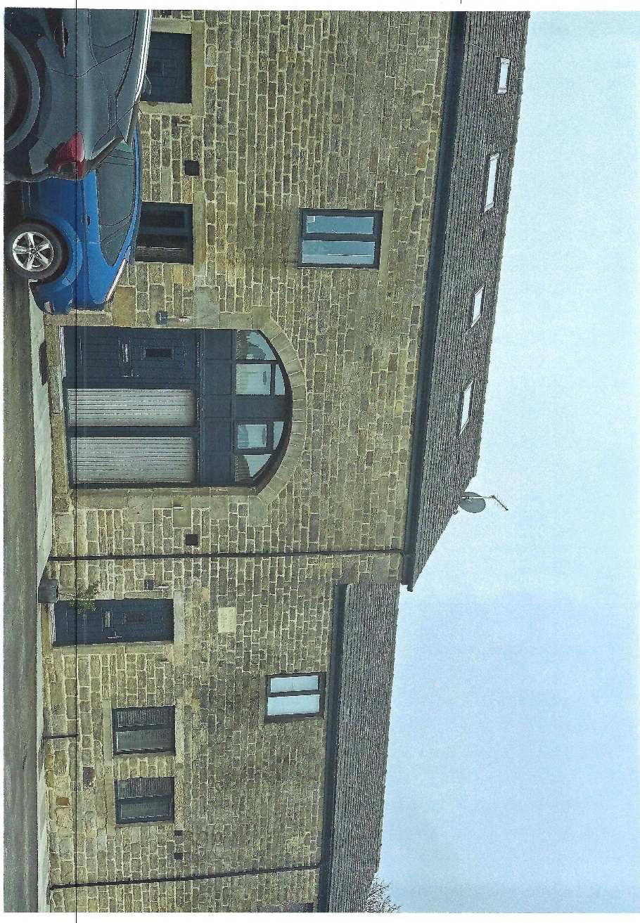

These are available to view on site
External doors
To be vertically slatted doors, stained to match the proposed window frames

Roof Light
The roof light to be Velux Conservation style (flush) to the dimensions as shown on the approved plans and elevations for the dwelling.

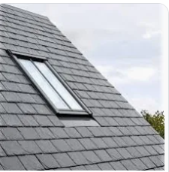

(as accepted by the LPA under the first attempt at the discharge of the condition)

Rainwater goods

In view of the LPA’s aversion to Upvc, the proposal is to use black painter cast iron rainwater goods as follows.
Trade details are submitted with the applicaton

Roof
Roof to be natural blue slate to match that on the adjoining barn conversions and which can be seen on site: -

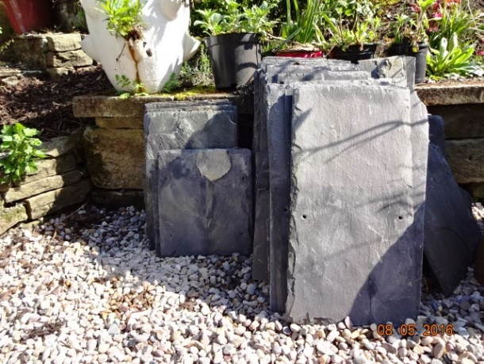

(As accepted by the LPA under the first attempt at the discharge of the condition)

